數值分析Jocobi method for eigenvalues

學號姓名: 00757025 何文豪

1.

matrix A

|  |  |  |  |
| --- | --- | --- | --- |
| 6 | 12 | 15 | 10 |
| 12 | 11 | 4 | 18 |
| 15 | 4 | 15 | 0 |
| 10 | 18 | 0 | 17 |

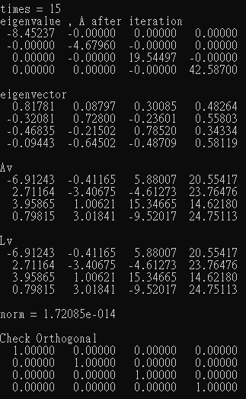

2.

offDiag , eigenvalues的結果放在002.txt裡

3.

N = 3 ~ 20 , the numbers of iterations

|  |  |  |  |  |  |  |  |  |  |
| --- | --- | --- | --- | --- | --- | --- | --- | --- | --- |
| N | M | N | M | N | M | N | M | N | M |
| 3 | 7 | 7 | 60 | 11 | 164 | 15 | 321 | 19 | 556 |
| 4 | 17 | 8 | 80 | 12 | 198 | 16 | 378 | 20 | 616 |
| 5 | 24 | 9 | 111 | 13 | 227 | 17 | 431 | X | X |
| 6 | 41 | 10 | 128 | 14 | 283 | 18 | 488 | X | X |

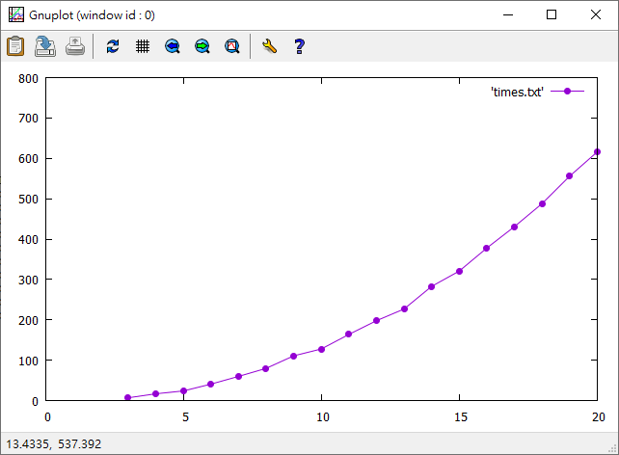

4.

offDiag is quadratic convergence

N = 10

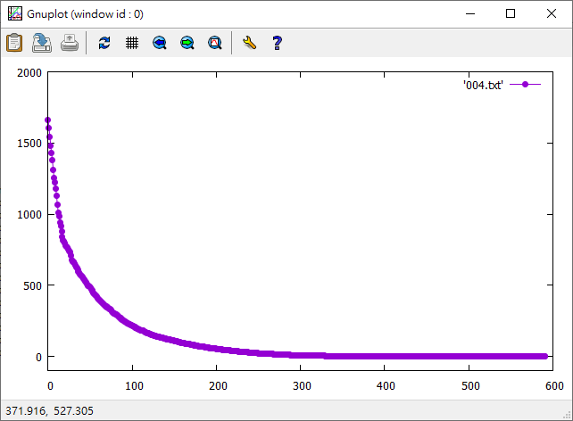

N = 20

