數值分析SOR Method and Heat Equation

學號姓名: 00757025 何文豪

1.

Gauss-Seidel method : w = 1 , Source = 5 , times = 898

Boundary : top= d = 0 , bottom = 20 , right = 30 , left = 30

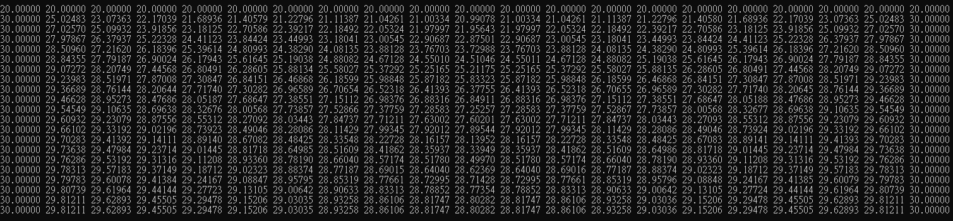

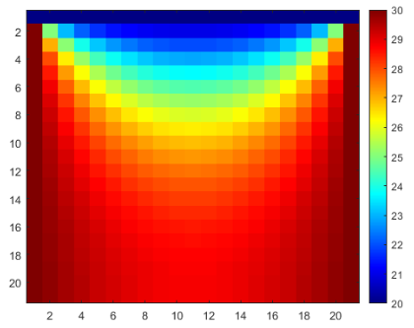

SOR Method : w = 1.2 , Source = 5 , times = 614

Boundary : top= d = 0 , bottom = 20 , right = 30 , left = 30

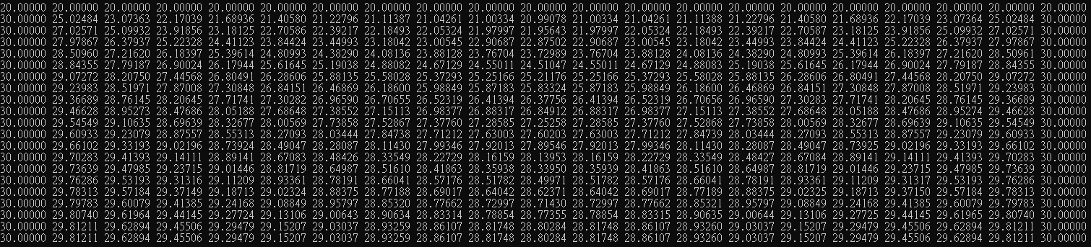



2.

Condition A : w = 1 , Source = 5 , times = 903

Boundary : top= d = 0 , bottom = 30 , right = 30 , left = 30

Result : 改變bottom boundary，溫度更為均勻，但收斂變慢了。

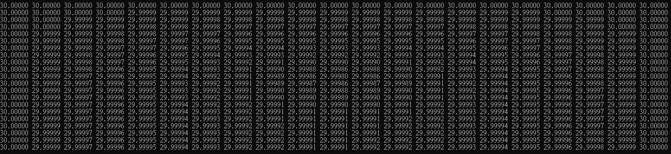

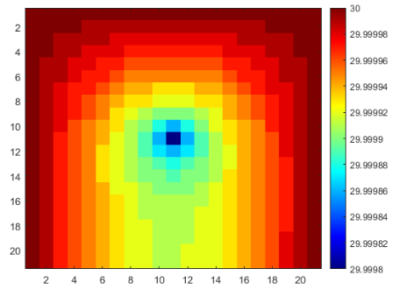

Condition B : w = 1 , Source = 5 , times = 577

Boundary : top= 30 , bottom = 30 , right = 30 , left = 30

Result : 改變top , bottom boundary，收斂得更快。

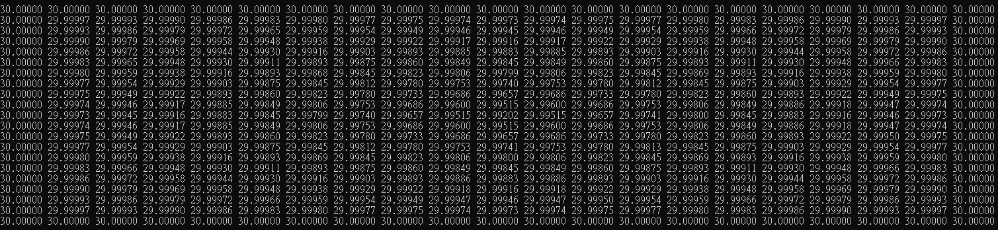

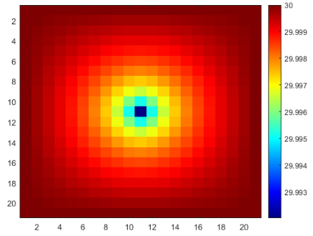

Condition C : w = 1 , Source = 10000 , times = 889

Boundary : top= d = 0 , bottom = 20 , right = 30 , left = 30

Result : 加大熱源2000倍，溫度分布與Gauss差別很大，但收斂次數差不多。

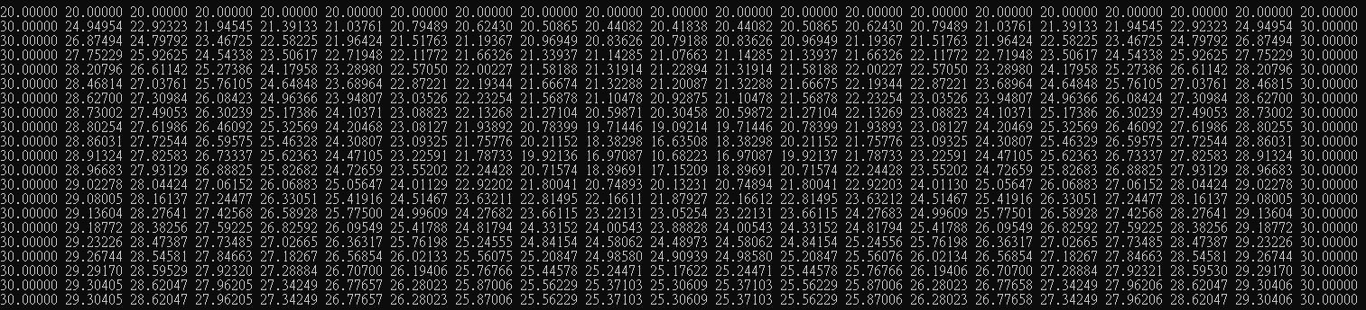

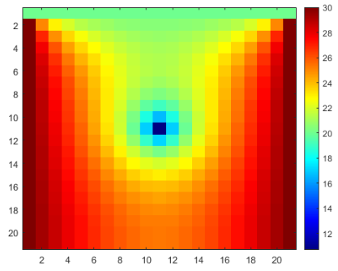

Condition D : w = 1 , Source = 0.05 , times = 898

Boundary : top= d = 0 , bottom = 20 , right = 30 , left = 30

Result : 減少熱源100倍，數值與Gauss只有些微的差距，但收斂次數不變。

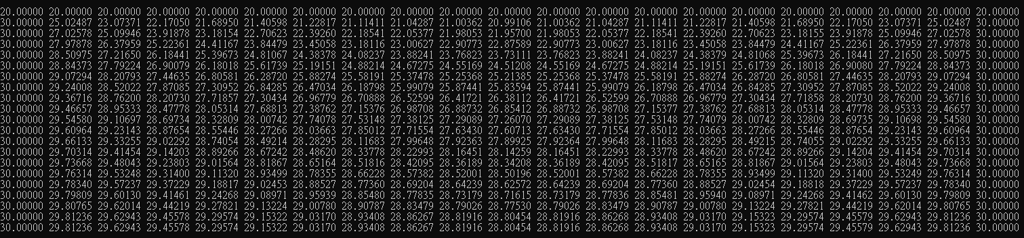

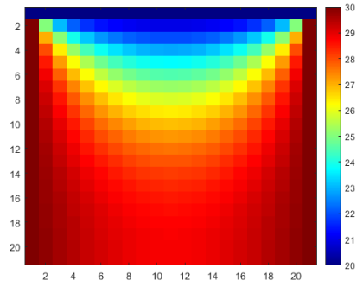

3.

|  |  |  |  |  |  |  |  |
| --- | --- | --- | --- | --- | --- | --- | --- |
| w | times | w | times | w | times | w | times |
| 1.00 | 898 | 1.25 | 556 | 1.50 | 314 | 1.75 | 118 |
| 1.05 | 818 | 1.30 | 501 | 1.55 | 274 | 1.80 | 83 |
| 1.10 | 744 | 1.35 | 450 | 1.60 | 234 | 1.85 | 107 |
| 1.15 | 677 | 1.40 | 402 | 1.65 | 196 | 1.90 | 165 |
| 1.20 | 614 | 1.45 | 357 | 1.70 | 158 | 1.95 | 343 |

w = 1.05 is the worst choice for the SOR method

w = 1.80 is the best choice for the SOR method

Condition E : w = 1.80 , Source = 5 , times = 83

Boundary : top= d = 0 , bottom = 20 , right = 30 , left = 30

Result : 改變w，數值與Gauss有些微的差距，但收斂次數變快10倍。

