Numerical Analysis Final Examination (過程要列.100 points)

- (a) Briefly describe Gaussian-elimination method for solving a linear system, 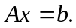 You must explain how to eliminate A into an upper triangular matrix first. Then you have to describe the backward substitution method for solving the upper triangular linear system. (b) What is partial pivoting ? Why partial pivoting is important for Gaussian elimination method ? (c) Solve the linear system by using Gaussian elimination method, if : 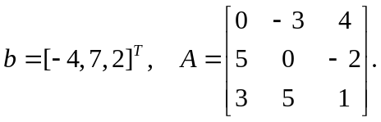 Please use partial pivoting in solving the system. (20 %)
- Use Doolittle’s method to decompose the following matrix into a lower triangular matrix and an upper triangle matrix: 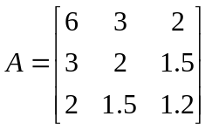. (10%)
- The generic form of iterative method for solving linear system is: 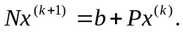 (a) Given the following data, for Jacobian method N = ? P= ? (b) for Gauss-Seidel method, N= ? P = ? (c) If w=1.2, and SOR method is used to solve the linear system, then x⁽¹⁾ = ? x⁽²⁾ = ? 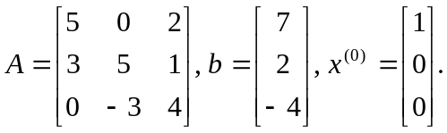 (15 %)
- Please use QR-decomposition method to convert Ax=b into Rx=b*. You must compute the Householder vector v[] and the Householder matrix H[][] for each step and write down the upper triangular matrix R[][] and the right hand side b*[]. 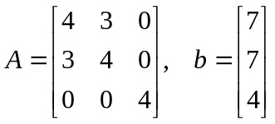. (10 %)
- (a) Describe the power method for computing the maximum eigen value and eigen vector of a matrix A. (b) Describe the inverse-power method for computing the minimum eigen value and eigen vector of a matrix A. (c) Use the power method to compute the maximum eigen-value and eigen-vector for the matrix A of problem 5. Assume the initial eigen-vector y=[1, 0, 0]^{T}. (Perform the computation by three iterations.) (15 %)
- (a) Describe the Jacobian method for solving the eigen-values and eigen-vectors of a symmetric matrix A. (b) Use the Jacobian method to compute the eigen-values and eigen vector of the following matrix: 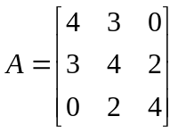. Please just perform the computation once and write down the rotation matrix P and the target matrix A after the similarity transformation. (15 %)
- (a) 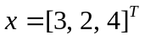, compute the 2-norm, 1-norm, and infinite norm of x. (b) Given a linear system Ax=b, what is the conditional number of A ? Why the conditional number is important ? (c) Compute the 1-norm and infinite norm of matrix A of problem 6. (15 %)

