Numerical Analysis Final Examination (過程要列.100 points)
- Compute the following values: (a) 1-norm, 2-norm, and ∞-norm of 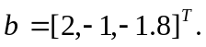, (b) 1-norm and ∞-norm of 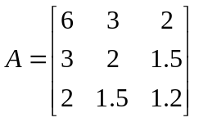.(10%)
- (a) Eliminate the matrix A of Problem 1 into an upper triangular linear system. Please use partial pivoting. (c) Solve the following triangular linear system by using backward substitution 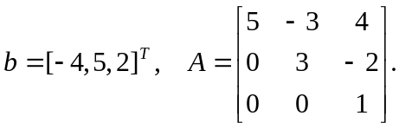 (15%)
- Use Doolittle’s method to decompose the following matrix into a lower triangular matrix and an upper triangle matrix: 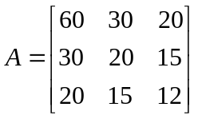. (10%)
- Apply iterative methods to solve 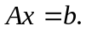 Please stop the computation once 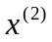 has been computed. (a) Jacobian method, (b) Gauss Seidel method, (c) SOR method with w=1.5. ? 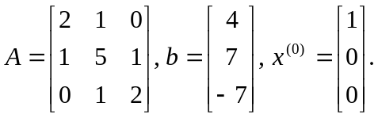 (20 %)
- (a) Use the power method for computing the maximum eigen value and eigen vector of a matrix A. (b) Use the inverse-power method to compute the minimum eigen value and eigen vector of a matrix A. 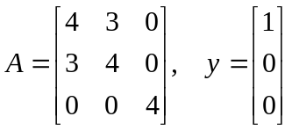.(20%)
- Use the Jacobian method to compute the eigen-values and eigen vector of the following matrix: 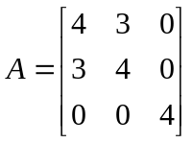. Please list all essential steps and the rotation matrix P and the target matrix A after the similarity transformation. (15 %)
- (a) Please use the Householder’s method to transform the matrix A of Problem 1 into a tri-diagonal matrix. (b) Describe the bisection method for computing an eigen value of a tri-diagonal matrix.

