Numerical Analysis Midterm Exam 100 points
- Derive the relative error of the following computation: 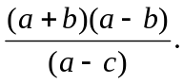 Assume the scalars a, b, and c contain some round-off errors and the operators , +, -, and / also introduce errors into the final result. (10%)
- Briefly explain IEEE 754 floating point representation. Please divide a computer word into three parts, show the lengths and positions of the parts in the computer word, and explain their functionalities.(10%)
- 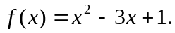 (a) Assume a=0, b=1, compute the root of f(x) by using bi-section method. You need to update your results only 3 times. (b) Let 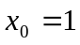, compute the root by using Newton’s method. You need to update your results only 3 times. (i.e. 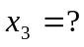) (16%)
- Assume the sample data are{(xi,fi)}= {(0,-6), (1, 0), (2,0), (3,0),(4,6),(5,24)}. (a) Derive the interpolation polynomial for the data set by using Lagrange polynomial. (b) Derive Newton’s polynomial for this data set. (16%)
- (a) Use the data given in problem 4 as input and compute the numerical integration by using trapezoid rule. (b) Compute the integration by using Simpson’s rule.(16%)
- If we approximate the second differentiation of f(x) by using the following formula, what is the truncation error ? (10%)
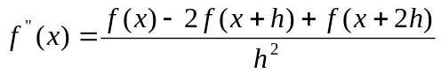
- Let r be the root of f(x). If the first derivative 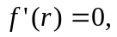 but second derivative 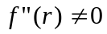. We modify Newton’s method by:
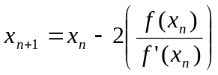,
prove that the new Newton’s method enjoys a quadratic convergent rate.(10%)
- Briefly describe the three methods for computing the first differentiation, f’(x), and the truncation errors of these methods: (a) forward method, (b) backward method, (c) central method. (12 %)

