Numerical Analysis Midterm Exam

- Define the following terms: Relative error, Absolute error, Truncation error, Round-off error. (10%)
- Let Compute f(x) by using Horner’s algorithm. Deduce (推導) the round-off error propagation in the computation. (15%)
- Let 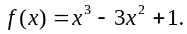 (a) Compute the root of f(x) by using Newton’s method up to the precision of 0.001. Let 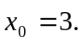 (b) Compute the root by using secant method. Let 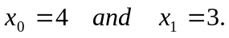 (15%)
- Assume that we have 6 sample data: (a) Deduce the Lagrange polynomial for the interpolation of f(x). (b) Write the Newton’s interpolation polynomial. (c) Assume x is in [-1,0]. If piecewise cubic polynomial is used for the interpolation. Please write down the cubic polynomial. (15%)
- Assume that we have 7 sample data: Compute the integration of f(x) by using (a) the Trapezoid rule, (b) Simpson’s rule.(15%)
- (a) Explain the Gaussian Quadrature integration method in detail. (b) Explain the reason why this method is so accurate for polynomial integration.(15%)
- (a) Deduce the central difference method for f’(x). (b) If x is at the left boundary of [a, b], i.e. x=a. We need to compute f’(x) with the truncation error 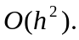 Please use f(a), f(a+h), and f(a+2h) to compute f’(x) such that we have a second order accuracy. (Please express ) (15%)

