Numerical Analysis Homework, Root-finding using Newton’s Method

- Implement Newton’s method for root-finding and compute the root of the following equation with initial value x₀=1 :
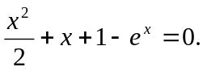
  - List all x_{i,} f(x_{i}), error, and i, for 0≦i≦20.
  - List all x_{i}, f(x_{i}), error, and i, for i > 20 and i%20==0.
  - How many iterations are required in order to achieve 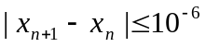 ?
  - Why does Newton’s method converges so slowly in this case ? (Hint: Use the error converging rate 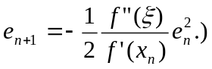
- Use your program to compute the root of the following function 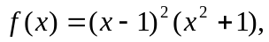assuming the initial value is x₀ = 11. Apparently, the root is x=1. (It is a double-root.)
  - Implement the standard Newton’s method: 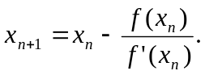
  - Implement the modified Newton’s method: 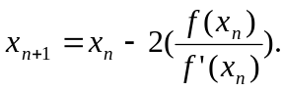
  - Implement the modified Newton’s method, 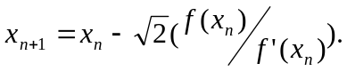
  - Compute the root using both procedures and print out the following information in each iteration:
    - Iteration index
    - The revised root x_{n}
    - The errors (1-x_{n}) and (x_{n}-x_{n-1}).
  - Please answer the following questions:
    - Do the modified Newton’s methods converge faster?
    - Are the converge rates of these 3 methods linear and quadratic?
  - Verify your answers using the results or any feasible examples deduced by you.
- Demo your programs in Lab503 two weeks later.
- Print the results on A4 size papers. Write your answers on A4 size paper too. You can annotate the results and write your own opinions, comments, and conjectures on them. Please staple your papers and hand in the papers when you dem your programs..

