Numerical Analysis Homework 1, Root-finding using Newton ’s Method

- Implement the 2D Newton’s method and compute the roots of the following 2D equations by using your program:
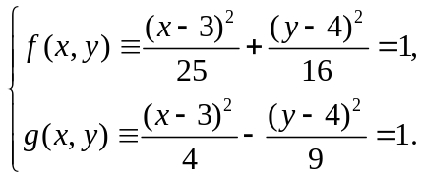
  - Use initial solution [3.01, 3.99] and compute 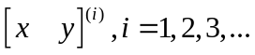
  - List all [x_{i,} y_{i}], and {f(x_{i,} y_{i}), g(x_{i,} y_{i})} for 0≦i≦20.
  - If the computation converges, how many iterations are required in order to achieve 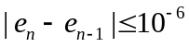? Please use 2-norm to estimate the magnitude of the error vector.
  - Try at least 4 other initial solutions (one initial solution in one quadrant, the center = [3, 4]) and compute the roots.
- Demo your programs in Lab503 two weeks later.
- Draw the graphs of f(x,y) and g(x,y) by using any graphics tools, for example gnuplot. Draw the paths created by linking [x_{i,} y_{i}].
- Try computing the roots by using more initial solutions. Are there initial solutions leading your program to diverge in the root-finding computation? If so, show the area(s) containing these initial guesses. Also show the regions in which all initial solutions leading the Newton’s method to converge.
- Try your best to explain the convergence conditions for computing the roots.
- If you had learned computer graphics knowledge, please design a program to show the progression of the computation.
- Print the results on A4 size papers. Write your answers on A4 size paper too. You should annotate the results and write your own opinions, comments, and conjectures on them. Please staple your papers and hand in the papers when you demo your programs.

