Iterative Methods and Heat Equation

- Solve the following Laplace’s equation: 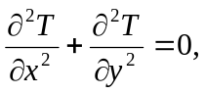 on the domain of [0,10]x[0,10]. Assume T=20 at the top, left, and right boundaries, and T=100 at the bottom boundary.
T=20
T=20
T=20
T=100
- Super-impose a 17 X 17 grid on the domain. Convert the PDE into a linear system by using finite difference method and solve the function T at all grid-points.
- Solve the linear system by using the following methods:
  - Gauss-Seidel method,
  - SOR method with w=1.6.
- Please stop the iteration if 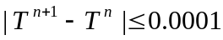. Assume the initial value of T is 20.
- Print out the solution in a 17 X 17 2D table.
- Print out the number of iterations for the the methods.
- Try w= 1.3, 1.4, 1.5, 1.6, 1.7, 1.8, and 1.9 for the SOR method. Which w value is the best choice?

