Iterative Methods and Heat Equation

- Solve the following Poisson equation: 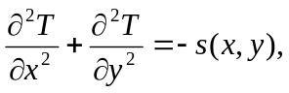 in the domain of D=[0,1]x[0,1]. Assume that the boundary conditions are: T=20 at the bottom, left, and right boundaries, and 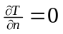at the top boundary, where n is the normal of the top boundary.
T=20
T=20
d(T)/d(n) =0
T=20
- The source function s(x, y)=1.0 at (0.5,0.5) otherwise s(x,y) =0.0.
- Super-impose a 21 by 21 grid on the domain and split the domain into a mesh. Discretize the PDE into a linear system by using finite difference method. Solve the function T at all grid-points. 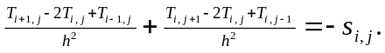
Where h is the spatial gap between grid-points.
- Solve the linear system by using the following methods:
  - Gauss-Seidel method, w=1.0.
  - SOR method with w=1.5.
- Please stop the iteration if 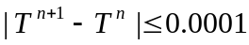. Assume the initial value of T is 0.
- Print out the solution in a 20 x 20 (or 10 x 10) 2D table, no boundary values.
- Print out the number of iterations for the two methods.
- Try w= 1.1, 1.2, 1.3, 1.4, 1.5, 1.6, 1.7, and 1.8. Which w value is the best choice for the SOR method ?
- (Optional) Implement the steepest descent method and compare the converge-rate of this method with the best SOR method.

