Numerical Analysis Homework, Gaussian Elimination Method
- Write a subroutine to construct a linear system, Ax = b. The entries of A and b are defined by: 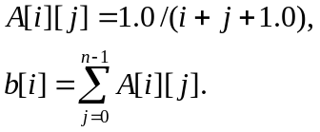 Matrix A is the Hilbert matrix.
- Implement the Gaussian-elimination method. The procedure header looks like:
void gauss_elm(double **A, double *b, double *x, int N);
where x is the unknown vector and N is the dimension of A.
- Requirements:
  - Print out N.
  - Print out x[].
  - Print out the norm of e, where e[i] = 1.0 – x[i].
  - Print out the norm of r, where r = b - Ax.
  - Please try N=5, 10, 15, 20, and 25.
- Your Gaussian elimination procedure should support partial pivoting.
- Analyze and explain the results as detail as possible.

