Numerical Integration Method

- Let . The integral range = [0..3].
- Implement the following integration methods:
  - Simpson’s rule,
  - Trapezoid rule,
  - Riemann sum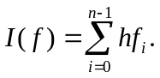
- Let N=8, generate the sample points and perform the integration by using the previous three methods. Please print out the results, the exact solution, and the errors of these methods.
- For each method, try N=8, 16, 32, 64, 128, …, and so on, until the absolute error is less than 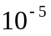. Please print out the integral results and the errors for all N values.
- Please write down the theoretical convergent rates of these methods. For each method, please compare the real convergent rate with the theoretical one. Do they match with each other ? Verify your answer.

