Numerical Integration Method

- Let 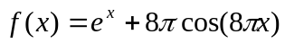. The integral range = [0..1].
- Implement the following integration methods:
  - Simpson’s rule,
  - Trapezoid rule,
- Let N=8, 16, and 32. Please generate the sample points and perform the integration by using the previous methods. Please print out the results, the exact solution, and the errors of these methods.
- How large should N be such that the absolute error is less than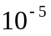? Please print out the integral results and the errors for the N values of the two methods.
- Please write down the theoretical convergent rates of these methods. For each method, please compare the real convergent rate with the theoretical one. Verify your answer and give some explanation..

