Polynomial Interpolation, the Newton’s Method

- Assume x belongs to [0, 6.3]. Sample (N+1) equally-spaced sample points in this domain. Let the target function be:
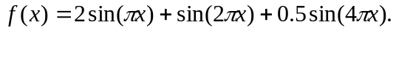
- Implement the Newton interpolation method and Lagrange polynomial method and interpolate the function values at x = (i+0.5)*h, where h = (1.0/N), for i = 0 to N-1.

- Compare the interpolated function values calculated by using both the methods, and the actual function values.

- Try the following three cases. Print out the values: x, p(x), f(x), and errors. The error at x is defined by |f(x)-p(x)|.
  - N = 6.
  - N = 12.
  - N = 24.

- Answer the following questions in your reports:
  - Is the accuracy getting improved, as the value of N increases ?
  - Are the errors at the first and the last interpolation points larger than that at the middle interpolation point, x = (N/2 + 0.5)*h?
  - Are the results of the Newton’s method better than that of the Lagrange polynomial method
  - Please analyze the results and try your best to explain the reasons?
- Hand-in your reports two weeks later in class, including the results and analysis.

