Iterative Methods and Heat Equation

- Solve the following Laplace’s equation: 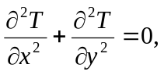 on the domain of [0,10]x[0,10]. Assume T=20 at the top, left, and right boundaries, and T=100 at the bottom boundary.
T=20
T=20
T=20
T=100
- Super-impose a 17 X 17 grid on the domain. Convert the PDE into a linear system by using finite difference method and solve the function T at all grid-points.
- Solve the linear system by using the following methods:
  - Jacobian method,
  - Gauss-Seidel method,
  - SOR method with w=1.5.
- Please stop the iteration if 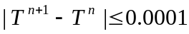. Assume the initial value of T is 0.
- Print out the solution in a 17 X 17 2D table.
- Print out the number of iterations for the three methods.
- Try w=1.2, 1.3, 1.4, 1.5, 1.6, 1.7, and 1.8. Which w value is the best choice for the SOR method ?

