Polynomial Interpolation, the Newton’s Method

- Assume x belongs to [0, 2]. Sample (N+1) equi-spaced sample points in this domain. Let the target function be:
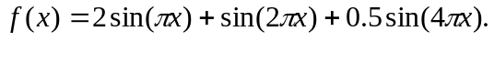
- Implement the Newton interpolation method and interpolate the function values at x = (i+0.5)*h, where h = (2.0/N), for i = 0 to N-1.

- Try the following three cases. Print out the values: x, p(x), f(x), and errors. The error at x is defined by |f(x)-p(x)|. Compare the interpolated function values, p(x), and the actual function values, f(x).
  - N = 12.
  - N = 18.

- Implement the piecewise cubic interpolation method and compute the function values at x = (i+0.5)*h, where h = (2.0/N), for i = 0 to N-1.

- Answer the following questions in your reports:
  - As the value of N increases, is the accuracy improved for the Newton’s method ?
  - Are the errors at the first and the last interpolation points larger than that at the middle interpolation point, x=(N/2 + 0.5)*h ?
  - Are the results computed by using the Newton’s method better than those produced by using the piecewise interpolation method ?

