Numerical Analysis Homework, Root-finding and Newton’s Method

- Implement Newton’s method for root-finding and solve the root of the following equation with initial value x₀=1 :
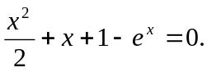
  - List all xi, f(xi), error, and i, for 0≦i≦30.
  - List all xi, f(xi), error, and i, for i > 30 and i%20==0.
  - How many iterations are required before 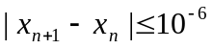 ?
  - Why Newton’s method converges so slowly in this case ? (Hint: Use the error converging rate 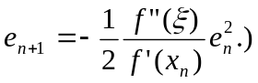
- 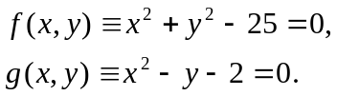 Implement the 2D Newton’s method and solve this non-linear system with the 4 initial values: (2, 2), (-2, 2), (2, -2), and (-2, -2).
  - There are 2 roots for this system, and f(x,y) is a circle and g(x,y) is a parabolic curve. Divide the rectangle (-5,-5) ←→(5,5) into 4 regions. Mark the regions where all initial points lead Newton’s method to diverge and the regions where all initial values lead Newton’s method to a root.
  - Please explain the reason behind the results which you obtain from part (a).

