Numerical Analysis Homework, Root-finding
- Implement Bisection method, Newton’s method, and Secant method for root finding.
- Compute the root of the following equation:
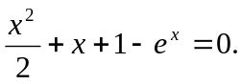
- For Newton’s method, select x0=1.
- For Bisection method, select a=2 and b= 0.
- For Secant method, select x0 = 2 and x1 = 1.
- List all xi, f(xi), error, and i, for 0≦i≦30.
- List all xi, f(xi), error, and i, for i > 30 and i%20==0.
- How many iterations are required before 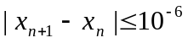 ?
- Which method converges faster and which one converges slowly ?
- Explain the reasons.

