BLACK HISTORY MONTH 2026
Daphne Steele: The NHS's First Black Matron
From British Guiana to matron of an English hospital in 1964
STUDENT WORKSHEET · AGES 11–16 · 60 MINUTES
Name: |  | Date:

1. Learning Objectives
By the end of this session, I will be able to:
■ Explain who Daphne Steele was and why she matters.
■ Put the key events of her life in order.
■ Describe the barriers she faced and what helped her.

2. Photo Detective
▶ DO NOW
Look closely at this photo. Don't guess her name yet – be a detective!
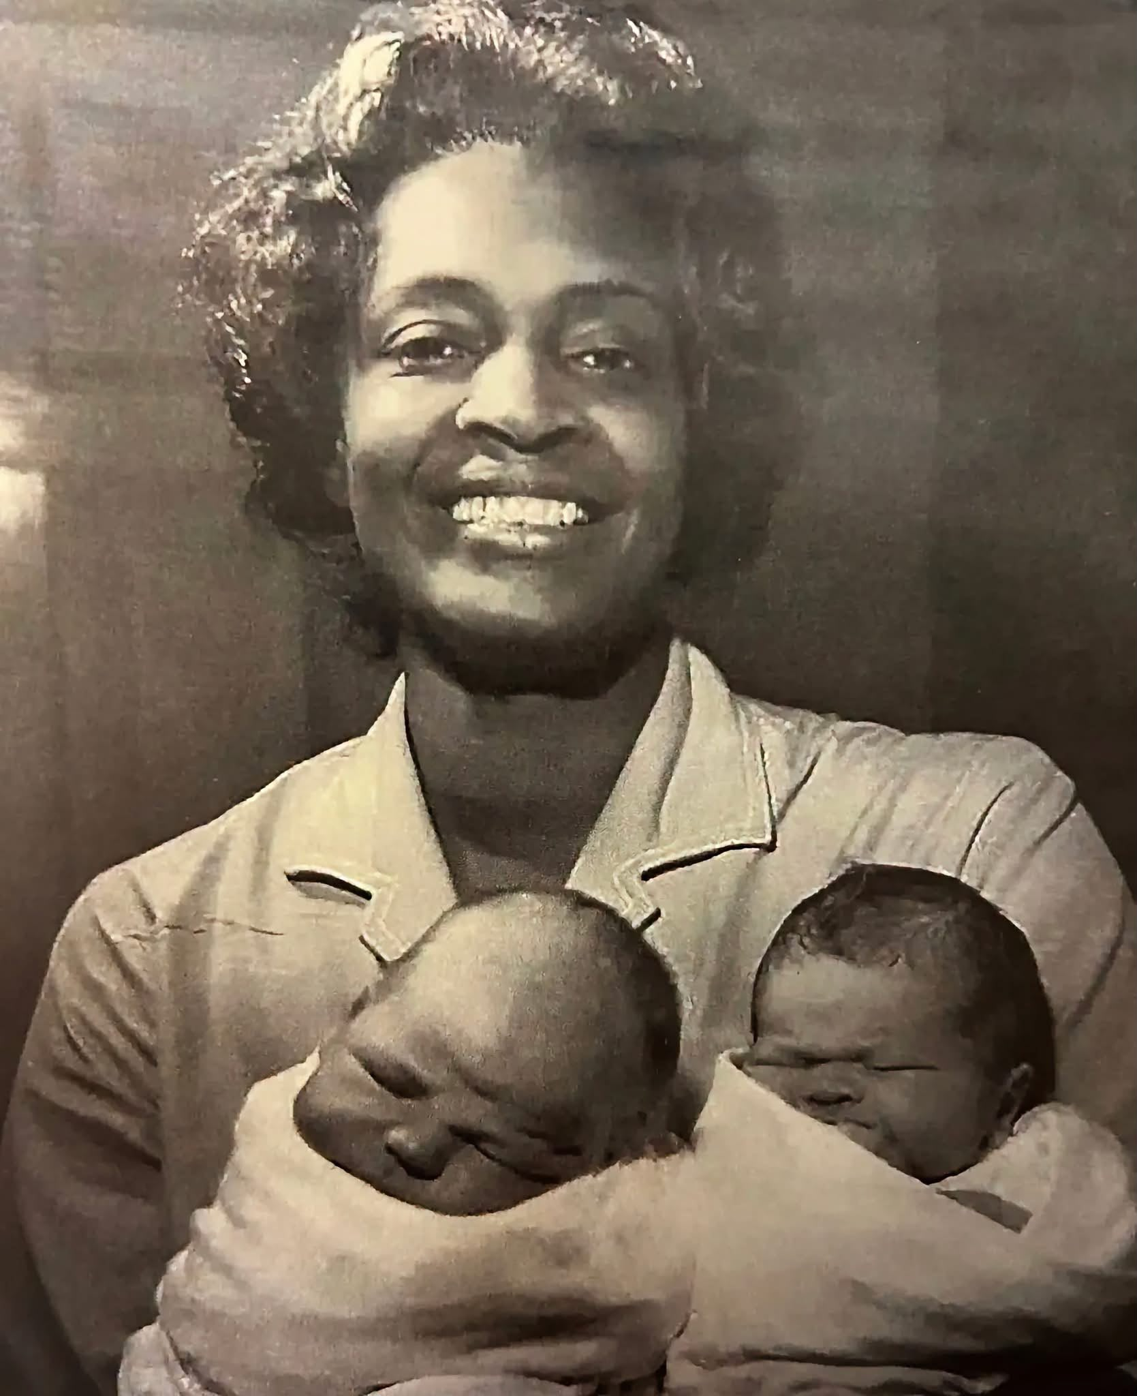 | What job do you think she does? Clue: look at her uniform and what she is holding.  Roughly when was this photo taken? What makes you think that?  How do you think she is feeling?

3. Learn
Who was Daphne Steele?
Daphne Steele was born in 1927 in British Guiana (now Guyana) in South America, the eldest of nine children. She trained as a nurse and midwife in the capital, Georgetown. In 1951, aged 23, she sailed for 14 days to England to work for the new National Health Service (NHS), which needed thousands of nurses.
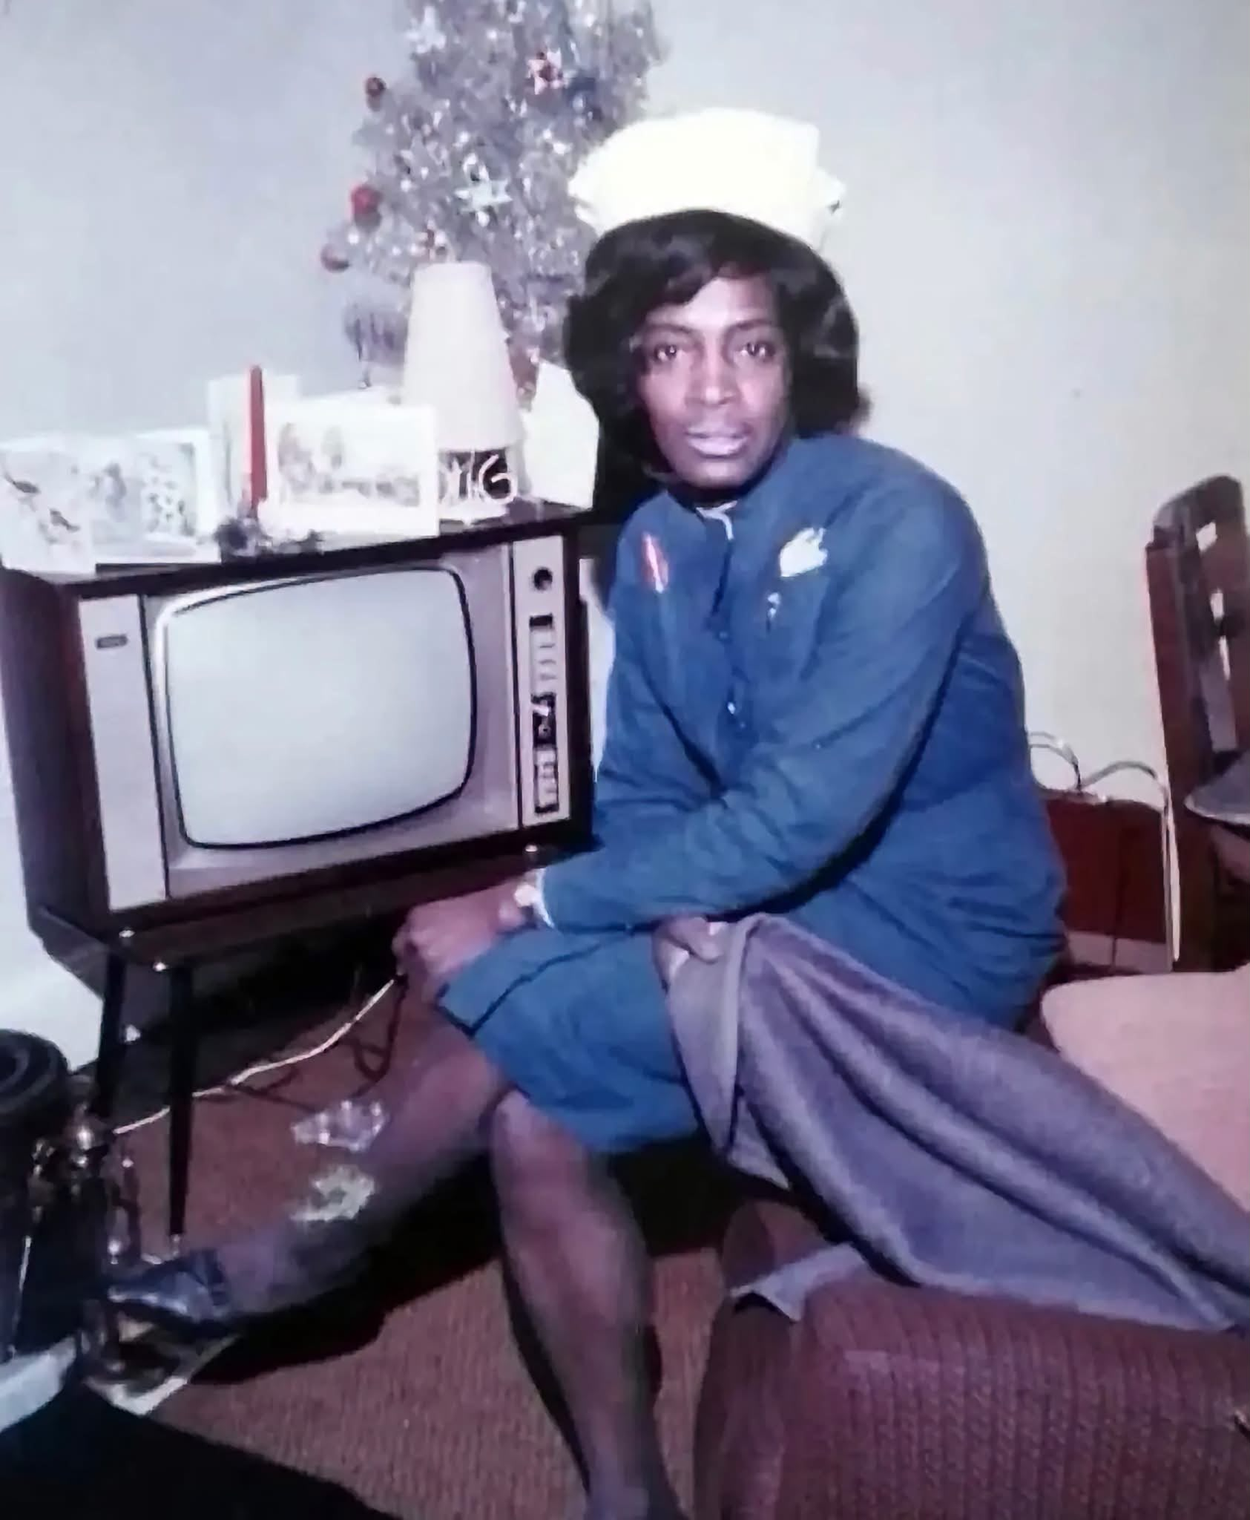
Daphne Steele at home at Christmas, in uniform and cap.
Making history
She trained again at St James' Hospital in Balham, London, and worked in the USA and Manchester. In 1964, aged 36, she became matron of St Winifred's Hospital in Ilkley, Yorkshire. She was the first Black matron in the NHS. Some patients were suspicious and called her “you people”, but she also received about 350 letters of support – and replied to every one.
Remembered today
Daphne died in 2004. In 2023 her sister Jeune Singh and former colleagues planted a tree in her memory at St George's Hospital, Tooting. In 2024 she became the first person outside London to receive an official national blue plaque. Every year on 15 October, her birthday, St George's celebrates Daphne Steele Day.
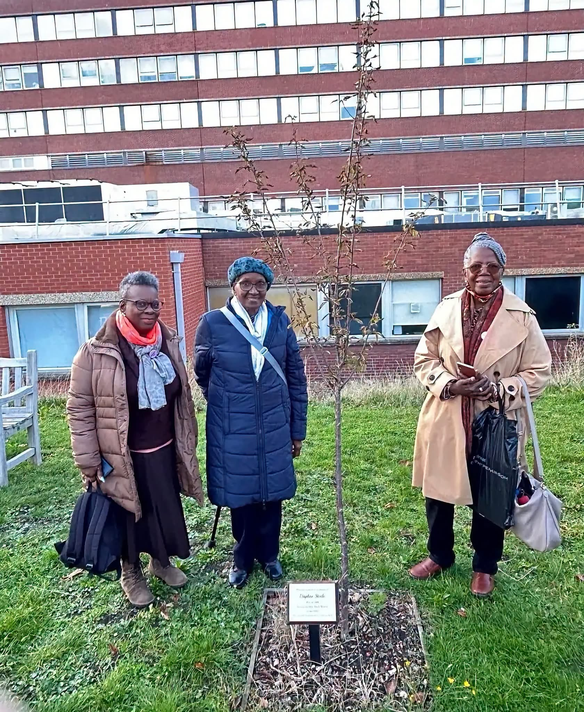
2023: the tree planted in Daphne's memory at St George's Hospital by her sister Jeune Singh and former colleagues Vilma Todd and Sylvia Simpson.
DID YOU KNOW?
A matron was the most senior nurse in a hospital, in charge of all the nurses and wards.

Word match: draw a line from each word to its meaning.
Word |  | Meaning
Matron | ● ● | The first person to do something, opening the way for others
Midwife | ● ● | How a person is remembered and what changed because of them
Pioneer | ● ● | The senior nurse in charge of a hospital's nurses and wards
Barrier | ● ● | A nurse who cares for mothers and newborn babies
Legacy | ● ● | Something that blocks or makes it harder to do something

4. Put Her Life in Order
Number the events 1 to 8, starting with the earliest.
No. | Event
 | Becomes the NHS's first Black matron in Ilkley
 | Born in British Guiana, the eldest of nine children
 | Blue plaque unveiled in her honour
 | Arrives in England at Plymouth after 14 days at sea
 | Starts training as a nurse in Georgetown
 | Retires after working as a health visitor
 | Works as a nurse in New Jersey, USA
 | Qualifies as a nurse and midwife in England

5. Barriers & Bridges
Barriers made things harder for Daphne. Bridges helped her get past them. Write each letter in the right column.
A. She left her family and country to work in a new land. | B. She had years of training and strong qualifications.
C. Some patients called her “you people”. | D. She received around 350 letters of support.
E. No Black woman had been an NHS matron before her. | F. She worked so hard her sister said she “never seemed to be off duty”.

BARRIERS (made it harder) | BRIDGES (helped her)

Which barrier do you think was the hardest? Why?

6. In Her Words
DAPHNE STEELE, 2002
“If one can do it, we all can do it.”

How much do you agree? Circle one.
1 Not at all | 2 | 3 | 4 | 5 Completely

Explain your choice. What does the quote mean to you?

7. A Letter to Daphne – 1964
When Daphne became matron she received about 350 letters – and replied to every one. Imagine it's 1964. Write her a short letter. You could congratulate her, say what her achievement means, or ask her a question.
Starters: “Congratulations on…” “You show us that…” “I want to ask you…”
Dear Matron Steele,

From, ______________________
8. True or False?
Statement | True | False
1. Daphne Steele was born in Jamaica. | ☐ | ☐
2. She arrived in England in 1951. | ☐ | ☐
3. She became a matron at a hospital in London. | ☐ | ☐
4. She was 36 when she became a matron. | ☐ | ☐
5. A statue of her was built at St George's Hospital in 2023. | ☐ | ☐
6. St George's Hospital celebrates Daphne Steele Day every October. | ☐ | ☐

9. Exit Ticket
One thing I learned today:

One pioneer in my life or community, and why:

How confident am I explaining her story? Circle one.
1 | 2 | 3 | 4 | 5

TAKE IT FURTHER (OPTIONAL)
Visit the Royal College of Nursing website (rcn.org.uk). Find one more fact about Black nurses in NHS history, or one route into nursing or midwifery that interests you.

