BLACK HISTORY MONTH 2026
Arthur Zang: The Cardiopad Inventor
How a young engineer brought heart tests to rural Cameroon
STUDENT WORKSHEET · AGES 11–16 · 60 MINUTES
Name: |  | Date:

1. Learning Objectives
By the end of this session, I will be able to:
■ Explain the problem Arthur Zang wanted to solve.
■ Describe how the Cardiopad works.
■ Come up with my own invention idea.

2. Do Now
▶ DO NOW
Imagine you live 200 miles from the nearest heart doctor and you start to feel chest pains. What could you do? What would make it hard?

3. Learn
The problem
Arthur Zang grew up in Cameroon, in Central Africa, and studied computer science and engineering in the capital, Yaoundé. In 2009 he met a heart doctor who told him a shocking fact: Cameroon had fewer than 50 heart specialists for more than 20 million people, and almost all of them worked in big cities. People in villages could not get their hearts checked.
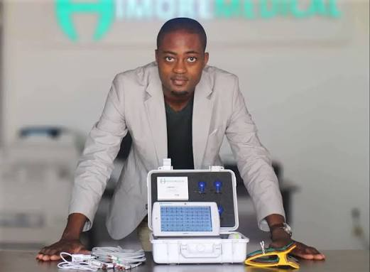
Arthur Zang with the Cardiopad, at his company Himore Medical.
The solution
Arthur designed the Cardiopad, a touchscreen tablet that lets a nurse do a heart test (an ECG) anywhere. The results are sent over the mobile phone network to a heart specialist, who reads them and sends back a diagnosis – sometimes within 20 minutes.
Making it real
Building it was hard. His mother took out a bank loan to help him, he asked for support on social media, and the country's president funded the first 20 devices. In 2014, aged 26, he won a Rolex Award, and in 2016 he won the Africa Prize for Engineering Innovation from the UK's Royal Academy of Engineering. His company is called Himore Medical.
DID YOU KNOW?
An ECG (electrocardiogram) records the tiny electrical signals your heart makes each time it beats.

Word match: draw a line from each word to its meaning.
Word |  | Meaning
Cardiologist | ● ● | A doctor's decision about what is wrong
ECG | ● ● | A doctor who specialises in the heart
Rural | ● ● | A person who creates something new
Inventor | ● ● | A test that records the heart's electrical signals
Diagnosis | ● ● | In the countryside, away from towns

4. How Does the Cardiopad Work?
Number the steps 1 to 6 in the right order.
No. | Event
 | The specialist reads the heart test
 | A health worker attaches sensors to the patient's chest
 | The result is sent over the mobile phone network to a heart specialist
 | The diagnosis and treatment are sent back to the village
 | The sensors send the heart signals to the tablet by Bluetooth
 | The tablet records the ECG

5. True or False?
Statement | True | False
1. Arthur Zang is from Cameroon. | ☐ | ☐
2. Cameroon had over 500 heart specialists when he started. | ☐ | ☐
3. The Cardiopad sends results using the mobile phone network. | ☐ | ☐
4. A bank refused to lend his family any money. | ☐ | ☐
5. He won an award from the UK's Royal Academy of Engineering. | ☐ | ☐
6. He was in his twenties when he won the Rolex Award. | ☐ | ☐

6. My Invention Pitch
Arthur noticed a real problem and solved it. Think of a problem in your area or community. Write a short pitch for an invention to solve it.
The problem is…
My invention is called…
It works by…
It will help…

7. What Do You Think?
“Young people can solve big problems.” How much do you agree? Circle one.
1 Not at all | 2 | 3 | 4 | 5 Completely

Explain your choice.

8. Exit Ticket
One thing I learned today:
One quality that helped Arthur succeed, and why:
How confident am I explaining this story? Circle one. | 1 2 3 4 5

