BLACK HISTORY MONTH 2026
What's Their Famous Export?
What do the countries on our flag border sell to the world?
ANSWER SHEET · AGES 11–16 · 30–45 MINUTES
HOW TO RUN IT
Start with Round 1 as a class warm-up. Round 2 works well in pairs or small teams with the word bank; award 1 point per correct answer (accept any sensible answer from the 'Famous export' column, e.g. 'gold' or 'cocoa' for Ghana). Exports change over time, so these show a well-known or major export for each country, not always the single biggest one.

1. Round 1: Quick Guess
1. Ethiopia  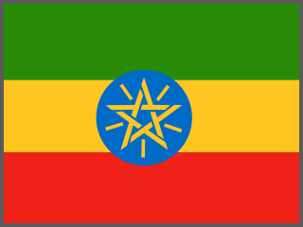  Coffee | 2. Côte d'Ivoire  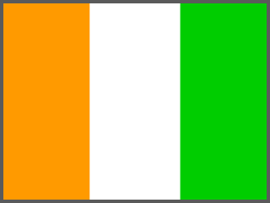  Cocoa | 3. Madagascar  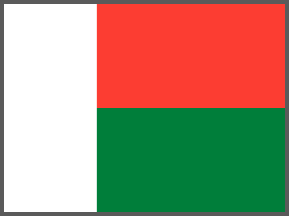  Vanilla | 4. Grenada  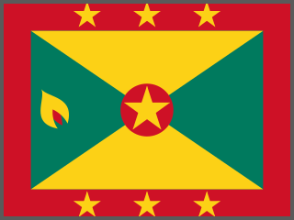  Nutmeg
5. Barbados  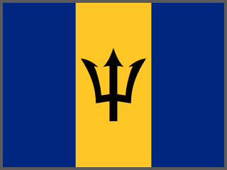  Rum | 6. Kenya  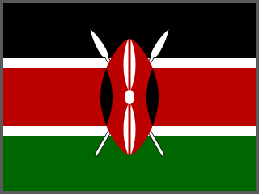  Tea | 7. Botswana  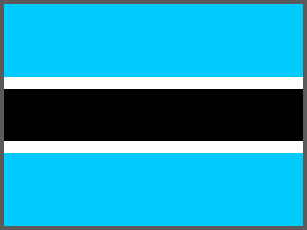  Diamonds | 8. Zambia  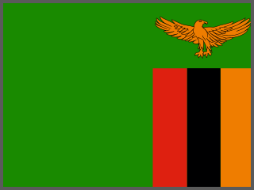  Copper

2. Round 2: All 66 Flags
 | Country | Famous export | Fun fact
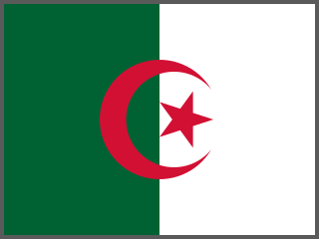 | 1. Algeria | Natural gas and oil | Pipes gas under the sea to Spain and Italy.
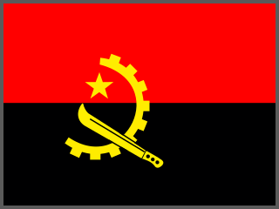 | 2. Angola | Crude oil (and diamonds) | Oil makes up most of what it sells abroad.
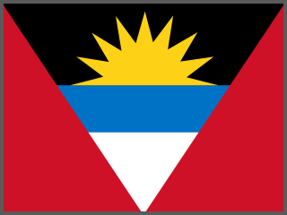 | 3. Antigua and Barbuda | Tourism | Said to have 365 beaches, one for every day.
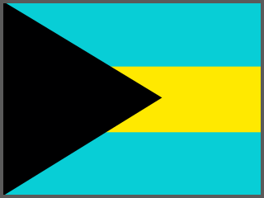 | 4. The Bahamas | Tourism (and spiny lobster) | Millions of visitors arrive by cruise ship.
 | 5. Barbados | Rum | Often called the birthplace of rum.
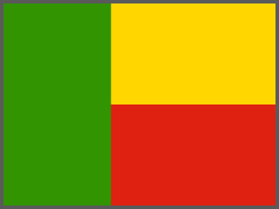 | 6. Benin | Cotton (and cashew nuts) | One of Africa's biggest cotton growers.
 | 7. Botswana | Diamonds | One of the world's top diamond producers.
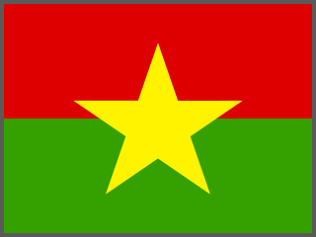 | 8. Burkina Faso | Gold (and cotton) | Gold is now its biggest export.
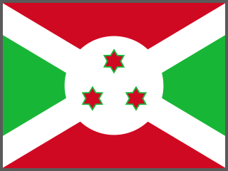 | 9. Burundi | Coffee (and tea) | Coffee grows on its green hills.
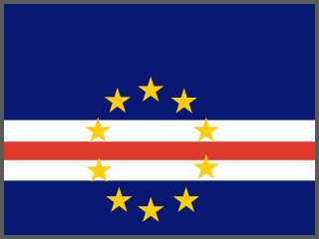 | 10. Cabo Verde | Fish, especially tuna | Surrounded by rich Atlantic fishing waters.
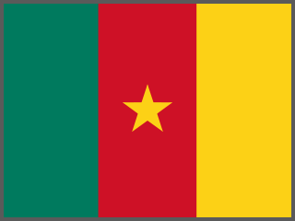 | 11. Cameroon | Cocoa (and oil and timber) | Cocoa beans are used to make chocolate.
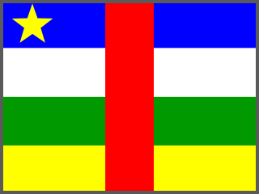 | 12. Central African Republic | Diamonds and timber | Also has large rainforests.
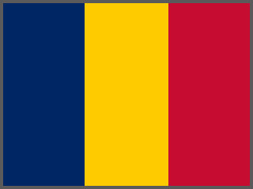 | 13. Chad | Crude oil | Oil travels by pipeline to the coast of Cameroon.
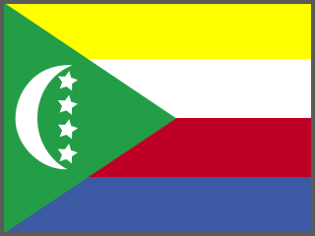 | 14. Comoros | Vanilla and ylang-ylang | Ylang-ylang flowers are used in perfumes.
 | 15. Côte d'Ivoire | Cocoa | The world's biggest cocoa producer.
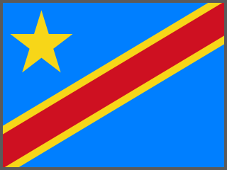 | 16. DR Congo | Cobalt and copper | Produces most of the world's cobalt, used in phone and car batteries.
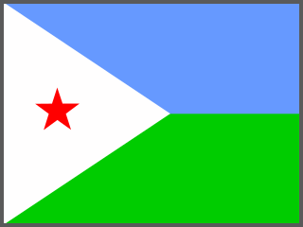 | 17. Djibouti | Port and shipping services | Its port handles most of Ethiopia's trade.
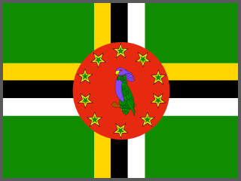 | 18. Dominica | Bananas | Known as the 'Nature Island' of the Caribbean.
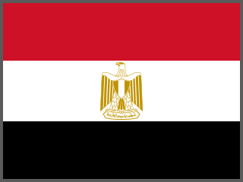 | 19. Egypt | Egyptian cotton (and natural gas) | Egyptian cotton is famous for soft sheets.
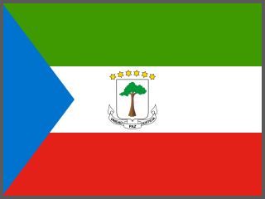 | 20. Equatorial Guinea | Oil and gas | Oil was found off its coast in the 1990s.
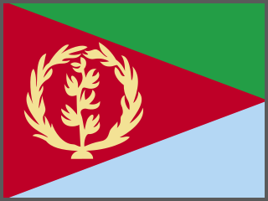 | 21. Eritrea | Zinc and copper | Mines metals near the Red Sea.
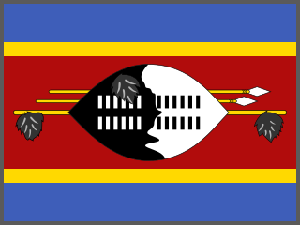 | 22. Eswatini | Sugar | Sugar cane grows in its lowlands.
 | 23. Ethiopia | Coffee | Believed to be the birthplace of coffee.
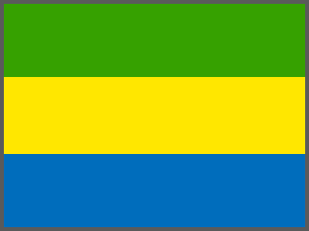 | 24. Gabon | Oil and manganese | Mostly covered by rainforest.
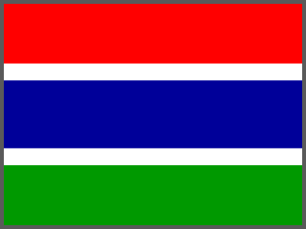 | 25. The Gambia | Groundnuts (peanuts) | Peanuts have been grown here for centuries.
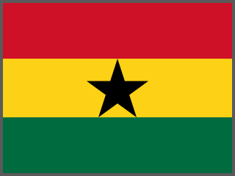 | 26. Ghana | Gold and cocoa | Once called the Gold Coast.
 | 27. Grenada | Nutmeg | A nutmeg appears on its flag. It's called the 'Isle of Spice'.
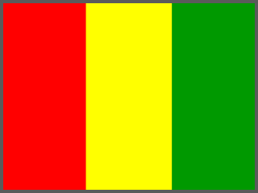 | 28. Guinea | Bauxite (used to make aluminium) | Has some of the world's largest bauxite reserves.
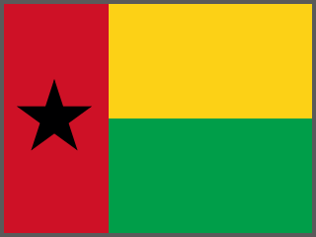 | 29. Guinea-Bissau | Cashew nuts | Cashews are its main source of income.
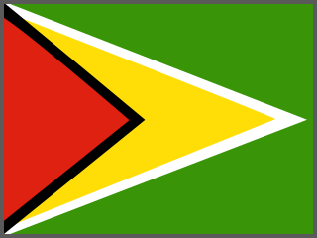 | 30. Guyana | Oil (and sugar and rice) | Huge oil finds since 2015 have changed its economy.
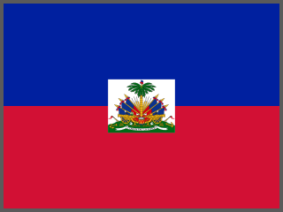 | 31. Haiti | Clothing, mangoes and vetiver oil | A top producer of vetiver oil, used in perfume.
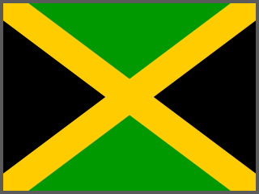 | 32. Jamaica | Alumina (and Blue Mountain coffee) | Blue Mountain coffee is among the world's most famous.
 | 33. Kenya | Tea (and cut flowers) | Many roses in UK shops are grown in Kenya.
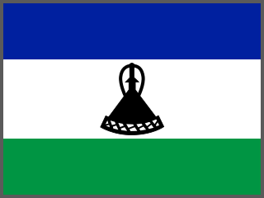 | 34. Lesotho | Water (sold to South Africa) and diamonds | Surrounded completely by South Africa.
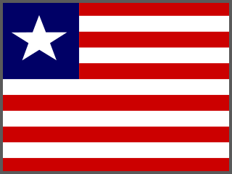 | 35. Liberia | Rubber and iron ore | Huge rubber farms supply tyre makers.
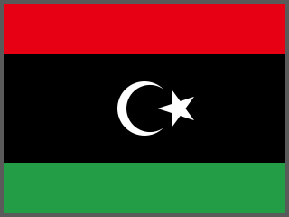 | 36. Libya | Crude oil | Has Africa's largest proven oil reserves.
 | 37. Madagascar | Vanilla | Grows most of the world's vanilla.
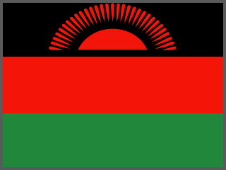 | 38. Malawi | Tobacco | Tobacco is its main export crop.
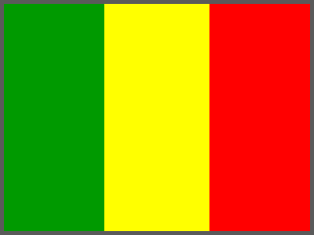 | 39. Mali | Gold (and cotton) | Linked to Mansa Musa's golden empire.
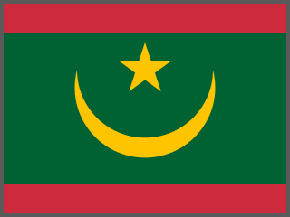 | 40. Mauritania | Iron ore (and fish) | One of the world's longest trains carries its iron ore.
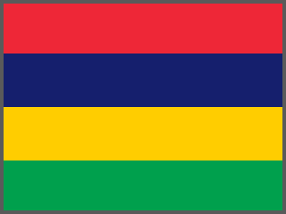 | 41. Mauritius | Sugar and clothing | Sugar cane covers much of the island.
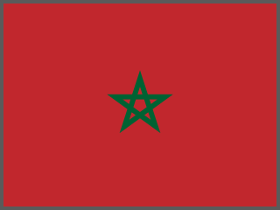 | 42. Morocco | Phosphates (for fertiliser) and cars | Holds most of the world's phosphate reserves.
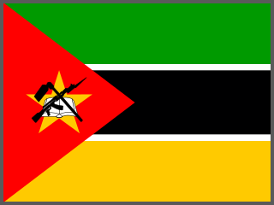 | 43. Mozambique | Aluminium and coal | Also has huge gas fields off its coast.
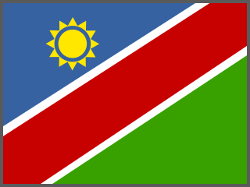 | 44. Namibia | Diamonds and uranium | Many diamonds are mined from the seabed.
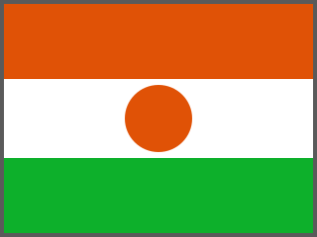 | 45. Niger | Uranium | Uranium is used to fuel nuclear power stations.
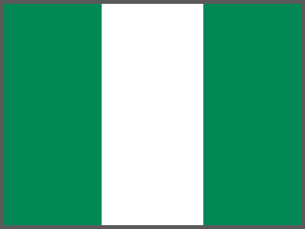 | 46. Nigeria | Crude oil | Africa's biggest oil producer for many years.
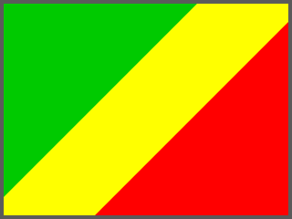 | 47. Republic of the Congo | Crude oil | Oil is pumped from fields off its coast.
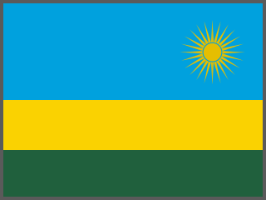 | 48. Rwanda | Coffee and tea | Known as the 'land of a thousand hills'.
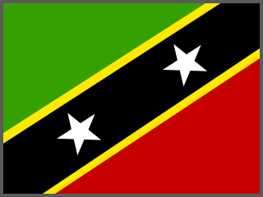 | 49. Saint Kitts and Nevis | Tourism (it once exported sugar) | Sugar was its main export until 2005.
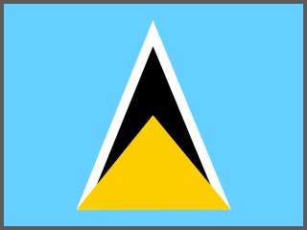 | 50. Saint Lucia | Bananas | Bananas were called 'green gold' here.
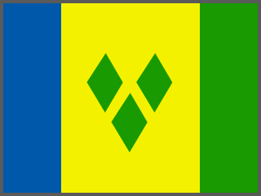 | 51. Saint Vincent and the Grenadines | Bananas and arrowroot | Arrowroot starch was once used in computer paper.
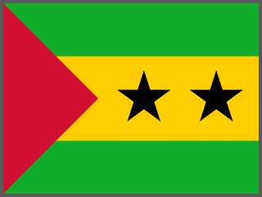 | 52. São Tomé and Príncipe | Cocoa | Was once the world's largest cocoa producer.
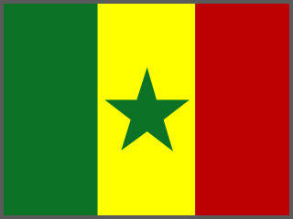 | 53. Senegal | Fish (and gold) | Fish is also the star of its national dish, thieboudienne.
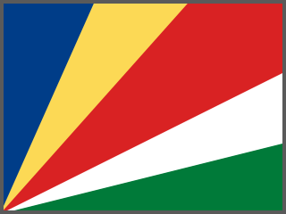 | 54. Seychelles | Canned tuna | Tuna canning is one of its biggest industries.
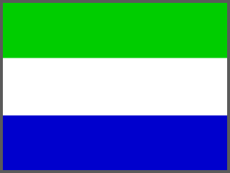 | 55. Sierra Leone | Diamonds (and iron ore) | Home of the Star of Sierra Leone, a huge diamond found in 1972.
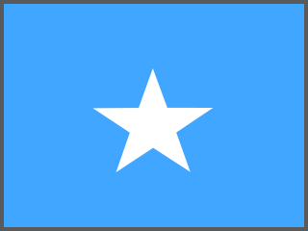 | 56. Somalia | Livestock (goats, sheep and camels) | Has one of the world's largest camel herds.
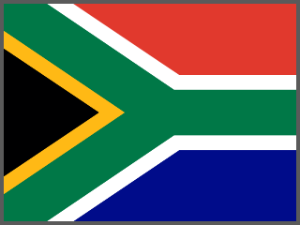 | 57. South Africa | Platinum and gold (and cars) | Produces most of the world's platinum.
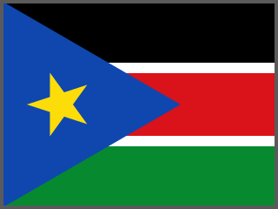 | 58. South Sudan | Crude oil | The world's newest country (2011).
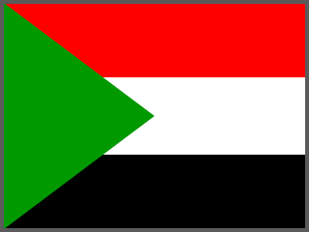 | 59. Sudan | Gold and gum arabic | Gum arabic from acacia trees is used in fizzy drinks and sweets.
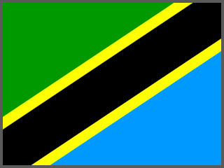 | 60. Tanzania | Gold (and tanzanite gems) | Tanzanite is found in only one place on Earth, near Mount Kilimanjaro.
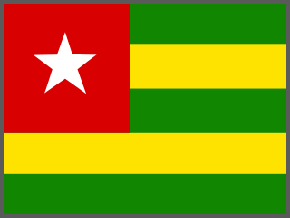 | 61. Togo | Phosphates (and cotton) | Phosphates are used to make fertiliser.
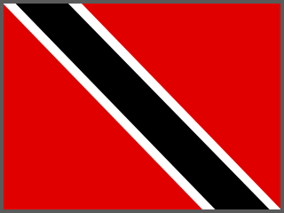 | 62. Trinidad and Tobago | Natural gas and oil | Also has a natural lake of tar called Pitch Lake.
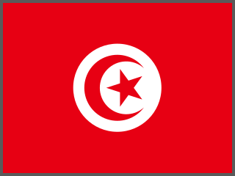 | 63. Tunisia | Olive oil | One of the world's biggest olive oil exporters.
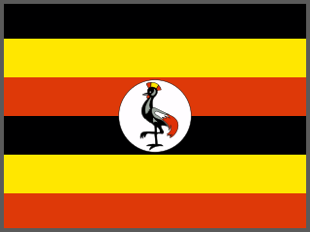 | 64. Uganda | Coffee | One of Africa's biggest coffee exporters.
 | 65. Zambia | Copper | Part of Africa's 'Copperbelt'.
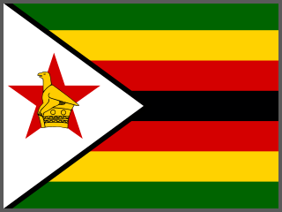 | 66. Zimbabwe | Tobacco and gold | Also home to Great Zimbabwe and Victoria Falls.

Food & farming | Minerals & metals | Energy (oil & gas) | Other (tourism, clothing…)

3. Round 3: Sort It Out
Category | Number of countries
Food & farming | 30
Minerals & metals | 19
Energy (oil & gas) | 11
Other (tourism, clothing…) | 6

Most common: Food & farming (30 countries). Accept small differences where students have chosen a different export for a country.
4. Talk It Out
Question | Points to draw out
Many countries on the list sell raw materials (like cocoa beans or copper). Other countries turn them into chocolate or phones and sell them for much more. Is that fair? | Most of the value is added in the factory, not the farm or mine. Côte d'Ivoire and Ghana grow most of the world's cocoa, but most chocolate profits are made elsewhere. Link to Fairtrade and to the Ancient African Kingdoms session (Mali's gold trade).
What problems might a country face if it depends on just one export? | If prices fall, crops fail or the resource runs out, the whole economy suffers. Countries try to spread their risk by selling many different things.
Look at something you own today. Which country might its materials have come from? | Phones and batteries (cobalt from DR Congo), chocolate (cocoa from West Africa), coffee (Ethiopia, Uganda), tea (Kenya).

