BLACK HISTORY MONTH 2026
What's Their Famous Export?
What do the countries on our flag border sell to the world?
STUDENT WORKSHEET · AGES 11–16 · 30–45 MINUTES
Name: |  | Date:

KEY WORD
An export is something a country sells to other countries. It can be a crop (like coffee), something dug from the ground (like gold or oil), or a service (like tourism).

1. Round 1: Quick Guess
▶ CHOOSE FROM: COFFEE · COCOA · VANILLA · NUTMEG · RUM · TEA · DIAMONDS · COPPER
1. Ethiopia  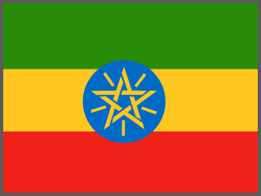  _________________ | 2. Côte d'Ivoire  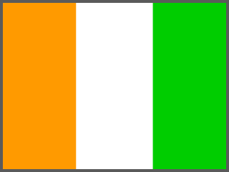  _________________ | 3. Madagascar  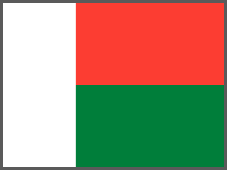  _________________ | 4. Grenada  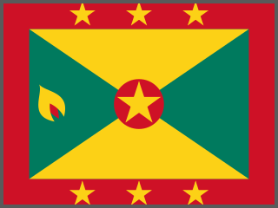  _________________
5. Barbados  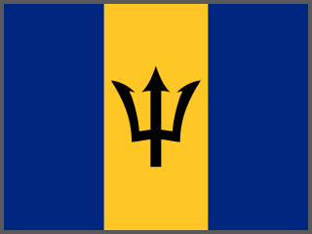  _________________ | 6. Kenya  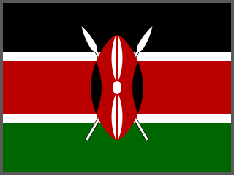  _________________ | 7. Botswana  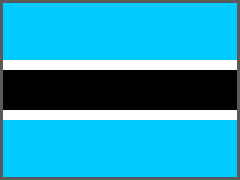  _________________ | 8. Zambia  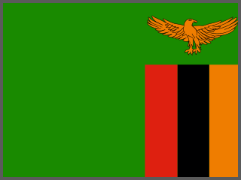  _________________

2. Round 2: All 66 Flags
▶ WRITE A FAMOUS EXPORT FOR EACH COUNTRY. SOME WORDS ARE USED MORE THAN ONCE
Alumina | Aluminium | Bananas | Bauxite | Cashew nuts | Clothing
Cobalt | Cocoa | Coffee | Copper | Cotton | Diamonds
Fish | Gold | Gum arabic | Iron ore | Livestock | Natural gas
Nutmeg | Oil | Olive oil | Peanuts | Phosphates | Platinum
Port services | Rubber | Rum | Sugar | Tea | Tobacco
Tourism | Tuna | Uranium | Vanilla | Water

 | Country | Famous export |  | Country | Famous export
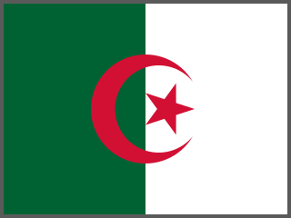 | 1. Algeria |  | 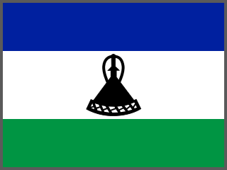 | 34. Lesotho
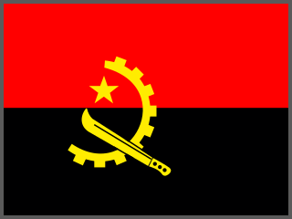 | 2. Angola |  | 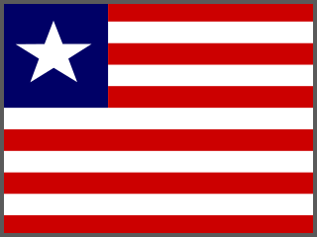 | 35. Liberia
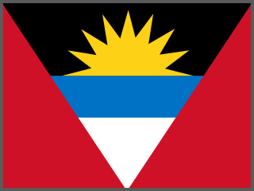 | 3. Antigua and Barbuda |  | 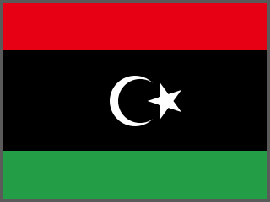 | 36. Libya
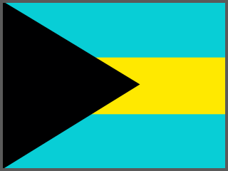 | 4. The Bahamas |  |  | 37. Madagascar
 | 5. Barbados |  | 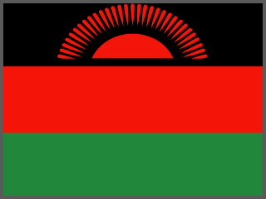 | 38. Malawi
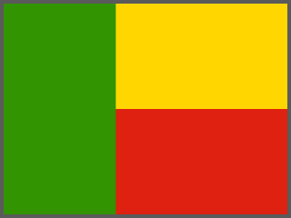 | 6. Benin |  | 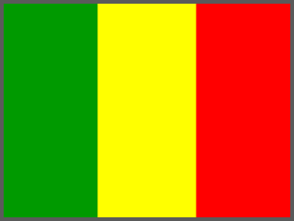 | 39. Mali
 | 7. Botswana |  | 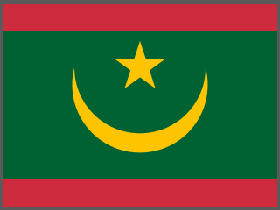 | 40. Mauritania
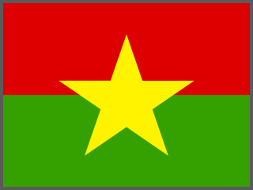 | 8. Burkina Faso |  | 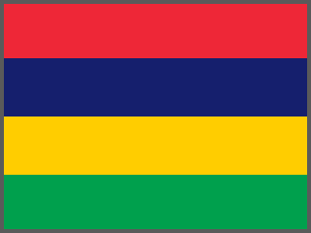 | 41. Mauritius
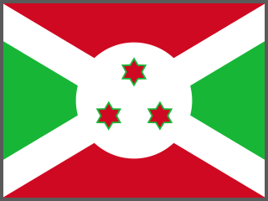 | 9. Burundi |  | 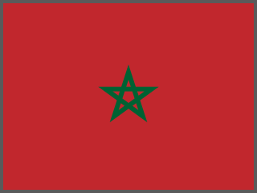 | 42. Morocco
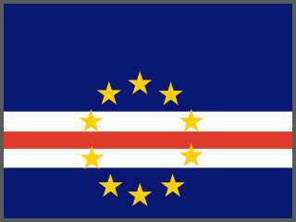 | 10. Cabo Verde |  | 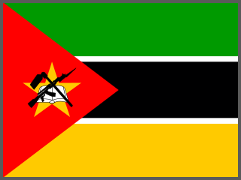 | 43. Mozambique
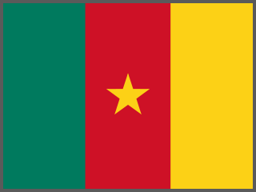 | 11. Cameroon |  | 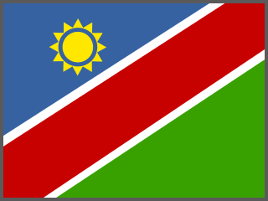 | 44. Namibia
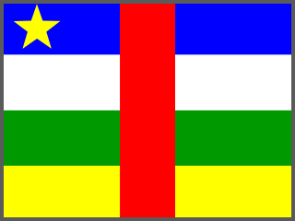 | 12. Central African Republic |  | 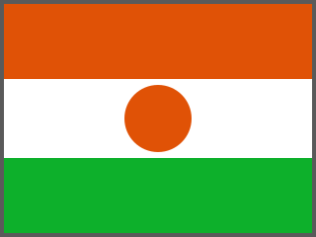 | 45. Niger
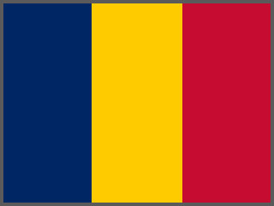 | 13. Chad |  | 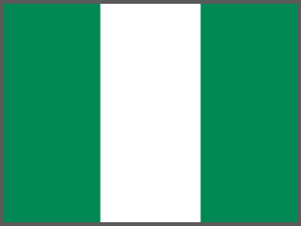 | 46. Nigeria
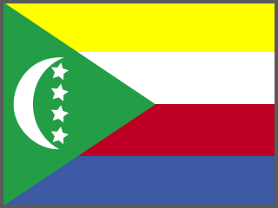 | 14. Comoros |  | 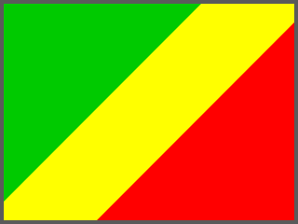 | 47. Republic of the Congo
 | 15. Côte d'Ivoire |  | 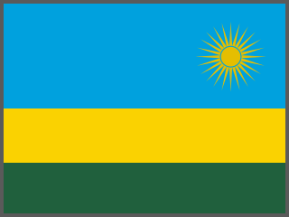 | 48. Rwanda
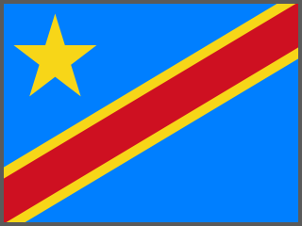 | 16. DR Congo |  | 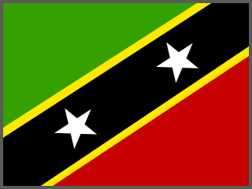 | 49. Saint Kitts and Nevis
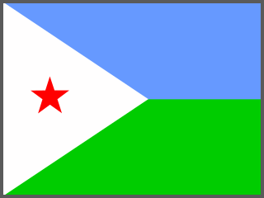 | 17. Djibouti |  | 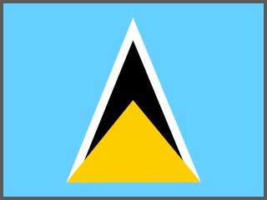 | 50. Saint Lucia
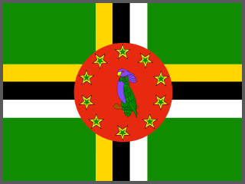 | 18. Dominica |  | 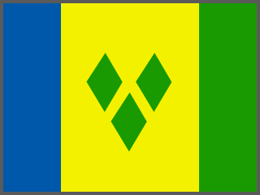 | 51. Saint Vincent and the Grenadines
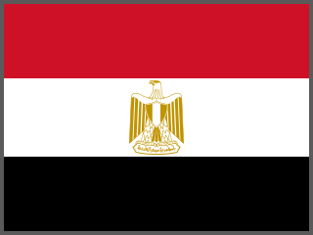 | 19. Egypt |  | 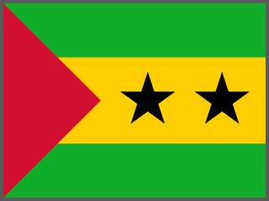 | 52. São Tomé and Príncipe
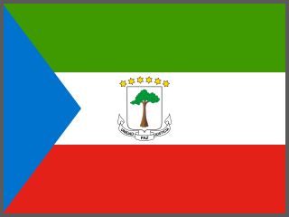 | 20. Equatorial Guinea |  | 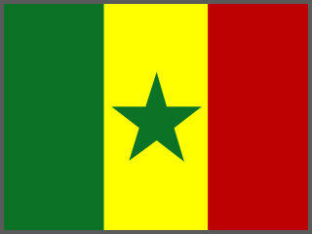 | 53. Senegal
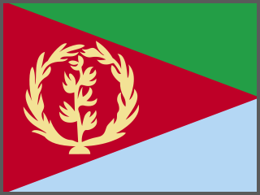 | 21. Eritrea |  | 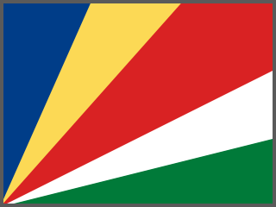 | 54. Seychelles
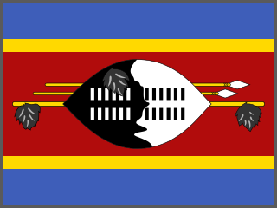 | 22. Eswatini |  | 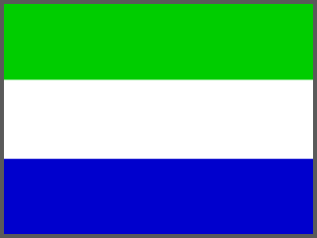 | 55. Sierra Leone
 | 23. Ethiopia |  | 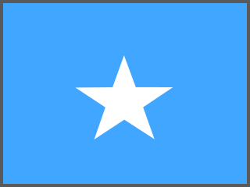 | 56. Somalia
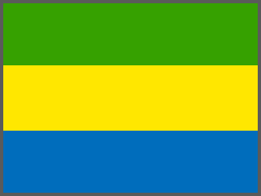 | 24. Gabon |  | 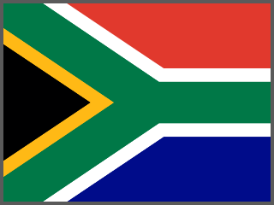 | 57. South Africa
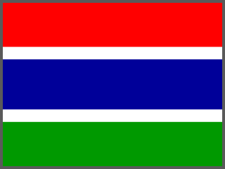 | 25. The Gambia |  | 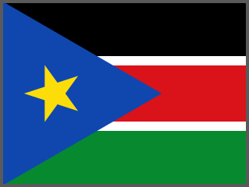 | 58. South Sudan
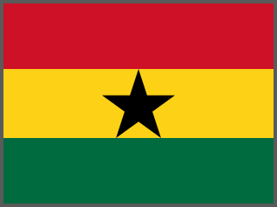 | 26. Ghana |  | 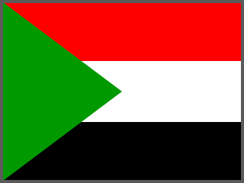 | 59. Sudan
 | 27. Grenada |  | 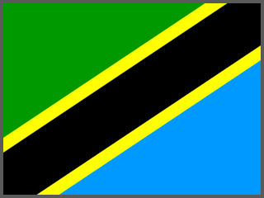 | 60. Tanzania
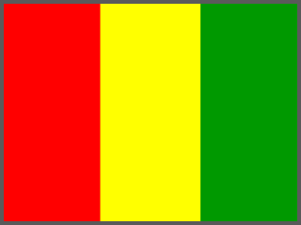 | 28. Guinea |  | 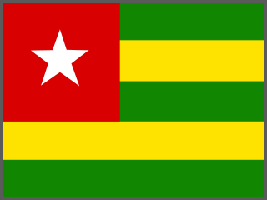 | 61. Togo
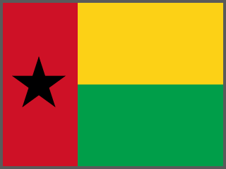 | 29. Guinea-Bissau |  | 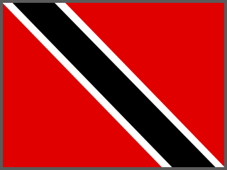 | 62. Trinidad and Tobago
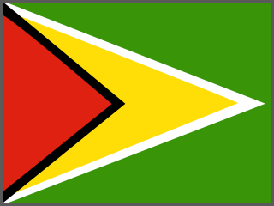 | 30. Guyana |  | 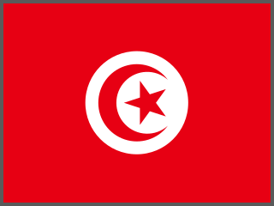 | 63. Tunisia
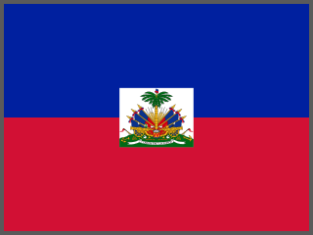 | 31. Haiti |  | 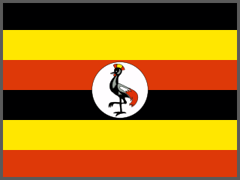 | 64. Uganda
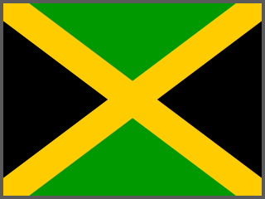 | 32. Jamaica |  |  | 65. Zambia
 | 33. Kenya |  | 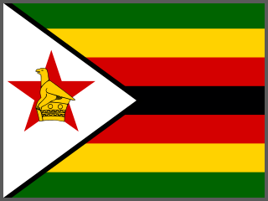 | 66. Zimbabwe

3. Round 3: Sort It Out
Use your Round 2 answers. Count how many countries fit each group.
Food & farming | Minerals & metals | Energy (oil & gas) | Other (tourism, clothing…)

Which group has the most countries? Why do you think that is?

4. Talk It Out
▶ TALK IT OUT — DISCUSS WITH A PARTNER OR GROUP
■ Many countries on the list sell raw materials (like cocoa beans or copper). Other countries turn them into chocolate or phones and sell them for much more. Is that fair?
■ What problems might a country face if it depends on just one export?
■ Look at something you own today. Which country might its materials have come from?

▶ WHERE DO YOU STAND? — CIRCLE A NUMBER
“Shoppers should pay more for Fairtrade products.”
1  Strongly disagree | 2  Disagree | 3  Not sure | 4  Agree | 5  Strongly agree
Because…

The most surprising export I found was:

