BLACK HISTORY MONTH 2026
Name the Flag
Can you recognise the flags of Africa and the Caribbean?
STUDENT WORKSHEET · AGES 11–16 · 20–30 MINUTES
Name: |  | Date:

1. Round 1: Warm-Up (1 point each)
▶ USE THE WORD BANK TO NAME EACH FLAG
Senegal | Kenya | Barbados | Jamaica | Morocco | Egypt
Haiti | Ghana | Trinidad and Tobago | Ethiopia | Nigeria | South Africa

1.  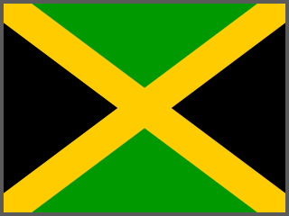  __________________ | 2.  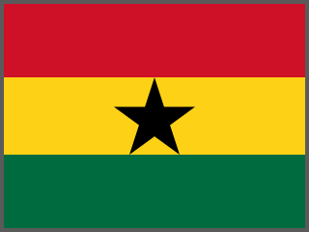  __________________ | 3.  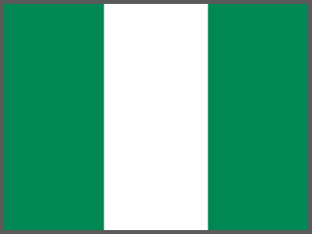  __________________ | 4.  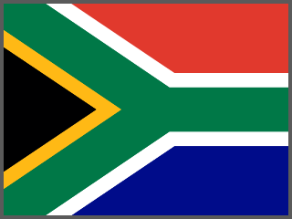  __________________

5.  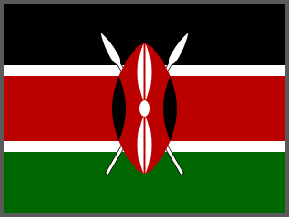  __________________ | 6.  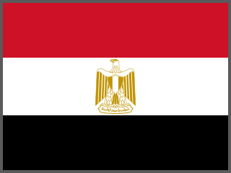  __________________ | 7.  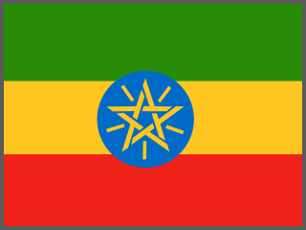  __________________ | 8.  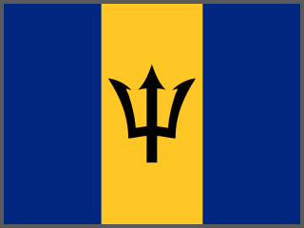  __________________

9.  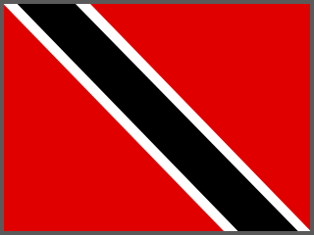  __________________ | 10.  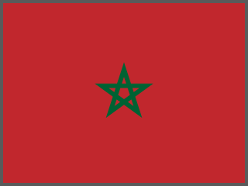  __________________ | 11.  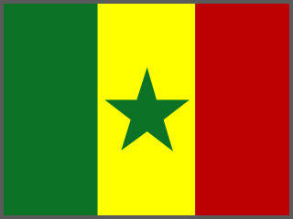  __________________ | 12.  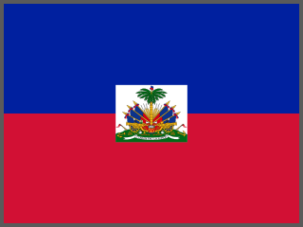  __________________

2. Round 2: Getting Harder (2 points each)
▶ NO WORD BANK THIS TIME. CLUE: 2 OF THESE ARE CARIBBEAN NATIONS
13.  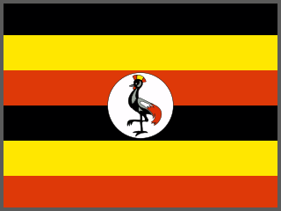  __________________ | 14.  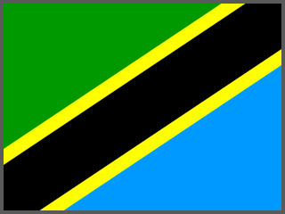  __________________ | 15.  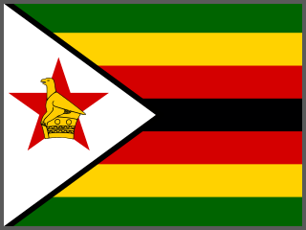  __________________ | 16.  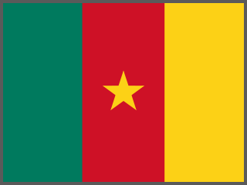  __________________

17.  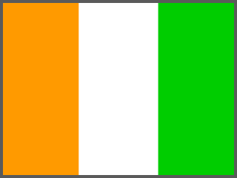  __________________ | 18.  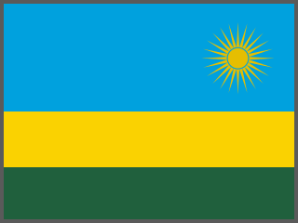  __________________ | 19.  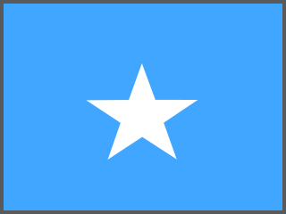  __________________ | 20.  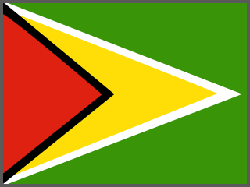  __________________

21.  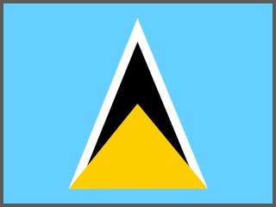  __________________ | 22.  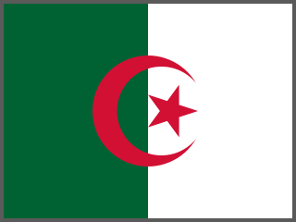  __________________ | 23.  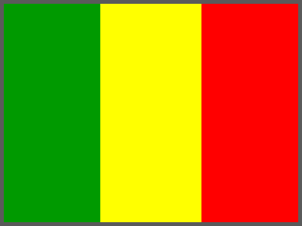  __________________ | 24.  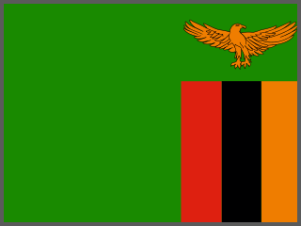  __________________

3. Round 3: Expert Challenge (3 points each)
▶ LOOK CLOSELY AT THE SYMBOLS FOR CLUES
25.  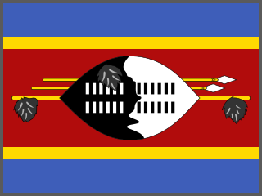  __________________ | 26.  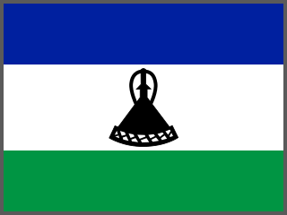  __________________ | 27.  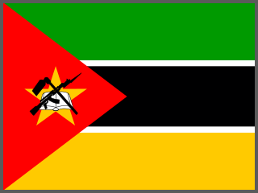  __________________ | 28.  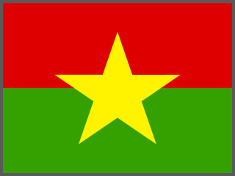  __________________

29.  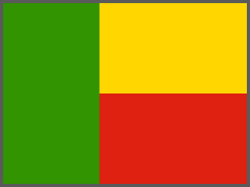  __________________ | 30.  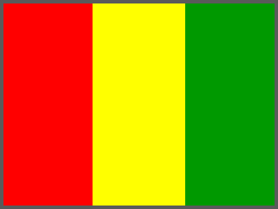  __________________ | 31.  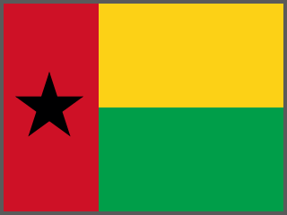  __________________ | 32.  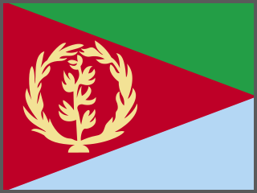  __________________

33.  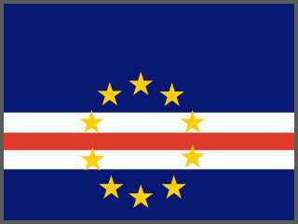  __________________ | 34.  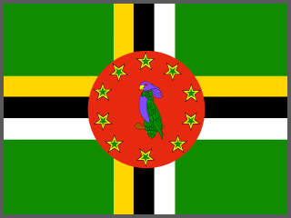  __________________ | 35.  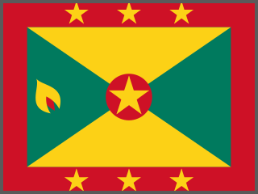  __________________ | 36.  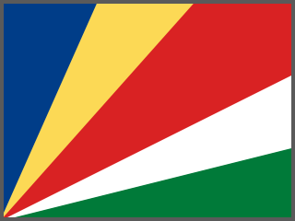  __________________

4. Round 4: Colour Detective
Many African flags use red, gold (yellow) and green. These are called the Pan-African colours, and they were inspired by the flag of Ethiopia. In 1957 Ghana became the first newly independent African country to use them on its flag.
1. Which Round 1 flags use red, gold AND green? Write their names:

2. Which colour does Jamaica's flag use instead of red?

5. Round 5: Flag Facts
▶ TRUE OR FALSE? — CIRCLE ONE
1. Jamaica's flag has no red, white or blue in it. | TRUE | FALSE
2. The black star on Ghana's flag is known as the 'Black Star of Africa'. | TRUE | FALSE
3. Kenya's flag shows a traditional shield and two spears. | TRUE | FALSE
4. Barbados's flag shows a complete trident. | TRUE | FALSE
5. Ethiopia's green, yellow and red inspired the colours of many African flags. | TRUE | FALSE

6. Design Your Own Flag Meaning
If you designed a flag for your school or community, which three colours would you choose, and what would each one stand for?

