BLACK HISTORY MONTH 2026
Kemet: The Black Land
Discovering the African civilisation we call Ancient Egypt
STUDENT WORKSHEET · AGES 11–16 · 45–60 MINUTES
Name: |  | Date:

1. Learning Objectives
By the end of this session, I will be able to:
■ Explain what 'Kemet' means and why the River Nile mattered so much.
■ Describe at least three achievements of Kemet in science, writing or building.
■ Discuss how and why people debate the identity of the ancient Egyptians, using evidence.
2. Warm-Up
▶ DO NOW
Where is Egypt? Which continent is it on? Write down one thing you already know about Ancient Egypt.

3. Learn
Kemet and the Nile
The people of Ancient Egypt called their land Kemet. The word means 'the Black Land'. It came from the rich, dark soil the River Nile left behind when it flooded each year. That soil let farmers grow wheat, barley and flax in the middle of the desert. The desert around it was called Deshret, 'the Red Land'.
A civilisation that lasted 3,000 years
Around 3100 BC, Upper and Lower Egypt were joined into one kingdom ruled by a pharaoh. Kemet then lasted for roughly 3,000 years. Its people built the pyramids at Giza, where the Great Pyramid was made for King Khufu around 2560 BC. They also developed hieroglyphic writing, wrote on paper made from the papyrus plant, and used a 365-day calendar.
Science and medicine
Imhotep designed the Step Pyramid of King Djoser, the first large stone pyramid. Later generations also honoured him as a great healer. Egyptian doctors wrote medical texts that describe how to treat wounds and broken bones, thousands of years before modern hospitals.
The Black Pharaohs of Kush
To the south of Egypt, in what is now Sudan, was the kingdom of Kush (Nubia). Around 730 BC the Kushite king Piye marched north and took control of Egypt. Kushite kings then ruled Egypt as the 25th Dynasty, often called the 'Black Pharaohs'. Sudan today has more pyramids than Egypt.
Map
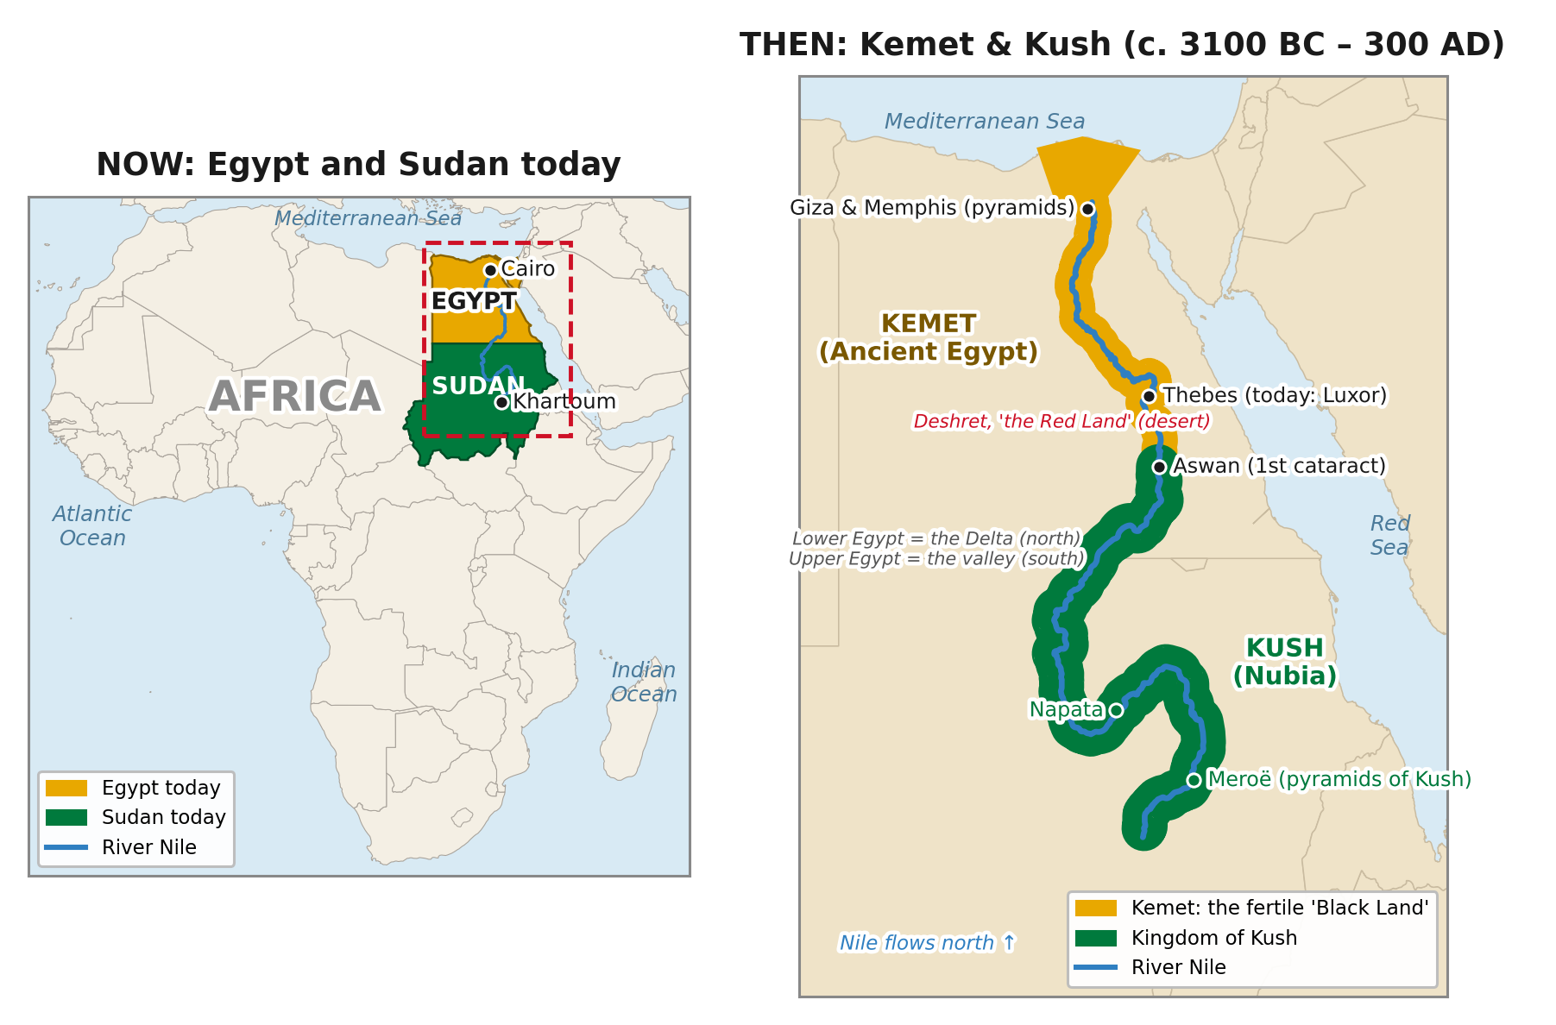
Kemet then and now: ancient Kemet and Kush along the Nile (right), and modern Egypt and Sudan (left).
DID YOU KNOW?
Sudan has more pyramids than Egypt. There are over 200 at sites such as Meroë, built by the kings and queens of Kush.

Achievement | What it was | Why it still matters
Pyramids | Huge stone tombs built with great skill | Maths and engineering still studied today
Hieroglyphs | One of the world's earliest writing systems | Writing lets us keep and share knowledge
365-day calendar | A year tracked by the Nile floods and the stars | Our calendar has 365 days too
Medicine | Written guides to treating injuries | An early step towards modern medicine

Key words
Key word | Meaning
Kemet | the ancient Egyptians' own name for their land: 'the Black Land'
Pharaoh | the ruler of Ancient Egypt
Hieroglyphs | a writing system that uses pictures and symbols
Papyrus | a reed plant used to make an early kind of paper
Dynasty | a line of rulers from the same family or group

4. Activities
▶ FILL THE GAPS — USE THE WORD BANK
Nile | pharaoh | papyrus | Kush | soil

1. Kemet means 'the Black Land' because of the dark ______________ left by the floods.
2. The River ______________ flooded every year and made farming possible.
3. Egyptians wrote on paper made from the ______________ plant.
4. The ruler of Ancient Egypt was called the ______________.
5. The 'Black Pharaohs' came from the kingdom of ______________.

▶ TRUE OR FALSE? — CIRCLE ONE
1. Kemet was the ancient Egyptians' own name for their land. | TRUE | FALSE
2. Egypt is in the Middle East, not in Africa. | TRUE | FALSE
3. Imhotep designed the Step Pyramid of King Djoser. | TRUE | FALSE
4. Egypt has more pyramids than any other country. | TRUE | FALSE
5. Kushite kings from Nubia once ruled all of Egypt. | TRUE | FALSE

▶ PUT IT IN ORDER — NUMBER THE BOXES 1 TO 4
The Great Pyramid is built for King Khufu (around 2560 BC)
Upper and Lower Egypt are united (around 3100 BC)
King Piye of Kush takes control of Egypt (around 730 BC)
Imhotep designs the Step Pyramid

▶ WRITE YOUR NAME IN HIEROGLYPHS — USE THE CHART
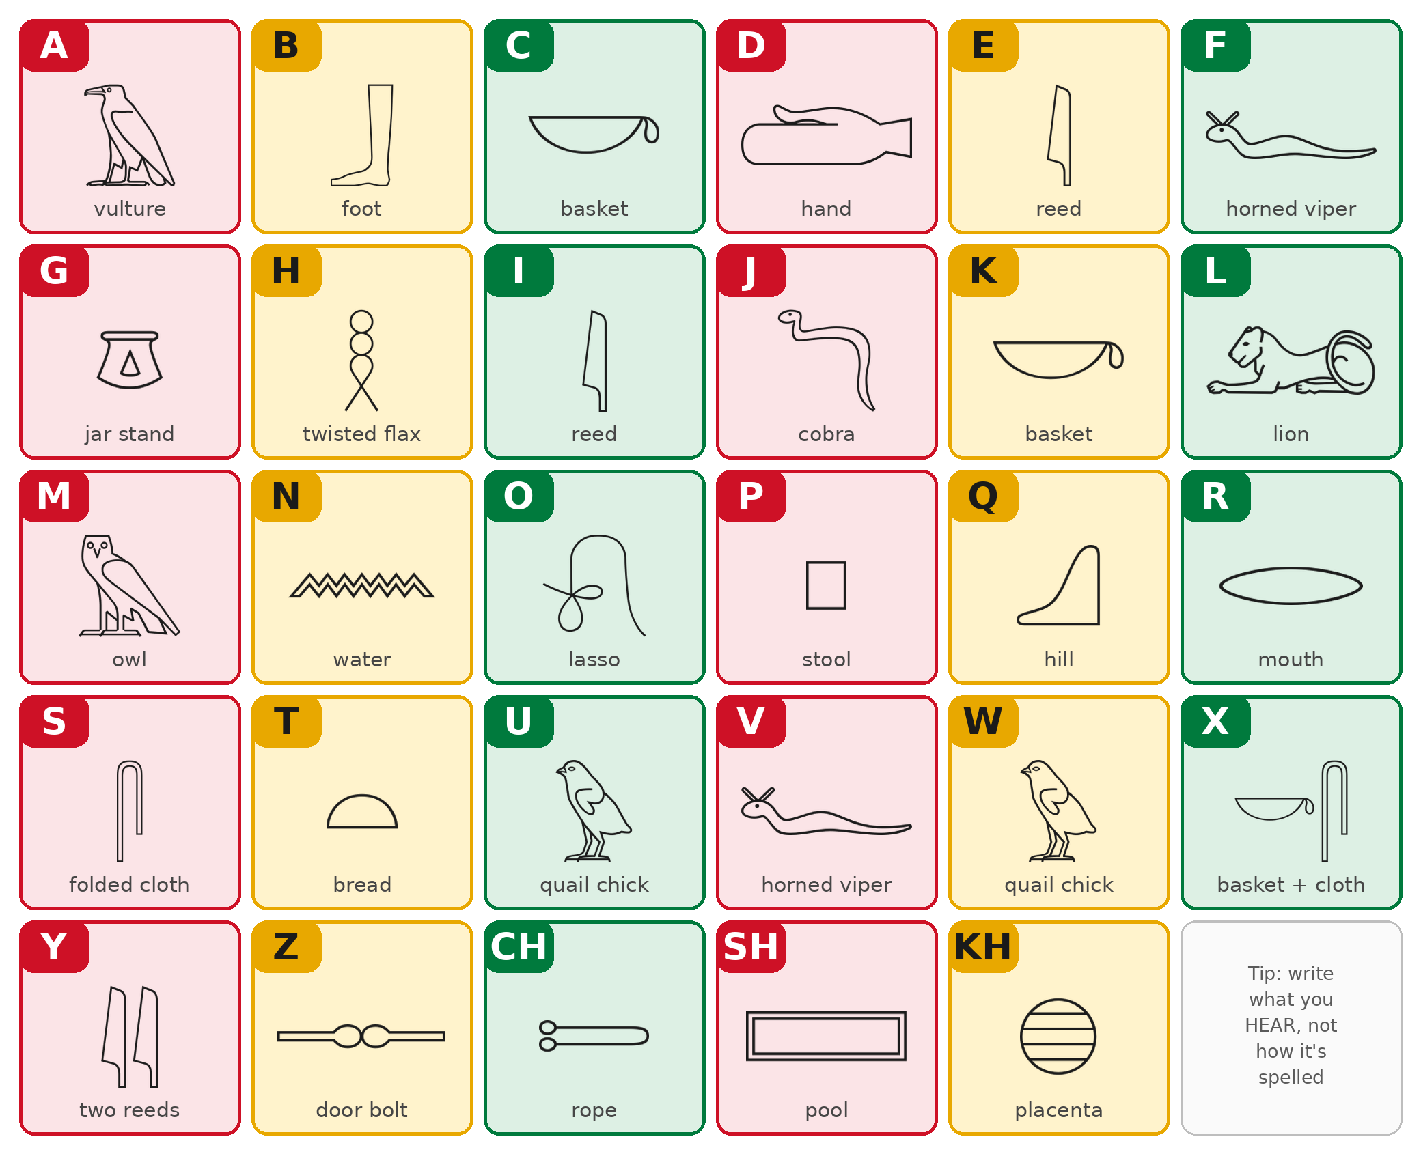
A simplified 'sound alphabet'. Ancient Egyptians wrote sounds, not letters like ours, so match what you hear.
My name in hieroglyphs:

5. Talk It Out
▶ TALK IT OUT — DISCUSS WITH A PARTNER OR GROUP
■ Why do you think Ancient Egypt is sometimes left out of 'African history'?
■ Kemet lasted about 3,000 years. What do you think helped it last so long?
■ Which achievement of Kemet do you think was most important? Why?

THE BIG QUESTION
Historians and communities debate what the ancient Egyptians looked like and how they should be described. The evidence includes art showing people with a range of skin tones, ancient writing, and DNA studies, and people read it in different ways. Everyone agrees on one thing: Kemet was an African civilisation.

What do you think, and why?

“No one is born wise.”
— The Maxims of Ptahhotep, an ancient Egyptian book of advice

6. Reflection & Exit Ticket
▶ WHERE DO YOU STAND? — CIRCLE A NUMBER
“Kemet should be taught in schools as a key part of African history.”
1  Strongly disagree | 2  Disagree | 3  Not sure | 4  Agree | 5  Strongly agree
Because…

▶ CONFIDENCE CHECK — CIRCLE ONE
How confident do I feel about today's topic?
1  Not at all | 2  A little | 3  Getting there | 4  Confident | 5  Very confident

One thing I learned today:

