BLACK HISTORY MONTH 2026
The Moors: Africa in Europe
How North African rulers shaped Spain for almost 800 years
STUDENT WORKSHEET · AGES 11–16 · 45–60 MINUTES
Name: |  | Date:

1. Learning Objectives
By the end of this session, I will be able to:
■ Explain who the Moors were and where they came from.
■ Describe at least three things the Moors brought to or built in Europe.
■ Consider why the word 'Moor' has been used in different ways.
2. Warm-Up
▶ DO NOW
Name a country in Europe and a country in Africa. How close do you think Spain and Morocco are to each other?

3. Learn
Who were the Moors?
'Moor' comes from the Latin word Maurus, used for people from Mauretania in North-West Africa. Europeans later used 'Moors' for the Muslim peoples of North Africa and Spain. They included Amazigh (Berber) people, Arabs, and Black Africans from further south, and over time many people born in Spain as well.
Crossing the sea: 711 AD
In 711 AD a Muslim army led by Tariq ibn Ziyad crossed the narrow sea from North Africa into Spain. Gibraltar is named after him: Jabal Tariq means 'the Mountain of Tariq'. Within a few years most of Spain and Portugal were under Muslim rule. This land was called al-Andalus.
A golden age of learning
Córdoba became one of the largest and richest cities in Europe, famous for its libraries, scholars and the Great Mosque. Muslim, Jewish and Christian thinkers worked there, and ideas in maths, medicine, astronomy and philosophy spread into the rest of Europe. The Moors also brought new crops such as rice, oranges and sugar cane, along with new ways of watering farmland.
The end of al-Andalus
Christian kingdoms in the north slowly took back land. In 1492 the last Muslim kingdom, Granada, fell to the Catholic Monarchs Ferdinand and Isabella. Granada's palace, the Alhambra, still stands today and is one of the most visited places in Spain.
Map
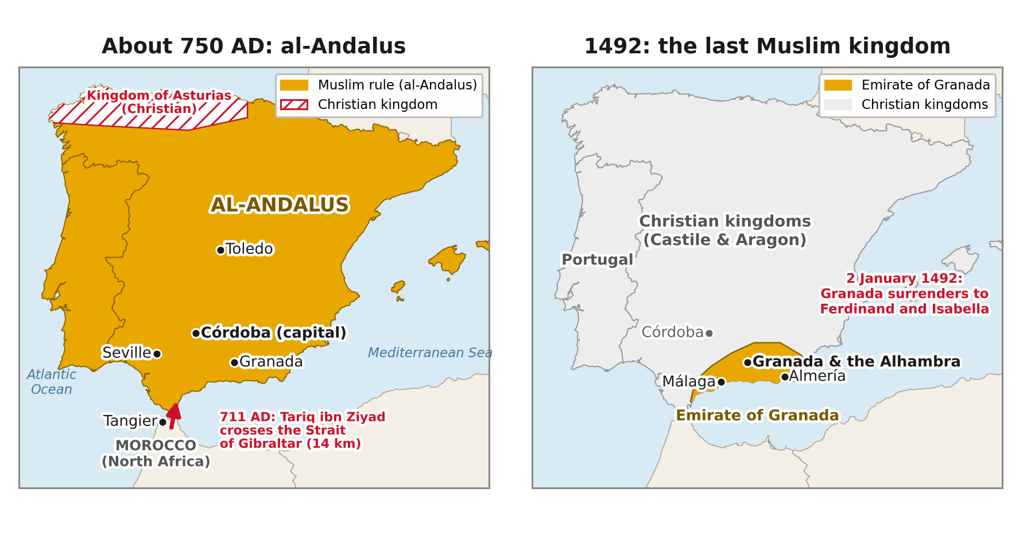
Left: al-Andalus about 750 AD, after Tariq ibn Ziyad crossed from Morocco in 711. Right: by 1492 only Granada remained.
The Alhambra, Granada
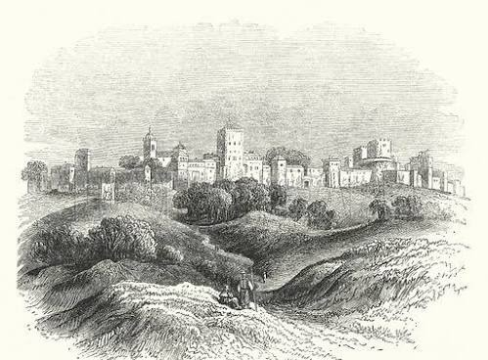 | 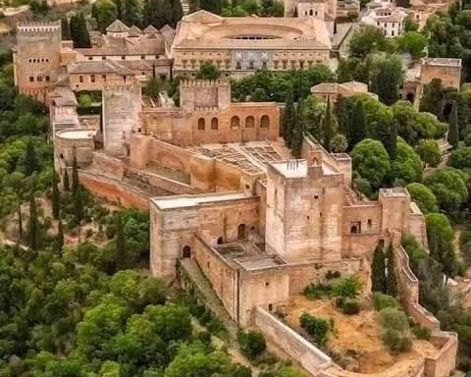
THEN: the Alhambra in a 19th-century engraving | NOW: the Alhambra today, high above Granada

DID YOU KNOW?
Spain and Morocco are only about 14 km (9 miles) apart at the narrowest point of the Strait of Gibraltar. On a clear day you can see Africa from Europe.

Place | What happened there | Can you visit it today?
Gibraltar | Tariq ibn Ziyad's army landed in 711 | Yes, and it is still named after him
Córdoba | A great centre of learning and libraries | Yes, the Great Mosque still stands
Granada | The last Muslim kingdom, which fell in 1492 | Yes, the Alhambra palace

Key words
Key word | Meaning
Moors | a name Europeans gave to the Muslim peoples of North Africa and Spain
al-Andalus | the Muslim-ruled part of Spain and Portugal
Amazigh (Berber) | the Indigenous people of North Africa
Scholar | a person who studies and teaches knowledge
Reconquista | the long campaign by Christian kingdoms to take back Spain

4. Activities
▶ MATCH IT — WRITE THE LETTER IN THE BOX
1. 711 AD |  |  | A. A palace in Granada
2. Gibraltar |  |  | B. Tariq ibn Ziyad crosses into Spain
3. Córdoba |  |  | C. The fall of Granada
4. The Alhambra |  |  | D. Named after Tariq: 'the Mountain of Tariq'
5. 1492 |  |  | E. A city famous for libraries and scholars

▶ QUICK QUIZ — TICK ONE ANSWER FOR EACH QUESTION
1. What was the Muslim-ruled part of Spain called?
☐ A. Mauretania
☐ B. al-Andalus
☐ C. Kemet
☐ D. Castile

2. Which of these did the Moors bring to Spain?
☐ A. Potatoes
☐ B. Tea
☐ C. Oranges and rice
☐ D. Chocolate

▶ SPIDER DIAGRAM — ADD A FACT OR IDEA IN EACH SPACE
Where from? | When? | Who led?
Key city | The Moors | Learning
Food & farming | Buildings | How it ended

5. Talk It Out
▶ TALK IT OUT — DISCUSS WITH A PARTNER OR GROUP
■ Why do you think the story of the Moors is not often taught in UK schools?
■ Córdoba had Muslim, Jewish and Christian scholars. What can people gain from working together?

THE BIG QUESTION
Some people describe the Moors as Black Africans. Historians point out that they came from many backgrounds: Amazigh (Berber), Arab, Black African and Spanish-born. European paintings and plays, such as Shakespeare's Othello, often showed 'Moors' as Black. So the word meant different things to different people.

What do you think, and why?

▶ ROLE PLAY — IN PAIRS
THE SCENE: It is the year 950. A young traveller arrives in Córdoba and meets a scholar at the library.
PERSON A  The traveller: you have never seen a city like this. Ask about the streets, the library and what people study. | PERSON B  The scholar: you are proud of your city. Explain what makes Córdoba special and what people are learning.

6. Reflection & Exit Ticket
▶ WHERE DO YOU STAND? — CIRCLE A NUMBER
“Europe would be very different today without the Moors.”
1  Strongly disagree | 2  Disagree | 3  Not sure | 4  Agree | 5  Strongly agree
Because…

▶ CONFIDENCE CHECK — CIRCLE ONE
How confident do I feel about today's topic?
1  Not at all | 2  A little | 3  Getting there | 4  Confident | 5  Very confident

One thing I learned today:

