BLACK HISTORY MONTH 2026
Shaka Zulu: Warrior King
How one leader built the Zulu Kingdom, and how we judge him today
STUDENT WORKSHEET · AGES 11–16 · 45–60 MINUTES
Name: |  | Date:

1. Learning Objectives
By the end of this session, I will be able to:
■ Describe Shaka's early life and how he rose to power.
■ Explain at least two ways Shaka changed Zulu warfare and society.
■ Weigh up whether Shaka should be remembered as a hero, a tyrant or both.
2. Warm-Up
▶ DO NOW
What makes someone a great leader? Write down three qualities.

3. Learn
Early life
Shaka was born around 1787 in what is now KwaZulu-Natal, South Africa. His father was Senzangakhona, a Zulu chief, and his mother was Nandi. Shaka and his mother were pushed out of the Zulu community when he was young, and he grew up facing hardship and bullying.
A soldier rises
As a young man, Shaka became a soldier for Dingiswayo, a powerful chief of the Mthethwa people. He quickly became known for his bravery and new ideas. After his father died in 1816, Shaka became chief of the Zulu, with Dingiswayo's support.
Changing the way of war
Shaka introduced a short stabbing spear (the iklwa) and a large shield, so warriors fought up close rather than throwing spears from a distance. He organised young men into regiments (amabutho) and trained them hard. He is linked with the 'bull horns' formation: the 'chest' met the enemy while the 'horns' circled round to surround them.
Kingdom and legacy
In about 12 years, Shaka made the Zulu one of the most powerful nations in Southern Africa. His wars also caused great suffering and forced many people from their homes. In September 1828 he was killed by his half-brothers Dingane and Mhlangana, and Dingane became king. Today many South Africans remember Shaka as a symbol of pride, strength and unity.
Map
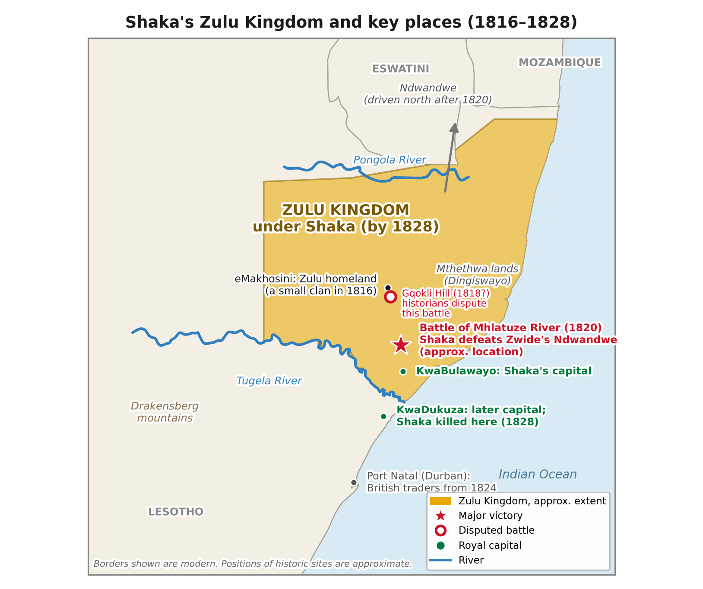
The Zulu Kingdom under Shaka, between the Pongola and Tugela rivers. Historic sites are approximate.
DID YOU KNOW?
Many early written accounts of Shaka came from European traders and writers. Some of them exaggerated his cruelty to make the Zulu seem 'savage', so historians treat these sources with care.

Change | Before Shaka | After Shaka
Weapons | Long throwing spears | Short stabbing spear and large shield
Army | Groups gathered when needed | Trained regiments by age group
Tactics | Battles often at a distance | The 'bull horns' surround formation
The Zulu | A small clan | A powerful kingdom

Key words
Key word | Meaning
Clan | a group of families who share a common ancestor
Regiment (ibutho) | an organised group of soldiers of similar age
Iklwa | the short stabbing spear Shaka is famous for
Tactics | planned ways of fighting or winning
Legacy | what a person leaves behind and how they are remembered

4. Activities
▶ PUT IT IN ORDER — NUMBER THE BOXES 1 TO 5
The Zulu Kingdom expands across the region
Shaka serves as a soldier under Dingiswayo
Shaka is killed by his half-brothers (1828)
Shaka is born to Nandi and Senzangakhona (around 1787)
Shaka becomes chief of the Zulu (1816)

▶ TRUE OR FALSE? — CIRCLE ONE
1. Shaka's mother was called Nandi. | TRUE | FALSE
2. Shaka introduced a long throwing spear. | TRUE | FALSE
3. The 'bull horns' formation was used to surround the enemy. | TRUE | FALSE
4. Shaka died of old age. | TRUE | FALSE
5. Every early written account of Shaka is completely reliable. | TRUE | FALSE

▶ FILL THE GAPS — USE THE WORD BANK
regiments | Dingiswayo | legacy | iklwa | 1828

1. As a young soldier, Shaka served under the chief ______________.
2. The short stabbing spear is called the ______________.
3. Shaka trained young men in organised ______________.
4. Shaka was killed in ______________.
5. How a person is remembered is called their ______________.

5. Talk It Out
▶ TALK IT OUT — DISCUSS WITH A PARTNER OR GROUP
■ Was Shaka a good leader? Use the qualities from your warm-up to decide.
■ Can a person be a hero and cause harm at the same time? Give an example.
■ Why does it matter who writes history?

THE BIG QUESTION
Hero or tyrant? Supporters say Shaka united many people, built a strong nation and was a military genius. Critics point to the violence and suffering his wars caused. Many historians say the truth is somewhere in between, and that some early accounts were written to make him look worse.

What do you think, and why?

▶ ROLE PLAY — IN PAIRS
THE SCENE: It is 1828. A young Zulu warrior and an elder meet by the fire to talk about King Shaka.
PERSON A  The young warrior: you admire Shaka's strength and victories. Explain why you think he is a great king. | PERSON B  The elder: you have seen both glory and suffering. Share your worries about the cost of Shaka's wars.

6. Reflection & Exit Ticket
▶ WHERE DO YOU STAND? — CIRCLE A NUMBER
“Shaka Zulu should be remembered mainly as a hero.”
1  Strongly disagree | 2  Disagree | 3  Not sure | 4  Agree | 5  Strongly agree
Because…

▶ CONFIDENCE CHECK — CIRCLE ONE
How confident do I feel about today's topic?
1  Not at all | 2  A little | 3  Getting there | 4  Confident | 5  Very confident

One thing I learned today:

