BLACK HISTORY MONTH 2026
Taste of Heritage: Picture Sheet
Photos of the six national dishes in the session
PICTURE SHEET · USE WITH THE NATIONAL DISHES WORKSHEET
Look at each dish. What ingredients can you spot? Which one would you most like to try?
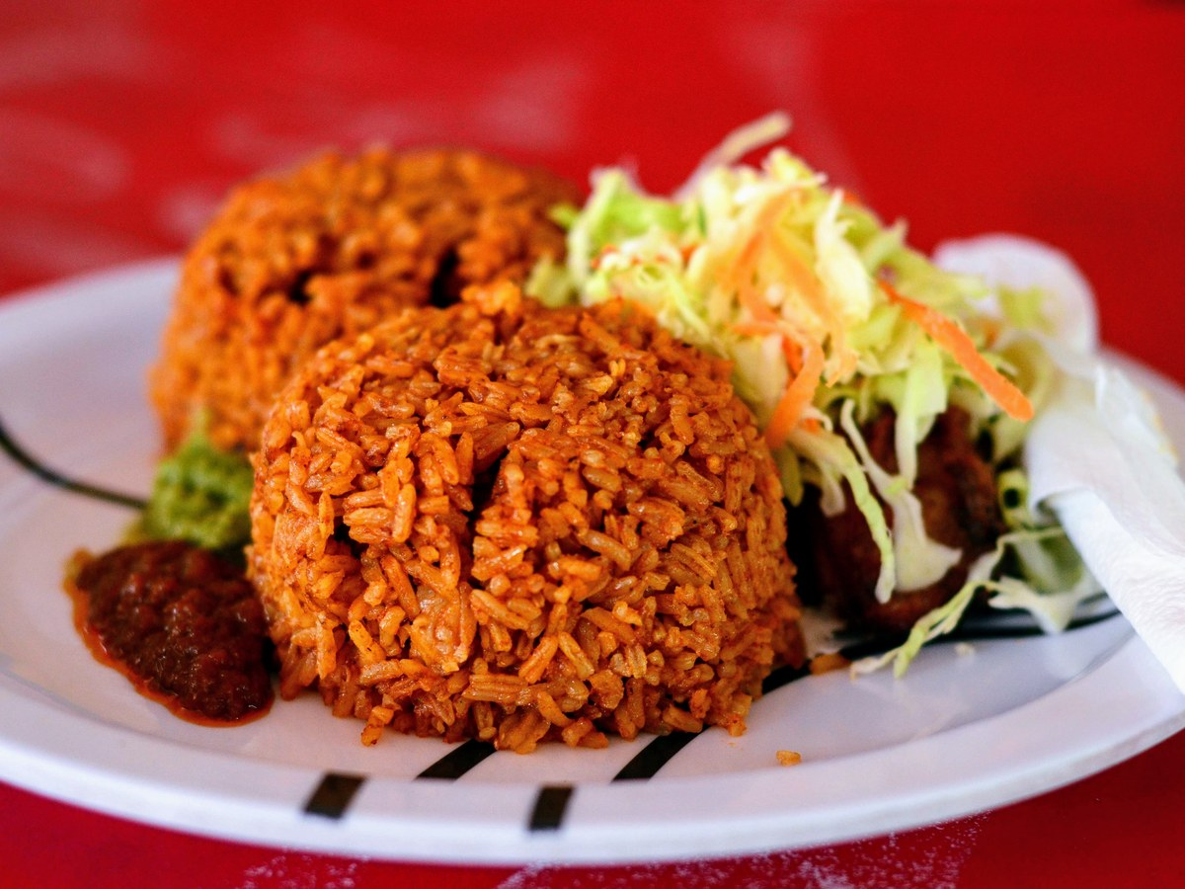 | 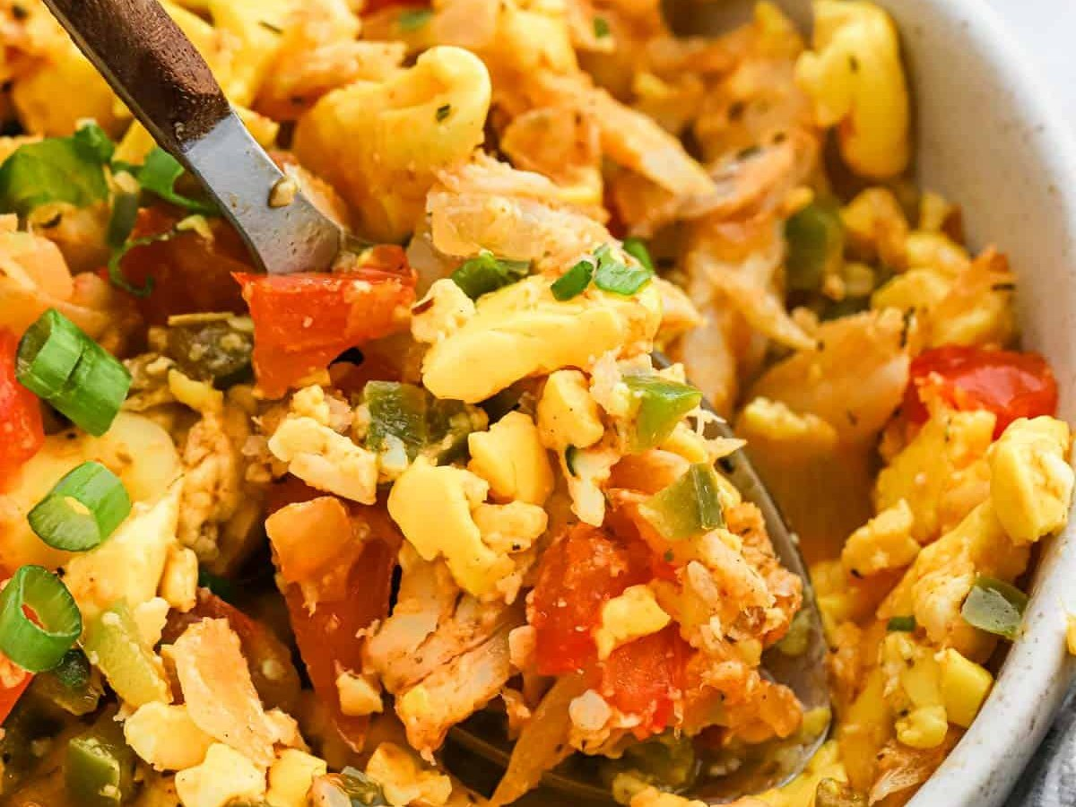
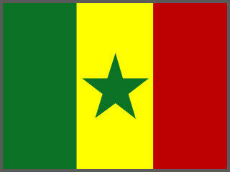 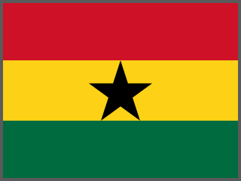 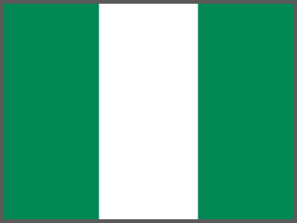 Jollof rice  Country: West Africa (Senegal, Ghana, Nigeria…)  Main ingredients: Rice, tomato, pepper, onion | 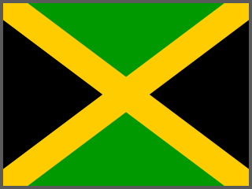 Ackee and saltfish  Country: Jamaica  Main ingredients: Ackee fruit, salted cod

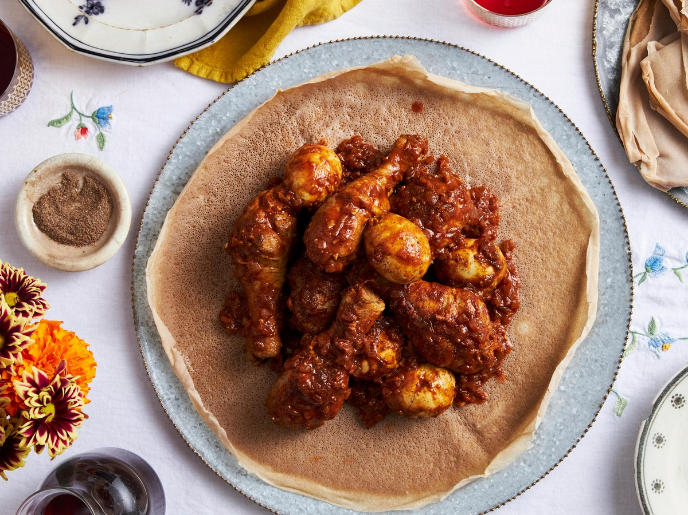 | 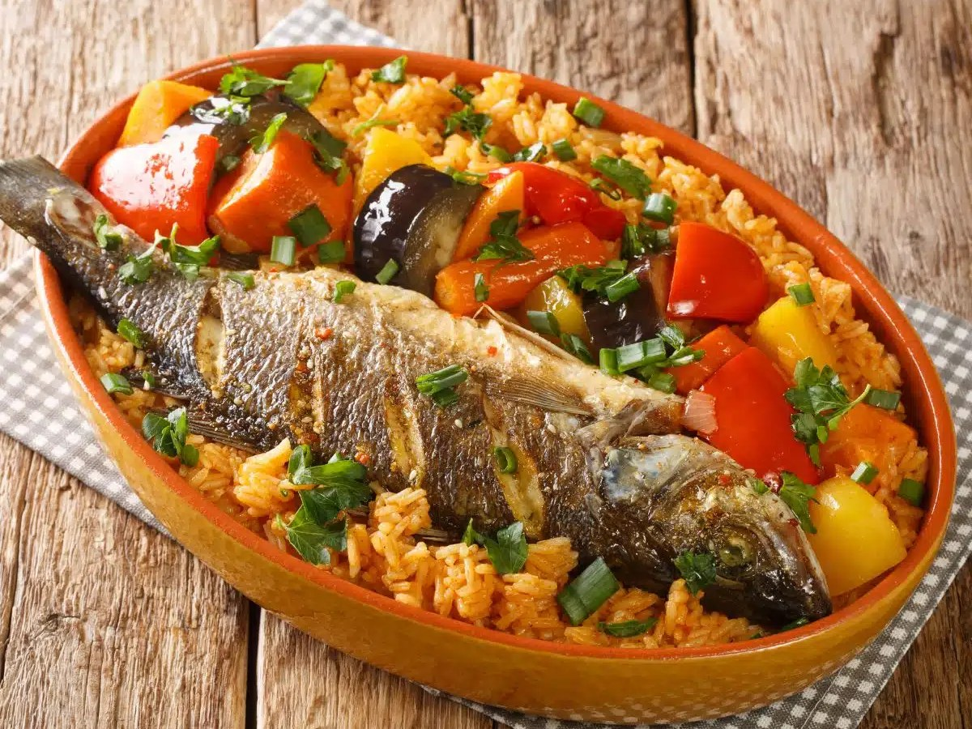
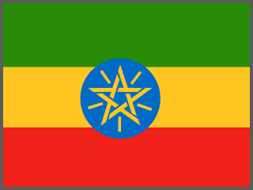 Injera with doro wat  Country: Ethiopia  Main ingredients: Teff flatbread, spicy chicken stew | Thieboudienne (ceebu jën)  Country: Senegal  Main ingredients: Fish, rice, vegetables

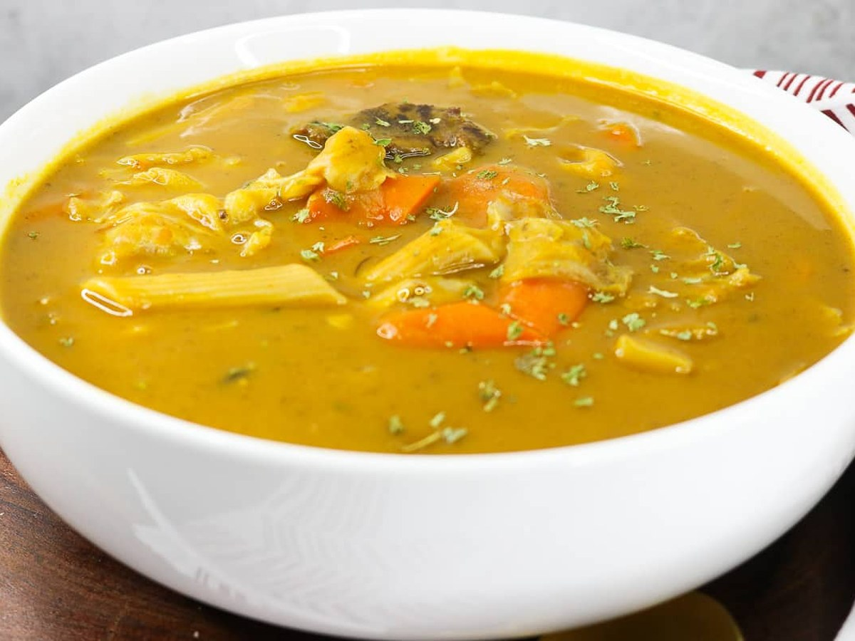 | 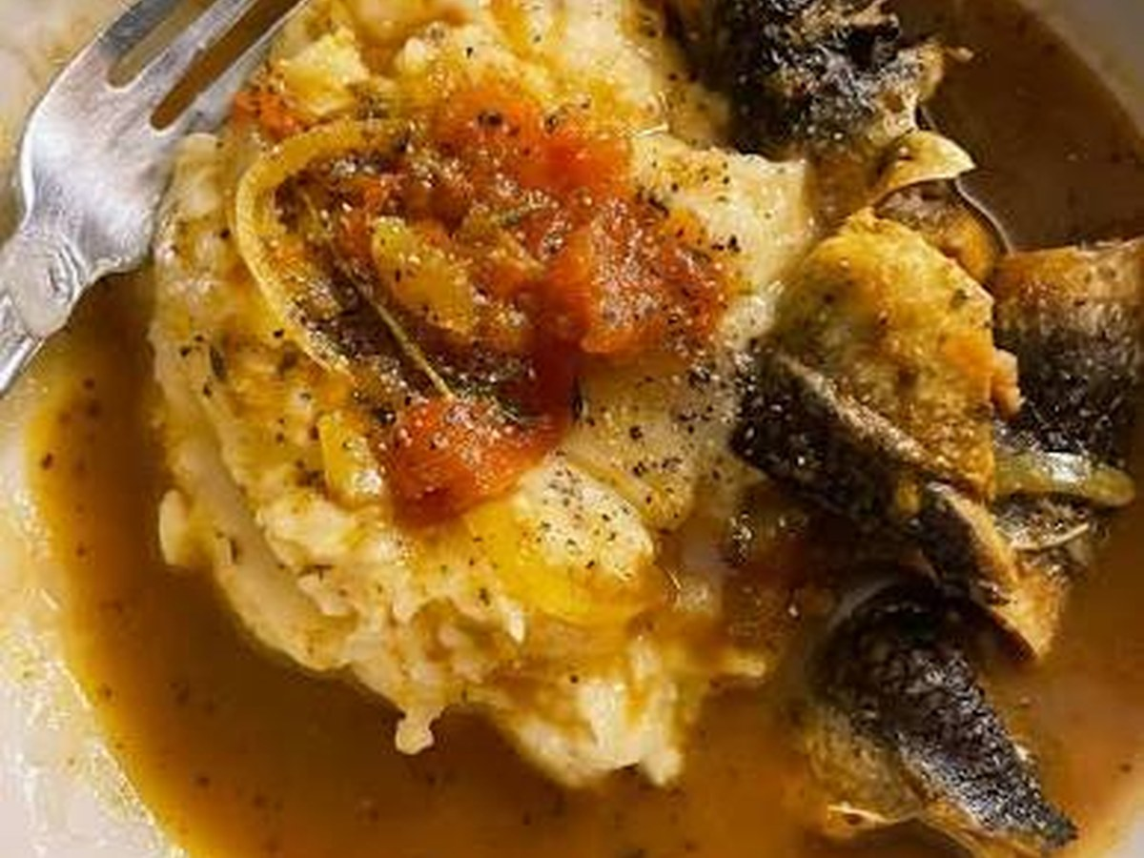
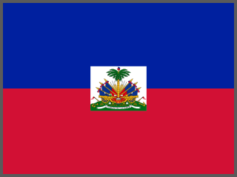 Soup joumou  Country: Haiti  Main ingredients: Squash, beef, vegetables | 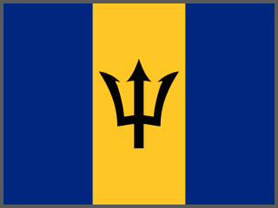 Cou-cou and flying fish  Country: Barbados  Main ingredients: Cornmeal, okra, fish

