BLACK HISTORY MONTH 2026
SECTION 1
Africa and the Caribbean
Kingdoms, Empires and Freedom
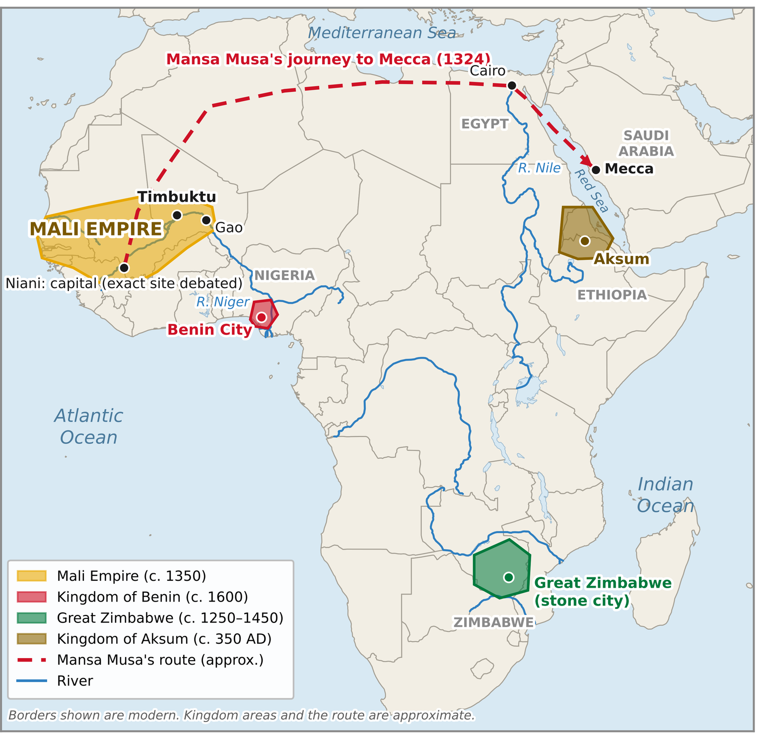
Ancient African kingdoms and Mansa Musa's journey to Mecca.
From the pyramids of Kemet to the mountains of the Jamaican Maroons and the fight for Cameroon's independence, discover the kingdoms Africans built, the empires that tried to control them, and the people who fought for freedom.
In this section
01 Kemet 26 Jim Jones and Jonestown, Guyana
02 The Moors 27 The Haitian Revolution
03 Shaka Zulu 28 The Jamaican Maroons
12 Ancient African Kingdoms 31 Rudolf Duala Manga Bell
25 King Leopold II and the Congo 32 Ruben Um Nyobè
BLACK HISTORY MONTH 2026
SECTION 2
Black Britain
Journeys, Struggles and Success
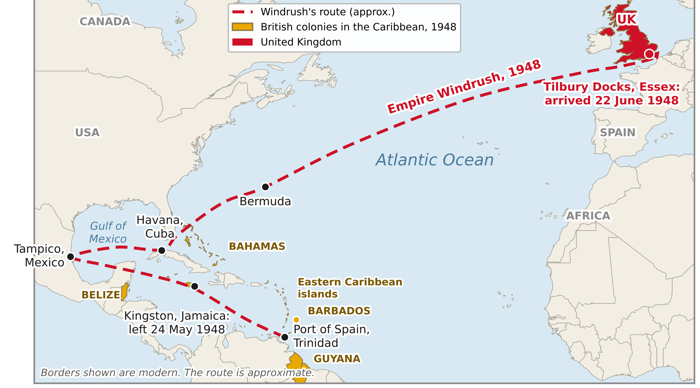
The voyage of the Empire Windrush from the Caribbean to Tilbury Docks, 1948.
Black people have been part of Britain's story for centuries. Meet the Windrush generation, the NHS's first Black matron, the campaigners of Bristol, wartime heroes and the music that changed British culture.
In this section
08 The Windrush Generation 16 From Windrush to Grime
09 Black Britain Before Windrush 20 Mary Seacole and Wartime Service
10 Bristol Bus Boycott 29 Daphne Steele
11 Walter Tull
BLACK HISTORY MONTH 2026
SECTION 3
Culture and Identity
Food, Heritage, Hair and Voice
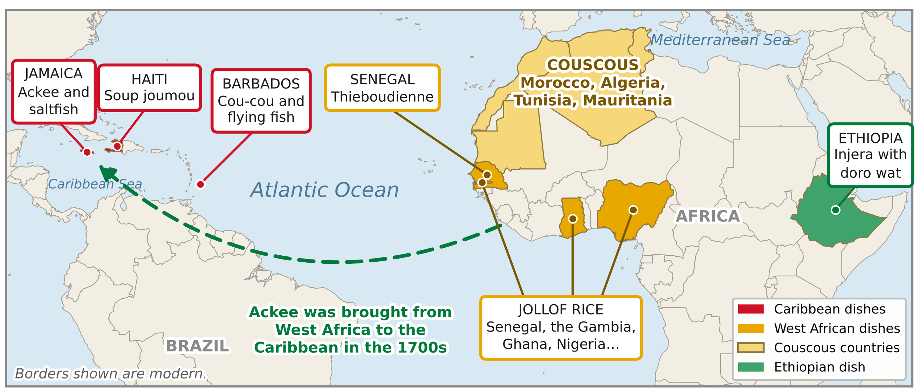
Where the national dishes in our sessions come from.
Explore the food, heritage, hair, words and images that shape who we are, and why seeing yourself represented matters.
In this section
05 National Dishes 15 Hair, Culture and Identity
13 Who Am I? Heritage and Identity 17 Spoken Word and Poetry
14 Representation Matters
BLACK HISTORY MONTH 2026
SECTION 4
Changemakers, Achievers and Justice
Inventors, Legends and Role Models
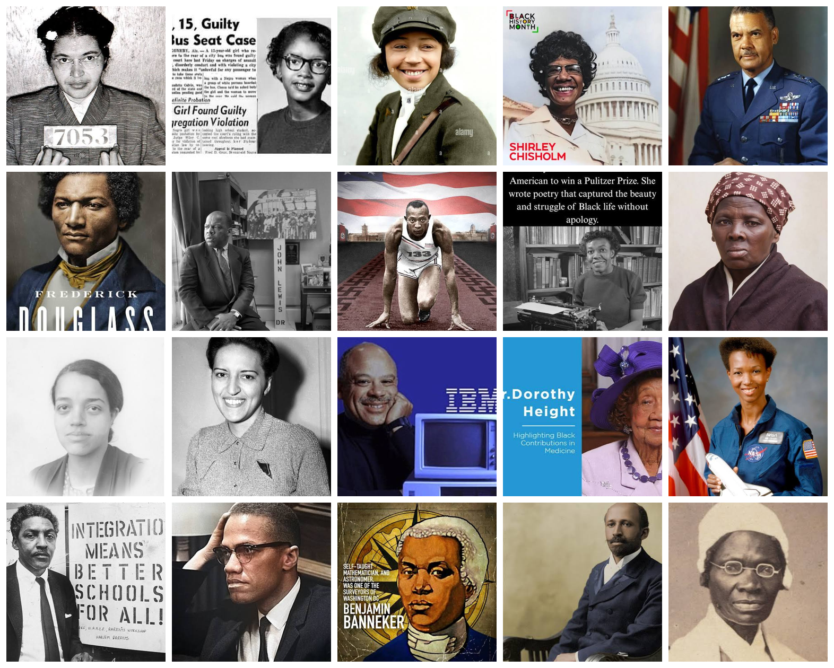
Some of the 20 fascinating Black history heroes you will meet.
From inventors and athletes to musicians, reformers and a pioneering sheriff, discover the people who broke barriers, challenged racism and changed the world.
In this section
04 Black Inventors 22 20th-Century Humanitarians and Reformers
06 Black Sports Legends 23 20th-Century Innovators
07 Black Music Legends 24 20 Fascinating Black History Heroes
18 Challenging Racism and Stereotypes 30 Arthur Zang
19 Changemakers 33 Lucius Amerson
21 Black British Role Models in Careers
BLACK HISTORY MONTH 2026
SECTION 5
Quizzes and Challenges
Test What You Know
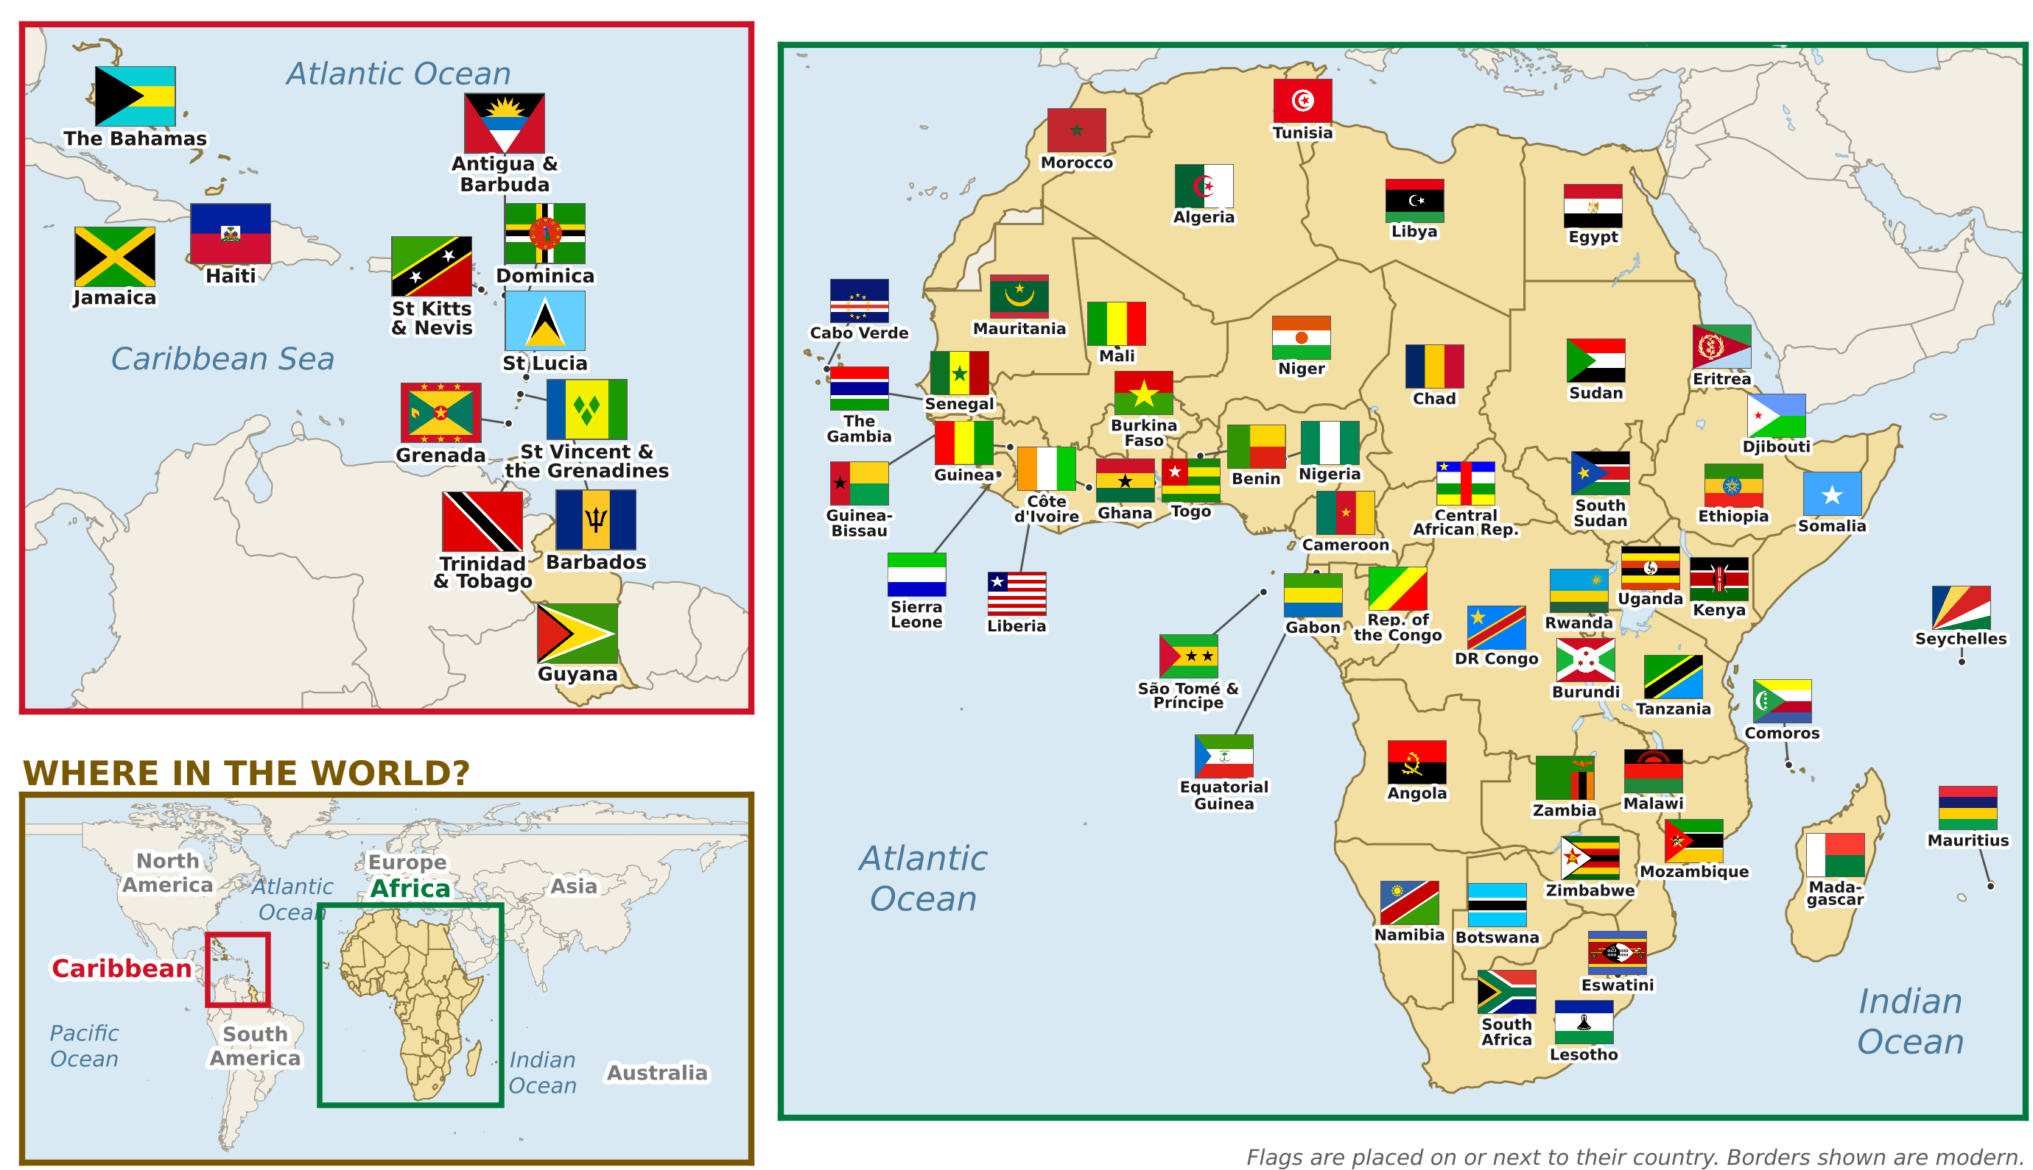
The 66 nations of Africa and the Caribbean on our flag border.
Put your knowledge to the test. Can you name the flags of Africa and the Caribbean, match countries to their famous exports, and find the hidden words from every section?
In this section
00 Name the Flag 00 Wordsearch 2: Black Britain
00 Famous Exports 00 Wordsearch 3: Culture and Identity
00 Wordsearch 1: Africa and the Caribbean 00 Wordsearch 4: Changemakers

