BLACK HISTORY MONTH 2026
King Leopold II and the Congo
Archive photographs: the evidence that shocked the world
ARCHIVE PHOTO SHEET · STAFF DISCRETION · USE WITH WORKSHOP 25
1. Before You Use This Sheet
CONTENT WARNING: GRAPHIC IMAGES
This sheet contains two historical photographs of real people who were mutilated or bereaved under King Leopold II's rule. They are distressing. Staff should decide whether, when and how to use them. This sheet is kept separate from the worksheet and Facilitator Guide so it can be left out entirely.

■ Never use these photographs as a surprise or as the opening hook. Use them only after the Learn section, once students understand the context.
■ Warn students first, and let anyone who prefers not to look turn away or step out, with no explanation needed.
■ Show one photograph at a time, briefly, then put it away and give time to talk. Do not leave them on screen during other activities.
■ Frame each photograph around the people in it and the courage it took to bear witness, not around the injuries.
■ For many groups, describing the photographs is enough. Showing them is optional.
■ Follow your setting's safeguarding policy if a student becomes distressed or makes a disclosure.

2. Photograph 1: Nsala of Wala (1904)
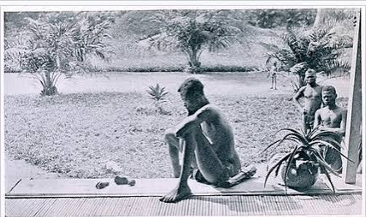
Nsala of Wala with the hand and foot of his daughter Boali, Baringa, Congo Free State, May 1904. Photograph by Alice Seeley Harris. Harris Papers, Anti-Slavery International.
Background
On 15 May 1904, at the Baringa mission, missionary Alice Seeley Harris photographed Nsala of Wala. The day before, sentries working for the ABIR rubber company had attacked his village because its rubber was not ready. They killed his wife, Bonginganoa, and his five-year-old daughter, Boali. Nsala carried his daughter's hand and foot to the mission as evidence. The photograph was shown at lantern lectures across Britain and the USA and printed in campaign publications. It became one of the most powerful pieces of evidence against Leopold's regime.
Questions to discuss
■ Nsala chose to be photographed. Why do you think he wanted the world to see this?
■ How might people in Britain in 1904 have reacted when they saw this at a public meeting?

3. Photograph 2: Survivors (1905)
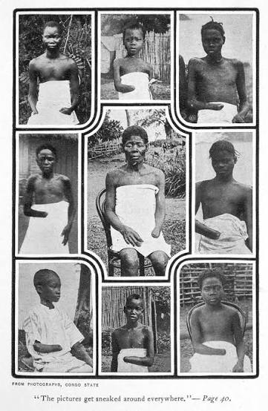
Photographs of survivors of mutilation in the Congo Free State, printed in Mark Twain's 'King Leopold's Soliloquy' (1905).
Background
This page of photographs shows Congolese children and adults whose hands had been cut off. It was printed in Mark Twain's satire 'King Leopold's Soliloquy' (1905), in which Twain imagines Leopold ranting against his critics. The caption quotes the imagined Leopold complaining that 'the pictures get sneaked around everywhere'. In the book, Twain has him call the camera 'the incorruptible Kodak', the one witness he could not bribe.
Questions to discuss
■ Why would a powerful king be afraid of a camera?
■ Link back to the warm-up: what plays the role of 'the incorruptible Kodak' today?

