BLACK HISTORY MONTH 2026
King Leopold II and the Congo
Rubber, terror and the people who exposed it (1885–1908)
FACILITATOR GUIDE · AGES 11–16 · 45–60 MINUTES
1. Session Overview
Duration | 45–60 minutes
Age group | 11–16 (adapt language and pace as needed)
You will need | Student worksheet (one each), pens, board. Optional: the archive photograph in Section 9 (staff discretion only; read the guidance there first).
Activity types | Put it in order, true or false, fill the gaps, witness match, group discussion, role play, opinion scale, confidence check.
Grouping | Whole class, pairs and small groups

2. Why This Session
Between 1885 and 1908, King Leopold II of Belgium ran the Congo Free State as his private property. To meet world demand for rubber, his officials and companies forced Congolese people to work under threat of hostage-taking, mutilation and death. The population fell dramatically. It is one of the worst atrocities of the colonial era, yet it is rarely taught in UK schools. The session also shows how Congolese survivors, Black American witnesses and British campaigners exposed the truth. That links to questions students face today about evidence, protest, statues and how countries deal with their past.
3. Learning Objectives
■ Explain how King Leopold II took control of the Congo and ran it for profit.
■ Describe how the rubber system harmed the Congolese people.
■ Explain how Congolese people and campaigners exposed the truth, and why it still matters today.
4. Session Flow
Mins | Section | What happens
5 | Warm-Up | Do Now: how would you find out about something terrible happening far away, today and in 1900? Keep answers on the board for the 'Did you know?' box.
15 | Learn | Work through the six sections, the size and rubber-system graphics, the timeline, the claims-versus-reality table and key words.
12 | Activities | Put it in order, true or false, gap fill, then the witness match.
8 | Talk It Out | Discussion questions and 'The Big Question' on apology and reparations.
8 | Role Play | Campaigner and doubter in pairs (London, 1905). Take feedback: what evidence changed minds?
5 | Reflection | Opinion scale on statues, confidence check and exit ticket.

5. Delivery Notes
■ Centre Congolese people as people who resisted, not only as victims. Highlight the forest refuges, refusals, Force Publique mutinies (for example the Batetela mutiny of 1897) and survivors who travelled to missions to testify.
■ Point out that two of the first people to expose Leopold were Black Americans: George Washington Williams (1890) and William Sheppard (1899). This is Black history as well as African history.
■ The death toll is an estimate. Model how historians handle uncertainty: there was no census before 1885, the figure of about 10 million (Adam Hochschild, Jan Vansina) comes from population decline, and other scholars suggest lower figures. Avoid treating a number as the point; the scale and the system are the point.
■ Link the warm-up to the 'Did you know?' box: photographs in 1904 did what phone footage does today.
■ Keep descriptions of violence at the level on the worksheet. Do not add graphic detail. The focus is on how the system worked, who profited, and how it was challenged.
■ The Berlin Conference fact (no African leaders invited) is a strong discussion hook. Ask: who decided, and who was affected?
■ On legacy: in June 2020 Antwerp removed a Leopold statue and King Philippe expressed 'deepest regrets' in a letter to the DRC's president. He repeated those regrets in the DRC in 2022, and Belgium returned a tooth of Patrice Lumumba to his family. A parliamentary inquiry ended in December 2022 without agreeing a formal apology.

6. Answer Key
Put it in order
Event (as shown on the worksheet) | Correct number
Box 1: The Casement Report is published (1904) | 4
Box 2: Leopold II becomes King of the Belgians (1865) | 1
Box 3: Belgium takes the Congo from Leopold (1908) | 5
Box 4: The air-filled tyre makes rubber demand soar (1888) | 3
Box 5: Leopold is recognised as ruler of the Congo Free State (1885) | 2

True or false
Statement | Answer | Why
1. Leopold II visited the Congo many times. | FALSE | He never visited it.
2. The Force Publique made villages meet rubber quotas. | TRUE | It used hostage-taking and violence.
3. African leaders were invited to the Berlin Conference. | FALSE | No African rulers or peoples were represented.
4. Photographs helped convince the public that the reports were true. | TRUE | Harris's lantern slides were shown at hundreds of meetings.
5. Historians agree on exactly how many people died. | FALSE | Estimates range from about 1 million to 10 million or more.

Fill the gaps
Sentence | Answer
1. Each village had to collect a fixed amount of rubber, called ______________. | quotas
2. After 1888, the world wanted huge amounts of ______________ for tyres. | rubber
3. Roger ______________ wrote a report for the British government in 1904. | Casement
4. Alice Seeley Harris's ______________ were shown at public meetings. | photographs
5. Belgium took the Congo from Leopold in ______________. | 1908

Witness match
Person | Letter
1. George Washington Williams | B
2. William Sheppard | E
3. Roger Casement | C
4. Alice Seeley Harris | A
5. E. D. Morel | D

7. Sensitivity & Safeguarding
BEFORE YOU DELIVER
This session covers mass violence, hostage-taking of women and children, mutilation and racism. Some students may have family links to the DRC or to other places affected by conflict or colonialism, and some may have experienced violence or trauma. Give a content note at the start, allow students to step out, and check in quietly if needed. Challenge any jokes or comments that make light of the suffering, and any racist remarks, using your setting's behaviour policy.

Follow your setting's safeguarding policy. If a student makes a disclosure, stay calm, listen, do not promise confidentiality, and report it to the Designated Safeguarding Lead.
8. Extension Ideas
■ Research Patrice Lumumba: who was he, and why is he remembered as a hero in the DR Congo?
■ Read extracts from Mark Twain's satire 'King Leopold's Soliloquy' (1905). How does he use humour to make a serious point?
■ Investigate where the minerals in our phones come from today, and whether people in the DR Congo benefit.
9. Archive Photographs (Staff Discretion)
CONTENT WARNING: GRAPHIC IMAGES
The first photograph shows a Congolese father looking at the severed hand and foot of his five-year-old daughter. The second shows children and adults whose hands were cut off. Both are distressing. They are included for staff to decide whether, and how, to use them. Do not print them on student worksheets.

Background
On 15 May 1904, at the Baringa mission, missionary Alice Seeley Harris photographed Nsala of Wala. The day before, sentries working for the ABIR rubber company had attacked his village because its rubber was not ready. They killed his wife, Bonginganoa, and his daughter, Boali. Nsala carried his daughter's hand and foot to the mission as evidence. The photograph was shown at lantern lectures across Britain and the USA and printed in campaign publications. It became one of the most powerful pieces of evidence against Leopold's regime.
If you choose to show them
■ Never use them as a surprise or as the opening hook. Show them only after the Learn section, once students understand the context.
■ Warn students first and let anyone who prefers not to look turn away or step out, with no explanation needed.
■ Frame it around Nsala's choice: he chose to bear witness so the world would know. Ask what courage that took.
■ Show each one briefly, then put it away and give time to talk. Do not leave it on screen during other activities.
■ Consider whether the worksheet's description is enough for your group. For many groups, describing the photos is the better choice.
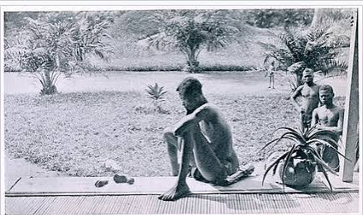
Photograph: Nsala of Wala with the hand and foot of his daughter Boali, Baringa, Congo Free State, May 1904. Alice Seeley Harris. Harris Papers, Anti-Slavery International.
Second photograph: survivors
This page of photographs of Congolese survivors whose hands had been cut off was printed in Mark Twain's satire 'King Leopold's Soliloquy' (1905), in which Twain imagines Leopold ranting against his critics. The caption quotes the imagined Leopold complaining that 'the pictures get sneaked around everywhere'. In the book, Twain has him call the camera 'the incorruptible Kodak', the only witness he could not bribe. It is a strong link to the worksheet's 'Did you know?' box and the warm-up on how the truth gets out.
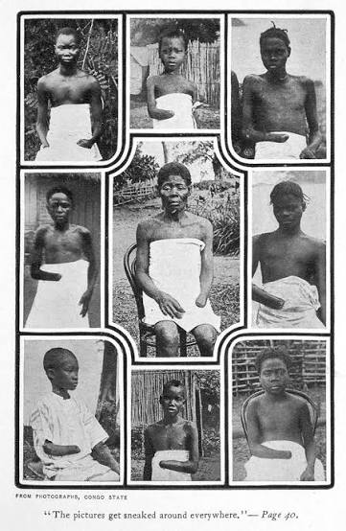
Photographs of survivors of mutilation in the Congo Free State, from Mark Twain's 'King Leopold's Soliloquy' (1905).

