BLACK HISTORY MONTH 2026
King Leopold II and the Congo
Rubber, terror and the people who exposed it (1885–1908)
STUDENT WORKSHEET · AGES 11–16 · 45–60 MINUTES
Name: |  | Date:

1. Learning Objectives
By the end of this session, I will be able to:
■ Explain how King Leopold II took control of the Congo and ran it for profit.
■ Describe how the rubber system harmed the Congolese people.
■ Explain how Congolese people and campaigners exposed the truth, and why it still matters today.
This session covers real violence and suffering. If anything upsets you, let a member of staff know.
2. Warm-Up
▶ DO NOW
If something terrible was happening far away today, how would you find out? List three ways. Then think: how would people have found out in 1900?

3. Learn
A king who wanted a colony
Leopold II became King of the Belgians in 1865. Belgium's government did not want colonies, so Leopold set out to get one for himself. He claimed his aims were to end slave raiding and help African people. At the Berlin Conference (1884–1885), European powers agreed rules for dividing up Africa. No African leaders were invited. In 1885 Leopold was recognised as ruler of the 'Congo Free State'. It was not a Belgian colony: it was his own personal property. He never once visited it.
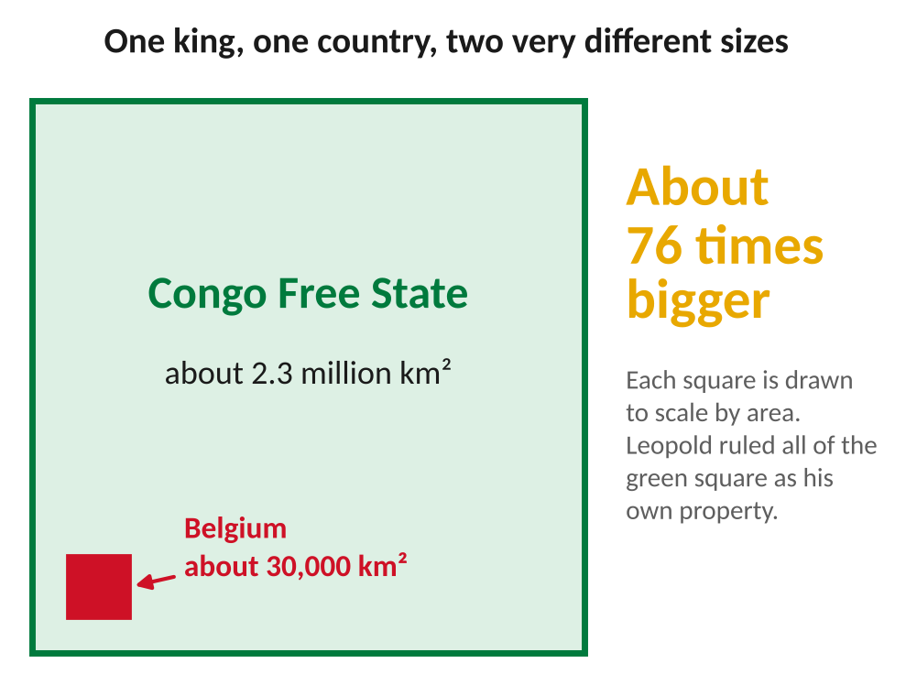
The Congo Free State compared with Belgium, drawn to scale by area.
Rubber and the 'red rubber' system
In 1888 the air-filled tyre was invented, and the world suddenly wanted huge amounts of rubber. Wild rubber vines grew in the Congo's rainforests. Leopold's officials and private companies set quotas: every village had to collect a fixed amount. An army called the Force Publique, led by European officers, made sure they did. Soldiers held women and children hostage until the men brought rubber back. Villages that fell short were burned, and people were beaten, maimed or killed. Soldiers sometimes cut off hands as proof that they had used their bullets.
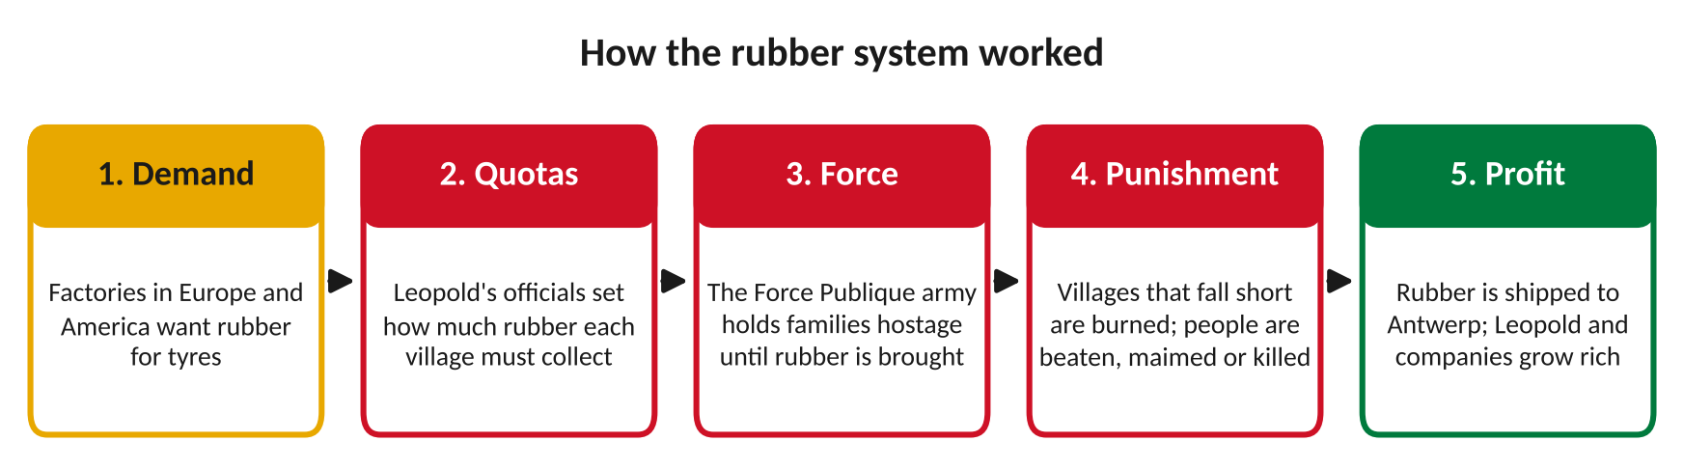
Each step in the chain made someone richer and someone else suffer.
The human cost
Nobody counted the dead. Violence, hunger, disease and people fleeing their homes all caused the population to fall sharply. A Belgian government commission in 1919 estimated that the population may have been cut by half. Historians still disagree about the exact number. Estimates range from around 1 million to 10 million or more. Behind every number were real families and communities.
Resisting and exposing the truth
Congolese people resisted. Many hid in the forest, refused to collect rubber or fought back, and some Force Publique soldiers rebelled. Witnesses spoke out too. George Washington Williams, an African American historian, wrote an open letter to Leopold in 1890. William Sheppard, an African American missionary, reported the abuses he saw. In 1904 Roger Casement's report for the British government confirmed them. That year Casement and E. D. Morel founded the Congo Reform Association. Missionary Alice Seeley Harris photographed victims, and her pictures were shown at hundreds of public meetings. Congolese survivors travelled to missions to tell their stories and be photographed, so the world could not look away.
What happened next
Under huge public pressure, Belgium took the Congo from Leopold in 1908. Before handing it over, Leopold had many of the Free State's records burned. Belgium ruled the 'Belgian Congo' until it won independence on 30 June 1960, with Patrice Lumumba as its first Prime Minister. Today the country is the Democratic Republic of the Congo (DRC).
Why it still matters
In 2020, during Black Lives Matter protests, statues of Leopold were damaged, and the city of Antwerp removed one. That June, King Philippe of Belgium wrote of his 'deepest regrets' for the wounds of the past. This was not a formal apology. In 2022 a Belgian parliamentary inquiry ended without agreeing to one.
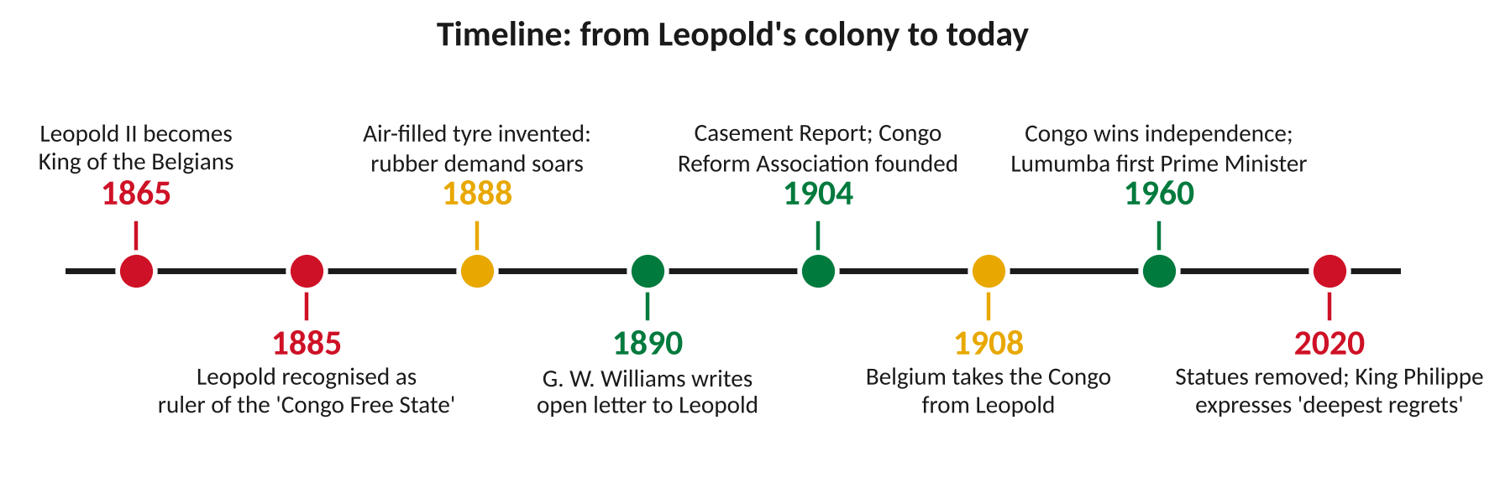
Key moments, from Leopold's colony to today.
DID YOU KNOW?
Many people in Europe did not believe written reports about the Congo. Photographs changed that. Alice Seeley Harris's pictures were shown as lantern slides at public meetings across Britain and America. Like phone footage today, pictures made the truth hard to deny.

Leopold's claims and the reality
Leopold claimed… | What really happened
"I will end the slave trade." | Congolese people were forced to work without pay, under threat of violence.
"Trade will be free for all nations." | Leopold and a few companies kept the profits for themselves.
"I am bringing civilisation." | Villages were burned and families were held hostage.
"This is a Free State." | The people who lived there were not free.

Key words
Key word | Meaning
Colony | a land and its people controlled by another country or ruler
Quota | a fixed amount that must be produced or collected
Force Publique | the army used to control the Congo Free State and enforce quotas
Atrocity | an act of extreme cruelty, especially against ordinary people
Campaign | an organised effort to change something, such as a law or policy
Reparations | making amends for a wrong, for example by paying money or returning items

4. Activities
▶ PUT IT IN ORDER — NUMBER THE BOXES 1 TO 5
The Casement Report is published (1904)
Leopold II becomes King of the Belgians (1865)
Belgium takes the Congo from Leopold (1908)
The air-filled tyre makes rubber demand soar (1888)
Leopold is recognised as ruler of the Congo Free State (1885)

▶ TRUE OR FALSE? — CIRCLE ONE
1. Leopold II visited the Congo many times. | TRUE | FALSE
2. The Force Publique made villages meet rubber quotas. | TRUE | FALSE
3. African leaders were invited to the Berlin Conference. | TRUE | FALSE
4. Photographs helped convince the public that the reports were true. | TRUE | FALSE
5. Historians agree on exactly how many people died. | TRUE | FALSE

▶ FILL THE GAPS — USE THE WORD BANK
quotas | Casement | rubber | photographs | 1908

1. Each village had to collect a fixed amount of rubber, called ______________.
2. After 1888, the world wanted huge amounts of ______________ for tyres.
3. Roger ______________ wrote a report for the British government in 1904.
4. Alice Seeley Harris's ______________ were shown at public meetings.
5. Belgium took the Congo from Leopold in ______________.

▶ WITNESS MATCH — WRITE THE CORRECT LETTER NEXT TO EACH PERSON
Person | Letter
1. George Washington Williams
2. William Sheppard
3. Roger Casement
4. Alice Seeley Harris
5. E. D. Morel

A. A missionary whose photographs were shown at public meetings.
B. An African American historian who wrote an open letter to Leopold in 1890.
C. A British official whose 1904 report for the government confirmed the abuses.
D. A shipping clerk who noticed ships arriving with rubber but leaving with guns, and set up the Congo Reform Association.
E. An African American missionary who reported the abuses he saw in the Kasai region.

5. Talk It Out
▶ TALK IT OUT — DISCUSS WITH A PARTNER OR GROUP
■ Why do you think Leopold called his colony a 'Free State'?
■ Why did it take years for people in Europe to believe what was happening?
■ Who should take responsibility for wrongs from the past: individuals, governments, or both?

THE BIG QUESTION
Should Belgium formally apologise and pay reparations to the DR Congo? Some people say a country should take responsibility for harm done in its name, even long ago. Others say people alive today are not to blame, or that money cannot fix the past. In 2020 King Philippe expressed 'deepest regrets', but Belgium has not made a formal state apology.

What do you think, and why?

▶ ROLE PLAY — IN PAIRS
THE SCENE: London, 1905. Two neighbours leave a public meeting where Alice Seeley Harris's photographs from the Congo were shown.
PERSON A  The campaigner: you are shocked by what you have seen. Persuade your neighbour to sign a petition and write to their MP. Use evidence from today. | PERSON B  The doubter: newspapers have praised King Leopold as a kind ruler. Ask hard questions. What would it take to change your mind?

6. Reflection & Exit Ticket
▶ WHERE DO YOU STAND? — CIRCLE A NUMBER
“Statues of King Leopold II should be removed from public places.”
1  Strongly disagree | 2  Disagree | 3  Not sure | 4  Agree | 5  Strongly agree
Because…

▶ CONFIDENCE CHECK — CIRCLE ONE
How confident do I feel about today's topic?
1  Not at all | 2  A little | 3  Getting there | 4  Confident | 5  Very confident

One thing I learned today:

