BLACK HISTORY MONTH 2026
Jim Jones and Jonestown, Guyana
How one man took control of hundreds of lives, and what we can learn (1955–1978)
STUDENT WORKSHEET · AGES 11–16 · 45–60 MINUTES
Name: |  | Date:

1. Learning Objectives
By the end of this session, I will be able to:
■ Explain who Jim Jones was and why many people, especially Black Americans, joined the Peoples Temple.
■ Describe how Jones built control over his followers, and how this ended in tragedy in Guyana in 1978.
■ Recognise warning signs of controlling groups and people today, and know where to get help.
This session covers the deaths of many people, including children, and mentions suicide. If anything upsets you, let a member of staff know.
2. Warm-Up
▶ DO NOW
Why do people join groups, such as teams, crews, clubs or online communities? List three things a group can give you. Then think: what could make a group harmful?

3. Learn
A preacher who promised equality
In 1955 Jim Jones, a white preacher, started the Peoples Temple church in Indianapolis, USA. At a time of segregation, his church welcomed Black and white people together. It ran food banks and care homes and spoke out against racism. Many Black Americans, especially Black women, joined because the Temple seemed to offer something rare: a community that treated them as equals. In 1965 the Temple moved to California, where it grew to thousands of members.
Behind the promises
Inside the Temple, Jones demanded total loyalty. Members handed over their homes, wages and savings. He told them that outsiders, the government and even their own families were enemies. People who questioned him were shamed in front of everyone or punished. He staged fake 'healings' to convince followers he had special powers.
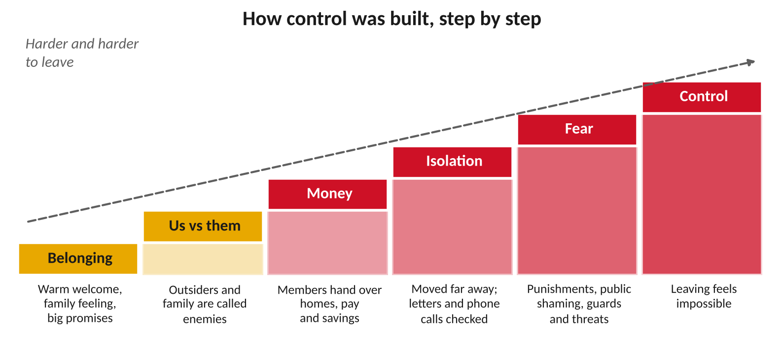
Controlling groups rarely start with fear. They usually start with belonging.
Why Guyana?
Guyana, on the north coast of South America, won independence from Britain in 1966. It is English-speaking, and most of its people have African or Indian heritage. In 1974 Prime Minister Forbes Burnham's government leased the Temple more than 3,800 acres of remote jungle. In 1977 a magazine was about to expose abuse inside the Temple, so Jones moved there with hundreds of followers. By 1978 nearly 1,000 people lived at 'Jonestown', far from their families and from help.
Life at Jonestown
Members worked long hours in the fields on very little food. Passports were taken away, letters and phone calls were checked, and armed guards patrolled. Jones spoke over loudspeakers for hours, day and night, warning that enemies were coming to destroy them. Leaving felt impossible.
18 November 1978
Worried families persuaded US Congressman Leo Ryan to visit. When some members asked to leave with him, Temple gunmen attacked his group at the nearby Port Kaituma airstrip, killing Ryan and four others. That evening, Jones ordered everyone at Jonestown to drink poison. In total, 918 people died, around a third of them children. Jim Jones also died. Children could not choose, and armed guards surrounded the adults. That is why many people now call it a mass murder, not a mass suicide.
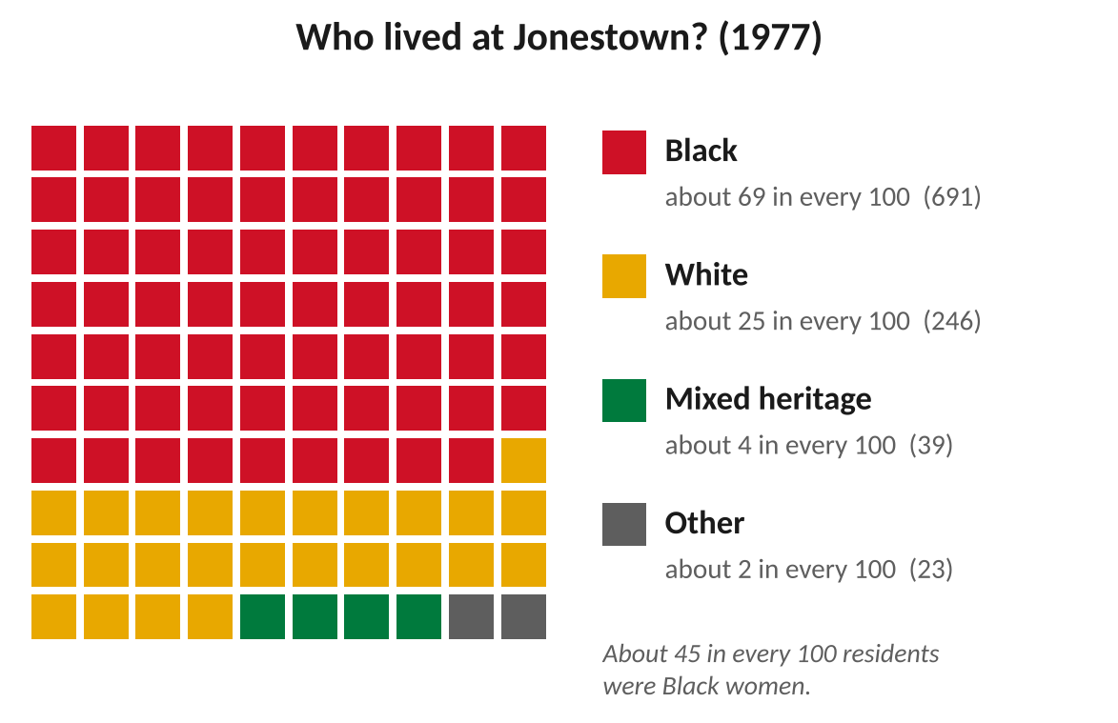
Most people at Jonestown were Black Americans.
Survivors, and Guyana's story
A few people survived by hiding or escaping into the jungle. Hyacinth Thrash, a 76-year-old Black woman, hid under her bed. Guyanese soldiers rescued five teenagers who had been lost in the jungle for three days. For Guyana, it was a national shock: an American group had brought death to its land. Critics in Guyana said Burnham's government had let the Temple run with almost no checks. For years, many people around the world knew Guyana only because of Jonestown, not because of its own people and history.
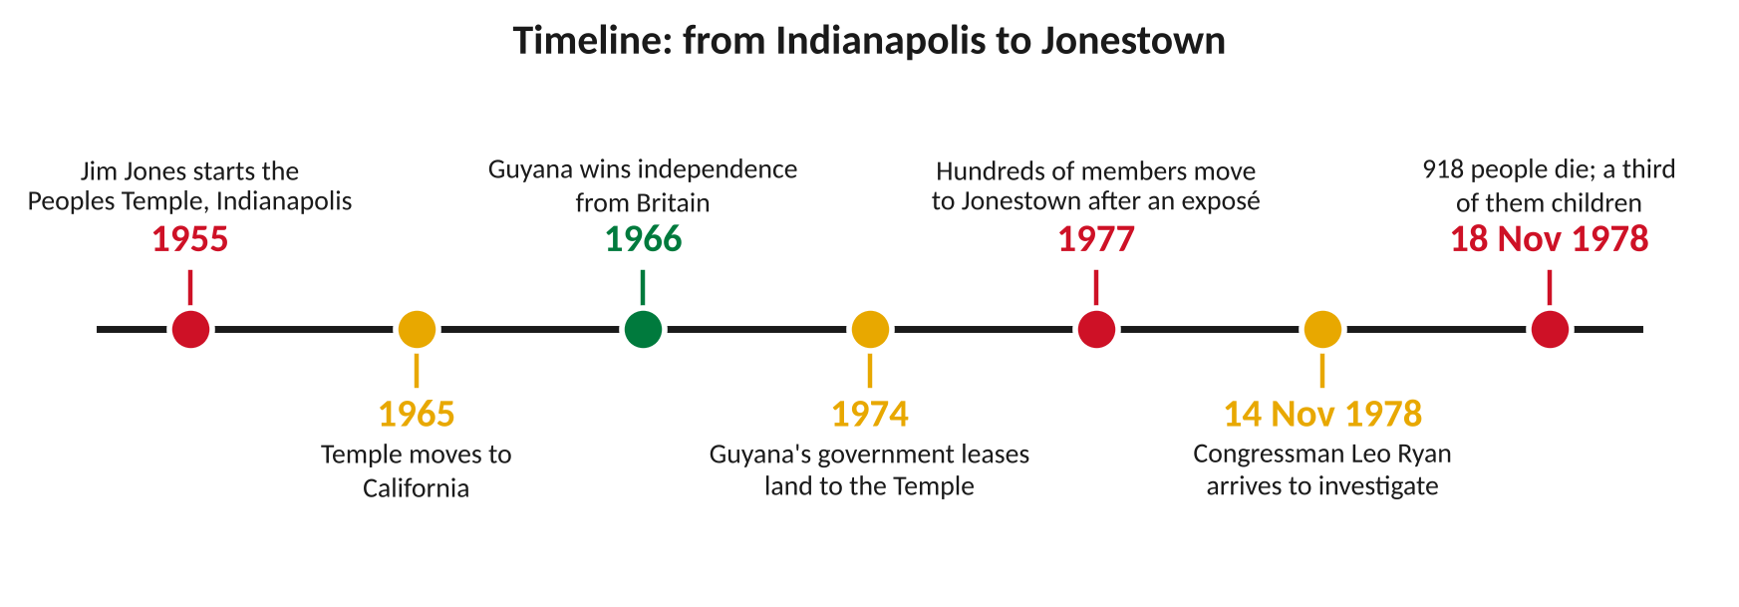
Key moments, from Indianapolis to Jonestown.
DID YOU KNOW?
You may hear the phrase 'drinking the Kool-Aid' used as a joke about blindly following someone. It comes from Jonestown. Survivors and relatives find it deeply hurtful, because it turns the deaths of hundreds of real people, including children, into a punchline.

What Jones promised, and what really happened
Jones promised… | What really happened
A family where everyone is equal. | Jones held all the power, and people who questioned him were punished.
A safe paradise in Guyana. | Hard work, little food, armed guards and no way home.
Protection from a dangerous world. | Members were cut off from family, friends and help.
Give everything for the cause. | Jones controlled all the money and property.

Key words
Key word | Meaning
Cult | a group led by one powerful person who controls members' beliefs and lives
Coercive control | a pattern of threats, punishment and pressure used to control someone
Manipulation | influencing someone in a sneaky or unfair way to get what you want
Isolation | cutting someone off from friends, family and outside help
Defector | someone who leaves a group, often against the group's wishes
Survivor | someone who lives through a disaster or harmful experience

4. Activities
▶ PUT IT IN ORDER — NUMBER THE BOXES 1 TO 5
Congressman Leo Ryan arrives at Jonestown (1978)
Jim Jones starts the Peoples Temple in Indianapolis (1955)
Hundreds of members move to Guyana (1977)
The Temple moves to California (1965)
Guyana's government leases land to the Temple (1974)

▶ TRUE OR FALSE? — CIRCLE ONE
1. Jim Jones started the Peoples Temple in Guyana. | TRUE | FALSE
2. Most people living at Jonestown were Black. | TRUE | FALSE
3. Everyone who died at Jonestown chose to die. | TRUE | FALSE
4. Congressman Leo Ryan went to Jonestown to investigate. | TRUE | FALSE
5. Guyana became independent from Britain in 1966. | TRUE | FALSE

▶ FILL THE GAPS — USE THE WORD BANK
Guyana | isolation | 1978 | Ryan | families

1. The Temple built a settlement in the jungle of ______________.
2. Cutting people off from friends and family is called ______________.
3. Congressman Leo ______________ flew to Jonestown to investigate.
4. Worried ______________ asked the government to check on their relatives.
5. The tragedy happened on 18 November ______________.

▶ SPOT THE WARNING SIGN — WRITE THE LETTER OF THE TACTIC
These things could be said by a gang, an online group or a controlling partner today. Which tactic is each one?
Tactic | What someone says
 | 1. "Only we really get you. Everyone else is against you."
 | 2. "You don't need your old friends any more."
 | 3. "From day one they gave me gifts and loads of attention."
 | 4. "Leave and you'll regret it. You know what happens to snitches."
 | 5. "Give us your bank card. We'll look after your money."

A. Belonging: a warm welcome, gifts and big promises.
B. Us vs them: outsiders and family are called enemies.
C. Money: taking control of what you own or earn.
D. Isolation: cutting you off from people who care about you.
E. Fear: threats and punishment to stop you leaving.

5. Talk It Out
▶ TALK IT OUT — DISCUSS WITH A PARTNER OR GROUP
■ Why do you think so many people trusted Jim Jones at first?
■ Why was it so hard for members to leave, even when things got worse?
■ Where might young people meet similar tactics today, for example in gangs, online groups or relationships?

THE BIG QUESTION
Who was responsible? Jim Jones held almost all the power. But some people argue that the US authorities ignored warnings from worried families, and that Guyana's government let the Temple run with few checks. Others say the blame belongs to Jones and the inner circle who carried out his orders.

What do you think, and why?

▶ ROLE PLAY — IN PAIRS
THE SCENE: San Francisco, 1977. A Temple member tells their cousin they are moving to Jonestown.
PERSON A  The Temple member: you are excited. Jim Jones has promised a 'promised land' free from racism. Explain why you want to go. | PERSON B  The cousin: you are worried. Don't argue or insult them. Ask calm questions to help them think about the warning signs.
6. Reflection & Exit Ticket
▶ WHERE DO YOU STAND? — CIRCLE A NUMBER
“Anyone could be drawn into a controlling group.”
1  Strongly disagree | 2  Disagree | 3  Not sure | 4  Agree | 5  Strongly agree
Because…

▶ CONFIDENCE CHECK — CIRCLE ONE
How confident do I feel about today's topic?
1  Not at all | 2  A little | 3  Getting there | 4  Confident | 5  Very confident

One thing I learned today:

WHERE TO GET HELP
If someone is controlling you, or you are worried about a group you or a friend are in, talk to a trusted adult. Childline: 0800 1111 (free, any time) or childline.org.uk. Samaritans: 116 123. If you are in danger right now, call 999.

