BLACK HISTORY MONTH 2026
The Haitian Revolution
How enslaved people defeated an empire and founded a free nation (1791–1804)
STUDENT WORKSHEET · AGES 11–16 · 45–60 MINUTES
Name: |  | Date:

1. Learning Objectives
By the end of this session, I will be able to:
■ Explain why Saint-Domingue was so valuable to France and how slavery made it rich.
■ Describe the key events and leaders of the Haitian Revolution.
■ Explain why the revolution mattered then, and why its legacy, including the 'independence debt', still matters today.
This session covers slavery and war. If anything upsets you, let a member of staff know.
2. Warm-Up
▶ DO NOW
What does freedom mean to you? Write down three words. Then think: what would you be willing to risk for it?

3. Learn
The richest colony in the world
Saint-Domingue, now Haiti, was a French colony on the Caribbean island of Hispaniola. By 1789 it was the richest colony in the world. It produced around 40% of the sugar imported by France and Britain, and 60% of the world's coffee. That wealth came from about 452,000 enslaved Africans, forced to work on plantations in brutal conditions. So many died that slave traders kept bringing more people from Africa. Free people of colour had some rights but still faced racist laws.
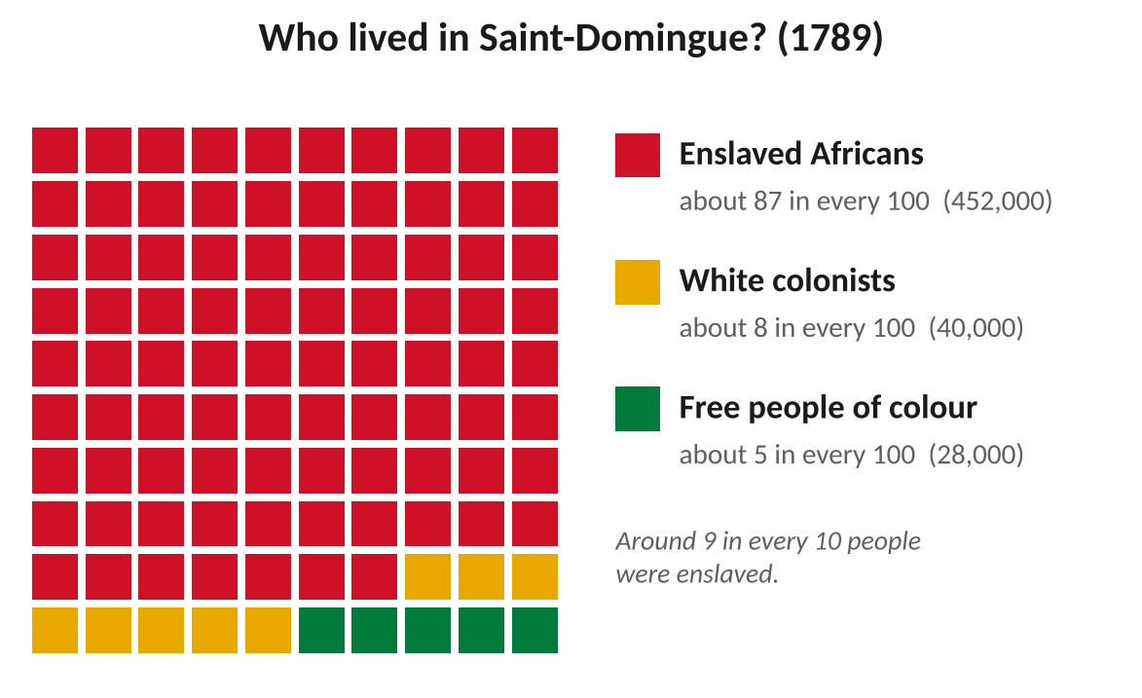
Enslaved people far outnumbered everyone else in Saint-Domingue.
The uprising begins
In August 1791, enslaved people met in secret at Bois Caïman for a Vodou ceremony led by Dutty Boukman and the priestess Cécile Fatiman. They planned a revolt. Within days, thousands rose up across the north, burning plantations. They were inspired by their own African traditions and by the French Revolution's promise of 'liberty, equality and fraternity', which France had never meant to share with them.
Toussaint Louverture
Toussaint Louverture had been born into slavery and taught himself to read. He became a brilliant general. Under pressure from the uprising, French officials freed the enslaved people of the north in 1793, and in 1794 France abolished slavery in all its colonies. Toussaint then fought for France, defeating Spanish and British armies. By 1801 he governed the whole island and wrote a constitution that banned slavery forever.
Napoleon strikes back
In 1802 Napoleon Bonaparte, the new ruler of France, sent a large army under General Leclerc with secret orders to bring back slavery. Toussaint was tricked into a meeting, arrested and shipped to a freezing prison in the mountains of France, where he died in April 1803.
DID YOU KNOW?
As he was taken away, Toussaint is said to have warned: "In overthrowing me, you have cut down in Saint-Domingue only the trunk of the tree of liberty. It will spring up again by the roots, for they are numerous and they are deep." He was right.

Victory and independence
Jean-Jacques Dessalines, another formerly enslaved general, led the fight on. Women fought too, including Sanité Bélair, an officer executed by the French in 1802. Yellow fever killed thousands of French soldiers. On 18 November 1803 the revolutionary army won the Battle of Vertières. On 1 January 1804 Dessalines declared independence and named the country Haiti, from the Taíno name 'Ayiti', meaning 'land of mountains'. Haiti became the first free Black republic, and the only nation ever created by a successful revolt of enslaved people. Having lost the colony, Napoleon also sold France's huge Louisiana territory to the USA.
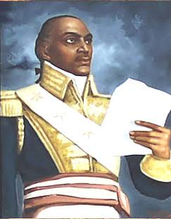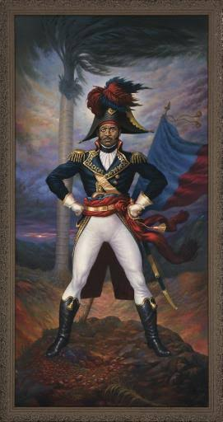
Toussaint Louverture (left) and Jean-Jacques Dessalines (right), as shown in later paintings.
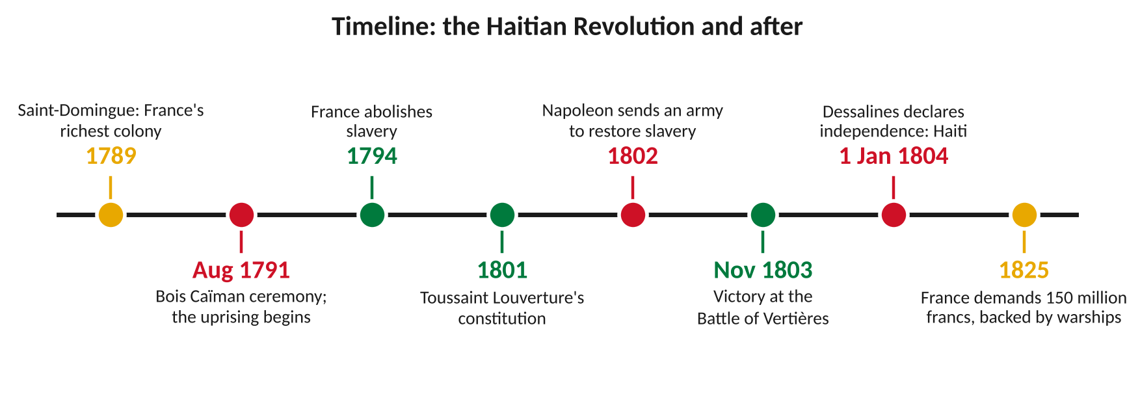
Key moments in the Haitian Revolution and after.
The price of freedom
Many powerful countries, including the USA, refused to recognise Haiti because they feared it would inspire revolts among the people they enslaved. In 1825 France sent 14 warships and demanded 150 million francs to compensate former slave-owners for their 'lost property'. Haiti had to borrow from French banks to pay. The debt was later cut to 90 million francs, but Haiti did not finish paying off the loans until 1947. In 2022, economists estimated this cost Haiti between $21 billion and $115 billion in lost growth. In 2025, France set up a commission to study the debt.
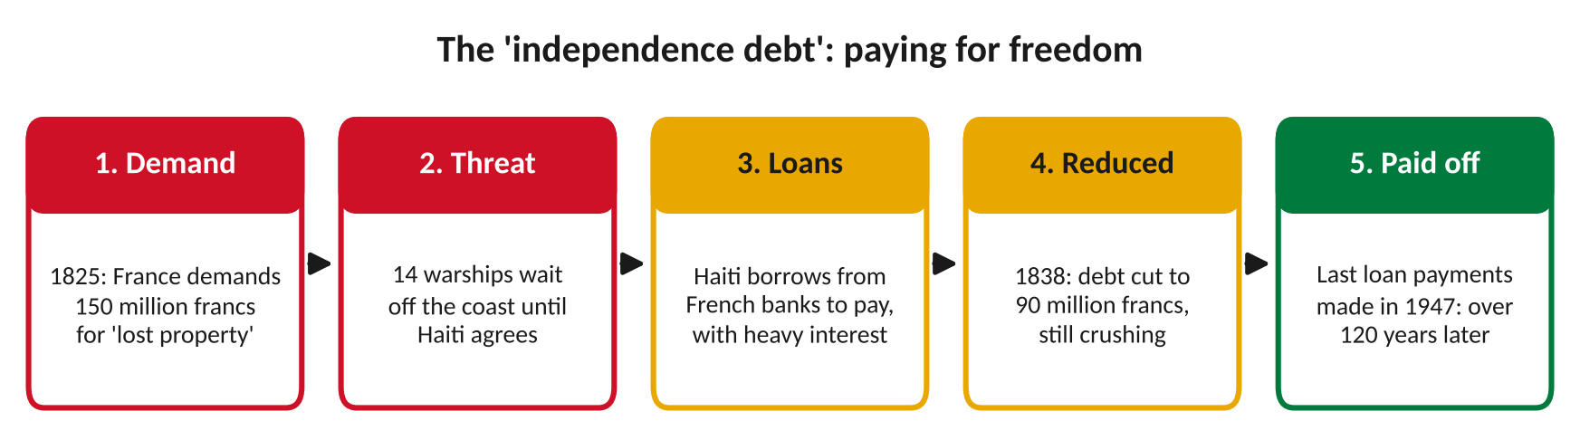
Haiti paid for its freedom for more than 120 years.
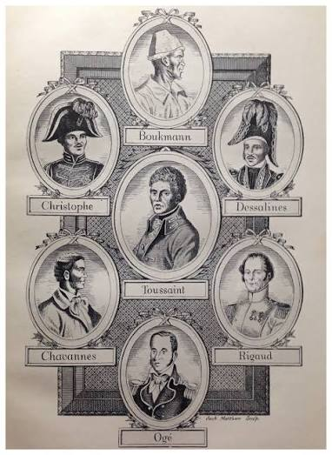
An old engraving of revolutionary leaders. Some were never painted in their lifetime, so their faces are the artist's imagination.
Key leaders
Leader | What they did
Vincent Ogé and Jean-Baptiste Chavannes | Free men of colour who led a revolt for equal rights in 1790; executed by the French in 1791.
Dutty Boukman | Vodou priest who helped lead the Bois Caïman ceremony and the first uprising (1791).
Cécile Fatiman | Vodou priestess at Bois Caïman who helped inspire the revolt.
Toussaint Louverture | Formerly enslaved general who defeated Spain and Britain and banned slavery (1801).
André Rigaud | General who led free people of colour in the south; later fought Toussaint for control.
Henri Christophe | General under Toussaint; later ruled northern Haiti as King Henri I and built the Citadelle fortress.
Sanité Bélair | Officer in the revolutionary army, executed by the French in 1802.
Jean-Jacques Dessalines | Led the final victory and declared Haiti's independence (1804).

Key words
Key word | Meaning
Colony | a land and its people controlled by another country
Plantation | a large farm growing crops such as sugar or coffee, worked by enslaved people
Enslaved | forced to work for others with no freedom or pay
Revolution | a powerful uprising that overturns the people in charge
Abolition | ending something by law, especially slavery
Indemnity | money demanded to make up for a loss

4. Activities
▶ PUT IT IN ORDER — NUMBER THE BOXES 1 TO 5
Dessalines declares Haiti independent (1804)
The uprising begins after Bois Caïman (1791)
France demands 150 million francs from Haiti (1825)
Napoleon sends an army to bring back slavery (1802)
France abolishes slavery in its colonies (1794)

▶ TRUE OR FALSE? — CIRCLE ONE
1. Saint-Domingue was one of the poorest colonies in the world. | TRUE | FALSE
2. Toussaint Louverture was born into slavery. | TRUE | FALSE
3. Napoleon wanted to bring back slavery in Saint-Domingue. | TRUE | FALSE
4. The name 'Haiti' comes from a French word for freedom. | TRUE | FALSE
5. Haiti paid off the independence debt within ten years. | TRUE | FALSE

▶ FILL THE GAPS — USE THE WORD BANK
Boukman | Toussaint | Vertières | Dessalines | 1804

1. Dutty ______________ helped lead the Bois Caïman ceremony.
2. ______________ Louverture wrote a constitution banning slavery.
3. The French army was defeated at the Battle of ______________.
4. Jean-Jacques ______________ declared Haiti's independence.
5. Haiti became independent on 1 January ______________.

▶ FRONT PAGE, 1 JANUARY 1804 — WRITE TWO HEADLINES
News of Haiti's independence reaches the world. Write a headline for each newspaper.
A newspaper in Haiti:

A newspaper read by plantation owners in Jamaica:

5. Talk It Out
▶ TALK IT OUT — DISCUSS WITH A PARTNER OR GROUP
■ Why do you think the Haitian Revolution frightened slave-owning countries like Britain and the USA?
■ Was it fair that Haiti had to pay France for its freedom? Explain your answer.
■ Why do you think the Haitian Revolution is less well known than the American or French revolutions?

THE BIG QUESTION
Should France repay Haiti? Some people say France should return the money, because it was taken under threat of warships and was based on treating human beings as property. Others say it happened 200 years ago and people today are not responsible. In 2003 Haiti asked France for around $21 billion. In 2025 France set up a commission to study the debt, but it has not agreed to pay anything back.

What do you think, and why?

▶ ROLE PLAY — IN PAIRS
THE SCENE: Saint-Domingue, 1802. News arrives that Napoleon's army has landed.
PERSON A  A soldier in Toussaint's army: you have fought for ten years and you will not go back to slavery. Persuade your friend to join the fight. | PERSON B  A farm worker: you are tired of war and afraid for your family. The French promise you will stay free. Should you trust them?

6. Reflection & Exit Ticket
▶ WHERE DO YOU STAND? — CIRCLE A NUMBER
“The Haitian Revolution should be taught in every UK school.”
1  Strongly disagree | 2  Disagree | 3  Not sure | 4  Agree | 5  Strongly agree
Because…

▶ CONFIDENCE CHECK — CIRCLE ONE
How confident do I feel about today's topic?
1  Not at all | 2  A little | 3  Getting there | 4  Confident | 5  Very confident

One thing I learned today:

