BLACK HISTORY MONTH 2026
The Jamaican Maroons
Freedom fighters of the mountains, from Nanny and Cudjoe to today
STUDENT WORKSHEET · AGES 11–16 · 45–60 MINUTES
Name: |  | Date:

1. Learning Objectives
By the end of this session, I will be able to:
■ Explain who the Maroons were and how they won and defended their freedom in Jamaica.
■ Describe the roles of leaders such as Nanny and Cudjoe, and what the peace treaties meant.
■ Weigh up the hard choices the Maroons faced, and explain how their legacy lives on today.
This session covers slavery and war. If anything upsets you, let a member of staff know.
2. Warm-Up
▶ DO NOW
Imagine you had to survive in the mountains with nothing but what you could carry. List three skills you would need. Then think: what would make a community strong enough to survive there?

3. Learn
Who were the Maroons?
Maroons were Africans and their descendants who escaped slavery in the Americas and built free communities in places that were hard to reach. In Jamaica, the first Maroons escaped from Spanish plantations. When England seized the island from Spain in 1655, many more enslaved people fled into the hills. Over the next 80 years, people who escaped from British sugar plantations joined them. The name probably comes from the Spanish word 'cimarrón', meaning wild or runaway.
Two Maroon nations
By the early 1700s there were two main groups. The Leeward Maroons lived in the Cockpit Country in the west, a maze of steep hills and hidden valleys, led by Cudjoe (also written Kojo). The Windward Maroons lived in the Blue Mountains in the east, where Nanny and Quao led them from a stronghold known as Nanny Town. Many Maroons had Akan roots in West Africa, in what is now Ghana, and kept their language, music and beliefs alive.
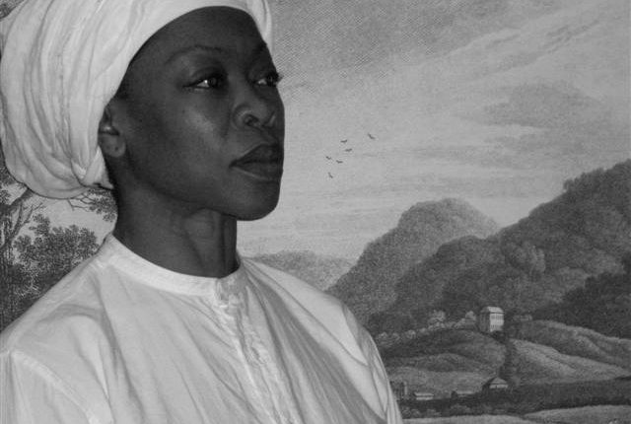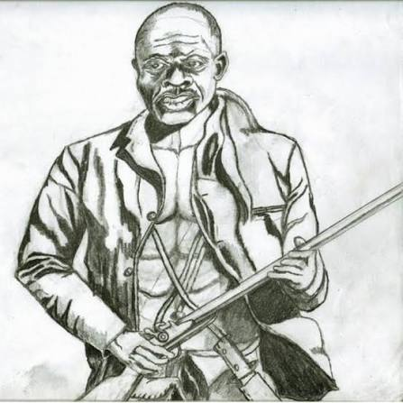
Modern artists' impressions of Nanny (left) and Cudjoe (right). No portraits of them were made in their lifetimes.
The First Maroon War
From about 1728 the British sent soldiers and armed militias to destroy the Maroon towns. They had more soldiers and more guns, but the Maroons knew the land. They used lookouts, camouflage and surprise attacks, and sent messages for miles by blowing an abeng, a cow-horn trumpet. After more than ten years of fighting, the British could not win.
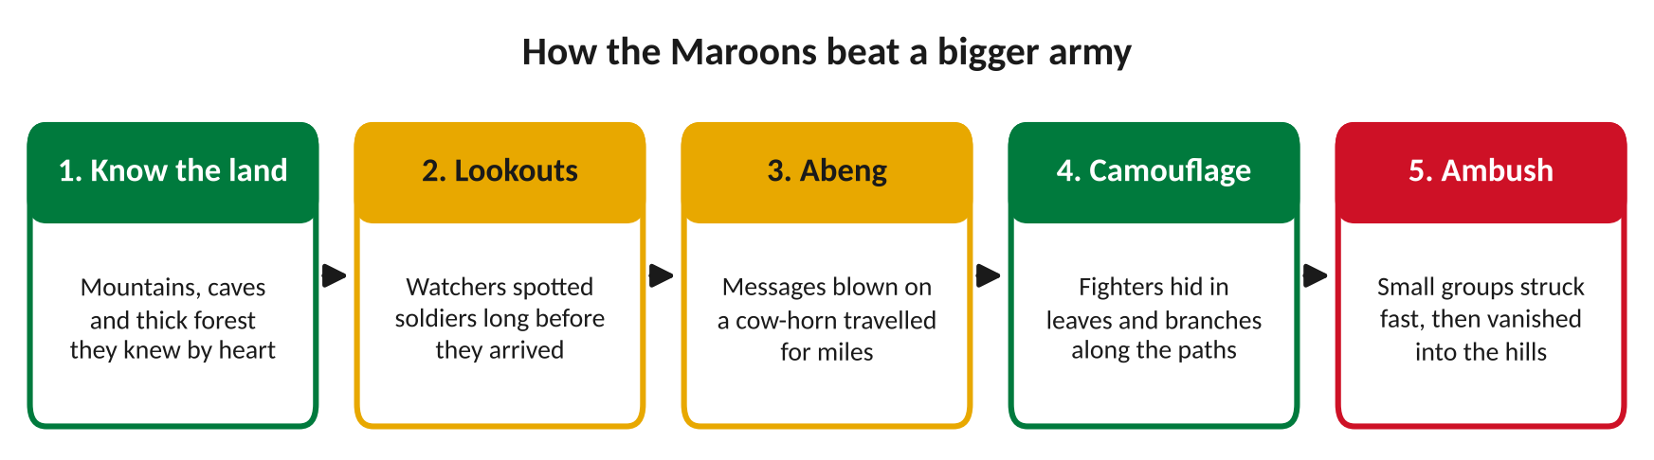
Knowledge, teamwork and planning beat greater numbers.
DID YOU KNOW?
Stories passed down by Maroons say that Nanny could catch bullets with her hands. Historians think her real power was as a brilliant leader who used the land, surprise and teamwork. Much of what we know about her comes from oral history, stories told across generations, because few written records survive. Today she is a National Hero of Jamaica and appears on the $500 note.

The peace treaties
In 1739 Cudjoe signed a peace treaty with the British, and in 1740 the Windward Maroons, led by Quao and Nanny, signed one too. The Maroons won their freedom and land. Nanny's people were granted 500 acres in Portland, which became Moore Town. But there was a heavy price. The Maroons agreed to return people who escaped slavery in future, and to help the British fight any uprisings. In 1760, Maroons helped defeat Tacky's Revolt, a major uprising of enslaved people.
The treaties: what each side got
The Maroons got… | The British got…
Freedom for their people, recognised in law. | An end to a war they could not win.
Land of their own to farm and live on. | A promise that Maroons would return people who escaped slavery.
The right to run their own towns. | Maroon help to fight future uprisings and invasions.
Peace after years of war. | A white official living in each Maroon town.

The Second Maroon War and exile
In 1795 war broke out again at Trelawny Town, after a dispute with the colonial government. The Trelawny Maroons surrendered after being promised they would not be sent away. The governor broke that promise. Nearly 600 Maroons were shipped to Nova Scotia in Canada. In 1800 many of them were moved again, to Freetown in Sierra Leone, West Africa, where their descendants helped shape the country's Krio culture.
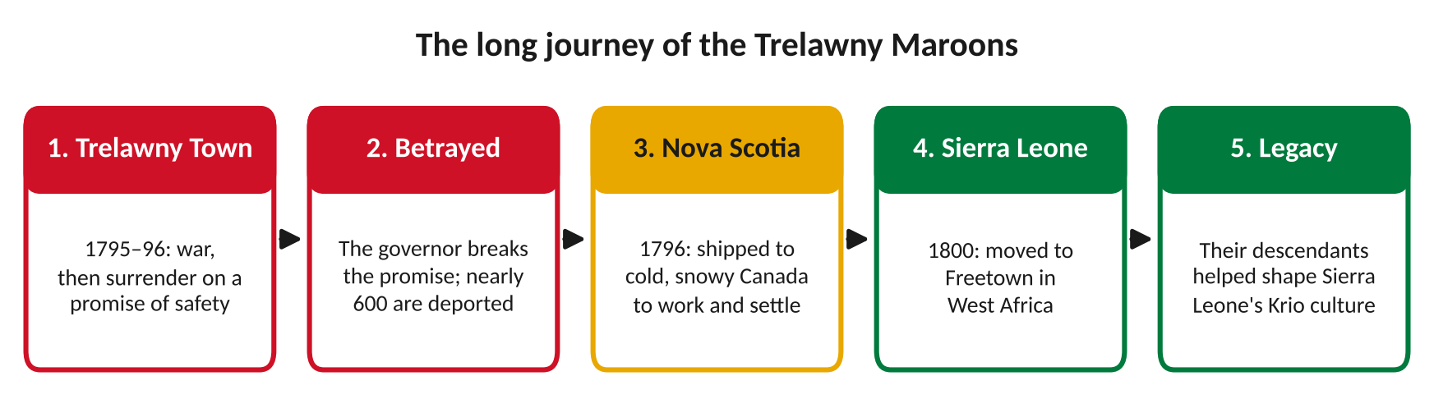
From Jamaica to Canada to West Africa.
Maroons today
Maroon communities still exist in Jamaica, in towns such as Accompong, Moore Town, Charles Town and Scott's Hall. Every 6 January, Accompong holds a festival to celebrate Cudjoe and the 1739 treaty, with drumming, dancing and the sound of the abeng. UNESCO recognises Moore Town's Maroon music and traditions as world heritage. Jamaica celebrates Nanny and its other National Heroes every October on National Heroes Day.
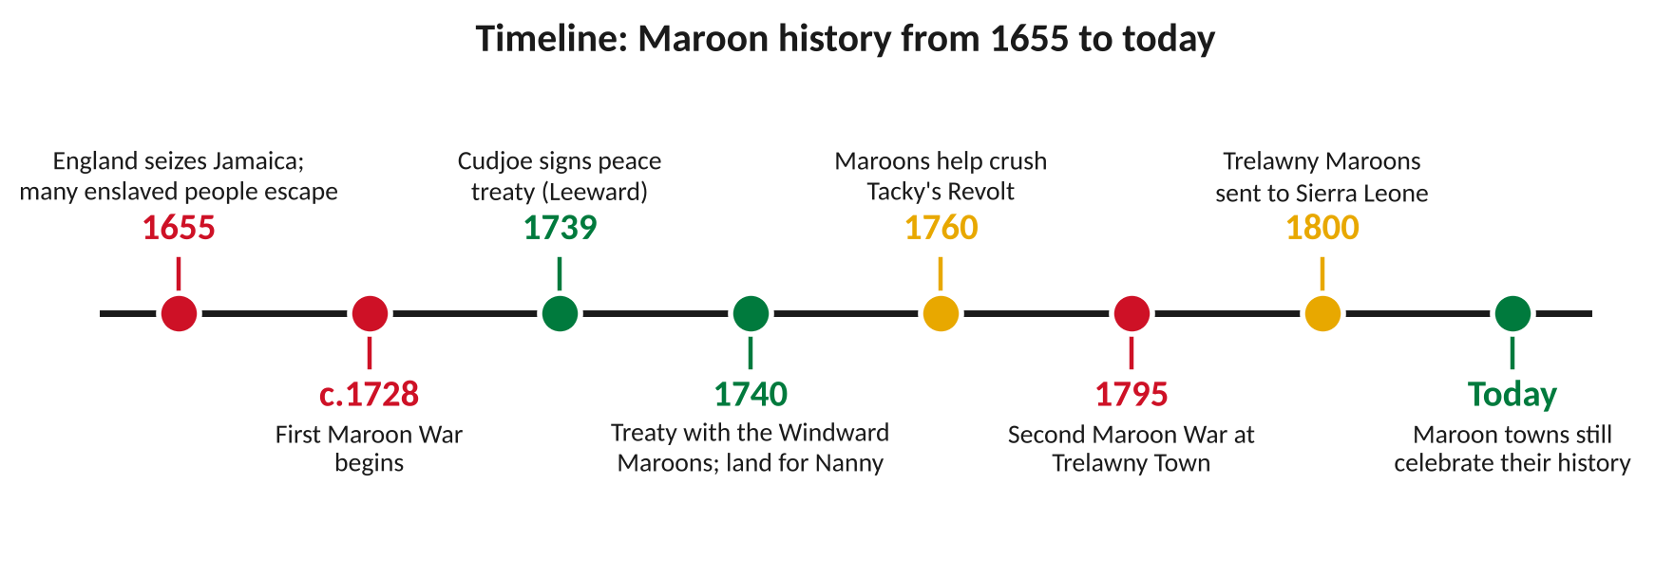
Key moments in Maroon history.
Key words
Key word | Meaning
Maroon | a person who escaped slavery and lived in a free community, or their descendant
Guerrilla warfare | fighting in small groups using surprise attacks rather than big battles
Abeng | a cow-horn trumpet used by Maroons to send messages
Treaty | a formal agreement between two sides, often to end a war
Oral history | history passed down by word of mouth through generations
Exile | being forced to leave your home country

4. Activities
▶ PUT IT IN ORDER — NUMBER THE BOXES 1 TO 5
Cudjoe signs a peace treaty with the British (1739)
England seizes Jamaica from Spain (1655)
The Trelawny Maroons are sent to Sierra Leone (1800)
The First Maroon War begins (around 1728)
The Second Maroon War breaks out at Trelawny Town (1795)

▶ TRUE OR FALSE? — CIRCLE ONE
1. Maroons were people who escaped slavery and built free communities. | TRUE | FALSE
2. Nanny led the Leeward Maroons in the Cockpit Country. | TRUE | FALSE
3. The treaties said Maroons had to return people who escaped slavery. | TRUE | FALSE
4. The Trelawny Maroons were deported to Nova Scotia in Canada. | TRUE | FALSE
5. Maroon communities no longer exist in Jamaica. | TRUE | FALSE

▶ FILL THE GAPS — USE THE WORD BANK
Nanny | abeng | Cudjoe | Accompong | Sierra Leone

1. ______________ led the Windward Maroons and is a National Hero of Jamaica.
2. Maroons sent messages by blowing an ______________.
3. ______________ signed the peace treaty for the Leeward Maroons in 1739.
4. Every 6 January, ______________ holds a festival to celebrate the treaty.
5. In 1800 the Trelawny Maroons were moved to ______________.

▶ WHO'S WHO? — WRITE THE CORRECT LETTER NEXT TO EACH NAME
Name | Letter
1. Nanny
2. Cudjoe
3. Quao
4. Tacky
5. Montague James

A. Led a major uprising of enslaved people in 1760.
B. Windward leader who signed the 1740 treaty alongside Nanny.
C. Leader of the Trelawny Maroons in the Second Maroon War (1795).
D. Windward leader and National Hero who appears on the $500 note.
E. Leeward leader who signed the first peace treaty in 1739.

5. Talk It Out
▶ TALK IT OUT — DISCUSS WITH A PARTNER OR GROUP
■ Why do you think a small group of Maroons could hold off the British army for so long?
■ Why might history focus more on armies and governments than on people like the Maroons?
■ The Trelawny Maroons were promised safety and then sent away. What does that tell you about trust and power?

THE BIG QUESTION
Survival or betrayal? By signing the treaties, the Maroons won freedom and land for their own people. But they also agreed to hand back others who escaped slavery and to help crush uprisings. Some people say they had no real choice and protected their communities. Others say they turned against people who were fighting for the same freedom.

What do you think, and why?

▶ ROLE PLAY — IN PAIRS
THE SCENE: The Cockpit Country, 1739. Cudjoe's council meets to decide whether to sign the British treaty.
PERSON A  The elder: you have seen years of war. The treaty means freedom, land and peace for our children. Argue that we should sign. | PERSON B  The young fighter: you escaped slavery yourself. How can we promise to send others back? Argue that we should keep fighting.
6. Reflection & Exit Ticket
▶ WHERE DO YOU STAND? — CIRCLE A NUMBER
“The Maroons were right to sign the peace treaties.”
1  Strongly disagree | 2  Disagree | 3  Not sure | 4  Agree | 5  Strongly agree
Because…

▶ CONFIDENCE CHECK — CIRCLE ONE
How confident do I feel about today's topic?
1  Not at all | 2  A little | 3  Getting there | 4  Confident | 5  Very confident

One thing I learned today:

