BLACK HISTORY MONTH 2026
20 Fascinating Black History Heroes
Reference Pack
PERSONAL DEVELOPMENT • IDENTITY & BLACK HISTORY
BEFORE WE BEGIN
Typically, this list would've started with Martin Luther King Jr, but he already has his own dedicated resources, so we're leaving room here for other Black History heroes who don't always get the same spotlight.

In This Pack
1. Rosa Parks | 11. Dorothy Johnson Vaughan
2. Claudette Colvin | 12. Jane Bolin
3. Bessie Coleman | 13. Mark E. Dean
4. Shirley Chisholm | 14. Dorothy Height
5. Benjamin O. Davis, Jr. | 15. Mae C. Jemison
6. Frederick Douglass | 16. Bayard Rustin
7. John Lewis | 17. Malcolm X
8. Jesse Owens | 18. Benjamin Banneker
9. Gwendolyn Brooks | 19. W.E.B Du Bois
10. Harriet Tubman | 20. Sojourner Truth

1. Rosa Parks
1913 – 2005  The first name on our list is the woman whose actions sparked the Civil Rights Movement which Martin Luther King led. More specifically, her refusal to stand up and free a row of four seats in the “colored” section of a bus in favour of a white passenger started the Montgomery bus boycott.  For these reasons, Rosa Louise McCauley Parks is also known as “the first lady of civil rights” and “the mother of the freedom movement”.  Rosa spent her life advocating for equal rights and freedom in the Civil Rights Movement. She was awarded the Presidential Medal of Freedom, the Congressional Gold Medal, and the Martin Luther King Jr. Award by the National Association for the Advancement of Colored People. | 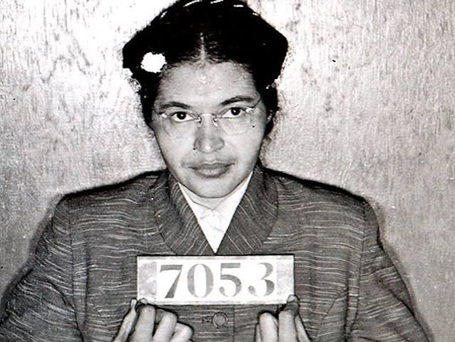  Rosa Parks

2. Claudette Colvin
1939 –  Before Rosa Parks, there was Claudette Colvin, although she's not nearly as popular as Rosa Parks. The reason why we compare these two women is that Claudette was the first woman to be detained for her resistance — choosing not to sit at the back of the bus. A very similar incident to Rosa Parks', although the story of Claudette was never publicised.  The reason for this is that, at the time, Claudette was only 15 years old, unmarried, and believed to be pregnant by a married man. At that time there was also strong gender discrimination and the Civil Rights Movement leaders believed she was not the right person to be the face of the movement. Nonetheless, Claudette was a fierce civil rights movement activist and a nurse aide who helped a lot of people. | 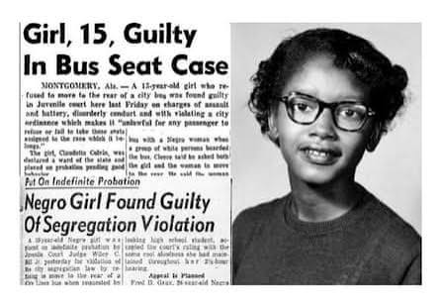  Claudette Colvin

3. Bessie Coleman
1892 – 1926  Bessie Coleman was the first African-American woman and the first Native American to hold an international pilot licence. In her life, she faced many obstacles both as a Black person and as a woman, but her dreams and determination were bigger than those obstacles.  A famous quote from her is “the air is the only place free from prejudice.”  To achieve her goals, she was forced to leave the United States as no school wanted to admit her due to being Black and a woman. So, she went and got her pilot licence in France. When she returned to the USA, she amazed and inspired many people and became known as “Queen Bess” and “Brave Bessie.” | 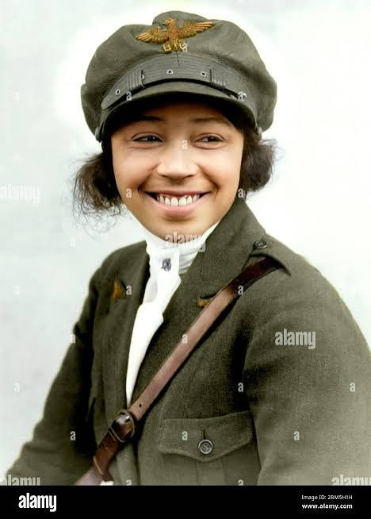  Bessie Coleman

4. Shirley Chisholm
1924 – 2005  Shirley Chisholm is a famous politician, educator, and writer, although her most notable achievements are being the first African-American candidate to make a bid to become U.S. President and the first African-American woman to be elected as a U.S. congresswoman.  Chisholm will be remembered for her bravery and fight to provide equal opportunities for Black people in the United States. After all, she has said she doesn't want to be remembered as the first person to do something but as a person who “has guts.” | 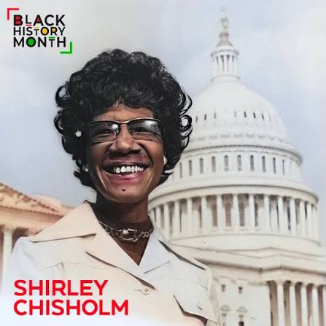  Shirley Chisholm

5. Benjamin O. Davis, Jr.
1912 – 2002  Benjamin was a United States Air Force general and commander of the World War II Tuskegee Airmen. He is remembered as the first African-American Brigadier General in the United States Air Force.  The Tuskegee Airmen, which he led, were the first Black military aviators in the U.S. Army Air Corps (AAC) (a precursor of the U.S. Air Force). Before the Tuskegee Airmen, the U.S. forces were composed completely of white service members, and few believed Black men could fly as effectively. However, when the country was in need of aviators, President Franklin D. Roosevelt started the “Tuskegee Experiment” — a flight school for Black pilots. While many doubted it would succeed, it was an astonishing success, and the first Tuskegee Airmen under General Benjamin O. Davis served the United States in World War II. | 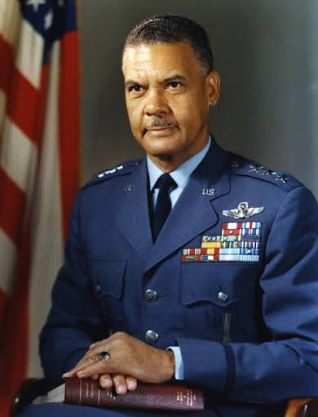  Benjamin O. Davis, Jr.

6. Frederick Douglass
1818 (assumed date) – 1895  Frederick Douglass was a man born in slavery who escaped and became a national leader of the abolitionist movement — a movement that fought to end slavery in the United States.  Douglass became a successful orator, writer, and statesman. He was most famous for his astonishing oratory skills. He was living proof against many racial beliefs that enslaved people lacked the intellectual abilities of white American citizens, so much that people didn't believe he had once been enslaved.  Douglass dedicated his life to the mission of ending slavery and travelled the world trying to convince people to end the practice. He wrote many anti-slavery books and gave powerful speeches until he died in 1895. | 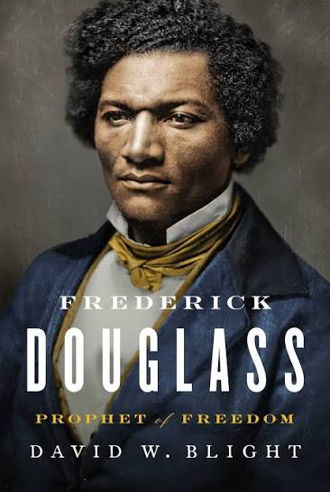  Frederick Douglass

7. John Lewis
1940 – 2020  John Lewis is a man who fought alongside Martin Luther King during the Civil Rights Movement. He marched for equality and freedom while risking his life for justice. He was one of the “Big Six” leaders of groups who organised the 1963 March on Washington. His actions and sacrifices led to the end of legal racial segregation in the United States. In an incident during the Selma to Montgomery marches, known as Bloody Sunday, where state troopers and policemen attacked the marchers, Lewis was leading the march.  In 1987, John Lewis was elected and served in the U.S. House of Representatives from Georgia's 5th district until his death. | 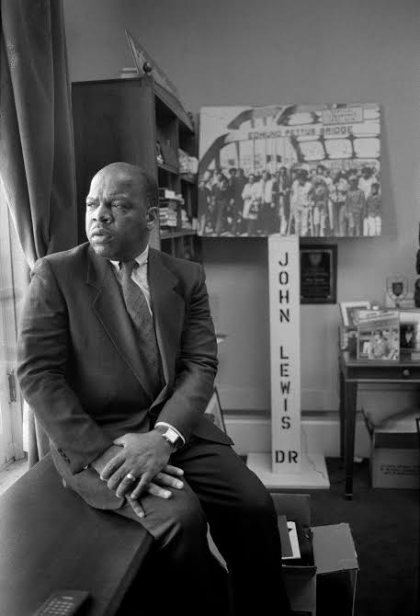  John Lewis

8. Jesse Owens
1913 – 1980  Jesse Owens was an extraordinary American track and field athlete who set the world record for the long jump at the 1936 Olympic Games in Berlin — a record held for 25 years. In 1936, Owens also became a four-time gold medallist in the Olympic Games, and even today, he's considered one of the greatest and most famous athletes in track and field history.  For his contributions to the success of the country, Owens received the Presidential Medal of Freedom in 1976. After his death, he was also awarded the Congressional Gold Medal (1980). | 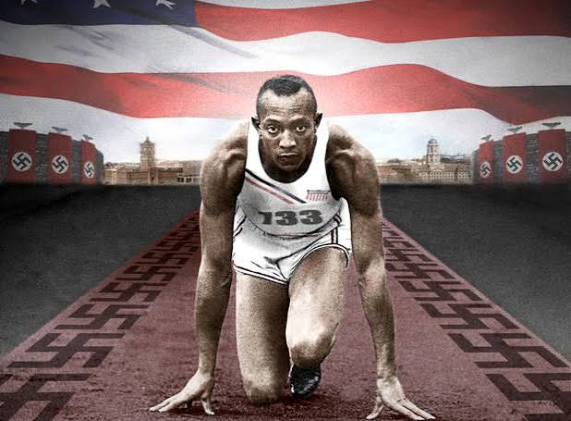  Jesse Owens

9. Gwendolyn Brooks
1917 – 2000  Continuing the list with Black History heroes with extraordinary talents, we get to Gwendolyn Brooks, teacher, author, and poet. She went down in history as the first Black author to win the Pulitzer Prize in 1950. Even today, she is considered one of the greatest poets of the 20th century, a reputation which brought her a job as a poetry consultant at the Library of Congress.  In 1976, Brooks also became the first Black woman inducted into the American Academy of Arts and Letters. During her lifetime, Brooks received many honours and awards. Her legacy lives on and inspires new generations to pursue a career in the arts. | 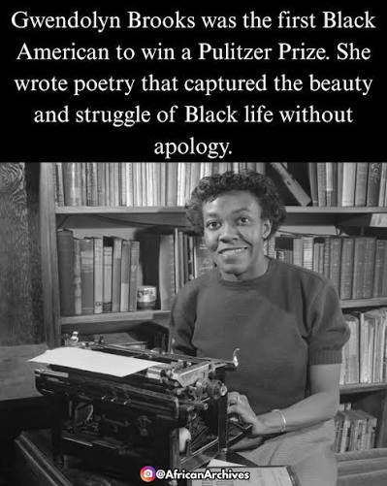  Gwendolyn Brooks

10. Harriet Tubman
Spy • 1822 – 1913  Harriet Tubman was an abolitionist, humanitarian, and Union armed scout and spy during the American Civil War. She was born into slavery but managed to escape and dedicated her life to helping other enslaved people. She organised around 13 escape missions in which she freed approximately 70 enslaved people. All this was possible thanks to a secret network of anti-slavery activists and safe houses.  During the Civil War, General Benjamin Butler recruited Tubman as a volunteer in the troop, becoming the only African-American in an all-white troop. In 1863, she led a team in charge of espionage, thanks to whom countless trapped enslaved people could escape.  In her later years of life, she became involved in the women's suffrage movement. | 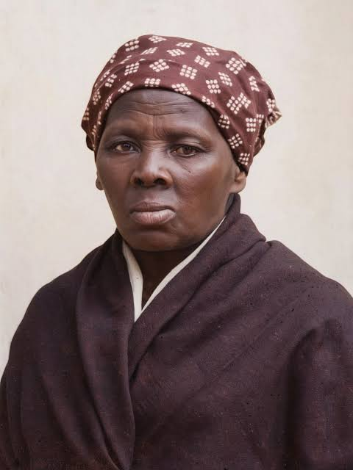  Harriet Tubman

11. Dorothy Johnson Vaughan
1910 – 2008  You may have seen the film Hidden Figures, about the three female African-American mathematicians who worked at NASA and had a pivotal role in John Glenn's launch into orbit.  Well, Dorothy Johnson Vaughan is one of the women on whom the film is based. She was a brilliant mathematician, known as a human-computer, who worked for the National Advisory Committee for Aeronautics and NASA. Her brilliance made her the first African-American woman to be in charge of a team at the West Area Computers centre. | 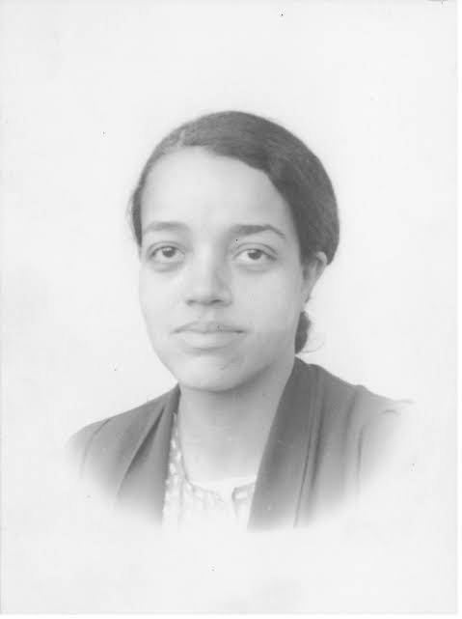  Dorothy Johnson Vaughan

12. Jane Bolin
1908 – 2007  Jane Matilda Bolin, LL.B. was the first Black woman to graduate from Yale University, pass the bar, and join the New York City Law Department. Bolin opened many doors in the field of law, as she also became the first Black female judge in the United States.  In 1939, she was appointed Judge of the Domestic Relations Court in New York, a position she held for 40 years. During her time as a judge, Bolin achieved two significant changes that made life easier for minorities in the US. First, she managed to change the law of assigning probation officers to every case, regardless of race or religion. Second, she managed to get publicly funded private child-care agencies to accept children regardless of ethnic background. | 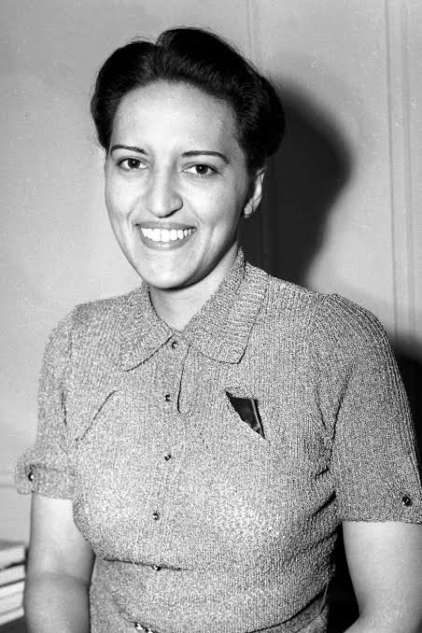  Jane Bolin

13. Mark E. Dean
1957 –  Mark E. Dean is an African-American pioneer of science and a brilliant inventor. He is one of the youngest people to have made it to this list, but with more than 20 patents in the field of computer engineering, he well deserved it. In 2000, the California African-American Museum honoured him by naming him one of the “50 Most Important African Americans in Technology.”  Today, Mark is one of the most appreciated and valuable engineering minds at the International Business Machines (IBM) Corporation. Although he has made a lot of incredible innovations, his most popular ones are the three patents on the original personal computer (PC) by International Business Machines (IBM). This means that Mark Dean is one of the key people who developed PCs. | 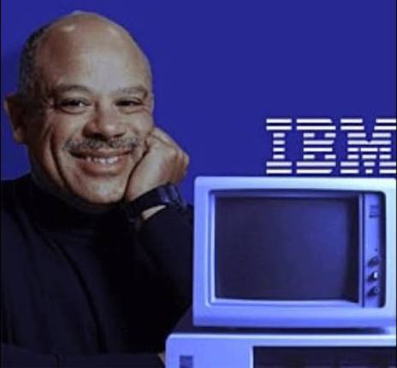  Mark E. Dean

14. Dorothy Height
1912 – 2010  Dorothy Height is another very important name related to the Civil Rights Movement and the fight to end segregation in the US. The world knows Height as the first leader in the Civil Rights Movement to recognise and fight against gender discrimination as part of the movement for freedom. She believed we can't have equality if we don't consider these two things as a whole.  Fighting to end women's unemployment and illiteracy, and to raise awareness for voting rights, she served as the president of the National Council of Negro Women for 40 years. She also led the Young Women's Christian Association (YWCA).  In her lifetime, she received many awards, including the Freedom from Want Award, the Citizens' Medal Award, the Congressional Gold Medal, and the Presidential Medal of Freedom. | 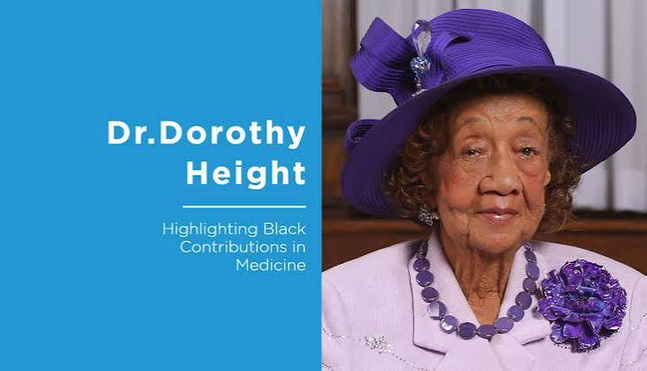  Dorothy Height

15. Mae C. Jemison
1956 –  Another young name on our list is the American engineer, physician, and NASA astronaut Mae C. Jemison. She is known as the first Black woman to travel into space.  Just how extraordinary Jemison is speaks to the fact that she received two undergraduate degrees, a medical degree, served two years as a Peace Corps medical officer in West Africa, and joined NASA's astronaut training programme, all before she was 30 years old.  In 1994 she founded a space camp for children between 12–16 years old and teaches environmental studies at Dartmouth College.  Mae has received many awards, including the Essence Science and Technology Award and the Ebony Black Achievement Award. In 1990 she was named Gamma Sigma Gamma Woman of the Year. Two years later, in 1992, an alternative public school in Detroit, Michigan, was named after her. | 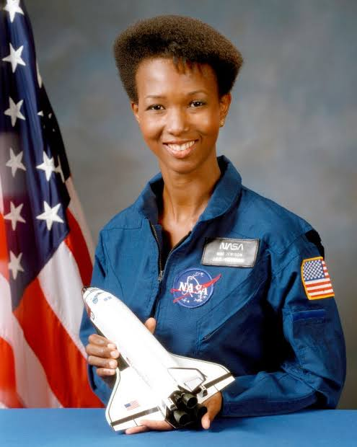  Mae C. Jemison

16. Bayard Rustin
1912 – 1987  Today, Rustin is considered one of the most important figures in the Civil Rights Movement, even though he remains one of the least known. A major reason for this is that he was tied to communism and was openly gay during a time when that was criminalised in the U.S. Many leaders distanced themselves from him, and even Martin Luther King, Jr. faced pressure to stop communicating with Rustin. However, Rustin was incredibly intelligent and remained a valuable asset to the movement, especially in organising non-violent marches, even though he rarely received public recognition for his role.  King and Rustin were the ones organising the Southern Christian Leadership Conference (SCLC), while Rustin and A. Philip Randolph organised early civil-rights marches on Washington, and later Rustin was the main organiser of the famous 1963 March on Washington.  In 1953, Rustin was arrested and convicted for his sexuality, something for which he received a pardon in 2020, 33 years after his death. In 2013, he was also posthumously awarded the Presidential Medal of Freedom. | 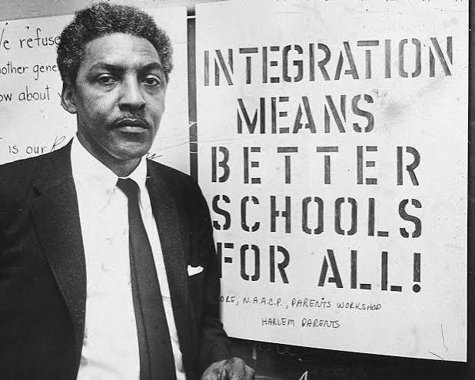  Bayard Rustin

17. Malcolm X
1925 – 1965  Malcolm X is yet another famous Civil Rights activist and a Muslim minister who spoke vocally for the Nation of Islam. He remained popular even though his approach was more assertive and sometimes clashed with the non-violence policy of Martin Luther King, Jr.  Just like King, Malcolm had great oratory skills and charisma, which helped him become a prominent figure in the movement. He is most famous for promoting Black nationalism in union with Islam.  Malcolm was assassinated at an Organization of Afro-American Unity rally on 21 February 1965. After his death, his most popular book, The Autobiography of Malcolm X, in which he predicted the impact of his death, became a bestseller and inspired the Black Power movement. | 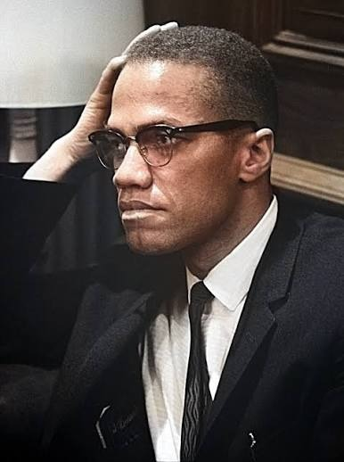  Malcolm X

18. Benjamin Banneker
1731 – 1806  Benjamin Banneker is a fascinating figure in history and an inspiring Black History hero who was a free, self-taught (no formal education) author, surveyor, astronomer, inventor, and landowner. He acquired a great deal of knowledge in mathematics and natural history, becoming one of the first Black intellectuals.  Banneker is known for constructing a wooden clock and making astronomical calculations and predictions, such as the solar eclipse in 1789. | 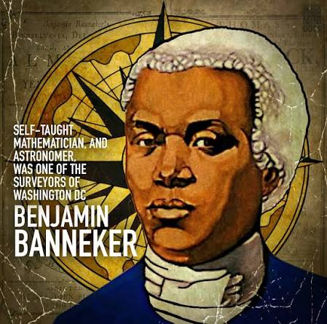  Benjamin Banneker

19. W.E.B Du Bois
1868 – 1963  William Edward Burghardt Du Bois was a famous American sociologist, historian, and civil rights activist who led important Black protests in the early 20th century.  Du Bois was a co-founder of the National Association for the Advancement of Colored People (NAACP), where he served as a researcher and editor of its magazine, The Crisis.  He was very well educated, having obtained a Ph.D. from Harvard University in 1895. Du Bois's degree was in the field of history, although he was mostly trained and worked in the social sciences, conducting research on the conditions in which Black people lived. He published “The Philadelphia Negro: A Social Study (1899)”, which represents the first case-study of a Black community in the USA. | 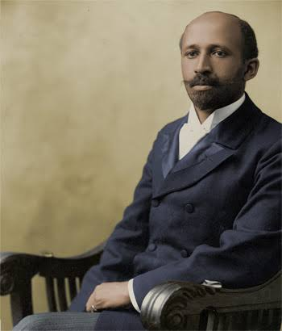  W.E.B Du Bois

20. Sojourner Truth
1797 – 1883  We finish this list of Black History heroes with one of the first prominent American abolitionists and women's rights activists. She was born into slavery but managed to escape with her daughter in 1826. Her son was left behind, and she went to court in an attempt to free him. In 1828, she became the first Black woman to win a court case of such nature against a white man.  After this, Truth became a vocal advocate for abolition and civil and women's rights in the 19th century. Her advocacy was so successful that she even received an invitation to meet President Abraham Lincoln and discuss these matters with him. | 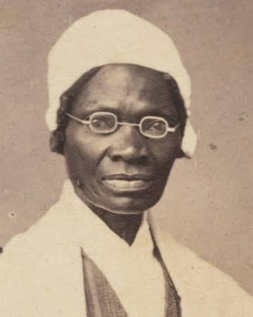  Sojourner Truth

