BLACK HISTORY MONTH 2026
The Windrush Generation
Who came, why they came, what they built, and the scandal that followed
STUDENT WORKSHEET · AGES 11–16 · 45–60 MINUTES
Name: |  | Date:

1. Learning Objectives
By the end of this session, I will be able to:
■ Explain who the Windrush generation were and why they came to Britain.
■ Describe how they contributed to British life, including the NHS and transport.
■ Explain what the Windrush scandal was and why it was wrong.
2. Warm-Up
▶ DO NOW
Imagine moving to a new country tomorrow. What would you pack, and what would you hope to find there?

3. Learn
The ship
The Empire Windrush arrived at Tilbury Docks in Essex on 22 June 1948. It carried 1,027 passengers, and more than 800 of them gave a Caribbean country as their last home. Jamaica was the most common. Many were ex-servicemen who had fought for Britain in the Second World War.
Why they came
Britain needed workers to rebuild after the war. The British Nationality Act 1948 said people from the colonies were British citizens with the right to live and work in the UK. Many saw Britain as the 'Mother Country' and came to find work, study and build a better future. People who came from the Caribbean between 1948 and 1973 are known as the Windrush generation.
What they built
Windrush-generation workers helped staff the new NHS, which was founded just two weeks after the ship arrived, in July 1948. They drove buses and trains, worked in factories and served in the forces. They also changed British culture through music, food, churches and Notting Hill Carnival. Many faced racism, such as signs saying 'No Blacks', and were refused housing and jobs.
The Windrush scandal
From around 2017, it came to light that some Windrush-generation people, who had lived legally in Britain for decades, were wrongly treated as illegal immigrants. Some lost jobs, homes and healthcare, some were detained, and some were deported. The government apologised, and a compensation scheme opened in 2019. Many people say the scheme has been too slow.
Map
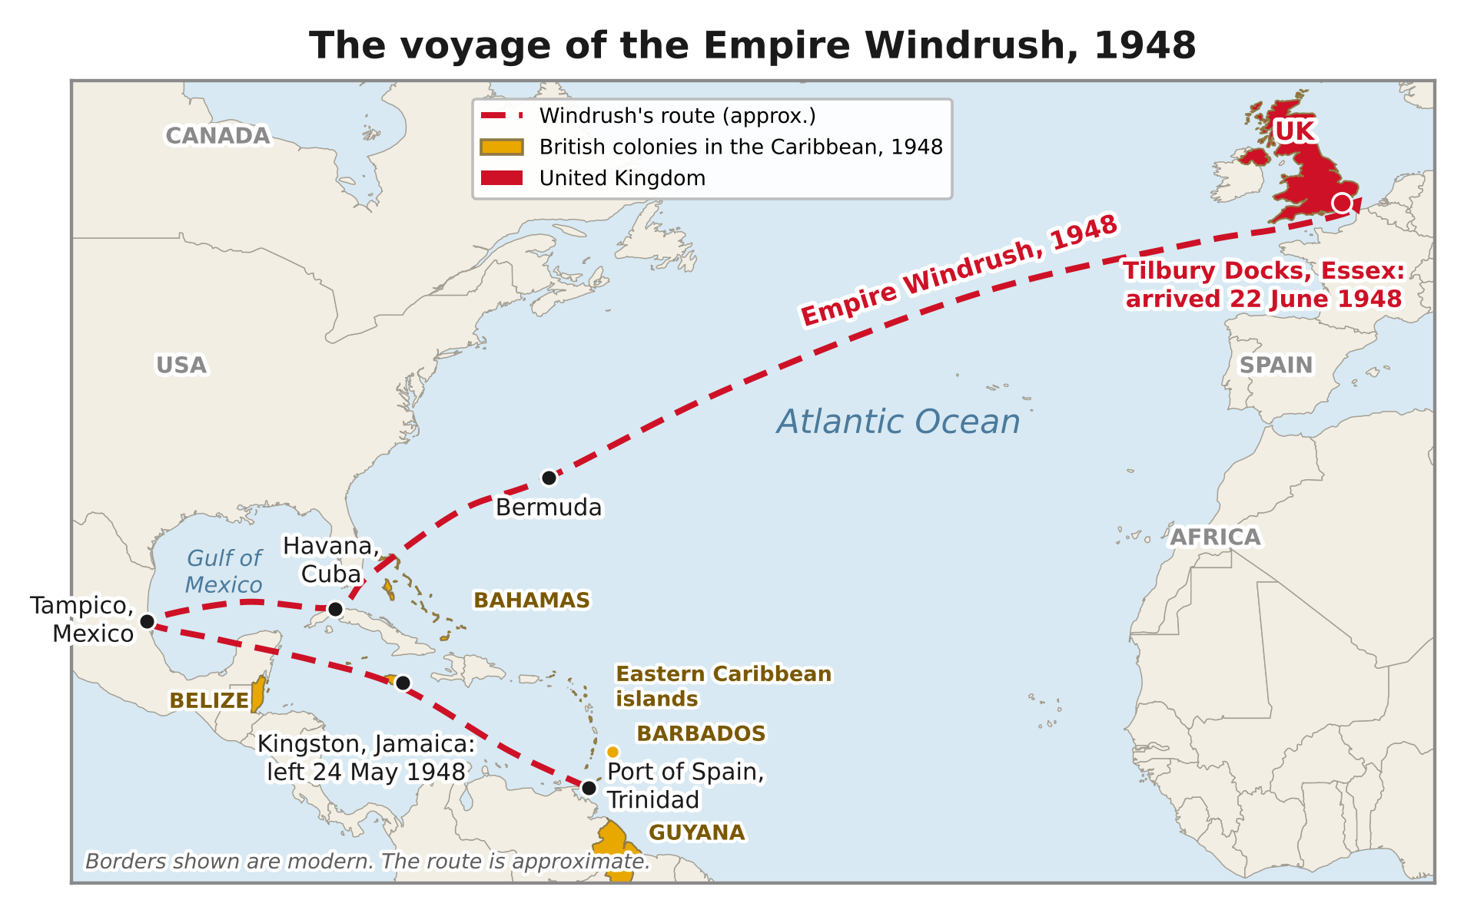
The Empire Windrush sailed from the Caribbean to Tilbury in 1948. Most passengers came from Jamaica. The route is approximate.
DID YOU KNOW?
Since 2018, 22 June has been celebrated as Windrush Day in the UK.

Area | Contribution
Health | Nurses, doctors and staff in the new NHS
Transport | Bus drivers, conductors and railway workers
Culture | Music, food, churches, Notting Hill Carnival
Armed forces | Served Britain in the Second World War

Key words
Key word | Meaning
Migration | moving from one place or country to live in another
Commonwealth | a group of countries, most once part of the British Empire
Citizen | a person who legally belongs to a country
Deport | to force someone to leave a country
Compensation | money paid to make up for harm or loss

4. Activities
▶ PUT IT IN ORDER — NUMBER THE BOXES 1 TO 5
The Empire Windrush docks at Tilbury (22 June 1948)
The Windrush scandal comes to light (around 2017)
Caribbean volunteers serve Britain in the Second World War
The NHS is founded (July 1948)
The British Nationality Act becomes law (30 July 1948)

▶ TRUE OR FALSE? — CIRCLE ONE
1. The Windrush generation had the right to live and work in Britain. | TRUE | FALSE
2. Everyone on the Windrush came from Jamaica. | TRUE | FALSE
3. The NHS was founded in 1948. | TRUE | FALSE
4. No Windrush-generation people were ever deported. | TRUE | FALSE

▶ LETTER HOME, 1948
Imagine you have just arrived in Britain on the Windrush. Write a letter home describing the journey, your first impressions and your hopes.

5. Talk It Out
▶ TALK IT OUT — DISCUSS WITH A PARTNER OR GROUP
■ Why do you think many people called Britain the 'Mother Country'?
■ How would it feel to be told you don't belong in a country you have lived in for 50 years?
■ What would Britain be like today without the Windrush generation?

6. Reflection & Exit Ticket
▶ WHERE DO YOU STAND? — CIRCLE A NUMBER
“The Windrush generation should be taught about in every school.”
1  Strongly disagree | 2  Disagree | 3  Not sure | 4  Agree | 5  Strongly agree
Because…

▶ CONFIDENCE CHECK — CIRCLE ONE
How confident do I feel about today's topic?
1  Not at all | 2  A little | 3  Getting there | 4  Confident | 5  Very confident

One thing I learned today:

