BLACK HISTORY MONTH 2026
Mary Seacole & Black Wartime Service
Courage in the Crimean War and the two World Wars
STUDENT WORKSHEET · AGES 11–16 · 45–60 MINUTES
Name: |  | Date:

1. Learning Objectives
By the end of this session, I will be able to:
■ Describe Mary Seacole's life and achievements.
■ Explain how people from Africa and the Caribbean contributed to both World Wars.
■ Consider why some contributions have been forgotten.
2. Warm-Up
▶ DO NOW
When you think of soldiers in the World Wars, who do you picture? Why?

3. Learn
Mary Seacole
Mary Seacole was born in Kingston, Jamaica, in 1805. She learned healing from her mother, who used traditional Caribbean medicine. When the Crimean War began in the 1850s, she offered to help as a nurse, but the British War Office turned her down. So she paid her own way to the Crimea.
'Mother Seacole'
In the Crimea, Mary built the 'British Hotel', where she sold food and supplies and cared for sick and wounded soldiers, sometimes on the battlefield itself. Soldiers called her 'Mother Seacole'. In 1857 she published her autobiography. In 2016 a statue of her was unveiled at St Thomas' Hospital, London.
The First World War
Around 15,000 men from the Caribbean served in the British West Indies Regiment. Hundreds of thousands of Africans served as soldiers and many more as carriers who transported supplies, and tens of thousands died. Walter Tull became one of the first Black officers in the British Army.
The Second World War
Around 6,000 Caribbean men served in the RAF, including Ulric Cross from Trinidad, a decorated navigator. More than 370,000 Africans fought for Britain. Lilian Bader was one of the first Black women to join the British armed forces. Many Windrush passengers in 1948 were ex-servicemen.
Map
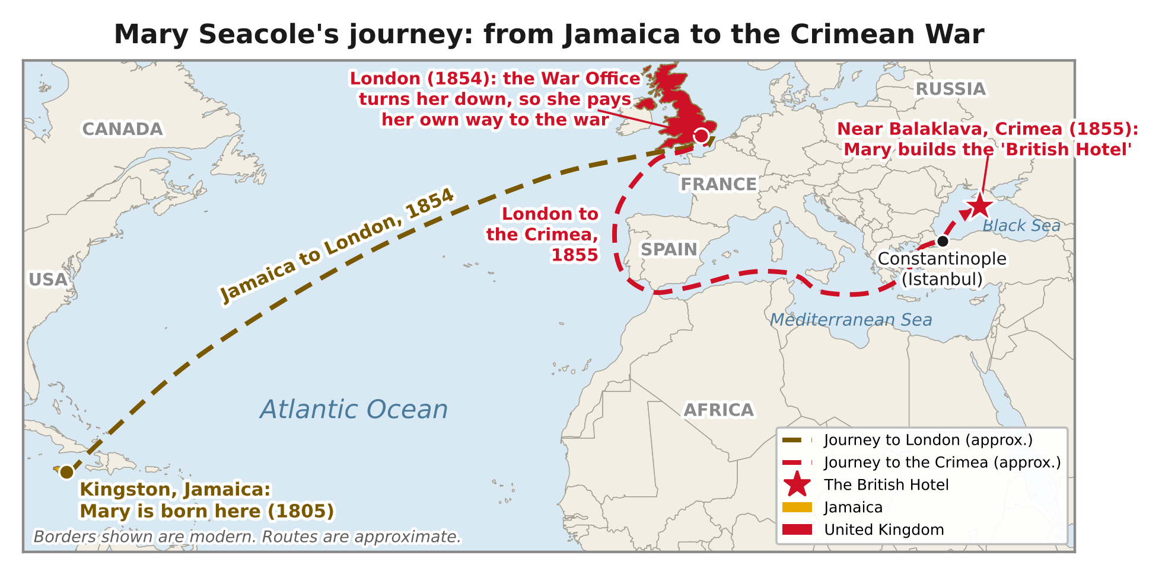
Mary Seacole's journeys from Jamaica to London (1854) and on to the Crimea (1855). Routes are approximate.
DID YOU KNOW?
In 2004, Mary Seacole was voted top of a poll of 100 Great Black Britons.

Person | War | Role
Mary Seacole | Crimean War | Nurse and businesswoman
Walter Tull | First World War | Army officer
Ulric Cross | Second World War | RAF navigator
Lilian Bader | Second World War | Instrument repairer, Women's Auxiliary Air Force

Key words
Key word | Meaning
Crimean War | a war (1853–1856) between Russia and an alliance including Britain
Regiment | a unit of an army
Carrier | a person who transported supplies for the army
Volunteer | someone who chooses to serve without being forced
Remembrance | honouring those who served and died in war

4. Activities
▶ PUT IT IN ORDER — NUMBER THE BOXES 1 TO 5
A statue of Mary Seacole is unveiled in London (2016)
Mary sets up the British Hotel in the Crimea (1850s)
Caribbean air crew serve in the RAF in the Second World War
Mary Seacole is born in Jamaica (1805)
The British West Indies Regiment serves in the First World War

▶ TRUE OR FALSE? — CIRCLE ONE
1. Mary Seacole was born in Jamaica. | TRUE | FALSE
2. The War Office paid for Mary to travel to the Crimea. | TRUE | FALSE
3. Soldiers called her 'Mother Seacole'. | TRUE | FALSE
4. No African soldiers served Britain in the Second World War. | TRUE | FALSE

▶ QUICK QUIZ — TICK ONE ANSWER FOR EACH QUESTION
1. What did Mary Seacole build in the Crimea?
☐ A. A school
☐ B. The British Hotel
☐ C. A church
☐ D. A bridge

2. Ulric Cross served as…
☐ A. A cook
☐ B. An RAF navigator
☐ C. A sailor
☐ D. A doctor

5. Talk It Out
▶ TALK IT OUT — DISCUSS WITH A PARTNER OR GROUP
■ Why do you think Mary Seacole was turned down by the War Office?
■ Why might the service of African and Caribbean people have been forgotten?
■ How should we remember them on Remembrance Day?

▶ ROLE PLAY — IN PAIRS
THE SCENE: It is 1855. A wounded soldier arrives at Mary Seacole's British Hotel.
PERSON A  The soldier: describe what's happened and ask Mary why she came all this way. | PERSON B  Mary Seacole: care for the soldier and explain why you refused to take 'no' for an answer.

6. Reflection & Exit Ticket
▶ WHERE DO YOU STAND? — CIRCLE A NUMBER
“Black wartime service should be part of every Remembrance Day.”
1  Strongly disagree | 2  Disagree | 3  Not sure | 4  Agree | 5  Strongly agree
Because…

▶ CONFIDENCE CHECK — CIRCLE ONE
How confident do I feel about today's topic?
1  Not at all | 2  A little | 3  Getting there | 4  Confident | 5  Very confident

One thing I learned today:

