BLACK HISTORY MONTH 2026
Rudolf Duala Manga Bell
The king who fought German land seizures with the law
STUDENT WORKSHEET · AGES 11–16 · 45–60 MINUTES
Name: |  | Date:

1. Learning Objectives
By the end of this session, I will be able to:
■ Explain what colonialism is.
■ Put the key events of Manga Bell's life in order.
■ Describe how he used peaceful methods to resist.

2. Warm-Up
▶ DO NOW
Someone with power tells your family to leave your home so other people can live there instead. What could you do about it?

3. Learn
A king in a colony
Rudolf Duala Manga Bell was born in 1873 in Douala, a port city in what is now Cameroon. In 1884 Germany made Cameroon its colony, called Kamerun. Rudolf was the son of the king of the Duala people and was sent to school in Germany. He became king in 1908.
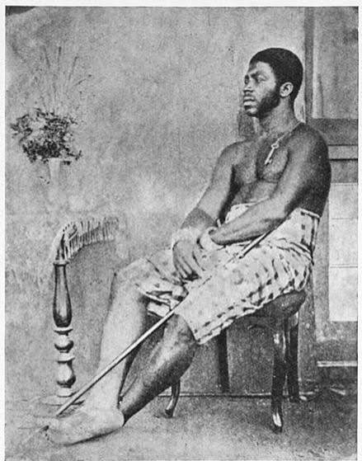  King Bell of the Duala, photographed about 1874 – the royal family Rudolf was born into. | 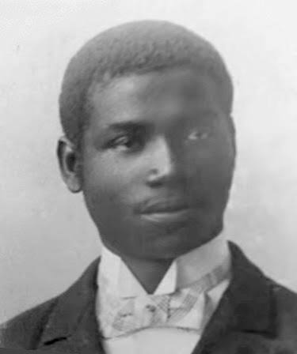  Rudolf Duala Manga Bell as a young man.

Land taken away
In 1910 the German government decided to move the Duala people away from their land by the river, so that only Europeans could live there. Rudolf fought back peacefully. He wrote letters, sent petitions to the German parliament and secretly sent his friend Adolf Ngoso Din to Germany to hire a lawyer.
Arrest and legacy
The Germans removed him as king. In 1914 he and Ngoso Din were arrested and charged with treason. After a rushed trial, both men were executed on 8 August 1914, just as the First World War began. Today he is a national hero in Cameroon, and the German cities of Berlin and Hamburg have started to honour him too.
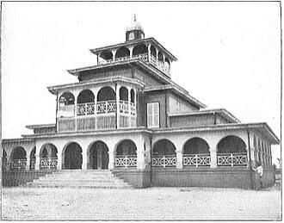  La Pagode, the Bell family's palace in Douala, in the early 1900s… |   …and La Pagode today. It still stands in Douala.

DID YOU KNOW?
The Duala people still sing a hymn about him, written in 1929.

Key words
Key word | Meaning
Colony | a country controlled by another country
Petition | a formal written request signed by people
Treaty | a written agreement between leaders
Treason | the crime of betraying your country's rulers
Expropriation | taking land away from its owners

4. Activities
▶ MATCH IT — WRITE THE LETTER IN THE BOX
Key word | Letter | Meaning
Colony |  | A. a written agreement between leaders
Petition |  | B. a country controlled by another country
Treaty |  | C. a formal written request signed by people
Treason |  | D. taking land away from its owners
Expropriation |  | E. the crime of betraying your country's rulers

▶ PUT IT IN ORDER — NUMBER THE BOXES 1 TO 8
Duala petitions are sent to the German parliament
Born in Douala, son of the Duala king
Executed after a rushed trial
Duala chiefs sign a treaty with Germany
Becomes king of the Duala
Removed as king by the German authorities
Educated at school in Germany
Germany plans to move the Duala off their land

▶ HOW DID HE FIGHT BACK? — TICK THE METHODS HE USED
Method | Used ✓
Writing letters | ☐
Sending petitions to the German parliament | ☐
Hiring a lawyer | ☐
Leading an armed uprising | ☐
Getting support from German journalists | ☐
Asking other countries for help | ☐

▶ TRUE OR FALSE? — CIRCLE ONE
1. Manga Bell was born in Douala. | TRUE | FALSE
2. Cameroon was a colony of France in 1884. | TRUE | FALSE
3. He went to school in Germany. | TRUE | FALSE
4. He led an army against the Germans. | TRUE | FALSE
5. He was charged with treason. | TRUE | FALSE
6. He lived to see the end of the First World War. | TRUE | FALSE

▶ A LETTER TO PARLIAMENT, 1912 — WRITE AS A DUALA CHIEF
Ask the German parliament to stop the land seizures. Starters: “We, the Duala people, ask you to…” “It is unfair that…” “Our land matters because…”
To the Members of the Reichstag,

5. Talk It Out
▶ TALK IT OUT — DISCUSS WITH A PARTNER OR GROUP
■ Why do you think he chose the law instead of weapons?
■ Was his trial fair? Why or why not?
■ Why is it important for countries like Germany to remember people like him?
■ Are there people today who protest using the law, petitions or the courts?

6. Reflection & Exit Ticket
▶ WHERE DO YOU STAND? — CIRCLE A NUMBER
“Peaceful protest can be more powerful than violence.”
1  Strongly disagree | 2  Disagree | 3  Not sure | 4  Agree | 5  Strongly agree

Because…

▶ CONFIDENCE CHECK — CIRCLE ONE
How confident do I feel about today's topic?
1  Not at all | 2  A little | 3  Getting there | 4  Confident | 5  Very confident

One thing I learned today:
One word to describe Manga Bell, and why:

