BLACK HISTORY MONTH 2026
Ruben Um Nyobè
The forgotten father of Cameroon's independence
STUDENT WORKSHEET · AGES 11–16 · 45–60 MINUTES
Name: |  | Date:

1. Learning Objectives
By the end of this session, I will be able to:
■ Explain why Cameroon was split between France and Britain.
■ Describe what Ruben Um Nyobè fought for.
■ Discuss why some heroes are forgotten.

2. Warm-Up
▶ DO NOW
Who decides which heroes we learn about in school? Why might some people be left out?

3. Learn
A divided country
Cameroon was a German colony. After Germany lost the First World War, the country was split: France ruled most of it, and Britain ruled a smaller part in the west. Ruben Um Nyobè was born in 1913 and grew up under French rule. He became a civil servant and a trade union leader, fighting for workers' rights.
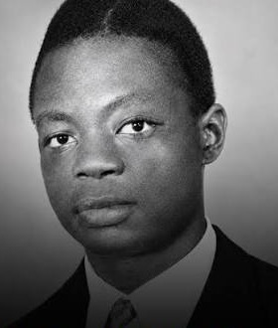
Ruben Um Nyobè (1913–1958), leader of the UPC.
Fighting for freedom
In 1948 he helped start the UPC (Union of the Peoples of Cameroon). It wanted two things: independence from France, and reunification – joining the French and British parts back together. He even travelled to New York to speak at the United Nations. In 1955 France banned the UPC, and he had to go into hiding in the forest.
Killed and forgotten
On 13 September 1958 Ruben Um Nyobè was killed by French soldiers. Cameroon became independent in 1960, but for more than 30 years it was forbidden to say his name. In 2025 the French president wrote to Cameroon's president admitting France's responsibility for his death.
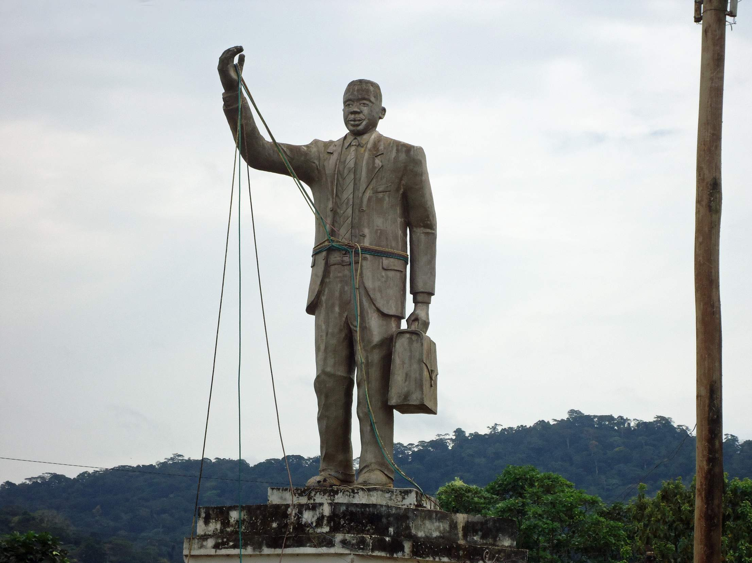
A statue of Ruben Um Nyobè in Cameroon, his hand raised as if speaking.
DID YOU KNOW?
His supporters called him “Mpodol” – the one who speaks for the people.

Key words
Key word | Meaning
Independence | a country ruling itself
Reunification | joining divided parts of a country back together
United Nations | an organisation where the world's countries meet
Banned | not allowed by law
Colony | a country controlled by another country

4. Activities
▶ MATCH IT — WRITE THE LETTER IN THE BOX
Key word | Letter | Meaning
Independence |  | A. an organisation where the world's countries meet
Reunification |  | B. a country ruling itself
United Nations |  | C. joining divided parts of a country back together
Banned |  | D. a country controlled by another country
Colony |  | E. not allowed by law

▶ PUT IT IN ORDER — NUMBER THE BOXES 1 TO 8
France bans the UPC
Born in the German colony of Kamerun
France admits responsibility for his death
Speaks at the United Nations in New York
Kamerun is split between France and Britain
Cameroon becomes independent
The UPC is founded in Douala
Killed by French soldiers

▶ TRUE OR FALSE? — CIRCLE ONE
1. Cameroon was once a German colony. | TRUE | FALSE
2. After the First World War, Cameroon was ruled by Spain and Portugal. | TRUE | FALSE
3. Um Nyobè spoke at the United Nations. | TRUE | FALSE
4. He became Cameroon's first president in 1960. | TRUE | FALSE
5. His party, the UPC, was banned by France. | TRUE | FALSE
6. For years it was forbidden to say his name in Cameroon. | TRUE | FALSE

▶ SPEECH TO THE UNITED NATIONS, 1952 — WRITE AS UM NYOBÈ
Explain to the world what the people of Cameroon want and why. Starters: “My name is… and I speak for…” “We want…” “It is unfair that…” “I ask the world to…”

5. Talk It Out
▶ TALK IT OUT — DISCUSS WITH A PARTNER OR GROUP
■ Why do you think the authorities banned people from talking about him?
■ He chose speeches and the UN rather than violence. Why might that have been powerful?
■ Why does it matter when a country admits it did wrong?
■ Who are the 'forgotten heroes' in your own family or community?

6. Reflection & Exit Ticket
▶ WHERE DO YOU STAND? — CIRCLE A NUMBER
“It matters when a country admits it did wrong in the past.”
1  Strongly disagree | 2  Disagree | 3  Not sure | 4  Agree | 5  Strongly agree

Because…

▶ CONFIDENCE CHECK — CIRCLE ONE
How confident do I feel about today's topic?
1  Not at all | 2  A little | 3  Getting there | 4  Confident | 5  Very confident

One thing I learned today:
Why should we remember Ruben Um Nyobè?

