BLACK HISTORY MONTH 2026
Lucius Amerson: The Sheriff Who Changed the South
Macon County, Alabama, 1966 – the first Black sheriff in the South since Reconstruction
STUDENT WORKSHEET · AGES 11–16 · 45–60 MINUTES
Name: |  | Date:

1. Learning Objectives
By the end of this session, I will be able to:
■ Explain why few Black people in Alabama could vote before 1965.
■ Describe how Lucius Amerson made history in 1966.
■ Read and explain election results.

2. Warm-Up
▶ DO NOW
Why does it matter who the police are in your area? Should they come from the community they serve?

3. Learn
Kept from voting
After slavery ended in the USA, some Black Americans in the South were elected as leaders – even as sheriffs. But from the late 1870s, unfair laws such as poll taxes and literacy tests stopped most Black people voting. By 1960, fewer than 1 in 10 Black adults in Alabama were registered to vote.
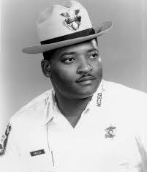
Lucius Amerson, sheriff of Macon County, Alabama.
A new law, a new sheriff
In 1965 the Voting Rights Act banned these tricks, and thousands of Black people in Macon County registered to vote. In 1966 Lucius Amerson, a former Army paratrooper, stood for sheriff – the elected head of the county's police. He promised to “protect and not oppress” and to give “fair and impartial law enforcement for black and white alike”. He won, becoming the first Black sheriff in the South for almost 90 years.
Twenty years on the job
He was sworn in in January 1967. Some white deputies refused to work for him, and he faced hostility from others in the justice system. But voters re-elected him four times, and he served for 20 years. In 2020 Alabama named a highway in Tuskegee after him.
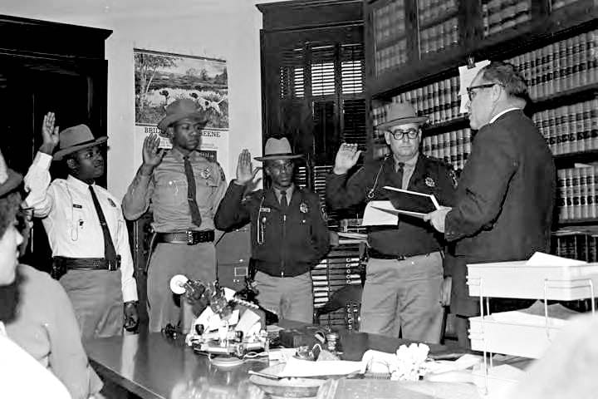
Lucius Amerson (left, in the white shirt) and his deputies take the oath from Probate Judge Preston Hornsby, January 1967.
DID YOU KNOW?
His badge and sunglasses are on display at the National Law Enforcement Museum in Washington, D.C.

Key words
Key word | Meaning
Sheriff | the elected head of law enforcement in a US county
Deputy | an officer who works for the sheriff
Election | a vote to choose who holds a job
Reconstruction | the years after the US Civil War when Black Americans briefly gained rights
Voting rights | the legal right to vote

4. Activities
▶ MATCH IT — WRITE THE LETTER IN THE BOX
Key word | Letter | Meaning
Sheriff |  | A. a vote to choose who holds a job
Deputy |  | B. the elected head of law enforcement in a US county
Election |  | C. an officer who works for the sheriff
Reconstruction |  | D. the legal right to vote
Voting rights |  | E. the years after the US Civil War when Black Americans briefly gained rights

▶ PUT IT IN ORDER — NUMBER THE BOXES 1 TO 8
Wins the general election in November 1966
Reconstruction ends and Black people in the South lose the vote
Retires after 20 years as sheriff
The Voting Rights Act becomes law
Lucius Amerson is born in Alabama
Sworn in as sheriff in January 1967
Serves in the US Army as a paratrooper
Wins the Democratic primary in May 1966

▶ READING THE RESULTS — USE THE TABLE TO ANSWER
Candidate (November 1966) | Votes | Share
Lucius Amerson | 3,868 | 64%
Harvey Sadler (sitting sheriff) | 2,002 | 33%
Bob Dawson | 149 | 2%

a) How many votes did the winner get?
b) What percentage of the vote did he get?
c) Compare the winner's votes with Harvey Sadler's.
d) Why could he win in 1966 but not ten years earlier?

▶ TRUE OR FALSE? — CIRCLE ONE
1. Amerson was elected in 1966. | TRUE | FALSE
2. Macon County is in Mississippi. | TRUE | FALSE
3. The Voting Rights Act helped Black people in Alabama register to vote. | TRUE | FALSE
4. He served only one term as sheriff. | TRUE | FALSE
5. Some white deputies refused to work with him. | TRUE | FALSE
6. Before becoming sheriff he was a teacher. | TRUE | FALSE

▶ MY CAMPAIGN SPEECH — WRITE AS AMERSON IN 1966
Ask the people of Macon County to vote for you. Starters: “My name is…” “If you elect me, I will…” “I will protect…” “Vote for me because…”

5. Talk It Out
▶ TALK IT OUT — DISCUSS WITH A PARTNER OR GROUP
■ Why do you think it took almost 90 years for the South to have another Black sheriff?
■ He promised to “protect and not oppress”. What is the difference?
■ Why would some deputies refuse to work for him? How might that have felt?
■ In the UK, Police and Crime Commissioners are elected. Should more people vote in those elections?

6. Reflection & Exit Ticket
▶ WHERE DO YOU STAND? — CIRCLE A NUMBER
“The police should reflect the community they serve.”
1  Strongly disagree | 2  Disagree | 3  Not sure | 4  Agree | 5  Strongly agree

Because…

▶ CONFIDENCE CHECK — CIRCLE ONE
How confident do I feel about today's topic?
1  Not at all | 2  A little | 3  Getting there | 4  Confident | 5  Very confident

One thing I learned today:
One reason Amerson's win mattered:

