BLACK HISTORY MONTH 2026
Taste of Heritage: National Dishes
Exploring African and Caribbean food and the stories behind it
STUDENT WORKSHEET · AGES 11–16 · 45–60 MINUTES
Name: |  | Date:

1. Learning Objectives
By the end of this session, I will be able to:
■ Match at least five national dishes to their countries.
■ Explain the story behind at least one dish, such as soup joumou or jollof rice.
■ Describe how food links to culture, history and identity.
2. Warm-Up
▶ DO NOW
What is your favourite meal? Is there a dish your family cooks for special occasions?

3. Learn
Jollof rice: West Africa's famous dish
Jollof rice is cooked in a spicy tomato, pepper and onion sauce. It is thought to come from the Wolof people of Senegal and the Gambia, and it is now loved across West Africa. Ghana and Nigeria have a famous, friendly rivalry over who makes the best jollof.
Recognised by UNESCO
UNESCO lists some traditions as 'intangible cultural heritage' to protect them. Senegal's thieboudienne (ceebu jën), a dish of fish, rice and vegetables, was added in 2021. So was Haiti's soup joumou, a squash soup. Couscous, shared by Algeria, Mauritania, Morocco and Tunisia, was added in 2020.
Soup joumou: the taste of freedom
Before independence, many enslaved people in Haiti were not allowed to eat soup joumou. When Haiti became the first free Black republic on 1 January 1804, people ate it to celebrate freedom. Haitians still eat it every New Year's Day.
From Africa to the Caribbean
Many Caribbean dishes have African roots. Jamaica's national dish, ackee and saltfish, uses ackee, a fruit brought from West Africa in the 1700s. Barbados has cou-cou (made from cornmeal and okra) with flying fish. Ethiopia's injera is a spongy flatbread made from a grain called teff, eaten with stews such as doro wat. You tear off a piece of injera and use it to scoop up the food.
Map
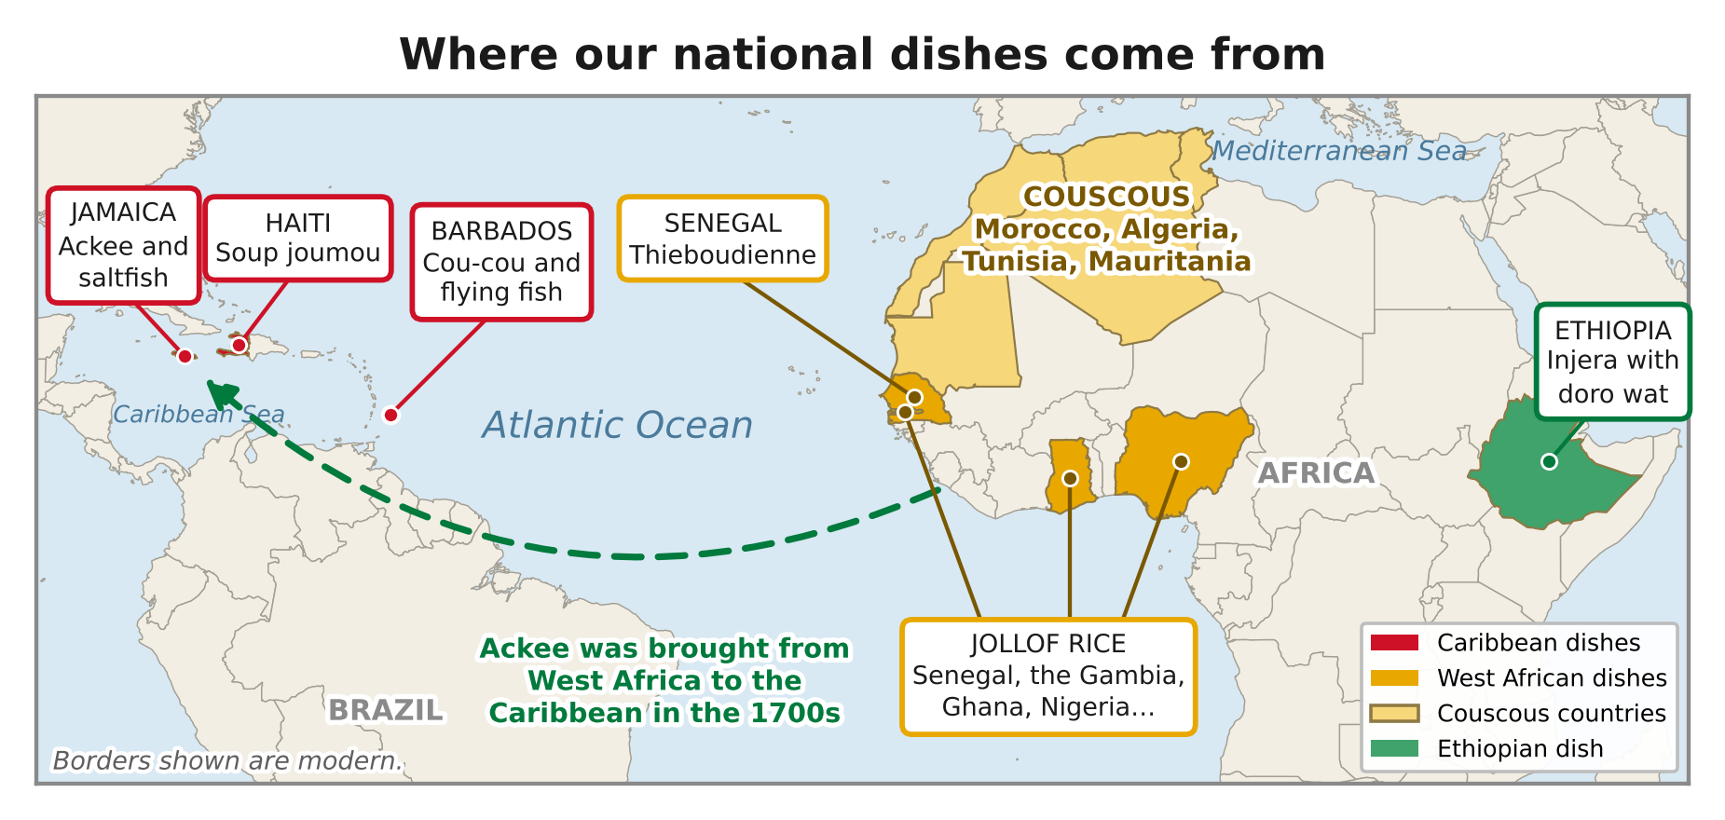
Where the dishes in this session come from, and how ackee travelled from West Africa to the Caribbean.
DID YOU KNOW?
22 August is World Jollof Rice Day.

Dish | Country | Main ingredients
Jollof rice | West Africa (Senegal, Ghana, Nigeria…) | Rice, tomato, pepper, onion
Ackee and saltfish | Jamaica | Ackee fruit, salted cod
Injera with doro wat | Ethiopia | Teff flatbread, spicy chicken stew
Thieboudienne | Senegal | Fish, rice, vegetables
Soup joumou | Haiti | Squash, beef, vegetables
Cou-cou and flying fish | Barbados | Cornmeal, okra, fish

Key words
Key word | Meaning
National dish | a dish strongly linked to a country's identity
Heritage | traditions passed down from earlier generations
UNESCO | a United Nations organisation that protects culture and heritage
Staple | a main food eaten regularly, such as rice or maize
Diaspora | people living away from their ancestors' homeland

4. Activities
▶ MATCH IT — WRITE THE LETTER IN THE BOX
1. Ackee and saltfish |  |  | A. Haiti
2. Injera |  |  | B. Jamaica
3. Thieboudienne |  |  | C. Barbados
4. Soup joumou |  |  | D. Senegal
5. Cou-cou and flying fish |  |  | E. Ethiopia

▶ TRUE OR FALSE? — CIRCLE ONE
1. Soup joumou is eaten in Haiti on New Year's Day to celebrate independence. | TRUE | FALSE
2. Injera is made from a grain called teff. | TRUE | FALSE
3. Ackee first grew in Jamaica. | TRUE | FALSE
4. Couscous is shared by several North African countries. | TRUE | FALSE
5. Jollof rice is only eaten in one country. | TRUE | FALSE

▶ FILL THE GAPS — USE THE WORD BANK
freedom | teff | UNESCO | Wolof | Ghana

1. Jollof rice is thought to come from the ______________ people.
2. Nigeria and ______________ have a friendly rivalry over jollof.
3. Soup joumou is eaten to celebrate ______________.
4. Injera is made from a grain called ______________.
5. ______________ protects important cultural traditions.

5. Talk It Out
▶ TALK IT OUT — DISCUSS WITH A PARTNER OR GROUP
■ Why do you think food is so important to people's identity?
■ How has African and Caribbean food changed what people eat in Britain?
■ Is there a dish that tells a story about your family or community?

▶ ROLE PLAY — IN PAIRS
THE SCENE: A food critic visits a restaurant serving a national dish from this session.
PERSON A  The chef: choose a dish. Describe how it is made and the story behind it, and persuade the critic it's the best. | PERSON B  The critic: ask about the ingredients and history, then give it a score out of 10 with reasons.

6. Reflection & Exit Ticket
▶ WHERE DO YOU STAND? — CIRCLE A NUMBER
“Learning about food is a good way to learn about history.”
1  Strongly disagree | 2  Disagree | 3  Not sure | 4  Agree | 5  Strongly agree
Because…

▶ CONFIDENCE CHECK — CIRCLE ONE
How confident do I feel about today's topic?
1  Not at all | 2  A little | 3  Getting there | 4  Confident | 5  Very confident

One thing I learned today:

