BLACK HISTORY MONTH 2026
Walter Tull: Breaking Barriers
Footballer, soldier and one of the first Black officers in the British Army
STUDENT WORKSHEET · AGES 11–16 · 45–60 MINUTES
Name: |  | Date:

1. Learning Objectives
By the end of this session, I will be able to:
■ Describe the main events of Walter Tull's life.
■ Explain the barriers he faced and how he overcame them.
■ Reflect on what we can learn from his resilience.
2. Warm-Up
▶ DO NOW
Think of a time when something was hard but you kept going. What helped you?

3. Learn
Early life
Walter Tull was born in Folkestone, Kent, in 1888. His father was from Barbados and his mother was English. Both his parents died when he was a child, and at the age of nine he and his brother were sent to an orphanage in Bethnal Green, London.
Football
Walter was a talented footballer. In 1909 he signed for Tottenham Hotspur, becoming one of the first Black professional footballers in England. At an away game in Bristol he faced vile racist abuse from the crowd. He later moved to Northampton Town, where he was a popular player.
War
When the First World War began in 1914, Walter joined the Football Battalion. He fought in the Battle of the Somme. Army rules at the time said officers had to be of 'pure European descent', but Walter was promoted to officer (Second Lieutenant) in 1917, becoming one of the first Black officers in the British Army.
Legacy
Walter was killed in action in France on 25 March 1918, aged 29. His body was never found. He was recommended for the Military Cross for bravery but never received it. Today he is remembered with memorials in Northampton and Folkestone, and people are campaigning for his medal to be awarded.
Walter Tull at Tottenham Hotspur
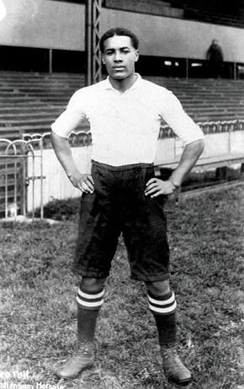
Walter Tull in his Tottenham Hotspur kit (about 1909)

DID YOU KNOW?
Walter's men tried to bring his body back under heavy fire because they respected him so much.

Barrier | How Walter responded
Losing both parents | Grew up in an orphanage and found football
Racist abuse from crowds | Kept playing with dignity
Army rules against Black officers | Became an officer anyway
War and danger | Led his men with courage

Key words
Key word | Meaning
Orphanage | a home for children whose parents have died or cannot care for them
Battalion | a large group of soldiers
Officer | a soldier who leads and gives orders to others
Resilience | the ability to keep going and recover from setbacks
Military Cross | a medal for bravery in battle

4. Activities
▶ PUT IT IN ORDER — NUMBER THE BOXES 1 TO 5
Walter signs for Tottenham Hotspur (1909)
Walter is killed in France (1918)
Walter is born in Folkestone (1888)
Walter becomes an army officer (1917)
Walter is sent to an orphanage

▶ TRUE OR FALSE? — CIRCLE ONE
1. Walter Tull's father was from Barbados. | TRUE | FALSE
2. Walter played for Tottenham Hotspur. | TRUE | FALSE
3. Army rules made it easy for Black men to become officers. | TRUE | FALSE
4. Walter received the Military Cross. | TRUE | FALSE

▶ QUICK QUIZ — TICK ONE ANSWER FOR EACH QUESTION
1. Which battle did Walter fight in?
☐ A. Hastings
☐ B. The Somme
☐ C. Waterloo
☐ D. Trafalgar

2. What does 'resilience' mean?
☐ A. Being the fastest
☐ B. Keeping going after setbacks
☐ C. Winning medals
☐ D. Being in charge

5. Talk It Out
▶ TALK IT OUT — DISCUSS WITH A PARTNER OR GROUP
■ What do you think kept Walter going when things were hard?
■ Why do you think he never received the Military Cross?
■ Footballers still face racist abuse today. What should happen when it occurs?

6. Reflection & Exit Ticket
▶ WHERE DO YOU STAND? — CIRCLE A NUMBER
“Walter Tull should be awarded the Military Cross now.”
1  Strongly disagree | 2  Disagree | 3  Not sure | 4  Agree | 5  Strongly agree
Because…

▶ CONFIDENCE CHECK — CIRCLE ONE
How confident do I feel about today's topic?
1  Not at all | 2  A little | 3  Getting there | 4  Confident | 5  Very confident

One thing I learned today:

