BLACK HISTORY MONTH 2026
Name the Flag
Can you recognise the flags of Africa and the Caribbean?
ANSWER SHEET · AGES 11–16 · 20–30 MINUTES
HOW TO RUN IT
Work in pairs or teams. Score 1 point per flag in Round 1, 2 points in Round 2 and 3 points in Round 3 (maximum 72), plus 1 point for each correct answer in Rounds 4 and 5. Tip: every flag in the quiz also appears on the border of the page, and the key on the last page of the Black History Month template names them all.

1. Round 1: Warm-Up (1 point each)
1.  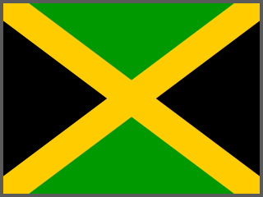  Jamaica | 2.  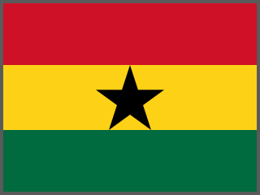  Ghana | 3.  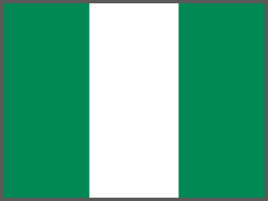  Nigeria | 4.  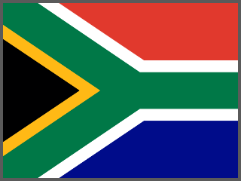  South Africa

5.  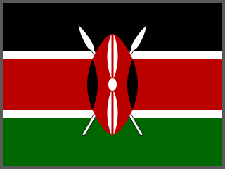  Kenya | 6.  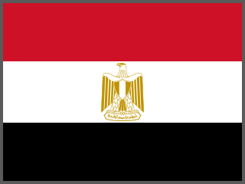  Egypt | 7.  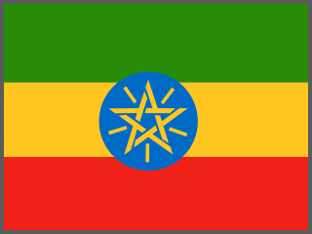  Ethiopia | 8.  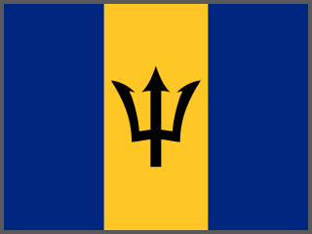  Barbados

9.  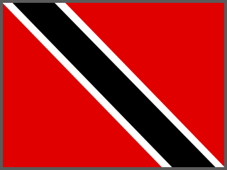  Trinidad and Tobago | 10.  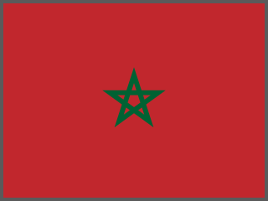  Morocco | 11.  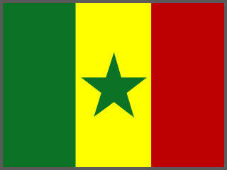  Senegal | 12.  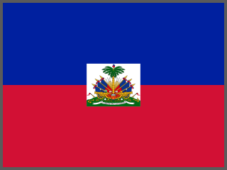  Haiti

2. Round 2: Getting Harder (2 points each)
13.  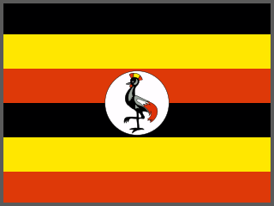  Uganda | 14.  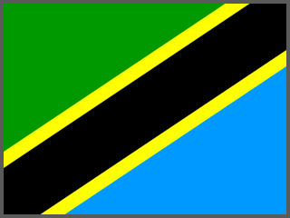  Tanzania | 15.  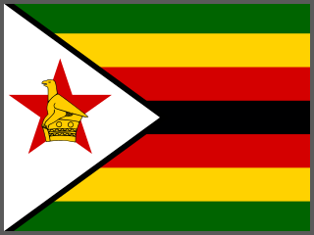  Zimbabwe | 16.  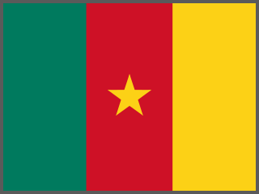  Cameroon

17.  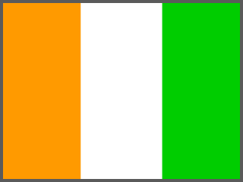  Côte d'Ivoire | 18.  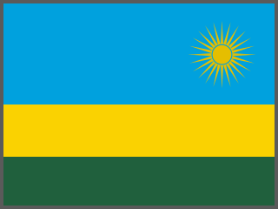  Rwanda | 19.  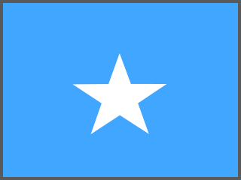  Somalia | 20.  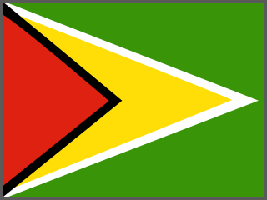  Guyana

21.  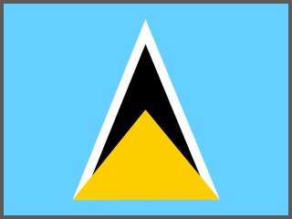  Saint Lucia | 22.  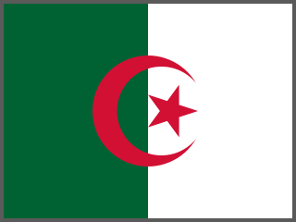  Algeria | 23.  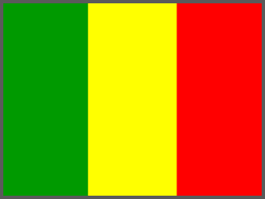  Mali | 24.  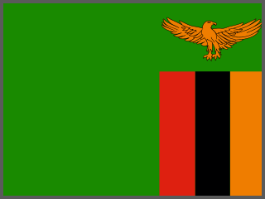  Zambia

3. Round 3: Expert Challenge (3 points each)
25.  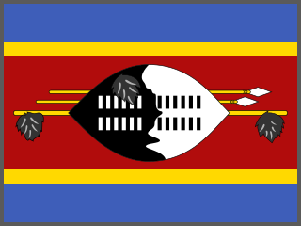  Eswatini  Shows a Nguni shield and two spears. | 26.  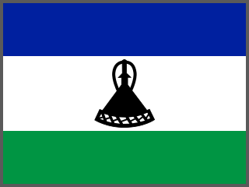  Lesotho  Shows a mokorotlo, a traditional Basotho hat. | 27.  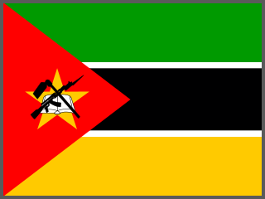  Mozambique  Includes a book, a hoe and a rifle. | 28.  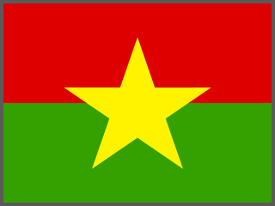  Burkina Faso  Its name means 'land of upright people'.

29.  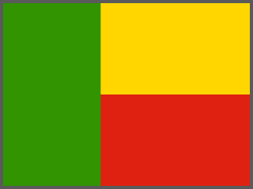  Benin  Uses the Pan-African colours. | 30.  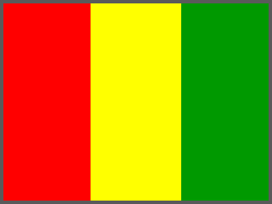  Guinea  Red, yellow, green, the reverse of Mali's flag. | 31.  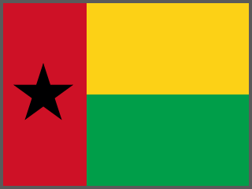  Guinea-Bissau  The black star stands for African unity. | 32.  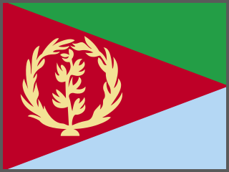  Eritrea  Shows an olive branch and wreath.

33.  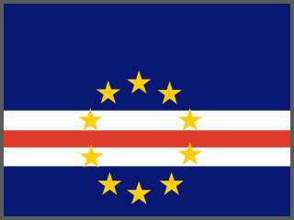  Cabo Verde  Ten stars for its ten main islands. | 34.  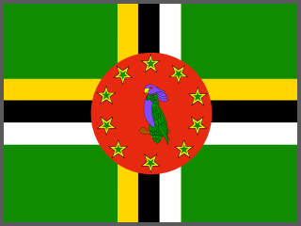  Dominica  Shows a Sisserou parrot, the national bird. | 35.  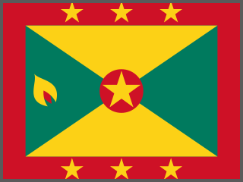  Grenada  Seven stars for its seven parishes. | 36.  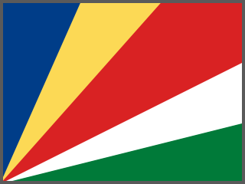  Seychelles  Five rays spreading from the bottom corner.

4. Round 4: Colour Detective
Many African flags use red, gold (yellow) and green. These are called the Pan-African colours, and they were inspired by the flag of Ethiopia. In 1957 Ghana became the first newly independent African country to use them on its flag.
Question | Answer
Which Round 1 flags use red, gold and green? | Ghana, South Africa, Ethiopia, Senegal (4 flags)
Which colour does Jamaica's flag use instead of red? | Black (with green and gold)

5. Round 5: Flag Facts
Statement | Answer | Why
1. Jamaica's flag has no red, white or blue in it. | TRUE | It is black, green and gold.
2. The black star on Ghana's flag is known as the 'Black Star of Africa'. | TRUE | Ghana's national football team is nicknamed the Black Stars.
3. Kenya's flag shows a traditional shield and two spears. | TRUE | A Maasai shield.
4. Barbados's flag shows a complete trident. | FALSE | The trident is broken, a symbol of breaking away from colonial rule.
5. Ethiopia's green, yellow and red inspired the colours of many African flags. | TRUE | These are called the Pan-African colours.

6. Discussion Points
■ Why do you think so many African flags share the same colours?
■ Mali, Guinea and Senegal have very similar flags. How can you tell them apart? (Senegal has a green star; Guinea's stripes run red-yellow-green; Mali's run green-yellow-red.)
■ What do symbols such as shields, spears, stars and birds tell us about a country's history and values?

