Lab 1: Installing and Running Eclipse

Objective:
Eclipse is open source software, mainly used as an Integrated Development Environment (IDE) and as a product base.

In this lab you will install and run Eclipse. Before you start installing it, the product must be downloaded from the www.eclipse.org site. After you have downloaded the file, you can proceed with the installation. Once the installation is completed, you will run Eclipse.

Lab:

Step 1: Download Eclipse
The software can be downloaded from the http://eclipse.org/downloads/index.php site. From this page choose the appropriate geographic region (North America for example), and choose the build you want to download. In most of the cases you will want to download the latest build. Click on the latest build and then choose the platform where you want to install the product.

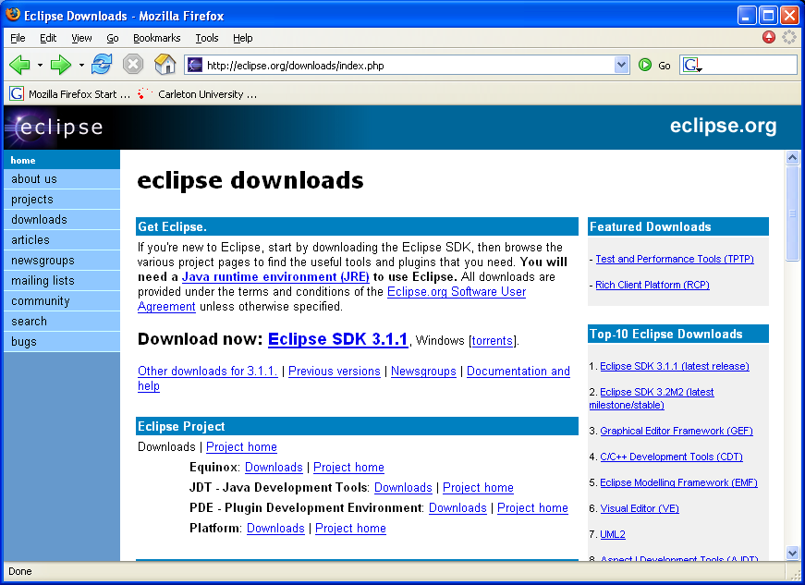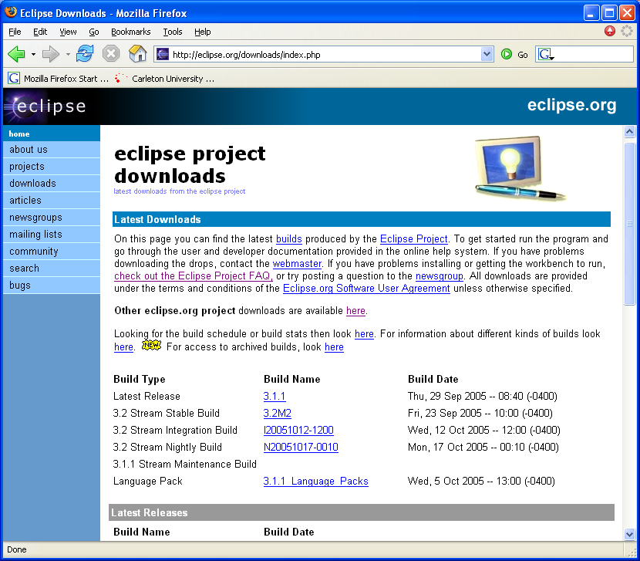

You will be prompted for what to do with the file. Choose to save the file to the local disk, and then specify the location for storing the file.

You have downloaded Eclipse at this point to your local machine.

Step 2: Install Eclipse
Once you have Eclipse downloaded to the local disk, you can proceed with the installation. The file you have downloaded is a ZIP file that contains entire Eclipse software. To install Eclipse, you simply unzip the downloaded file to the local disk, e.g. c:\ drive. Extracting the ZIP file to the c:\ drive will result in creating c:\eclipse directory that contains the Eclipse executable file (eclipse.exe).

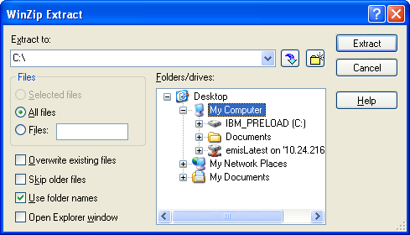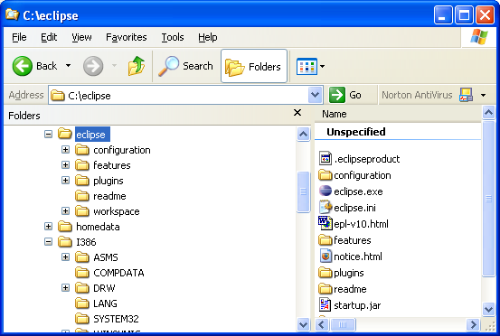

Step 3: Run Eclipse
Double-click on the eclipse.exe file to run Eclipse. As Eclipse is built in Java, the software requires a Java runtime environment (JRE) or a Java Development Kit (JDK) with a javaw.exe to run. If you don’t have the path set for javaw.exe a dialog with a message about missing JRE/JDK will come up.

In this case setup, make the JAVA_HOME environment variable point to your JDK installation directory. If you don’t have a JDK or a JRE installed on your local drive, you can find a JRE from the Eclipse download site (http://eclipse.org/downloads/index.php )

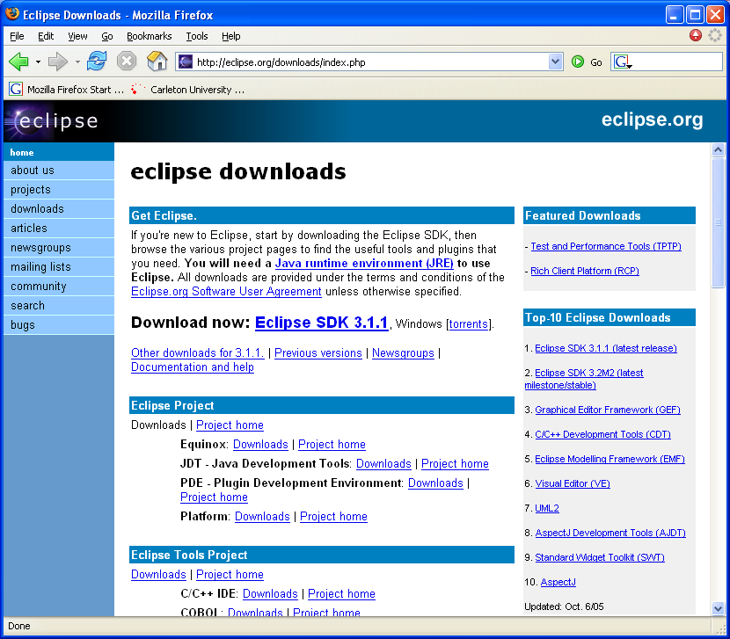

Once you have the JRE installed locally, you can setup the JAVA_PATH environment variable if it hasn’t done so for you.

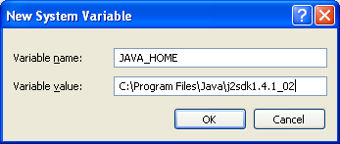

After you have JAVA_PATH in place and double-click on eclipse.exe file, the installation will complete by prompting for creation of the workspace directory (default workspace directory is under the install directory, e.g., c:\eclipse\workspace) and the Workbench will appear.

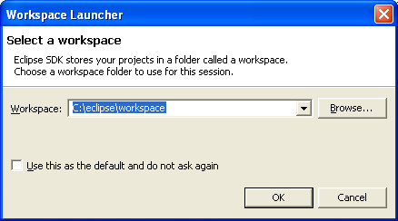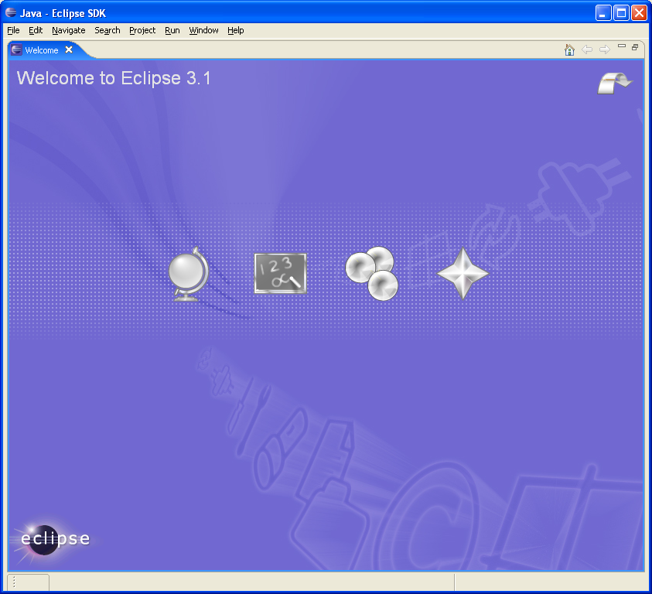

Summary:
In this lab you have installed and run Eclipse.

Lab 02: Setting Up the Lab Environment

Objective:
In this lab you will be working on the Code Rally game (the game can be downloaded from http://www.alphaworks.ibm.com/tech/coderally), an Eclipse plug-in that will be used as the lab’s base. In particular you will be developing Java code that represents a car and controls the car, and than you will customize the plug-in with some extra features.

The Code Rally game allows you to build a car and test it locally against existing cars. Rally cars can move around on a track and obtain important information such as the location of various objects on the track and the current capabilities of other cars.

Cars can collide with other cars, throw things to distract other cars, and they can enter a protected mode to (temporarily) protect themselves from being hurt by other cars.
In this lab you will simply setup the environment for future labs, i.e., you will install the Code Rally plug-in into Eclipse environment.

Lab:

Step 1: Install Code Rally plug-in
Eclipse plug-ins are located under Eclipse’s installation \plugins\ directory. Installing plug-in in Eclipse really means copying appropriate plug-in files under that directory. Each plug-in has a directory under \plugins\ directory. The Code Rally plug-in comes as a ZIP file and installing it simply means unzipping the file to the \plugins\ directory.

Unzip the provided CodeRallyPkg.zip file into the plugins directory of Eclipse’s installation directory. After this action you should see the com.ibm.coderally directory under Eclipse’s plugins directory. For example, there will be a directory

c:\eclipse\plugins\com.ibm.coderally.

To be more compliant with the 3.1 release of Eclipse, rename the directory as follows:

c:\eclipse\plugins\com.ibm.coderally_1.1.1

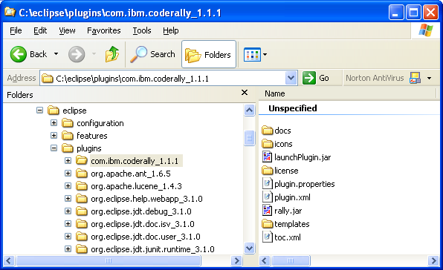

We need to set up a project for developing rally cars. The CodeRally plug-in directory contains a templates directory with source code (CodeRally and CodeWizards directories) for developing cars. Copy these directories from the templates directory to your workspace directory, e.g., the default workspace created under Eclipse’s installation directory, i.e. it is c:\eclipse\workspace.

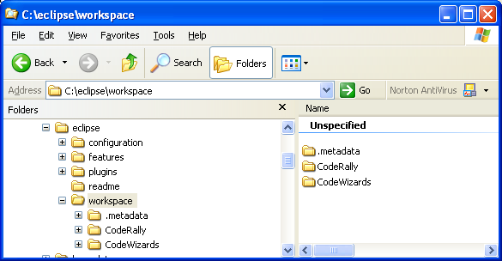

The new directories created in the workspace (c:\eclipse\workspace\CodeRally) will be the directory of a project that we will build in next lab when we start working on a rally car.

Close the Eclipse environment if it is already open and restart Eclipse. A restart will force the environment to pick up the newly installed plug-in. Click on the Workbench icon (located in the top-right corner) will open the Resource perspective (default one to open when Workbench starts up). The toolbar items for Code Rally game will show up.
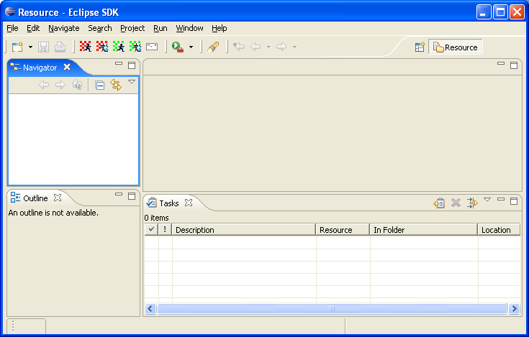

Now you are ready to start working on a car class.

Summary:
In this lab you have installed Eclipse plug-in required for running the game.

Lab 03: Building and Running a Java Application

Objective:
In this lab you will implement the RallyCar class that you will use to race against other cars. The game itself provides a framework that you will extend by adding details to the car you are building. Lab instructions contain modifications of the most important details from the game’s documentation. For the full documentation, refer to manual in the CodeRally’s plug-in directory ( ..\eclipse\plugins\com.ibm.coderally_1.1.1\docs\manual.html). The game’s documentation is also available from Eclipse help menu, i.e., through the Help Contents menu option. There is also number of rules associated with the car class. Here are the most important ones:

- You are not permitted to create constructors for your Cars or use static initialization blocks
- Your Car should not create any threads.
- It is ok to use System.out.println() to display information in the console, from your Car class.
- Your Car’s move operation is time limited.
- Running the simulation in Java debug mode causes all move and initialization time limits to be automatically turned off.

Lab

Step 1: Define the RallyCar class
Create a CodeRally Java project within Eclipse. The project’s content already exists in the user’s file system as it was created in the previous lab by you. Once you create the actual Eclipse project the default implementation from the directory structure will be brought to Eclipse environment. This default implementation includes the implementation of the RallyCar class. The class is defined in the default package.

There are four method stubs in the Car class that you must complete to identify your car:

- getSchoolName()
- getName()
- getColor()
- inialize()

Do not do any computations other than returning values in the first three methods. Please see the CodeRally documentation (..\eclipse\plugins\com.ibm.coderally_1.1.1\docs\manual.html) for what you must specifically return and do in these methods.

Step 2: Code the move() method
Implement your Car’s move() method. See the CodeRally documentation for sample move methods and details you must complete.

Step 3: Run the car
Once you have finished coding of the move() method you can run your car locally against some sample cars. Click on the Run the private track button from the Code Rally’ toolbar.

The game will start and you will be prompt to choose an opponent to run against. The following are sample cars.

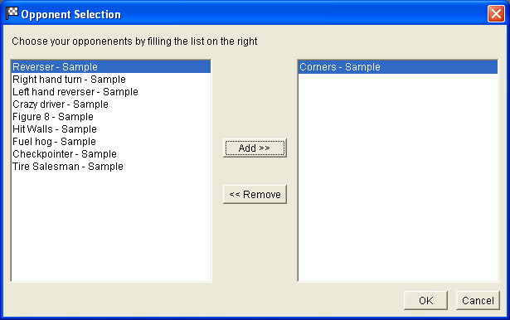

After choosing the opponents for the game, you will see how your car performs against other cars. You can make modifications to your car to improve its performance and run the game again after that.

Summary:
In this lab you have implemented your car and run it against some example cars.

Lab 04: Using JUnit

Objective:
In this lab you will write some unit tests for testing the car class that you’ve coded in the previous lab. The unit testing is usually done at the class level. The open source testing framework JUnit, which is part of the Eclipse platform, is mainly used for the unit testing. The Eclipse platform also provides wizards for creating unit tests.

During this lab you will create some test cases and you will also create a test suite that groups test cases together and allows testing at the higher level, i.e. allows testing of multiple test units at the same time.

Step 1: Set-up the lab
Test cases are usually stored in a package separate from the code. For the exercise purpose you will define test classes in the same package as RallyCar class (default package, as Code Rally looks there for a car class) but keep in mind that in reality you would probably have these classes split in different packages.

Step 2: Write the test case
Create a new test case for the RallyCar class you have defined in the previous lab. Do this by selecting the default package and select the context menu New -> JUnit TestCase.

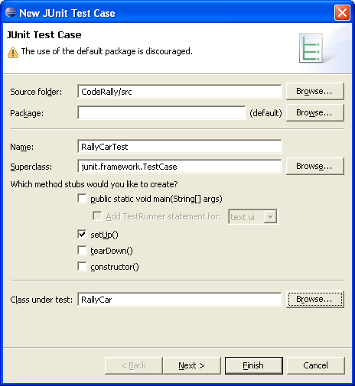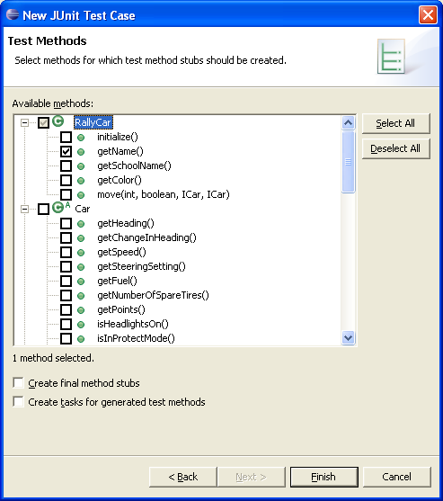

Call the TestCase RallyCarTest. Have the setUp() method defined for the class and also choose getName() method for testing in the wizards.

Because you’re testing the behavior of the RallyCar class in this test case, you need to have a reference to an instance of this class. Define the field car of type RallyCar (class you’ve build in the previous lab) in the test case class.

In the setUp() method of the test case class assign a new instance of the RallyCar class to the car field. The method will run when test case runs.
In the testGetName() method of the test case write the test criteria for testing the car name. You can write assertEquals(car.getName(),"xxx"); where “xxx” is the name of your car.

Step 3: Run the test case
Select the test case class in the Workbench and choose Run -> Run As -> JUnit Test menu option. The test will run and test results will be displayed in the JUnit result view.

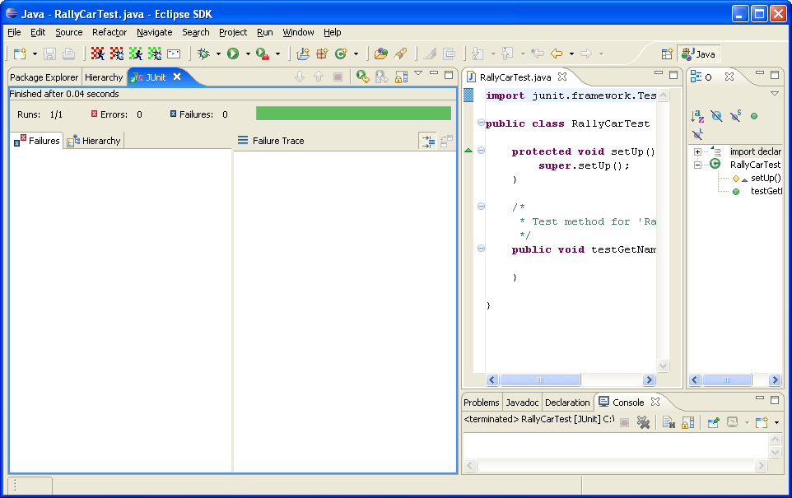

Change the testGetName() method in the test case class and have wrong car name in the test criteria. Run the test case again and the failure trace should come up in the JUnit result view.

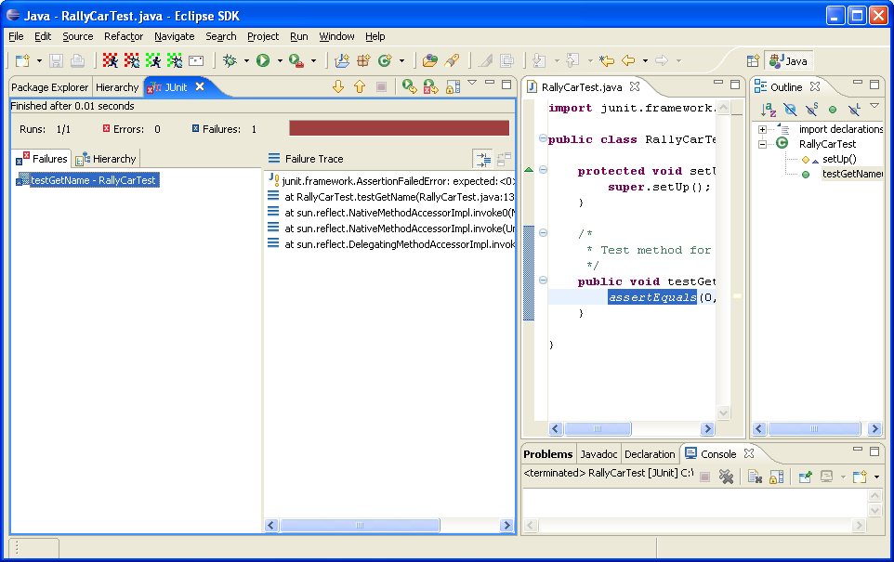

Step 4: Write another test case
Write another test case that will test different method of the RallyCar class. You will create another test class for the exercise purposes. In the reality you will probably test entire behavior of one class in a single test case class, i.e. you would have one test class per domain class. Repeat the set up for the new test case from the previous test case (creation of filed and initialization in the setUp() method). In the test case class write the code for testing the getSchoolName() method of the RallyCar class. Run the test case class.

Step 5: Write and run a test suite
Write a test suite that will contain both previously defined test case classes. The test suite is created by choosing File -> New -> Other… menu option and selecting JUnit and TestSuite from the wizard.

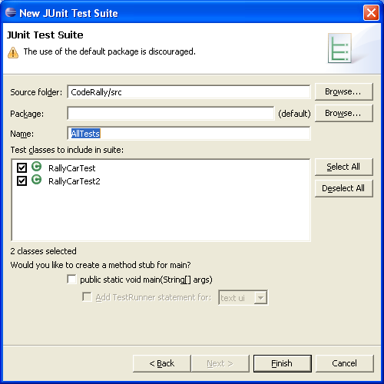

Run the test suite class the same way as you run the test cases classes. Both of the containing test case classes will run and all results will be displayed in the JUnit result view.

Summary:
In this lab, you have learned how to write and run JUnit test cases and test suites in Eclipse environment.

Lab 05: Debugging in Eclipse

Objective:
In this lab you will become more familiar with Eclipse Java Development Tools as you will be using some of the most commonly used tools, in particular the Debugger, the Scrapbook and the Inspector. These tools are very helpful when developing Java code. In this lab you will be stepping through the execution of the Java code that will be used later in the labs for reading results of running the Code Rally game. This code will be provided to you for using it in this lab, and you will execute the code from the Scrapbook and also use the Debugger to step through the execution.

Step 1: Set-up the lab
Create a new project and import (File system) the class CodeRallyScoreboard that is provided for this lab in the directory \Lab05\. Don’t just select the class file for the import. Select the \Lab05\ directory only. This selection will import the class and its package structure. This class contains code for reading the code rally results from the file that is automatically generated by the game.

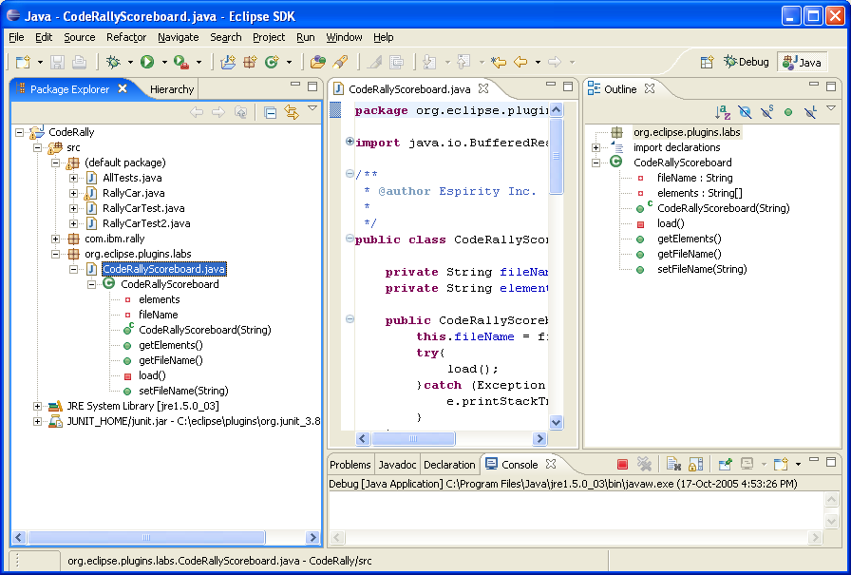

Step 2: Use the Scrapbook page and Inspector
An instance of the CodeRallyScoreboard is created using the constructor CodeRallyScoreboard (String). The parameter passed to the constructor is a name of the scoreboard file. The default file is in your workspace directory, e.g. ..\workspace\.metadata\.plugins\com.ibm.coderally_1.1.1\scoreboard.txt and is created during the code rally game. When an instance of the class is created a load() method is called, and in this method the scoreboard file is read and elements array of the scoreboard object populated. This array contains information that can be used later for displaying game results in a separate view.

Create a new Scrapbook page in the current project (File -> New -> Scrapbook Page). Type in the code for creating new instance of the CodeRallyScoreboard class, and than send the message getElements() to that instance. Highlight the code and choose Inspect from the context menu. You should get the result similar to the picture below:

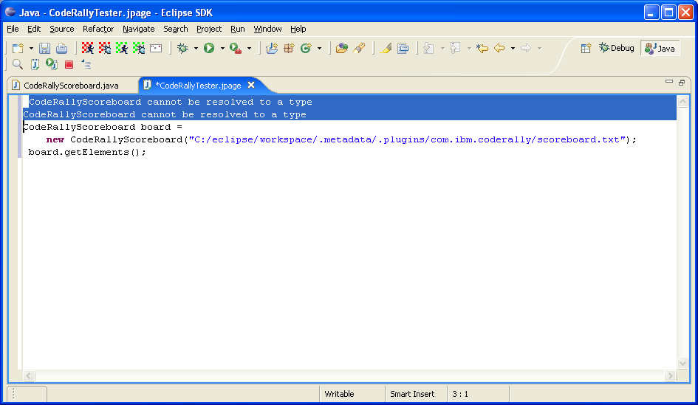

The highlighted lines were added after code execution. Why type CodeRallyScoreboard cannot be resolved? Well, the code is running outside of the context of package that contains our class, so we need to use full class qualifier in the scrapbook. Instead of adding package qualifier to the class, you can set imports for the page by choosing Set Imports from the context menu on the page, and than choose the packages you use in the code on the page.

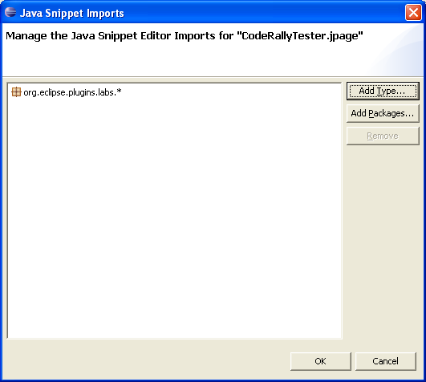

Highlight the code again and inspect it again. The expression view comes up displaying the array of strings that is returned from the getElements() method of the CodeRallyScoreboard.

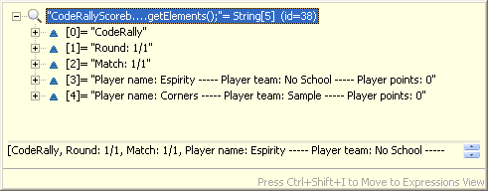

Expend objects contained within the array and look at their details.

Step 3: Use the Debugger
Set up the breakpoint in the constructor of the CodeRallyScoreboard class. Execute the code from the scrapbook page again. The execution should stop at the breakpoint. Step through the method until you get to the load() method. Step into this method and than step through the method and observe values for the variables in the Variables view.

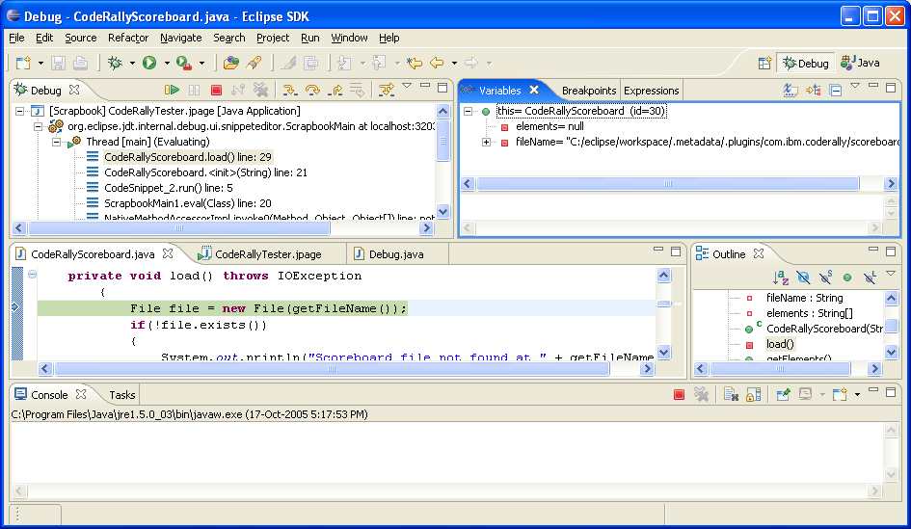

Go through the entire method and Resume the execution at the end.

Summary:
In this lab you have used some of the most important Eclipse Java Development Tools, including the Debugger, the Inspector and the Scrapbook.
Lab 06: Exploring the Plug-ins Directory

Objective:
In this lab you will explore the plug-in directory and learn what pieces the directory consists of. In the previous labs we have already installed the plug-in for the Code Rally game. In this lab you will look at this directory and identify individual pieces required by the plug-in to run.

Step 1: Locate the plug-in directory
Find the com.ibm.coderally_1.1.1 plug-in directory located under the platform’s \plugins\ directory.

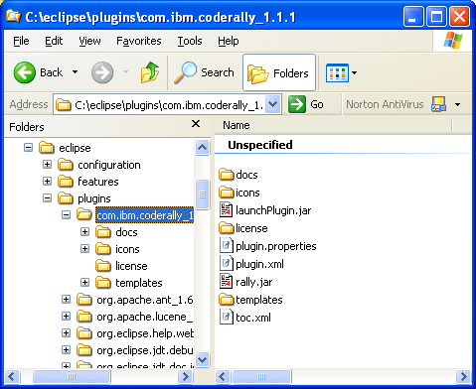

Step 2: Identify the plug-in structure
Find all the files required to run the plug-in. Answer the following questions:
- In which file is the plug-in defined?
- Which file(s) contain the code for running the plug-in?
- Where are the icons used by the plug-in stored?
- What is the plug-in property file used for?
- What is the \docs\ sub-directory used for? Is toc.xml file used for the same purpose? Open the Eclipse help to find answers on these questions.

The answers on these questions are at the Appendix, end of the lab guide.

Summary:
In this lab you have explored the plug-in directory and you have identified files required to run a plug-in.

Lab 07: Adding Menus to the Workbench

Objective:
In this lab you will extend the Workbench with Code Rally menus. Menus should duplicate functionality of the Code Rally toolbar buttons. In other words, you will add one top-level menu with five different menu options that could be used for running game in private and public modes, for debugging it in private and public modes, and for submitting the code. When you finish this lab you should be able to use game controls either from the toolbar or from the pull-down menu.

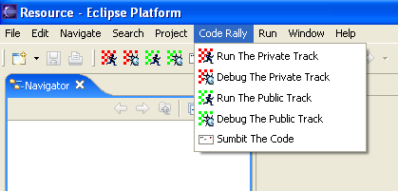

There are two different approaches for accomplishing this lab:

- Modifying existing code rally plug-in, which would require modification of the existing plug-in manifest file
- Creating new plug-in that will reuse code for controlling the game from existing code rally plug-in

We will use the second approach, as it will get us through the entire process of creating, installing and running new plug-in.

Step 1: Create a new project
Create project CodeRallyExtension in Eclipse Workbench. In the project’s properties add JAR files org.eclipse.jface_3.1.0.jar, org.eclipse.swt_3.1.0.jar, org.eclipse.core.runtime_3.1.0.jar, org.eclipse.ui.workbench_3.1.0.jar, org.eclipse.swt.win32.win32.x86_3.1.0.jar and launchPlugin.jar to the project build path. Also, copy the \icons\ directory from the original plug-in to the project.

When you create project that contain plug-in as a regular Java project, its output folder must be CodeRallyExtension\bin so that the code for running the perspective can be found in the running Workbench instance when testing the plug-in (you will do this in later steps). The output folder can be changed from project property window. If you created the project as default plug-in project, that will be the default output folder, and there is no need to change it.

Step 2: Define plug-in manifest files
Define new plug-in manifests file (META-INF/MANIFEST.MF and plugin.xml) in the new project. The plugin.xml file will contain details on what menu extensions should be added and what should be executed when menu items are chosen run-time. The manifest.mf contains the following:

Manifest-Version: 1.0
Bundle-ManifestVersion: 2
Bundle-Name: Code Rally Extension
Bundle-SymbolicName: org.eclipse.plugins.labs.coderally; singleton:=true
Bundle-Version: 1.0.0
Bundle-Vendor: Espirity
Bundle-Localization: plugin
Require-Bundle: com.ibm.coderally,
org.eclipse.ui.workbench,
org.eclipse.swt,
org.eclipse.jface,
org.eclipse.ui
Eclipse-AutoStart: true

The plugin.xml contains the following:

- Extension points. There should be only one extension for the actions set, which will require id, and label attributes. Also define the attribute visible, which will indicate if the plug-in should be visible initially, and set the attribute to false. Action set should define one top-level menu with five menu items. The menu should have id, label and separator attributes defined. Menu items can simply be defined under menu as group markers, for example:

<menu id="org.eclipse.plugins.labs.coderally.actions.menu"
label="Code Rally" path="additions">
<separator name="coderally" />
<groupMarker name="runPrivateTrack" />
<groupMarker name="debugPrivateTrack" />
<groupMarker name="runPublicTrack" />
<groupMarker name="debugPublicTrack" />
<groupMarker name="submitCode" />
</menu>

- After defining the menu (with menu items, i.e. group markers), you will have to define actions to point to individual menu item. In other words, you have to define which action and corresponding class should be executed after each menu item is chosen. Specify org.eclipse.plugins.labs.coderally.actions.TestAction as action delegate class. You will define class details in the next step. In the new plug-in manifest file the action is defined like the following:

<action
id="org.eclipse.plugins.labs.coderally.actions.runprivate"
menubarPath="org.eclipse.plugins.labs.coderally.actions.menu/runPrivateTrack"
label="Run The Private Track"
icon="icons/run.gif"
class="org.eclipse.plugins.labs.coderally.actions.TestAction">
</action>

In this example, the menubarPath attribute points to the menu item (group marker) defined under the menu element while icon and class attributes are taken from the Code Rally’s original manifest file and represent icon that appears in the menu and class executed after menu item is clicked.

To find documentation on ActionSets, enter “platform extension points” into Eclipse’s Help facility. This will provide you with a list of extension points and their parameters.

Actions later refer to the classes that are defined in the launchPlugin.jar file of the code rally plug-in. Make sure the JAR file is added to the project’s build path.

Step 3: Define the action delegate class
Create a package org.eclipse.plugins.labs.coderally.actions and define a class TestAction in this package. This class is an action delegate class for the action defined in the manifest in the previous step. In the action delegate class behavior is defined in the run(IAction) method, which executed when action happens. In our case the method will run when the menu item is clicked. The method should look like the following:

public void run(IAction action)
{
Display display = Display.getDefault();
Shell shell = new Shell (display);
MessageDialog.openInformation(
shell,
"Test",
"Test Message");
}

Step 4: Modify the plug-in manifest
Considering that the action delegate class code uses the code from launchPlugin.jar file, which is part of the code rally plug-in, you will need to make this plug-in required for the new plug-in, so the JAR file can be found when the plug-in runs. To make this JAR file visible to other plug-ins you need to change its plugin.xml file for the original code rally plug-in to include the code:

<runtime>
<library name="launchPlugin.jar">
<export name="*"/>
</library>
</runtime>

Add <groupMarker> and <action> pairs for other menu options that correspond to the toolbar actions of the code rally plug-in. Instead of defining new action delegate classes for each menu action you can simply reuse action classes used by the code rally plug-in toolbar actions. For completing this you can open the plug-in manifest file from the original code rally plug-in and refer to the actions used in that file. For example the manifest file could contain the code like following:

<menu
…
<groupMarker
name="debugPrivateTrack">
</groupMarker>
…
</menu>

<action
id="org.eclipse.plugins.labs.coderally.actions.debugprivate"
menubarPath="org.eclipse.plugins.labs.coderally.actions.menu/debugPrivateTrack"
label="Debug The Private Track"
icon="icons/debug.gif"
class="com.ibm.jgfw.plugin.TestDebugAction">
</action>
…

Step 5: Test the plug-in
One the plug-in is developed click on the Run -> Run As -> Eclipse Application menu option. This will a launch new instance of the Workbench with plug-ins from the development environment in it. You can also select Run -> Run…
and enter properties for your run configuration.

The visible attribute for the action set may be set to false, and the plug-in won’t be visible when environment starts-up. Select Window -> Customize Perspective… from the pull-down menu and enable plug-in.

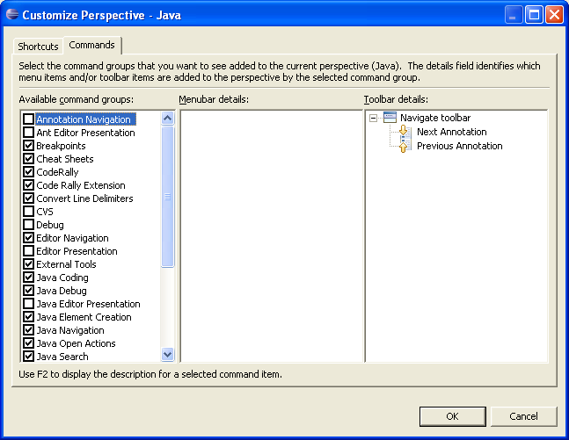

The top-level menu Code Rally with its menu option will appear in the Workbench window.

To test if plug-in menu options work you actually need to import the CodeRally project into the runtime Workbench. Copy the project from the \workspace\ directory into \runtime-workspace\ directory.

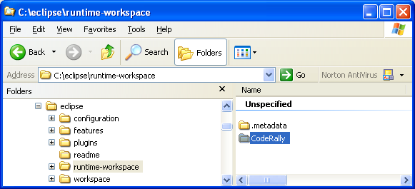

Once the project is there, choose File -> Import… and than Existing Project into Workspace option from the runtime Workbench and import the CodeRally project. Click on menu items will test the plug-in code.

Step 6: Install and run the plug-in

Create a build.properties file with the following content:

source.. = src/
output.. = bin/
bin.includes = plugin.xml,\
META-INF/,\
.,\

icons/

Export the project using the Deployable plug-ins and fragments export option. Identify the archive file location in the wizard.

To run the new plug-in, unzip the produced archive zip file into an installed Eclipse plugins directory and start Eclipse. Your plug-in should work as it did in the Runtime Workspace testing.

Summary:
In this lab you have implemented your first plug-in that extends the Workbench with a menu for manipulating code rally game.

Lab 08: Adding Views to the Workbench

Objective:
In this lab you will extend the Code Rally game within the Workbench with a view that will display the results of the latest game played.

The code for displaying results will be provided to you and you will be developing a plug-in with a view that will use this code. After you finish this lab there should be a view that displays game’s results:

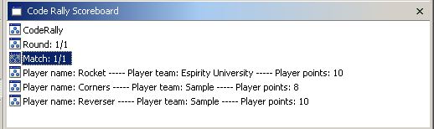

Lab

Step 1: Create new plug-in project with a view
Using Eclipse’s wizards for a plug-in with a view, create new a PDE plug-in project (CodeRallyScoreboard) that will contain the view (CodeRallyScoreboardView).
Specify org.eclipse.plugins.labs as Java package name on the Main View Settings page. The view class will be created in this package. When creating the view there are two different options for showing the content in the view: table viewer and tree viewer. In the above picture a table viewer was chosen. Also, when going through the wizard you will have an option of choosing what actions and menus the view should contain. Considering that the view is designed to simply display game results, all these options can be turned off.

After the plug-in project with a view is created all the pieces needed for the plug-in will be in the project itself.

In next few steps you will simply look at some of these, and also add to the view code for displaying the game results, and than test the plug-in. At the end you will install and run the plug-in.
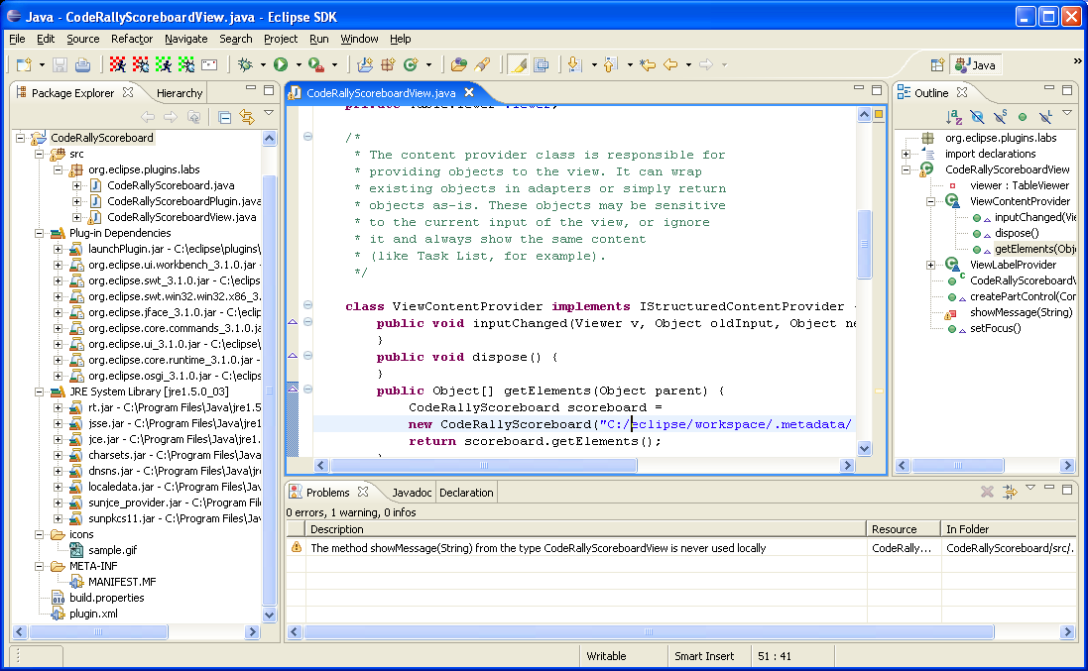

Step 2: Examine the manifest file
Double-click on the plug-in manifest.mf file to open it. All of the elements were created based on the inputs you specified in the plug-in wizard. Look at the elements that identify plug-in attributes. It should look similar to the following:

Bundle-SymbolicName: org.eclipse.plugins.labs; singleton=true
Bundle-Version: 1.0.0
Bundle-Vendor: Espirity
Bundle-Name: CodeRallyScoreboard
Bundle-Localization: plugin
Require-Bundle: com.ibm.coderally,
org.eclipse.ui.workbench,
org.eclipse.swt,
org.eclipse.jface,
org.eclipse.ui,
org.eclipse.core.runtime
Eclipse-AutoStart: true
Bundle-Activator: org.eclipse.plugins.labs.CodeRallyScoreboardPlugin

Look at the extensions in the plugin.xml file. Where is the extension you defined?

<extension
point="org.eclipse.ui.views">
<category
name="Code Rally Scoreboard Category"
id="CodeRallyScoreboard">
</category>
<view
name="Code Rally Scoreboard"
icon="icons/yourNewGifHere.gif"
category="CodeRallyScoreboard"
class="org.eclipse.plugins.labs.CodeRallyScoreboardView"
id="org.eclipse.plugins.labs.CodeRallyScoreboardView">
</view>
</extension>
</plugin>

The extension defined is identified as point attribute of the extension element. You can see that the package name you specified was used for the view class defined in the plugin.xml file..

Step 3: Add the code to the view
Import the CodeRallyScoreboard.java from the provided \Lab08\ directory into the same package where the view is defined. This class contains a code that reads the latest game results from the file that is generated by the game, and you will add this code to the view.

The CodeRallyScoreboard class defines a method getElements() that returns an array of String objects that can be used for displaying results in the view. Your CodeRallyScoreboardView class defines an inner class ViewContentProvider, responsible for generating view’s content. This class defines a method getElements() that returns an array of objects to be displayed in the view. In this method you can simply return elements from the CodeRallyScoreboard class:

public Object[] getElements(Object parent) {
CodeRallyScoreboard scoreboard =
new CodeRallyScoreboard("C:/eclipse/workspace/.metadata” +
“/.plugins/com.ibm.coderally/scoreboard.txt ");
return scoreboard.getElements();
}

The parameter passed to the constructor of the CodeRallyScoreboard class is the location of the file where game’s results are stored. The default location is used in the code above.

To refresh the view when game results change send the message refresh() to the viewer of the view in the setFocus() method:

viewer.refresh();

Step 4: Test the plug-in
To test the plug-in click on the Run -> Run As -> Eclipse Application menu option. This will launch a new instance of the Workbench containing all workbench plug-ins. When the new Workbench comes up use the Show View menu option to open the Scoreboard view:

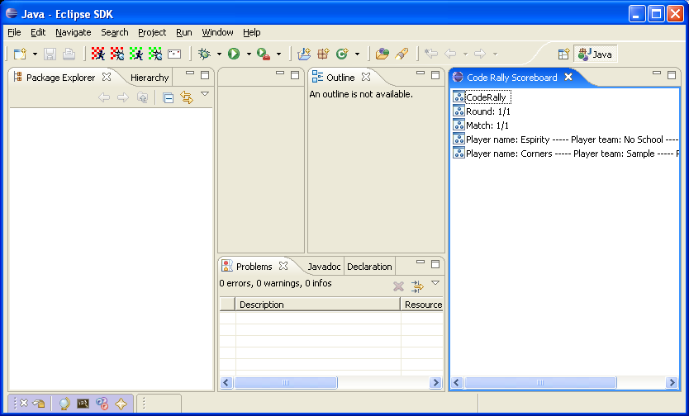

Step 5: Install and deploy the plug-in

Make sure the build.properties file has the following contents:

source.. = src/
output.. = bin/
bin.includes = plugin.xml,\
META-INF/,\
.,\

icons/

Export the project using the Deployable plug-ins and fragments export option. Identify the archive file location in the wizard.

To run the new plug-in, unzip the produced archive zip file into an installed Eclipse plugins directory and start Eclipse. Your plug-in should work as it did in the Runtime Workspace testing.

Summary:
In this lab you implemented a plug-in with a view that displays results of the Code Rally game.

Lab 09: Adding Perspectives to the Workbench

Objective:
In this lab you will extend the Workbench with a custom perspective that will contain views and editors related to the Code Rally game. The perspective can be used to code the game car and also view the results from running the game.

Lab

Step 1: Create a class that defines perspective layout
Create new PDE project in Eclipse that will contain code for the perspective you are adding. The initial perspective layout should be dictated by the code. Initially, the following views should be visible:

- Navigator view (view’s id is IPageLayout.ID_RES_NAV)
- Outline view (view’s id is IPageLayout.ID_OUTLINE)
- Scoreboard view (view’s id is as defined in the previous lab)

Also, you should be able to show additional views from the Show View menu option. These views include:

- Task view (view’s id is IPageLayout.ID_TASK_LIST)
- Properties view (view’s id is IPageLayout.ID_PROP_SHEET)
- Bookmarks view (view’s id is IPageLayout.ID_BOOKMARKS)

The layout should include a folder that contains views created left of the editor area. The editor area should be initially visible.

Hint: The class that defines perspective layout should implement the IPerspectiveFactory interface and the actual layout should be defined in the createInitialLayout(IPageLayout layout) method of this class. The resulting layout should be as on the picture below:

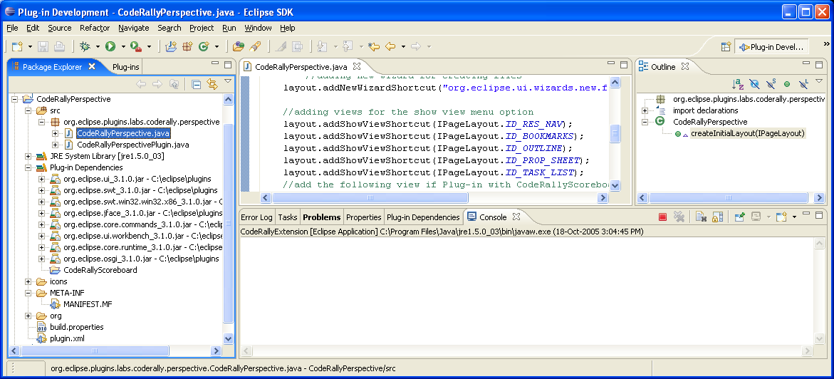

Step 2: Examine the manifest file
Double-click on the plug-in manifest.mf file to open it. All of the elements were created based on the inputs you specified in the plug-in wizard. Look at the elements that identify plug-in attributes.

Manifest-Version: 1.0
Bundle-ManifestVersion: 2
Bundle-Name: Code Rally Perspective
Bundle-SymbolicName: org.eclipse.demo.plugins.labs.coderally.perspective; singleton:=true
Bundle-Version: 1.0.0
Bundle-Localization: plugin
Require-Bundle: org.eclipse.ui,
org.eclipse.core.runtime,
org.eclipse.plugins.labs
Eclipse-AutoStart: true
Bundle-Vendor: Espirity
Bundle-Activator: org.eclipse.plugins.labs.coderally.perspective.CodeRallyPerspectivePlugin

Look at the extension in the plugin.xml file. Where is the extension you have defined? The extension point should be (org.eclipse.ui.perspectives) and include the perspective name, class (defined in the Step 1), id and icon. The icon will be provided by you in the next step.

Step 3: Create the plug-in’s icons and directory
Create an icons directory in your project. Copy any icons you identified in step 2 into this directory. For testing purposes, look at other Eclipse plugin directories for interesting icons to use. If you want, just import the \icons\ directory from the provided \Lab9\ directory into the project. You can import the directory by copying it into the project root directory within the Workbench.

Step 4: Test the plug-in
To test the plug-in click on the Run -> Run As -> Eclipse Application menu option. This will launch a new instance of the Workbench with plug-ins from the development environment in it. Select Window -> Open Perspective and when the dialog comes up select the CodeRallyPerspective and click OK.

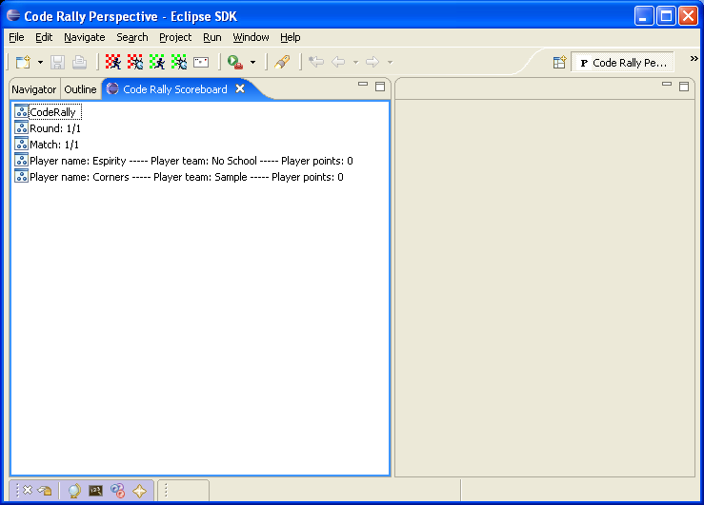

Step 5: Install and deploy the plug-in

Make sure the build.properties file has the following contents:

source.. = src/
output.. = bin/
bin.includes = plugin.xml,\
META-INF/,\
.,\

icons/

Export the project using the Deployable plug-ins and fragments export option. Identify the archive file location in the wizard.

To run the new plug-in, unzip the produced archive zip file into an installed Eclipse plugins directory and start Eclipse. Your plug-in should work as it did in the Runtime Workspace testing.

Summary:
In this lab you have implemented a plug-in with a perspective that contains the scoreboard view used for displaying results of the code rally game.

APPENDIX

Answers to the questions from Step 2 of the Lab 6
  - Plug-in is defined in the plugin.xml file. There is no manifest.mf file since this is the old, non-osgi technique of specifying plug-ins.
  - Code that actually runs plug-in is contained in the jar file, in this case that’s launchPlugin.jar file. If you open the plugin manifest file (plugin.xml) the library containing the code is specified under the <runtime><library> element.
  - Icons used by the plug-in are stored under the \icons\ directory. In the plug-in manifest file this directory is specified for the icon attribute when actions are defined.
  - Plug-in properties file is used for externalizing text from the plug-in. If you look at the manifest file, you will notice that instead of hard-coding strings in there, the file points to the keys from the properties file.
  - The \docs\ directory contains online documentation for the plug-in that is part of the Eclipse documentation. The toc.xml file specifies what topics are displayed in the Help content when Help runs.

We have provided solutions to the labs in Solutions.v3.1 download directory in ZIP format. To view the solutions in the Eclipse environment do the following:
  - Unzip the ZIP file for a solution into Eclipse's workspace directory
  - Click on Refresh from the project's context menu in Eclipse.

