Developing Java applications for Eclipse

Hands-on exercises

Lab 01: Installing and Running Eclipse

Objective:
Eclipse is open source software, mainly used as an Integrated Development Environment (IDE) and as a product base.

In this lab you will install and run Eclipse. Before you start installing it, the product must be downloaded from the www.eclipse.org site. After you have downloaded the file, you can proceed with the installation. One the installation is completed you will run Eclipse.

Lab:

Step 1: Download Eclipse
The software can be downloaded from the www.eclipse.org/downloads/index.php site. From this page choose the appropriate geographic region (North America for example), and choose the build you want to download. In most of the cases you will want to download the latest build. Click on the latest build and then choose the platform where you want to install the product.

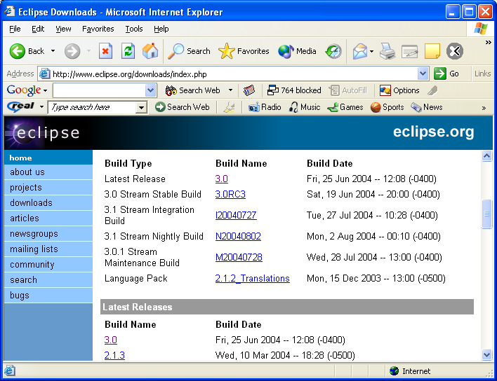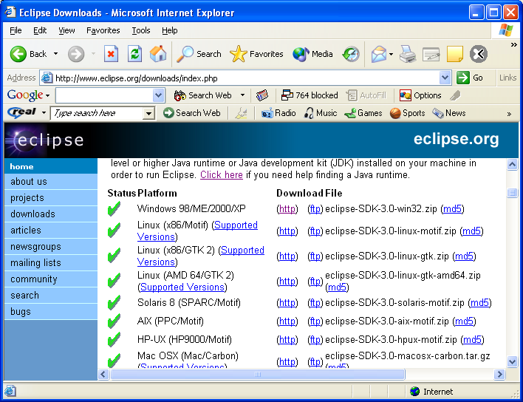

You will be prompted for what to do with the file. Choose to save the file to the local disk, and then specify the location for storing the file.

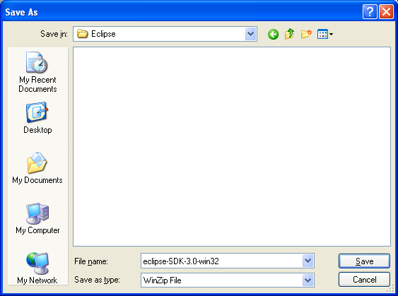

You have downloaded Eclipse at this point to your local machine.

Step 2: Install Eclipse
Once you have Eclipse downloaded to the local disk, you can proceed with the installation. The file you have downloaded is a ZIP file that contains entire Eclipse software. To install Eclipse, you simply unzip the downloaded file to the local disk, e.g. c:\ drive. Extracting the ZIP file to the c:\ drive will result in creating c:\eclipse directory that contains the Eclipse executable file (eclipse.exe).

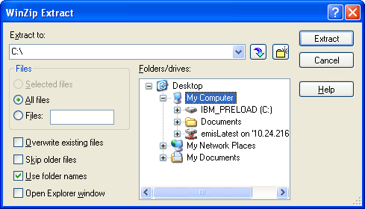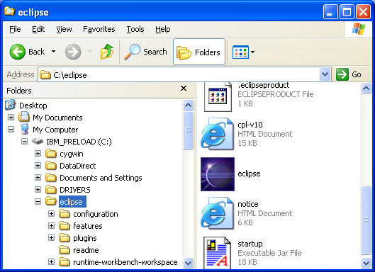

Step 3: Run Eclipse
Double-click on the eclipse.exe file to run Eclipse. As Eclipse is built in Java, the software requires a Java runtime environment (JRE) or a Java Development Kit (JDK) with a javaw.exe to run. If you don’t have the path set for javaw.exe a dialog with a message about missing JRE/JDK will come up.

In this case setup, make the JAVA_HOME environment variable point to your JDK installation directory. If you don’t have a JDK or a JRE installed on your local drive, you can find a JRE from the Eclipse download site (http://eclipse.org/downloads/index.php).

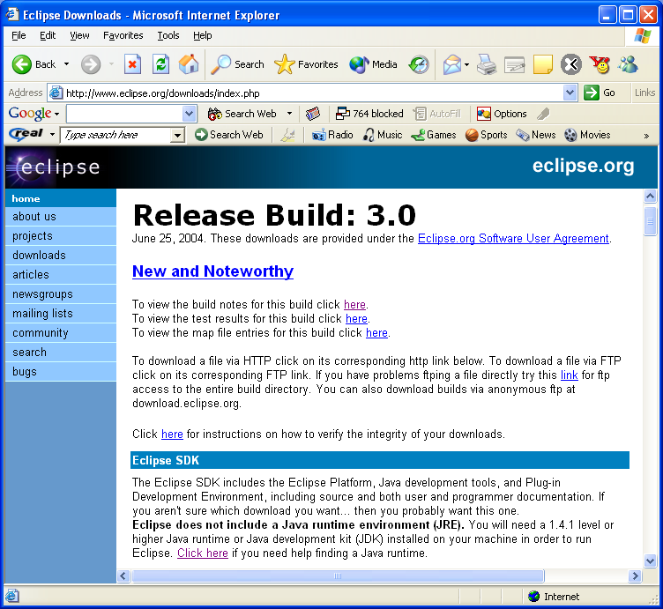

Once you have the JRE installed locally, you can setup the JAVA_PATH environment variable if it hasn’t done so for you.

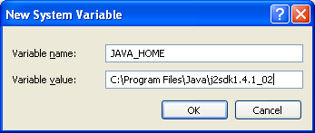

After you have JAVA_PATH in place and double-click on eclipse.exe file, the installation will complete by prompting for creation of the workspace directory (default workspace directory is under the install directory, e.g., c:\eclipse\workspace) and the Workbench will appear.

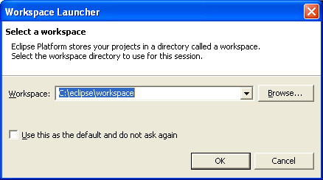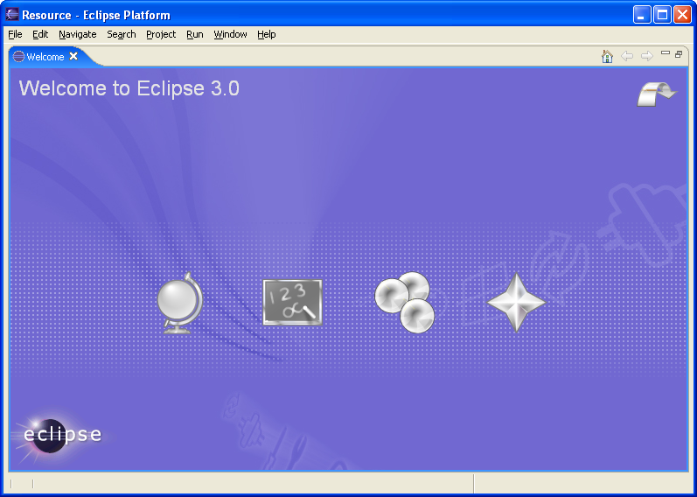

Summary:
In this lab you have installed and run Eclipse.

Lab 02: Object-Oriented Concept, Game of Life

Objective:
In this lab you will learn about the problem domain that you will be working on for the reminder of the labs. This lab will explain the rules of the Game of Life, which you will try to model. The Game of Life is one of the most well-known 2-dimensional cellular automations. It is not a real game, as there are no players, no winners, or losers. It is a game where the starting position and the rules determine everything that happens after that. More information on the game and its background can be found at http://www.math.com/students/wonders/life/life.html and http://mathworld.wolfram.com/CellularAutomaton.html links.
Rules of the Game of Life:
Life is played on a grid of square cells--like a chessboard -- extending infinitely in every direction. A cell can be live or dead.

A marker on a cell indicates a live cell. An empty cell indicates dead cell. Each cell in the grid has a neighborhood consisting of the eight cells in every direction including diagonals. To apply one step of the rules, count the number of live neighbors for each cell. What happens next depends on this number:
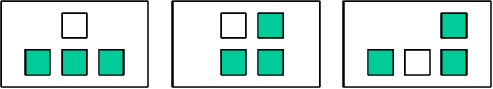
- Birth Rule: A dead cell with exactly three live neighbors becomes a live cell.
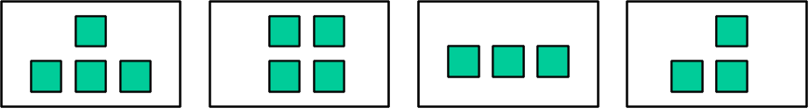
- Survival Rule: A live cell with two or three live neighbors stays alive.
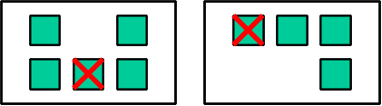
- Death Rule: In all other cases, a cell dies or remains dead.

The number of live neighbors is always based on the cells before the rule is applied.

Lab:

Step 1: Identify objects in the game
Look at the game requirements above and try to identify the objects involved in the game (objects are usually identified by looking for nouns in the requirements).
What objects can you identify in the game?
Here are some questions that may help you identifying objects:
- What represents the game itself?
- What is the game played on?
- What influences how the game evolves over time?
As there may be several appropriate answers to the questions above, it is probably correct to say that most obvious objects are game, board and rule, and that these objects make up the game.

Step 2: Identify basic classes
Based on the results of previous step what classes make up the game system? What are the class names, data and behavior?
The basic classes in the system may be Game, Board and Rule. Game has a board and set of rules, as well as an index “generation” to identify how many generations a board evolves. Board has cells, and it is initialized at creation time with some pattern of live and dead cells. Rule may have a name and a type and evaluates for every cell of the board. Rule type can be birth, survival, or death. When it evaluates, a Rule’s type is checked and based on the type different computations performed.

Summary:
In this lab you have analyzed the problem domain of the game you will be implementing in remaining labs.

Lab 03: Java Overview

Objective:
In this lab you will use the Scrapbook to evaluate some Java code. The Scrapbook is used in Eclipse to test and evaluate code. First you will need to create a project and within the project a new Scrapbook. The exercise should make you more familiar with the Eclipse environment as well as with basic Java syntax and rules.

Lab:

Step 1: Create a Scrapbook page
In the Eclipse environment select File -> New -> Project… -> Java -> Java Project, specify project name ExperimentLab and click Finish.

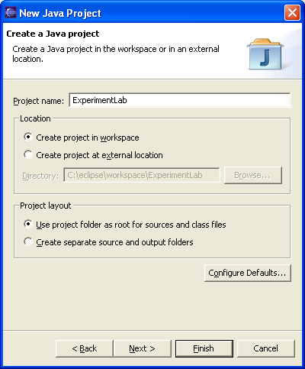

A New Java project is created. From the pull-down menu choose File -> New -> Other… -> Java -> Scrapbook Page than specify page name (ExperimentgPage) with project selected and click Finish.

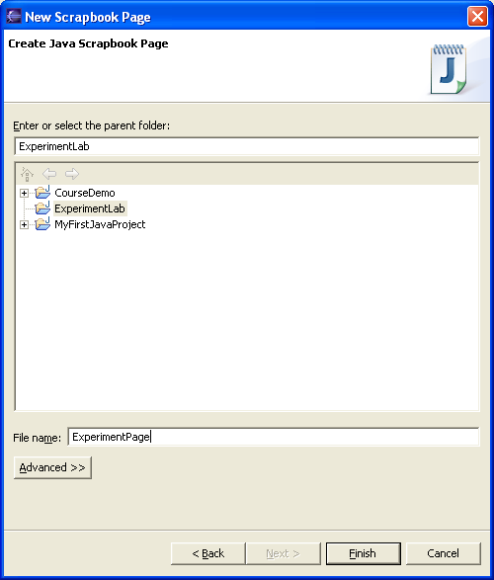

A page editor will open the page.

Step 2: Evaluating and displaying the following expressions:
Write and display the result of evaluating the following expression:
5 + 2 * 10 /4 – 7;
What is the result? Is it expected?
Answer: In evaluating expression above first 2*10 is evaluated to 20 and than 20/4 evaluates to 5. After that 5+5-7 evaluates to the final result 3.

Step 3: Experiment with primitives and variables
Write and display the result of evaluating the following expressions:
int a = 6;
double b = a;
b;
What happens? Was int converted to double, and why?
Answer: The double primitive type is a wider type than int type and JVM is capable of converting int to double by doing automatic, implicit casting.

Now write and display the result of evaluating the following expressions:
double a = 6;
int b = a;
b;
What happens now? Why did you get the “Type mismatch: cannot convert from double to int” message? What if you evaluated (int)b at the end?
Answer: The double type cannot be converted to int type, as it is wider type and no implicit casting is done. With explicit cast (int)b you are saying to the JVM that is ok to assign wider type to narrower type.

Write and display the result of evaluating the following expressions:
long a = 45L;
double b = a;
b;
What is the result of evaluating expressions now?
Write and display the result of evaluating the following expressions:
double a = 45.00;
long b = a;
b;
What is the result of evaluating expressions now? Did you get the same result as in previous evaluation? Why?
Answer: Both types are same size. In the first expression evaluation a long type is assigned to a double and that is handled by JVM as double is of higher precision. In the second example however, higher precision type is assigned to lower, and you get an error. Even if an explicit cast was used here the JVM couldn’t handle it.

Step 4: Messages and objects
Inspect the following expression from the Scrapbook:

String myString = new String("My String");
myString

An Inspector shows up. Look at all characters that make up the inspected string.

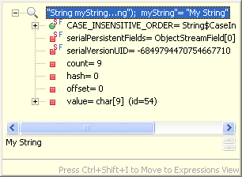

Now evaluate the following expression:

String myString = new String("My String");
System.out.println(myString);

What is the message you sent to the output object? Where does the string get printed?
Answer: println is the message sent to the out object. The string is printed to the standard Java console represented with a Console view in Eclipse.

Step 5: Literals
Inspect the literal "This is a string" in the Scrapbook. What kind of object it is? What is the difference between the literal and evaluating new String("This is a string") expression?
Answer: The "This is a string" is a literal string object. It is the same as the string object created using new String("This is a string") expression.

Step 5: Arrays
Create and inspect an array of 5 integers initialized to zeros.
Create and inspect multidimensional array of 5 arrays created in the previous step.

Summary:
In this lab you have used the Eclipse Scrapbook to evaluate and run simple Java code.

Lab 04: Building Java classes

Objective:
In this lab you will become familiar with Eclipse Java Development Tools. In particular you will build basic game classes. After you finish this lab you should be familiar with creating classes using Eclipse, as well as using Eclipse Java refactoring tools.

Lab:

Step 1: Create the project
Create new Java project called LifeGame. To create a project, choose from the pull-down menu: File -> New -> Project -> Java -> Java Project and click Next. Specify name of the project and click Finish.

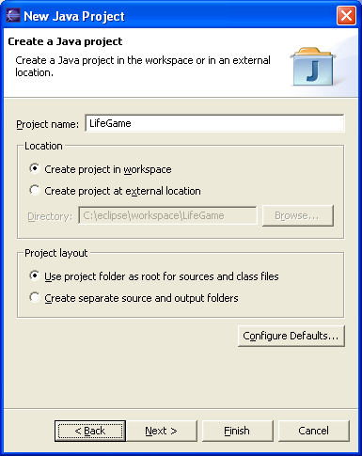

Step 2: Create package
Create package that will contain domain classes for the game. Packages group classes by functionality and are their namespaces. Usually classes that represent a model are in the same package, classes used for testing are in a different package, etc. To create new package, select the project and choose New -> Package from the context menu. Use org.eclipse.lifegame.domain as a package name and click Finish.
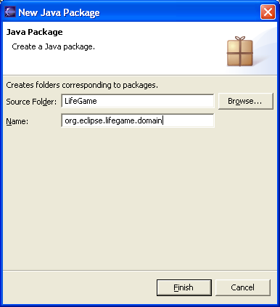

Step 3: Create Game and Board classes
Create a class Board that will have private field cells that is 2-dimensional array of integers. The cells field should be 10x10 and will contain either zeros or ones after game runs.

Generate getter and setter for the field. Add a constructor to the Board class that will accept 2-dimensional array as a parameter. This will represent pattern (initial cells state) for the game when it runs. Also override the default constructor to simply initialize cells to 2-dimensional array (10x10) when created.

Define two evolve methods in the class: evolve(Game) and evolve(Game,int). These methods do have a void return type and should iterate through their cells and based on rules evolve them to the next stage. The evolve method that accepts an integer as parameter evolves the board many times (depending on the parameter). Leave these methods empty for now as you will implement them in the later labs.

Override the toString() method in the Board class to simply return string "Board for game of life" . Later in the labs you will add more behavior to this method.

Create a class Game that has board field of type Board and field generation of type int (indicates how many generation should board evolve). Generate getter and setter for the added fields. Add a constructor to the Game class that will accept a board as a parameter and initialize game’s board field to the parameter, and initialize generation to 1.

Step 4: Creating Game and Board instances
Use the Scrapbook from previous labs to create and instance of the Board class. The classes will not be visible in the Scrapbook. First of all you have to add LifeGame project as a dependency to the project containing the Scrapbook.

Select the ExperimentLab project and choose Properties from the context menu. Click on the Java Build Path and select Projects tab. Select the LifeGame project and click OK.

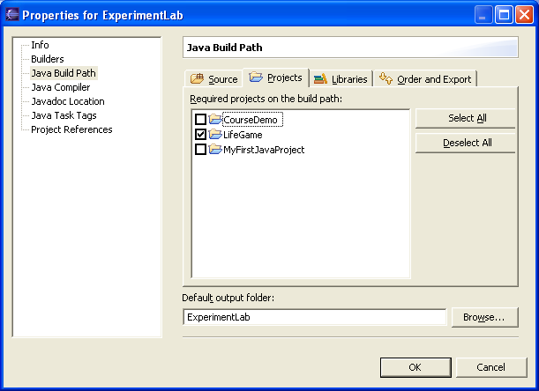

In the Scrapbook choose Set Imports from the context menu and than select Add Packages… button. Select the package that contains classes and click OK twice.

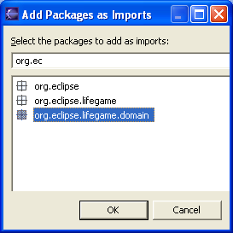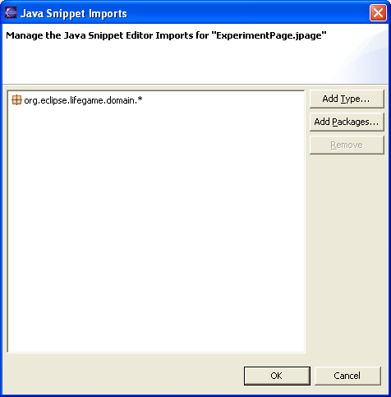

Create an instance of the Game class passing the previously created board object. Inspect the game object.

In the Scrapbook, you may have code like the following:

int[][] boardCells = {
{0, 0, 0, 0, 0, 0, 0 , 0, 0, 1},
{0, 0, 0, 0, 0, 0, 0 , 0, 0, 1},
{0, 0, 0, 0, 0, 0, 0 , 0, 0, 1},
{0, 0, 0, 0, 0, 0, 0 , 0, 0, 1},
{0, 0, 0, 0, 0, 0, 0 , 0, 0, 1},
{0, 0, 0, 0, 0, 0, 0 , 0, 0, 1},
{0, 0, 0, 0, 0, 0, 0 , 0, 0, 1},
{0, 0, 0, 0, 0, 0, 0 , 0, 0, 1},
{0, 0, 0, 0, 0, 0, 0 , 0, 0, 1},
{0, 0, 0, 0, 0, 0, 0 , 0, 0, 1}};
Board board = new Board(boardCells);
Game game = new Game(board);
game

Summary:

In this lab you have created basic classes for Game of Life, and you became familiar with writing constructors, methods, and defining fields.

Lab 05: Using the Debugger

Objective:
In this lab you will become more familiar with Eclipse Java Development Tools as you will be using some of the most commonly used tools, in particular the Debugger, and again the Scrapbook and the Inspector. These tools are very helpful when developing Java code. In this lab you will be stepping through the execution of a new Board constructor and you will try to identify and correct inappropriate behavior.

Step 1: Create a Rule class
In the LifeGame project, create new class Rule (same package as other game classes) that has a private field name of String type. Generate getter and setter for the field. The class will be used later in the labs to represent different game rules. For now you will create basics for this class.

Add a constructor to the class that accepts a String parameter and assigns it to the name field. The constructor should look like this:

public Rule(String name){
name = name;
}

Step 2: Create a Rule instance
Create new rule instance using defined constructor in the Scrapbook and inspect it. What is the name field value?

Obviously the name field is not set in the constructor for some reason. You will need to use the Debugger to see what happens when name is passed to the constructor.

In the LifeGame project, create new package org.eclipse.lifegame.test and add a LifeTester class to the package. When you create the class make sure you select creation of the main() method.
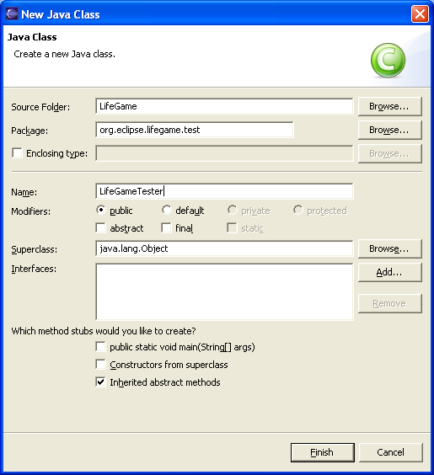

You will use this class to invoke Debugger, and test some code.
In the main() method write the code from the Scrapbook. The code should look like the following:

public static void main(String[] args) {
Rule rule = new Rule("Survival");
System.out.println(rule.getName());
}

Note that Rule class is in different package, and that you need to add import statement. Run the class by choosing Run -> Run As -> Java Application from the pull-down menu. The null is printed to the Console.

Step 3: Debug the constructor
Set a breakpoint in the main method and run the LifeGameTester again. Did Debugger come up? In order to invoke Debugger you need to choose Debug option instead of Run option for the LifeGameTester class.

The Debugger comes up and stops the execution in the main method where the breakpoint was set.
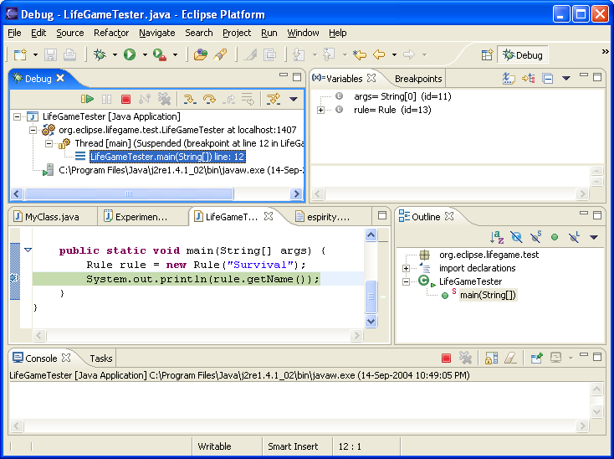

Step into the constructor and evaluate parameter passed as well as the name field. Can you see the problem with the code?

The constructor uses expression name = name; where name is the parameter passed to the constructor and at the same time a field in the class. When code evaluates, the passed name value is assigned to passed name variable. This has no effect and the Eclipse recognizes that and displays a warning next to this expression.

The appropriate expression would be this.name = name; where this.name means field and name means passed parameter.

If you evaluate code with the breakpoint from the Scrapbook, the Debugger should open. If code has warnings, the Debugger will not open.

Summary:
In this lab you have become familiar with using the Eclipse Debugger.
Lab 06: Control Statements

Objective:
In this lab you will use control statements to implement some of the behavior in the game classes. In particular you will implement Singleton pattern for the Game class, and the toString() method of the Board class.

Lab:

Step 1: Implement Singleton pattern for the Game class
How many instances of the Game class you will need at the same time in one single application? Well, most likely you will need only one instance of the Game class in one application. This instance should represent the game itself. This is known as a Singleton pattern, when no more than one instance of the class can be created within the same JVM. In this step you will implement this pattern for the Game class.

Define a private static field called theInstance in the Game class. This field should store the instance of the class, so field’s type should be Game. Add a public static method getInstance() to the Game class that will return instance of the class stored in theInstance field . In the method check first if field’s value is null, and if it is create new Game instance and assign it to the field. This implementation is known as lazy initialization.
Change the constructors of the Game class to private, so only class itself can use them. This will prevent anybody else of creating instances of the class.

Use newly implemented pattern in the Scrapbook to test the code. Inspect the expression Game.getInstance();

Step 3: toString() method of the Board class
In previous labs you have defined the toString() method for the Board class to return a simple String. The toString() is a textual representation of the object. When object is printed to the standard Java console this method is used. Board contains cells that are zero or one. When board is printed to the console, for cell containing zeros a blank should be printed and for cell containing one an X should be printed.

Implement the toString() method to return a String based on this specification. This will allow us to see how board looks like on the Console.

To implement proper behavior you will need to iterate through array of arrays, and check each cell. Use StringBuffer class for appending characters.

Use the Scrapbook to test toString() method by creating and printing the board instance to the Console.
For example Scrapbook code could be like the following:

int[][] boardCells = {
{0, 0, 0, 0, 0, 0, 0 , 0, 0, 1},
{0, 0, 0, 0, 0, 0, 0 , 0, 0, 1},
{0, 0, 0, 0, 0, 0, 0 , 0, 0, 1},
{0, 0, 0, 0, 0, 0, 0, 0, 0, 1},
{0, 0, 0, 0, 0, 0, 0, 0, 0, 1},
{0, 0, 0, 0, 0, 0, 0, 0, 0, 1},
{0, 0, 0, 0, 0, 0, 0, 0, 0, 1},
{0, 0, 0, 0, 0, 0, 0, 0, 0, 1},
{0, 0, 0, 0, 0, 0, 0, 0, 0, 1},
{0, 0, 0, 0, 0, 0, 0, 0, 0, 1}};
Board board = new Board(boardCells);
System.out.println(board);

This code would print to the Console like this:

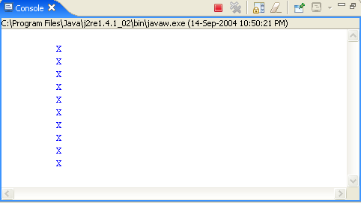

Or, the code could be like the following:

int[][] boardCells = {
{0, 0, 0, 1, 0, 0, 0, 0, 0, 0},
{0, 0, 1, 0, 1, 0, 0, 0, 0, 0},
{0, 0, 0, 1, 0, 0, 0, 0, 0, 0},
{0, 0, 0, 1, 0, 0, 0, 0, 0, 0},
{0, 0, 1, 0, 1, 0, 0, 0, 0, 0},
{0, 0, 0, 1, 0, 0, 0, 0, 0, 0},
{0, 0, 0, 1, 0, 0, 0, 0, 0, 0},
{0, 0, 1, 0, 1, 0, 0, 0, 0, 0},
{0, 0, 1, 0, 1, 0, 0, 0, 0, 0},
{0, 0, 0, 1, 0, 0, 0, 0, 0, 0}};
Board board = new Board(boardCells);
System.out.println(board);

And it should print like this:

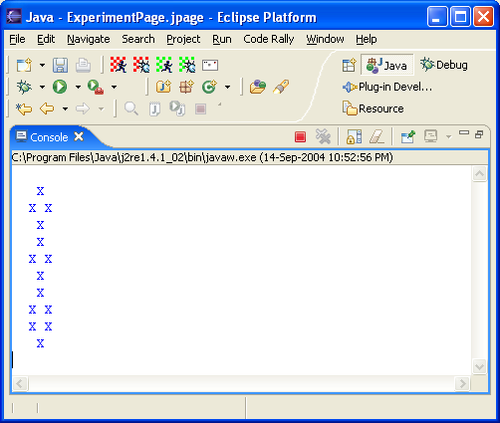

Summary:
In this lab you have used control statements to implement Singleton pattern for the Game class and toString() method for the Board class.

Lab 07: Inheritance

Objective:
In this lab you will be using inheritance for better design, increased flexibility and maintainability of the system.

Inheritance helps with refactoring the code, as well as with appropriate representation of the objects (i.e. it makes objects closer to the real life). Quite often some commonalities between similar classes are abstracted in an abstract super class and reused in subclasses. An abstract class is a class that cannot have instances. Interfaces are used in Java for further abstraction as they define only object’s protocol. Interfaces are also commonly used for cross-hierarchy polymorphism. In this lab you will be making use of both, abstract classes and interfaces. In these labs you are focusing on 2-dimensional cellular automation in the form of game of Life. In this particular lab you will make system flexible for handling different versions of cellular automation games.

Step 1: Redesign the Board class
Board class that we defined in previous labs contains 2-dimensional cells, which means it is really a 2-dimensional board. What would happen if you wanted to introduce 3-dimensional board? Would the Board class change? What about 1-dimensional? Every time when you wanted to introduce new game (problem) of cellular automation you would need to change the class. What all boards have in common, and what are differences between them? The difference between board is in their cells, as with 1-dimensional board cells are 1-dimensional array, with 2-dimensional board cells are 2-dimensional array, etc. Also implementation of evolve() protocol is different as different boards evolve differently.

Change the Board class name to TwoDimensionalBoard as that is what we really implemented as a Board class. To change name of the class select the class and choose Refactor -> Rename option from the context menu. The Eclipse will open dialog for changing the name:

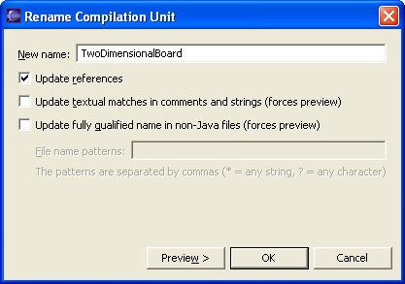

Create an abstract class Board with abstract evolve protocol – evolve(Game, int) and evolve(Game) methods. This will force all subclasses of the Board class to implement these methods on their own. Change the superclass of the TwoDimensionalBoard class to Board (…extends Board…).

When you changed the name of the class all references got updated, which means that board field in the Game class is of type TwoDimensionalBoard now. You want to keep this field generic, so change its type to Board. Change its getter and setter to return and accept Board type as well.

Step 2: Redesign the Rule class – Strategy pattern
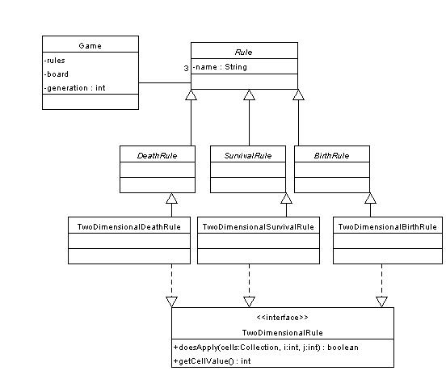

Rule class that you have defined before has name field. This could be an indicator what type of rule it is. Rule should have a method doesApply() that returns boolean depending whether rule applies for current cell or not. The protocol should check the name of the rule first and than based on it do different computation. With this approach there may be some potential issues with maintaining when new rules are introduced, as method would have to change. Better approach is to have specific Rule class for each rule in the game. Each class would have to implement its own doesApply() protocol. By doing this if new rule is introduced in the game, new specific class is created and method doesApply() implemented. You could abstract behavior all of rules to the Rule abstract class. Change the Rule class definition to abstract.
Create abstract classes DeathRule, SurvivalRule, and BirthRule as subclasses of the Rule class, and create TwoDimensionalDeathRule, TwoDimensionalSurvivalRule and TwoDimensionalBirthRule subclasses of just created abstract classes.

The doesApply() method is very specific to different game dimensions. In other words, two-dimensional rule method accepts two-dimensional array of cells as parameter. How can we force all two-dimensional rules to have same protocol, and at the same time inherit from different super classes? The answer is in cross-hierarchy polymorphs and interfaces.
Create new interface TwoDimensionalRule and define methods:
public int getCellValue();
public boolean doesApply(int[][] cells, int i, int j);
Implement the getCellValue() method in all two-dimensional classes. The method should simply return int value, for birth and survival rules that would be 1, and for death rule that would be 0.

Change all TwoDimensionalXYZRule classes to implement created interface.
Add a field rules to the Game class. Field should be an array of rules, and there should be exactly 3 rules assigned to the array.
The pattern that you have just implemented and that is indicated in the above picture is known as a Strategy pattern.

Step 3: Import the Rule classes
As there is lots of coding in the rule classes, simply import all rule classes (3) that are provided to you. These classes have implemented methods based on simple game rules specified in the requirements of the game.

Step 4: Redesign the Game class
Make a Game class previously defined abstract. You will notice that Eclipse gives you an error as no instances of the class can be created and we create one in the singleton implementation. Create TwoDimensionalGame class that inherits from Game class.
Default constructor in the Game class should initialize rules, and it may look like the following:
public Game(){
this.rules = new Rule[3];
}
Initialize rules array in the constructor of the Game class to instances of the corresponding two-dimensional rule classes defined in the previous step.
The constructor may look like the following:

private TwoDimensionalGame(){
setBoard(new TwoDimensionalBoard());
getRules()[0] = new TwoDimensionalBirthRule();
getRules()[1] = new TwoDimensionalSurvivalRule();
getRules()[2] = new TwoDimensionalDeathRule();
}

You will also need to move singleton implementation from Game class to its subclass.

Step 5: Implement the Board protocol
Implement the evolve methods in the TwoDimensionalBoard class. The evolve(Game, int) method simply iterate through the loop for the passed index (int) and in each iteration it calls evolve(Game) method and prints itself to the standard console.. The code may look like the following:

public void evolve(Game aGame, int index){
if (index == 0) return;
for (int i = 1; i <= index; i++){
evolve(aGame);
System.out.println(this);
}
}
The evolve(Game) method iterates through board cells and for each cell checks if any rule from game’s rule applies. For the rule that applies current cell value is set to the rule’s cell value. If no rules apply for a cell than simply print the statement out to the Console stating that no rules apply for a current cell. The code that you write may look like the following:
public void evolve(Game aGame){
boolean doesAnyApply = false;
TwoDimensionalRule rule = null;
for (int i = 0; i < cells.length; i++){
for (int j = 0; j < cells[0].length; j++){
doesAnyApply = false;
for (int k = 0; k < aGame.getRules().length; k++){
rule = (TwoDimensionalRule)aGame.getRules()[k];
if(rule.doesApply(getCells(), i, j)){
getCells()[i][j] = rule.getCellValue();
doesAnyApply = true;
break;
}
}
if (!(doesAnyApply))
System.out.println("No rules apply for cell[" + i + "][" + j + "]");
}
}
}

Step 6: Implement run method in the Game class
Now you have most of the pieces to run the game. Add a run() method of void return type to the Game class. The method should simply call evolve method on the game’s board and pass games generation and game itself as a parameters.
The method may look like the following:
public void run(){
getBoard().evolve(this, getGeneration());
}

Step 7: Test the game
Change the LifeGameTester class to create new instance of the TwoDimensionalBoard, assigns some initialized cells to the board, and than get instance of the TwoDimensionalGame, assign previously created board to it, assign 10 as a generation to the instance and finally run the instance.
The main method may look like the following:
public static void main(String[] args) {
int[][] boardCells = {
{0, 0, 0, 1, 0, 0, 0 , 0, 0, 0},
{0, 0, 1, 0, 1, 0, 0 , 0, 0, 0},
{0, 0, 0, 1, 0, 0, 0 , 0, 0, 0},
{0, 0, 0, 1, 0, 0, 0 , 0, 0, 0},
{0, 0, 1, 0, 1, 0, 0 , 0, 0, 0},
{0, 0, 0, 1, 0, 0, 0 , 0, 0, 0},
{0, 0, 0, 1, 0, 0, 0 , 0, 0, 0},
{0, 0, 1, 0, 1, 0, 0 , 0, 0, 0},
{0, 0, 1, 0, 1, 0, 0 , 0, 0, 0},
{0, 0, 0, 1, 0, 0, 0 , 0, 0, 0}};
TwoDimensionalBoard board = new TwoDimensionalBoard(boardCells);
TwoDimensionalGame game = TwoDimensionalGame.getInstance();
game.setBoard(board);
game.setGeneration(10);
game.run();
}
Run the tester class. Observe behavior as you run it multiple times for different cell values.
After refactoring and redesigning the classes you may have a class diagram like on the picture below:
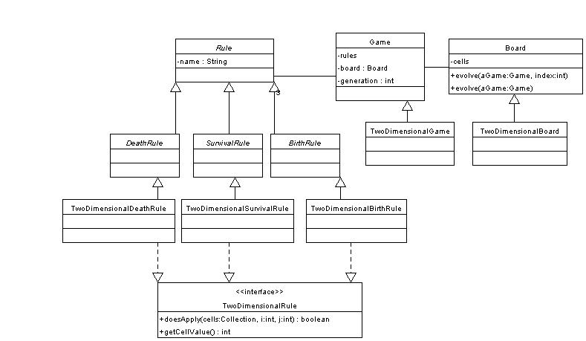

Summary:
In this lab you have used inheritance, abstract classes, interfaces, and Eclipse refactoring tools.

Lab 08: Collections

Objective:
In this lab you will be using collections to implement board evolvement history in the game. When board evolves cells change their values, and board is essentially in a new state. At the end of game’s generation, board has new generation state and all previous states are lost. You will implement the history of board evolvement in the Game class.

Lab

Step 1: Add a boardHistory field to the Game class
Define new fields boardHistory of type ArrayList in the Game class. Generate getter and setter for the field. In the Game constructor initialize field to a new ArrayList instance.

Step 2: Add a history manipulation protocol
Define new method addToHistory(Board) in the Game class. The method should accept an instance of Board class as a parameter and simply add it to the games boardHistory collection.
Define another method clearHistory() in the Game class that will remove all elements from the boardHistory collection.

Step 3: Use history manipulation protocol
Change the run() method in the Game class to clear the board history before it asks board to evolve.

After board evolves its new state should be added to game’s board history before board evolves again. Modify evolve(Game, int) method of the Board class to add the board to game’s history after each evolving. You may use expression aGame.addToHistory(this); in the for loop.

Step 4: Implement print history
In the previous lab you have added printing of the board to the standard console every time when board evolves in the evolve(Game,int) method. This was does for testing purposes so you can see how board cell change values. In the reality responsibility for printing the board will be on some other object. To support that, you will need to remove the print statement from the evolve(Game,int) method. After that add a printHistory() method to the Game class that will iterate through history collection of boards and for each iteration print the board to the console. Keep in mind that each object in the collection has to be casted to its type. boardHistory will contain objects of type Board, so in each iteration through the history you will need to cast objects to this type.
The method may look like this:
public void printHistory(){
Iterator iterator = getBoardHistory().iterator();
Board board = null;
while (iterator.hasNext()){
board = (Board)iterator.next();
System.out.println(board);
}
}

Step 5: Add more to the singleton
When you use singleton pattern you are using one single instance. In the dynamic development environment when you change object’s state and behavior regularly this may cause unwanted behavior. You need to clear the singleton each time after making changes to the code to make sure it behaves properly.
Add a public static method to the TwoDimensionalGame class that will simply assign instance to null:

public static void clearInstance(){
theInstance = null;
}
You can use this methods every time before reusing singleton.

Step 6: Test the code
Change the tester class to use implemented print history protocol after game runs. Run the tester again.

Summary:
In this lab you have used Java collections to keep track of the board history behavior in the game.

Lab 09: Exception Handling

Objective:
The objective of this lab is to work with exceptions. In this lab you will learn how to throw and catch exceptions.

Lab:

Step 1: Create Game of Life Exception
In the game of life, it is possible to create a situation where no rule applies to a given cell. In this case a cell never dies and is born. Therefore, the cell remains unchanged for the entire game. This is an exceptional condition because at least one rule should always apply in every generation of a cell.

Create a new exception class LifeGameException in the package org.eclipse.lifegame.support. The exception class should inherit from the Exception class. Provide two constructors for the class. The first is the default constructor. The second is a constructor that has on String parameter that is the error message for the exceptions, and it’s overridden from the super class. In this constructor you can simply call the constructor from the super class that sets passed error message to an error message field.

Step 2: Throw the Exception
Update your Board class to throw the exception. You will need to physically throw the exception in the method of your TwoDimensionalBoard class where you detect that no rule applies. You will also have to identify that the corresponding method throws the exception. This will also have to be done in the methods for the abstract Board class too.

Step 3: Catch the Exception
The place where you run the Game will now have to catch the new exception. Add this functionality to your implementation. When the exception is thrown you should stop evolving the game and pop up an error message. You can create an error dialog using the following code:

try {
...

}catch (LifeGameException exception) {
Display display = new Display ();
Shell shell = new Shell (display);
MessageDialog.openError(shell, "Error with Game", exception.getMessage());
}

To use the MessageDialog you will need to include the following import statements in your class:
import org.eclipse.swt.widgets.Display;
import org.eclipse.swt.widgets.Shell;

And include the libraries swt.jar and jface.jar in your projects build path.

Step 4: Test the Exception
Test your exception by creating a situation in your application that throws the exception.

Summary:
In this lab you have created a new exception, used it to identify and exceptional condition in your application and handled it when the situation presented itself.
Lab 10: Streams

Objective:
The objective of this lab is to work with streams. In this lab you will learn how write and read data to and from a file using streams

Lab:

Step 1: Create Game Methods
Add two new methods to the class Game called:

public void saveCurrentBoardToFile(String filename);
public void loadBoardFromFile(String filename);

These methods should write the board of the game into a given file and also read the board from a given file. In other words, the write method should serialize game’s board to a file, and the read method should deserialize board object from the given file and set game’s board to it.

Step 2: Create Abstract Board Methods
Add two new abstract methods to the class Board called:

public abstract void saveCurrentBoardToFile(String filename);
public abstract void loadBoardFromFile(String filename);

Step 3: Test You Methods
You can test your implementation by evaluating following code in the Scrapbook (you can use the Scrapbook from the ExperimentLab):

int[][] boardCells = {
{0, 0, 0, 1, 0, 0, 1 , 0, 1, 0},
{0, 0, 1, 0, 1, 0, 1 , 0, 0, 0},
{1, 0, 0, 1, 0, 0, 1 , 0, 0, 0},
{0, 0, 0, 1, 0, 0, 1 , 0, 0, 0},
{0, 0, 1, 0, 1, 0, 1 , 1 ,0, 0},
{0, 0, 0, 1, 0, 0, 1 , 1, 1, 0},
{0, 0, 0, 1, 0, 0, 1 , 1, 0, 1},
{1, 0, 1, 0, 1, 0, 1 , 0, 1, 0},
{0, 0, 1, 0, 1, 0, 1 , 0, 1, 1},
{0, 0, 0, 1, 0, 0, 1 , 0, 0, 1}};
TwoDimensionalBoard board = new TwoDimensionalBoard(boardCells);
TwoDimensionalGame.clearInstance();
TwoDimensionalGame game = TwoDimensionalGame.getInstance();
game.setBoard(board);
game.saveCurrentBoardToFile("c:/game.txt");
int[][] newBoardCells = {
{1, 1},
{1, 1}};
board = new TwoDimensionalBoard(newBoardCells);
game.setBoard(board);
System.out.println(game.getBoard());
game.loadBoardFromFile("c:/game.txt");
System.out.println(game.getBoard());

In the code you first create board, and save it to a file. Than you create a new, smaller board, assign it to a game, which thereby deleted the old game board. After this you print new board, loaded the old one, assign it to a game, and print it, so you can visually validate that the load and write worked. You can always check what was written to the file by looking at it manually using your favorite word processor. When serializing objects into a file the data written are binary, but when you write other data (primitives, text), it should be human readable.

Summary:

In this lab you have used Java streams to save game’s board to a file, and load it from a file.

Lab 11: Generating Javadoc in Eclipse

Objective:
The objective of this lab is to familiarize you with documenting you Java code with Javadoc comments and tags and with using the Javadoc tool in Eclipse to produce the Javadoc output of the standard doclet.

Lab:

Step 1: Fully Comment your Game Class
Take you Game class and comment it fully.
- Provide a comment before the class that also includes author, version and see tags.
- Comment the beginning of every method. Make sure to identify the parameters and return value using the tags param and return.
- When useful, add the tag see and the corresponding class to you method comments

It is useful to include HTML tags in your javadoc text. For example, the following is a comment with tags (<p>, <tt></tt>, <i></i>) you can also imbed in your documents. Try them out and see what they do.

* <p>Many different types of exceptions can happen. For example
* throw <tt>LifeGameException</tt> might be thrown.
* It is wrong to write a program that depended on an
* exception for its correctness: <i>the fail-fast behavior
* should not be used</i>

Step 2: Export the Javadoc
Export your Life Game package as Javadoc. Select only your package to create the Javadoc when presented the Javadoc generation wizard. Don’t forget to set the options and destination directory. If all goes well you should see something like the following in the console window. If you see comment coloured RED, you have a problem. Read the comment and fix it.

Loading source files for package org.eclipse.lifegame.test...
Loading source files for package org.eclipse.lifegame.support...
Loading source files for package org.eclipse.lifegame.domain...
Constructing Javadoc information...
Standard Doclet version 1.4.1

Generating C:\eclipse\workspace\LifeGame\doc\constant-values.html...
Building tree for all the packages and classes...
Generating C:\eclipse\workspace\LifeGame\doc\org\eclipse\lifegame\test\class-use\LifeGameTester.html...
Generating C:\eclipse\workspace\LifeGame\doc\org\eclipse\lifegame\support\class-use\LifeGameException.html...
Generating C:\eclipse\workspace\LifeGame\doc\org\eclipse\lifegame\domain\class-use\TwoDimensionalSurvivalRule.html...
Generating C:\eclipse\workspace\LifeGame\doc\org\eclipse\lifegame\domain\class-use\TwoDimensionalRule.html...
Generating C:\eclipse\workspace\LifeGame\doc\org\eclipse\lifegame\domain\class-use\TwoDimensionalGame.html...
Generating C:\eclipse\workspace\LifeGame\doc\org\eclipse\lifegame\domain\class-use\TwoDimensionalDeathRule.html...
Generating C:\eclipse\workspace\LifeGame\doc\org\eclipse\lifegame\domain\class-use\TwoDimensionalBoard.html...
Generating C:\eclipse\workspace\LifeGame\doc\org\eclipse\lifegame\domain\class-use\TwoDimensionalBirthRule.html...
Generating C:\eclipse\workspace\LifeGame\doc\org\eclipse\lifegame\domain\class-use\SurvivalRule.html...
Generating C:\eclipse\workspace\LifeGame\doc\org\eclipse\lifegame\domain\class-use\Rule.html...
C:\eclipse\workspace\LifeGame\org\eclipse\lifegame\domain\Game.java:48: warning - @return tag has no arguments.
Generating C:\eclipse\workspace\LifeGame\doc\org\eclipse\lifegame\domain\class-use\Game.html...
Generating C:\eclipse\workspace\LifeGame\doc\org\eclipse\lifegame\domain\class-use\DeathRule.html...
Generating C:\eclipse\workspace\LifeGame\doc\org\eclipse\lifegame\domain\class-use\Board.html...
C:\eclipse\workspace\LifeGame\org\eclipse\lifegame\domain\Game.java:34: warning - @return tag has no arguments.
Generating C:\eclipse\workspace\LifeGame\doc\org\eclipse\lifegame\domain\class-use\BirthRule.html...
Generating C:\eclipse\workspace\LifeGame\doc\org\eclipse\lifegame\domain\package-use.html...
Generating C:\eclipse\workspace\LifeGame\doc\org\eclipse\lifegame\support\package-use.html...
Generating C:\eclipse\workspace\LifeGame\doc\org\eclipse\lifegame\test\package-use.html...
Building index for all the packages and classes...
Generating C:\eclipse\workspace\LifeGame\doc\overview-tree.html...
Generating C:\eclipse\workspace\LifeGame\doc\index-files\index-1.html...
Generating C:\eclipse\workspace\LifeGame\doc\index-files\index-2.html...
Generating C:\eclipse\workspace\LifeGame\doc\index-files\index-3.html...
Generating C:\eclipse\workspace\LifeGame\doc\index-files\index-4.html...
Generating C:\eclipse\workspace\LifeGame\doc\index-files\index-5.html...
Generating C:\eclipse\workspace\LifeGame\doc\index-files\index-6.html...
C:\eclipse\workspace\LifeGame\org\eclipse\lifegame\domain\Game.java:90: warning - @return tag has no arguments.
C:\eclipse\workspace\LifeGame\org\eclipse\lifegame\domain\TwoDimensionalBoard.java:22: warning - @return tag has no arguments.
C:\eclipse\workspace\LifeGame\org\eclipse\lifegame\domain\Game.java:76: warning - @return tag has no arguments.
C:\eclipse\workspace\LifeGame\org\eclipse\lifegame\domain\Rule.java:19: warning - @return tag has no arguments.
Generating C:\eclipse\workspace\LifeGame\doc\index-files\index-7.html...
Generating C:\eclipse\workspace\LifeGame\doc\index-files\index-8.html...
Generating C:\eclipse\workspace\LifeGame\doc\index-files\index-9.html...
Generating C:\eclipse\workspace\LifeGame\doc\index-files\index-10.html...
Generating C:\eclipse\workspace\LifeGame\doc\index-files\index-11.html...
Generating C:\eclipse\workspace\LifeGame\doc\index-files\index-12.html...
Generating C:\eclipse\workspace\LifeGame\doc\index-files\index-13.html...
Generating C:\eclipse\workspace\LifeGame\doc\deprecated-list.html...
Building index for all classes...
Generating C:\eclipse\workspace\LifeGame\doc\allclasses-frame.html...
Generating C:\eclipse\workspace\LifeGame\doc\allclasses-noframe.html...
Generating C:\eclipse\workspace\LifeGame\doc\index.html...
Generating C:\eclipse\workspace\LifeGame\doc\packages.html...
Generating C:\eclipse\workspace\LifeGame\doc\overview-summary.html...
Generating C:\eclipse\workspace\LifeGame\doc\overview-frame.html...
Generating C:\eclipse\workspace\LifeGame\doc\org\eclipse\lifegame\domain\package-frame.html...
Generating C:\eclipse\workspace\LifeGame\doc\org\eclipse\lifegame\domain\package-summary.html...
Generating C:\eclipse\workspace\LifeGame\doc\org\eclipse\lifegame\domain\package-tree.html...
Generating C:\eclipse\workspace\LifeGame\doc\org\eclipse\lifegame\support\package-frame.html...
Generating C:\eclipse\workspace\LifeGame\doc\org\eclipse\lifegame\support\package-summary.html...
Generating C:\eclipse\workspace\LifeGame\doc\org\eclipse\lifegame\support\package-tree.html...
Generating C:\eclipse\workspace\LifeGame\doc\org\eclipse\lifegame\test\package-frame.html...
Generating C:\eclipse\workspace\LifeGame\doc\org\eclipse\lifegame\test\package-summary.html...
Generating C:\eclipse\workspace\LifeGame\doc\org\eclipse\lifegame\test\package-tree.html...
Generating C:\eclipse\workspace\LifeGame\doc\org\eclipse\lifegame\test\LifeGameTester.html...
Generating C:\eclipse\workspace\LifeGame\doc\org\eclipse\lifegame\support\LifeGameException.html...
Generating C:\eclipse\workspace\LifeGame\doc\org\eclipse\lifegame\domain\TwoDimensionalRule.html...
Generating C:\eclipse\workspace\LifeGame\doc\org\eclipse\lifegame\domain\BirthRule.html...
Generating C:\eclipse\workspace\LifeGame\doc\org\eclipse\lifegame\domain\Board.html...
Generating C:\eclipse\workspace\LifeGame\doc\org\eclipse\lifegame\domain\DeathRule.html...
Generating C:\eclipse\workspace\LifeGame\doc\org\eclipse\lifegame\domain\Game.html...
Generating C:\eclipse\workspace\LifeGame\doc\org\eclipse\lifegame\domain\Rule.html...
Generating C:\eclipse\workspace\LifeGame\doc\org\eclipse\lifegame\domain\SurvivalRule.html...
Generating C:\eclipse\workspace\LifeGame\doc\org\eclipse\lifegame\domain\TwoDimensionalBirthRule.html...
Generating C:\eclipse\workspace\LifeGame\doc\org\eclipse\lifegame\domain\TwoDimensionalBoard.html...
Generating C:\eclipse\workspace\LifeGame\doc\org\eclipse\lifegame\domain\TwoDimensionalDeathRule.html...
Generating C:\eclipse\workspace\LifeGame\doc\org\eclipse\lifegame\domain\TwoDimensionalGame.html...
Generating C:\eclipse\workspace\LifeGame\doc\org\eclipse\lifegame\domain\TwoDimensionalSurvivalRule.html...
Generating C:\eclipse\workspace\LifeGame\doc\serialized-form.html...
Generating C:\eclipse\workspace\LifeGame\doc\package-list...
Generating C:\eclipse\workspace\LifeGame\doc\help-doc.html...
Generating C:\eclipse\workspace\LifeGame\doc\stylesheet.css...
6 warnings

Now look in the destination directory you identified to Javadoc. You should see the resulting HTML files. If you choose the default output directory, it will be created under the project’s root in the workspace and will also be shown in the Eclipse Workbench.

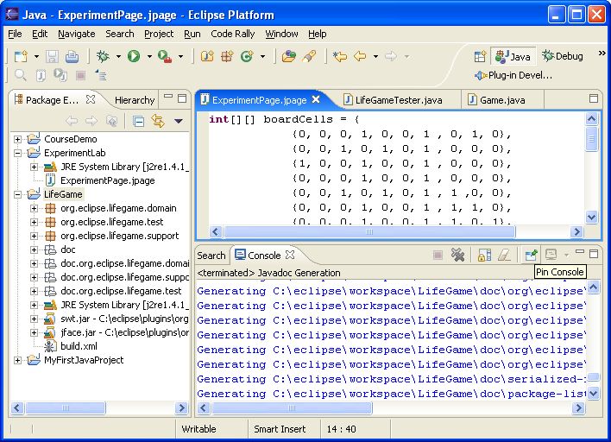

Double-click on the index.html file will show Javadoc as follows:
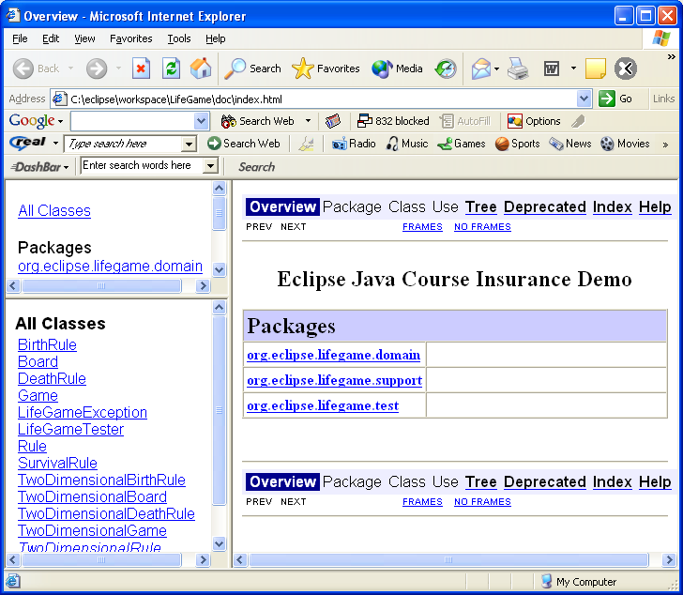
Lab 12: Using Ant in Eclipse

Objective:
The objective of this lab is to familiarize you with the activities you need to perform in order to us Ant in Eclipse. These activities include writing a build.xml file and then running the various tasks you have include in the file. A second objective is to get you to use some of the major tasks that Ant provides.

Lab:

Step 1: Create an build.xml file
In your game of life project create a new file called build.xml. Create a build file that has the following tasks and targets:

- An initialize target that creates two directories: build/classes and bin.
- A compile target that depends on the initialize target that compiles all the files in your org/eclipse/lifegame/ directory, putting the class files in the build/classes directory.
- An archive target that depends on the compile target that builds a JAR file, bin/lifegame.jar, from the classes in the directory build/classes.
- An execute target that depends on the compile target that runs the class org.eclipse.lifegame.test.LifeGameTester from the build/classes directory.
- A clear target that depends on the initialize target that deletes the directories build and bin.

Step 2: Run the build.xml file with only the initialize target
Select the build.xml file and using the right mouse button select Run Ant … from the popup menu. Select the initialize target and select Run.

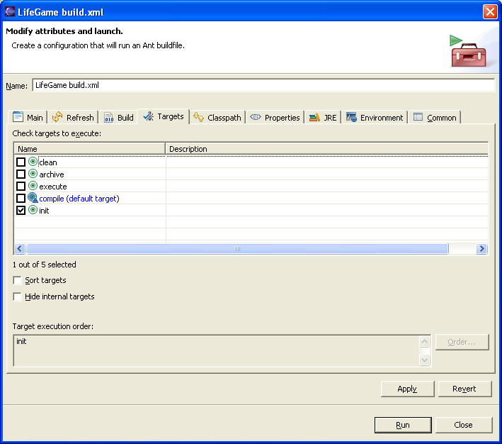

You should see something like the following:

Buildfile: C:\eclipse\workspace\LifeGame\build.xml
init:
BUILD SUCCESSFUL
Total time: 300 milliseconds

You might note that the build and bin directories do not show up in your Eclipse environment. Don’t worry your Package Explorer just needs refreshing. Select you LifeGame project, popup the right menu button and select refresh. You should now see the directories. Don’t forget to do this operation whenever you add or remove things from the underlying directory structure.

Step 3: Run the compile target
Select the build.xml file and using the right mouse button select Run Ant … from the popup menu. Select the compile target and select Run. Don’t forget that the javac task requires the java compiler. You will need to add the tools.jar file from your JDK installation to the Ant classpath first. Also, you will need to add a dependant jface.jar an swt.jar files to Ant classpath, as shown below, or you could also specify them in the classpath argument of the target in the build file.

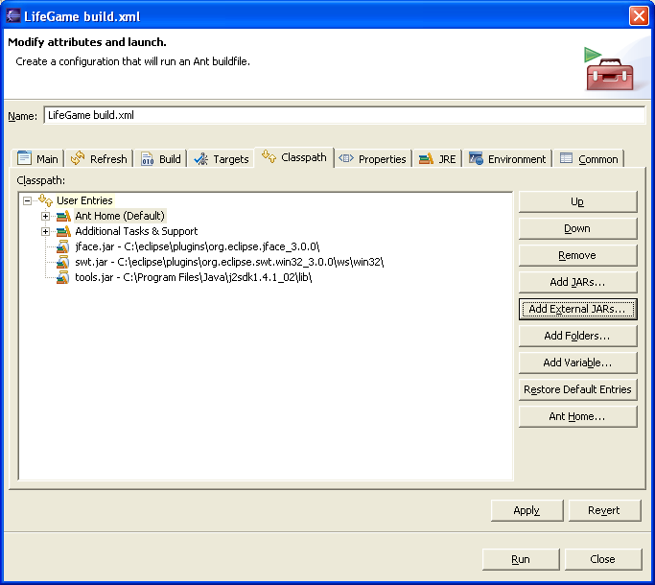

You should see something like the following:

Buildfile: C:\eclipse\workspace\LifeGame\build.xml
init:
compile:
[javac] Compiling 14 source files to C:\eclipse\workspace\LifeGame\build\classes
BUILD SUCCESSFUL
Total time: 2 seconds

Check to see that the new class files are in the build/classes directory.

Step 4: Run the archive target
Select the build.xml file and using the right mouse button select Run Ant … from the popup menu. Select the archive target and select Run. You should see the following:

Buildfile: C:\eclipse\workspace\LifeGame\build.xml
init:
compile:
[javac] Compiling 14 source files to C:\eclipse\workspace\LifeGame\build\classes
archive:
[jar] Building jar: C:\eclipse\workspace\LifeGame\bin\lifegame.jar
BUILD SUCCESSFUL
Total time: 2 seconds

Check to see that the new JAR file is in the bin directory and that it contains your class files.

Step 5: Run the execute target
Select the build.xml file and using the right mouse button select Run Ant … from the popup menu. Select the execute target and select Run. You should see the following:

Buildfile: C:\eclipse\workspace\LifeGame\build.xml
init:
compile:
[javac] Compiling 14 source files to C:\eclipse\workspace\LifeGame\build\classes
execute:
[java] X XXX
[java] X X X
[java] X X XX
[java] X XX X X
[java] X X X X
[java] X X X XX
[java] XXX XX
[java] XX
[java] XX X
[java] X X XXX
[java] X XX X
[java] XX XX X XX
[java] X X X X
[java] XX X X XX
[java] X X XX
[java] XXX
[java] X
[java] X XX
[java] X X
[java] X XXX
[java] XXX X
[java] X
[java] XX X
[java] XX X XX
[java] XX
[java] XX
[java] X
[java] X XX
[java] XX X
[java] X X X
[java] XXX XX
[java] X X X
[java] X X X X
[java] XX X X
[java] XX
[java] XXXX
[java] XX XX
[java] X X X
[java] X X X
[java] X X X
[java] X XX XX
[java] X XX X X
[java] XXXXXXX X
[java] XX
[java] XXX
[java] X
[java] X XX
[java] XX X
[java] X X X
[java] X X XX
[java] X X X X
[java] X X
[java] XXXXXXX X
[java] XX
[java] XXX
[java] X
[java] XX XX
[java] XX X XX
[java] X XX X X
[java] X X X XXX
[java] X X
[java] X X X XX
[java] XX XXX X
[java] X X XX
[java] XXX
[java] X
[java] X XX
[java] XX X XX
[java] X X X X
[java] X XX XXX
[java] X X X X
[java] X X X XXX
[java] XX X X
[java] XX
[java] XXX
[java] XXXXXX
[java] XX XX
[java] X XX XX
[java] X X X XXX
[java] X X X
[java] X X X XXX
[java] XX X X
[java] X X
[java] XXX
[java] X
[java] XXXXX X
[java] XX
[java] XXXXXX
[java] X XX
[java] X X
[java] X X X XX
[java] X X
[java] X
BUILD SUCCESSFUL
Total time: 2 seconds

Step 6: Run the clean target
Select the build.xml file and using the right mouse button select Run Ant … from the popup menu. Select the clean target and select Run. You should see the following:

Buildfile: C:\eclipse\workspace\LifeGame\build.xml
init:
clean:
[delete] Deleting directory C:\eclipse\workspace\LifeGame\build
[delete] Deleting directory C:\eclipse\workspace\LifeGame\bin
BUILD SUCCESSFUL
Total time: 1 second

Refresh you Eclipse project environment and make sure the directories have been deleted.

Summary:
In this lab you have Eclipse’s Ant facility to compile, execute and package your Game of Life application.

Lab 13: Building GUI with SWT

Objective:
The objective of this lab is to familiarize you with Eclipse’s Standard Widget Toolket (SWT). Specifically, the lab will help you learn how to use one of the more popular layout managers: FormLayout, many of the SWT widgets, and how to build GUI’s using SWT widgets and the two patterns discussed in the slides: View Event Handler Pattern and the Complete Update Pattern.

Lab:

Step 1: Don’t Forget
To run a standalone SWT application you must set the VM arguments in the Run Wizzard/argument tab to the following (note forward /’s):

-Djava.library.path="C:/Program Files/eclipse/plugins/org.eclipse.swt.win32_3.0.0/os/win32/x86"

where C:/Program Files/eclipse is replaced by your Eclipse install directory

Step 2: Develop To Do List
Develop a view called SecondToDoList that is similar to the one described in the slides, except for the following two additions:

- The button widgets are a fixed size
- Add a “Delete All Button” the deletes all of the items in the To Do list
- Enable and Disable the Delete All Button when appropriate

Note that you must add external swt.jar file to your project’s path. The file is located under swt plug-in directory off the eclipse’s installation directory.

You can use the provided ToDoListView - found in Lab13 - that contains code from the slides as a starting point for creating new view.

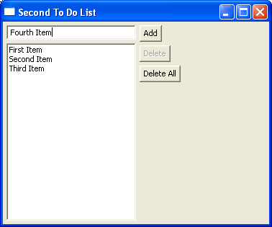

Step 3: Traffic Light Simulator
Develop a traffic light simulator that is a visual presentation of a traffic light. The traffic light model is provided as a class TraficLight, and as follows (NOTE: You don’t have to tylpe in the code, simply copy the provided TraficLight class to a package) – found in Lab 13:

public class TrafficLight {

int currentState;

// Constructor that makes a red traffic light
public TrafficLight() {
currentState = 1;
}

// Advance the traffic light to the next state
public int advance() {
setState(getState() % 3 + 1);
return currentState;
}

// Return the state of the traffic light (as a number from 1 to 3)
public int getState() {
return currentState;
}

// Set the state of the traffic light (as a number from 1 to 3)
// If the integer is out of range, do nothing
public void setState(int newState) {
if ((newState > 0) && (newState <4))
currentState = newState;
}

// Return a string representation of the traffic light
public String toString() {
switch(getState()) {
case 1: return "Red Traffic Light";
case 2: return "Yellow Traffic Light";
case 3: return "Green Traffic Light";
};
return "Broken Traffic Light";
}

public boolean isRed() {
return getState() == 1;
}

public boolean isYellow() {
return getState() == 2;
}

public boolean isGreen() {
return getState() == 3;
}
}

Your view should contain each of the following widget:

- Text
- CheckButton
- Combo
- Three Radio Buttons
- Advance Push Button
- List

You can layout your widgets in any way, just make sure that they don’t overlap with one other. The overall layout should look something like the picture below.

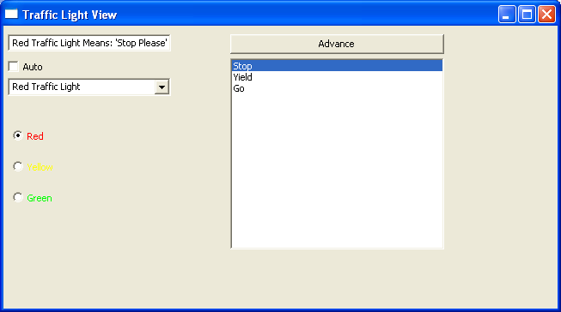

The goal is to have the view reflect the model. Each widget can be used to set the model, except for the Text widget (shown in the upper left hand corner). For example, pushing the Advance button advances the state of the traffic light. You can select the light in the List, or use the Radio Buttons, or use the Combo. Ticking the Auto check box, makes the lights cycle every second. The important part of your solution is that no matter which widget sets the state of the traffic lights, all other widgets should be updated to reflect the new state.

You may find the following useful for this lab:

When you create different button types you specify different parameters for button constructor:

pushButton = new Button(shell, SWT.PUSH); //creates push button
radioButton = new Button(shell, SWT.RADIO); //creates radio button
checkBox = new Button(shell, SWT.CHECK); //creates check box

To create a Timer that sends a message every n milliseconds you use the following:

new javax.swing.Timer (n, new TimerEventHandler());

The actionPerformed message is sent to the TimerEventHandler. This is a class you create and use to perform actions at defined periods. For example:

private class TimerEventHandler implements ActionListener {
public void actionPerformed(ActionEvent e) {
//Your handler code goes here
}
}

Most widgets have color properties. You can browse the individual class, but the following is usually safe to do.

aButton.setForeground (new Color(display, 255,0,0));

In this example, I set the foreground color of a button that is on the Display identified by display. The color I choose was RED. The arguments to the Color constructor are the RGB values. So in my case, I have the RED value set to the maximum of 255. You can play GREEN and BLUE values yourself. As a tip, YELLOW is just RED and GREEN.

Summary:
In this lab you have used the Eclipse’s SWT to build a GUI application.

