ECE 4755 Digital Signal Processing Laboratory
Final Project Report
Wayne Blaylock
October 5, 2026

Introduction
This project applies a 10-point discrete Fourier transform and its inverse to the speech recording and impulse response from Lab 7. The same transform is done in MATLAB, in floating-point C, and on the DSPLab TMS320C5509A. The last part multiplies the speech DFT by the impulse DFT in 10-sample blocks and takes the inverse transform, which is a 10-point circular convolution of each pair of blocks.
speech.wav is 182,932 samples at 44,100 Hz (4.148 s). impulse.wav is 130,036 samples at the same rate (2.949 s). echo_speech.wav from Lab 7 is included with the signal files but is not used in the calculations. The handout does not allow fft or ifft, so every transform uses the DFT and IDFT sums. The full recordings do not fit in C5509 on-chip memory, so the board runs use 256-sample excerpts: speech starting at sample 43968 and the impulse starting at sample 55680.

Method

Segmented 10-point DFT and IDFT
Each recording is split into non-overlapping blocks of 10 samples. The last block is zero-padded. Speech needs 18,294 blocks and 8 pad samples. The impulse needs 13,004 blocks and 4 pad samples. For block x[n],
X[k] = sum from n = 0 to 9 of x[n] exp(-j 2 pi k n / 10), k = 0 to 9.
The inverse is x[n] = (1/10) sum from k = 0 to 9 of X[k] exp(+j 2 pi k n / 10). MATLAB uses my_dft.m and my_idft.m. The C programs use the same sums with cos and sin.

C speech and impulse results
Question 2 reads the speech samples and writes speech_dft.txt with the real part, imaginary part, and magnitude of each bin. Question 3 reads that file and writes speech_idft.txt. Question 5 repeats both steps for impulse.wav. Question 4 and the second half of Question 5 plot those text files against the original wav files in MATLAB.

DSPLab
The board project is an empty CCS project for the TMS320C5509A with the XDS100v2 connection and dsplab55.gel on the C55xx core. The D/A tab is set to 10 kHz, FIFO length 256, signed. The oscilloscope input is D/A. Samples are written to 0x400002 only when bit 5 of the status register at 0x400008 is set. Key D0 at 0x600800 selects the impulse excerpt. Each of the 10 magnitude bins is held for 25 samples so the scope shows a bar graph. The product in Question 7 is Yr = Xr Hr - Xi Hi and Yi = Xr Hi + Xi Hr. Question 8 takes the IDFT of that product and writes the real part as a time waveform. Both traces are scaled to the DAC range.

Frequency-domain product
Question 9 plots the same excerpt product and IDFT that the board computed. Question 10 does the product on the full files. The impulse is zero-padded to the speech length so segment s of speech is multiplied by segment s of the impulse. A third plot repeats the board excerpts so it can be compared with Question 9.

Discussion

Question 1: MATLAB speech DFT and IDFT
The speech waveform is the Lab 7 recording. A single 10-sample block has a short DFT with energy in the low bins, which is expected for a 44.1 kHz sample rate and a 10-point transform (bin spacing is 4,410 Hz). The IDFT of every block, after the pad samples are dropped, matches the original. The largest absolute error was 2.78e-16, which is roundoff.
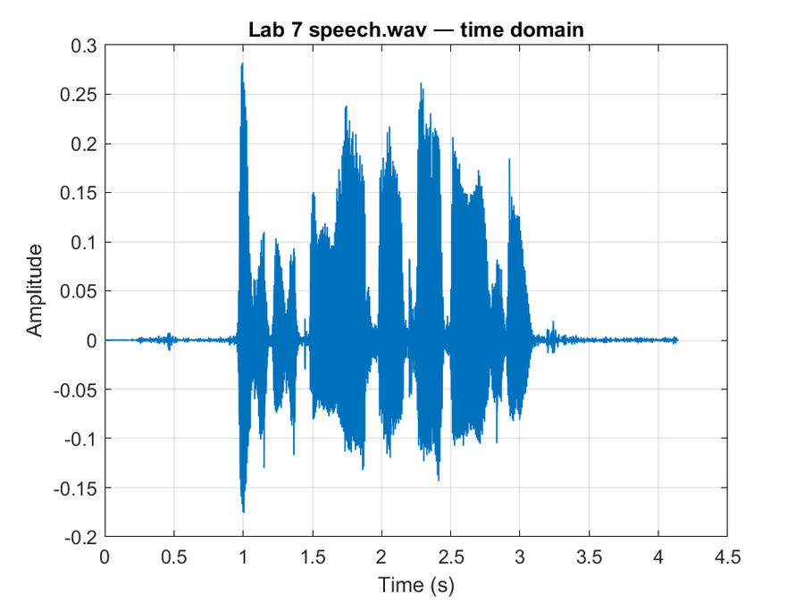
Figure 1. speech.wav in the time domain.
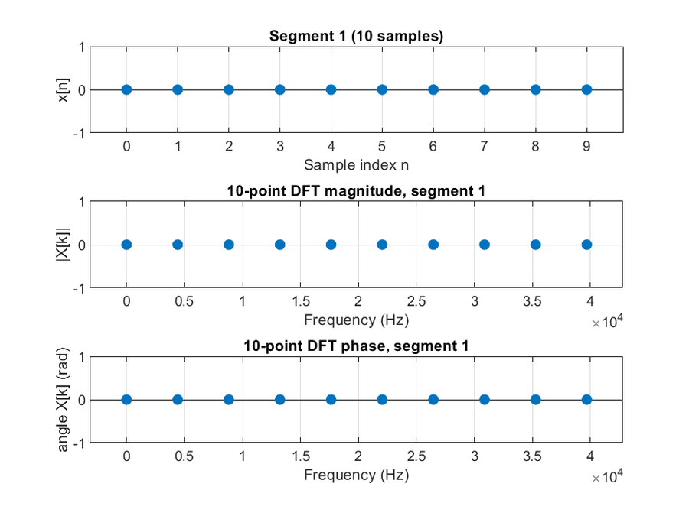
Figure 2. One 10-sample speech segment, its DFT magnitude, and its DFT phase.
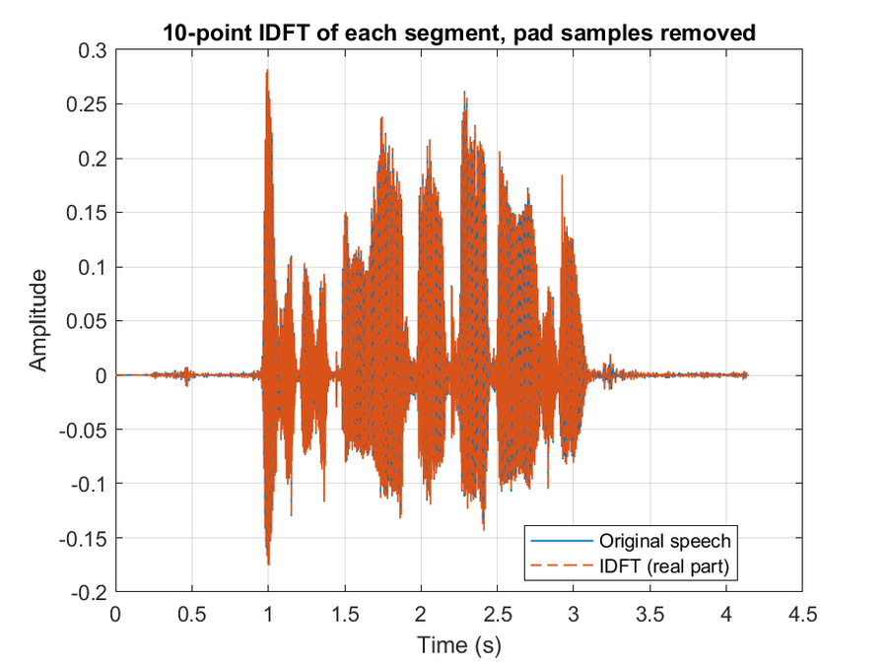
Figure 3. IDFT of the segmented speech DFT compared with the original recording.

Questions 2 to 4: floating-point C on the speech signal
The C DFT and IDFT use the same block length and the same pad. Question 4 plots the C IDFT on top of speech.wav and plots the concatenated C magnitude. The C IDFT sits on the original waveform, and the error plot stays at numerical noise. One voiced block (segment 4500) was also checked against a fresh MATLAB DFT of the same samples. The two magnitude plots agree, so the text files are the same transform as Question 1, not a different scaling or bin order.
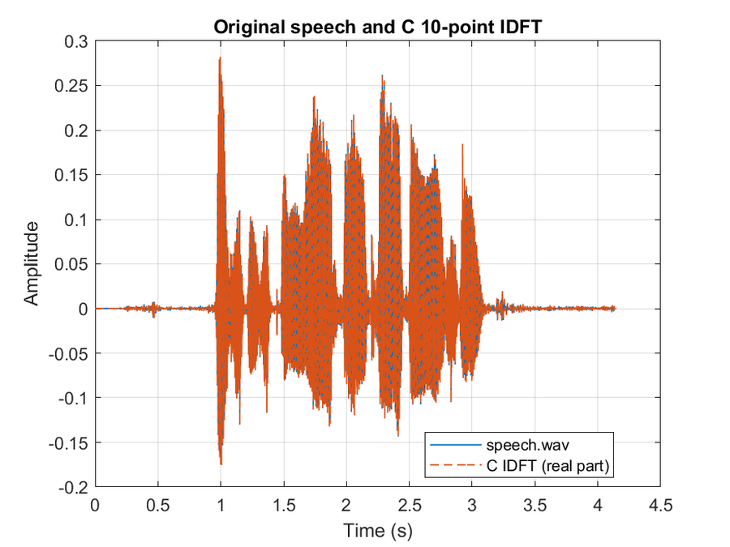
Figure 4. speech.wav and the Question 3 C IDFT.
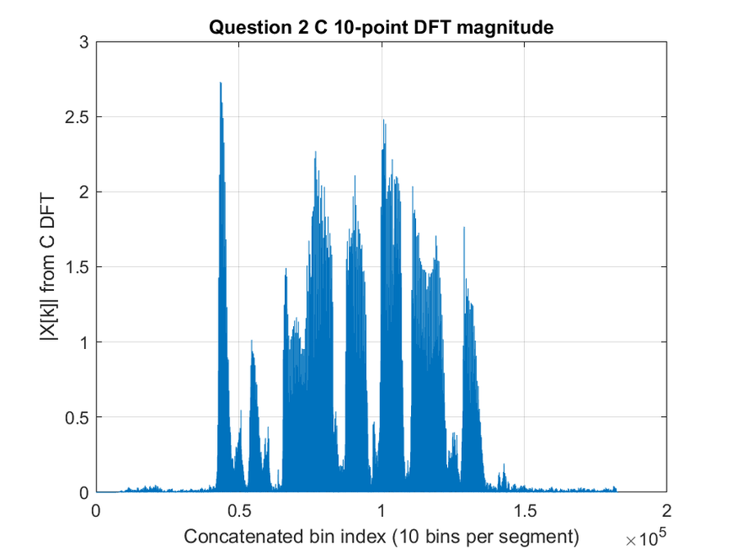
Figure 5. Concatenated 10-point DFT magnitude from the Question 2 C code.

Question 5: impulse response
impulse.wav is shorter and has a sharper attack than the speech file. The same 10-point procedure was used. The MATLAB IDFT again matches the file after the 4 pad samples are removed. The C IDFT of the impulse DFT matches the wav file the same way. The impulse spectrum is broader than the speech spectrum, which fits a shorter, more impulse-like waveform.
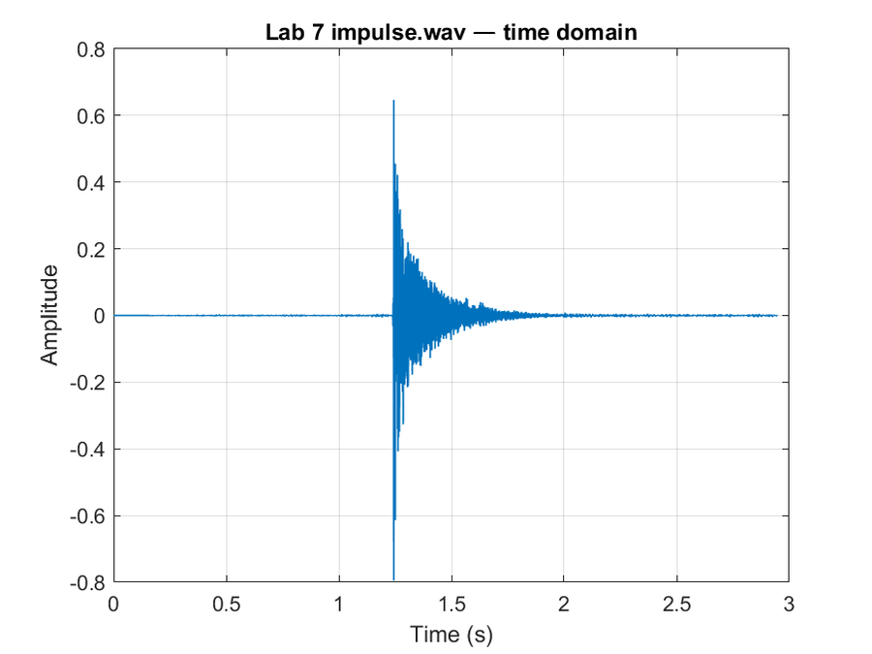
Figure 6. impulse.wav in the time domain.
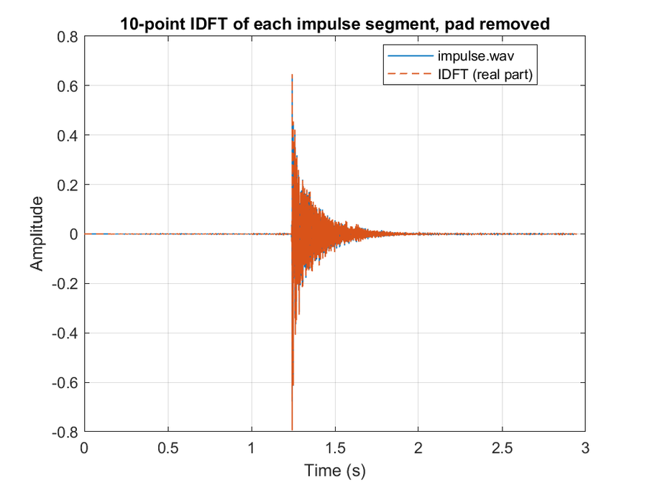
Figure 7. MATLAB IDFT of the segmented impulse DFT compared with impulse.wav.
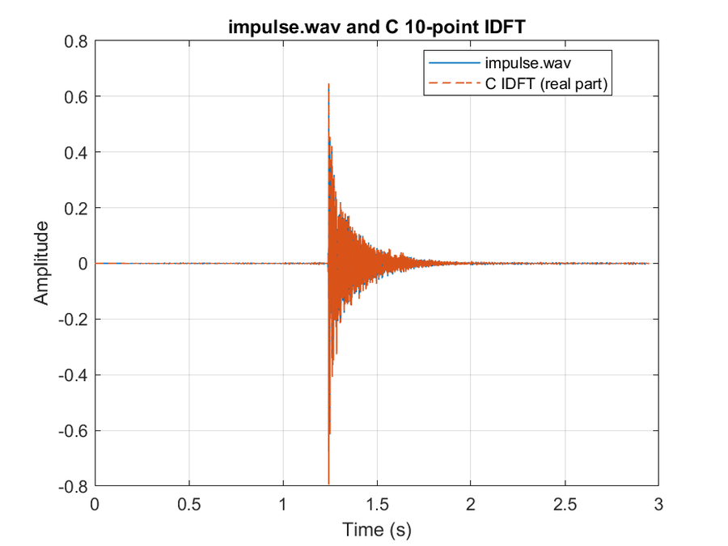
Figure 8. impulse.wav and the C IDFT of the impulse DFT.

Question 6: DFT on the DSPLab
The scope photos are the average magnitude of the 10-point DFT, with each bin stretched into a bar. D0 released is the speech excerpt. D0 pressed is the impulse excerpt. Speech energy sits in the low bins. The impulse excerpt is more spread out. The scope is auto-scaled, so the bar heights are relative, not the raw floating-point magnitudes.
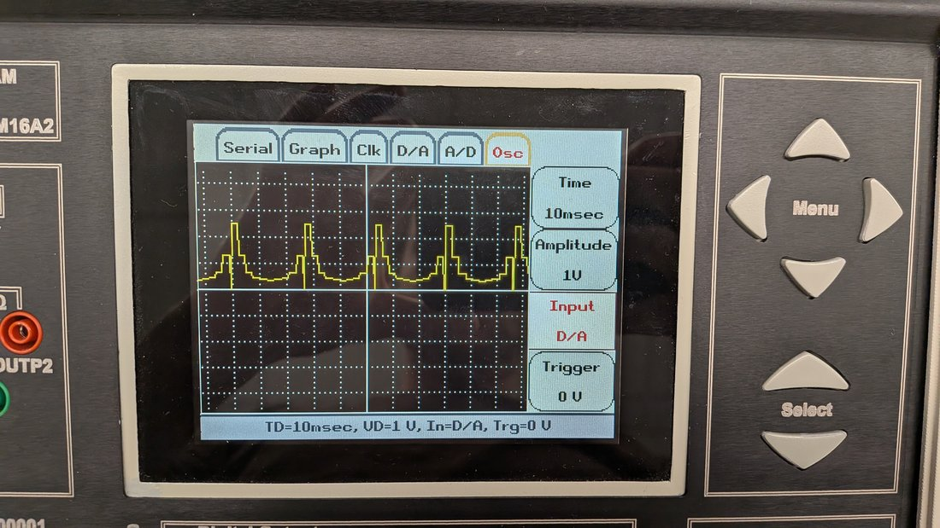
Figure 9. DSPLab oscilloscope, Question 6 speech DFT magnitude (D0 released).
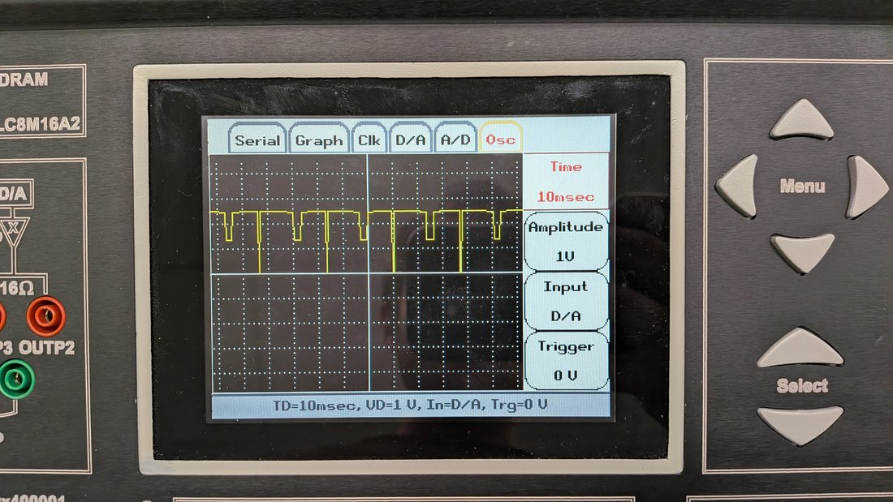
Figure 10. DSPLab oscilloscope, Question 6 impulse DFT magnitude (D0 pressed).

Questions 7 and 8: product and IDFT on the DSPLab
Question 7 multiplies the two excerpt DFTs, block by block, and plots the average magnitude. The scope again shows 10 bars. Question 8 takes the IDFT of each product. That waveform is the circular convolution of each 10-sample speech block with the matching impulse block. A few blocks dominate the peak, so after DAC scaling the scope shows repeated spikes with a flat baseline. That matches the MATLAB waveform in Question 9, where the small samples are still visible because they are not scaled to the largest peak.
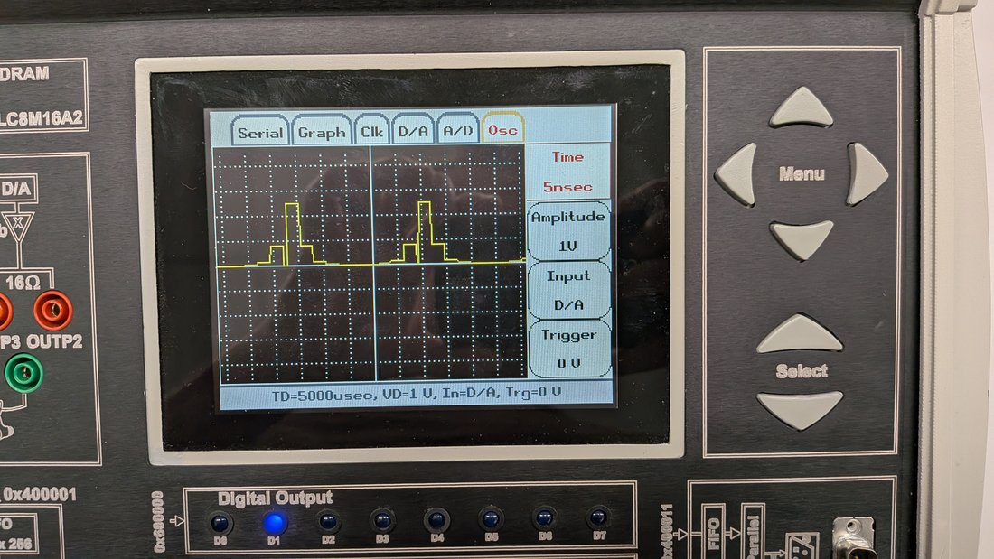
Figure 11. DSPLab oscilloscope, Question 7 magnitude of X[k] H[k].
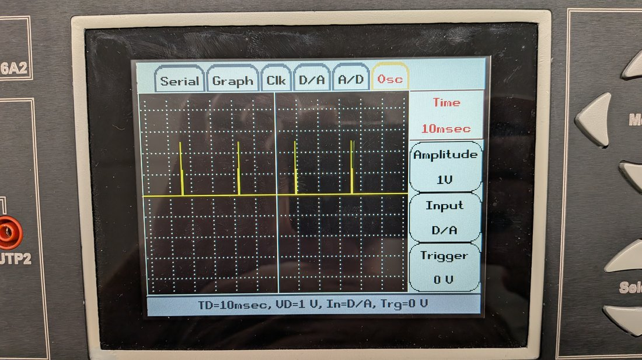
Figure 12. DSPLab oscilloscope, Question 8 IDFT of X[k] H[k].

Question 9: MATLAB plots of the board results
These plots use the same 256-sample excerpts and the same sums as the board. Figure 13 is the average product magnitude plotted in Question 7. Figure 14 is the IDFT plotted in Question 8. The shapes agree with the scope photos. The counts do not, because the DAC code scales the peak to about 20,000 counts.
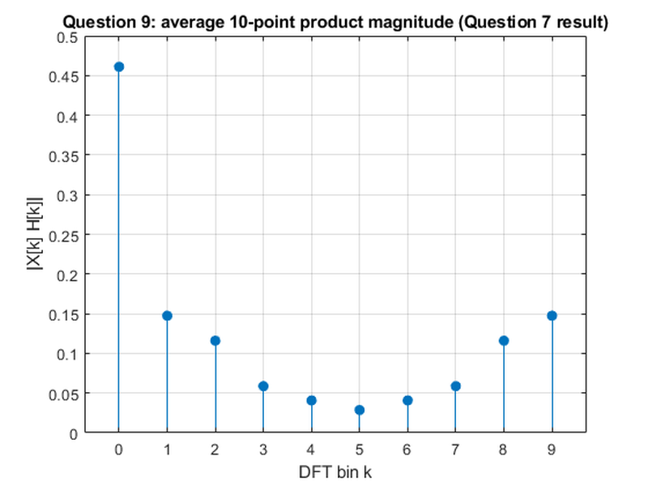
Figure 13. Question 9 plot of the Question 7 product magnitude.
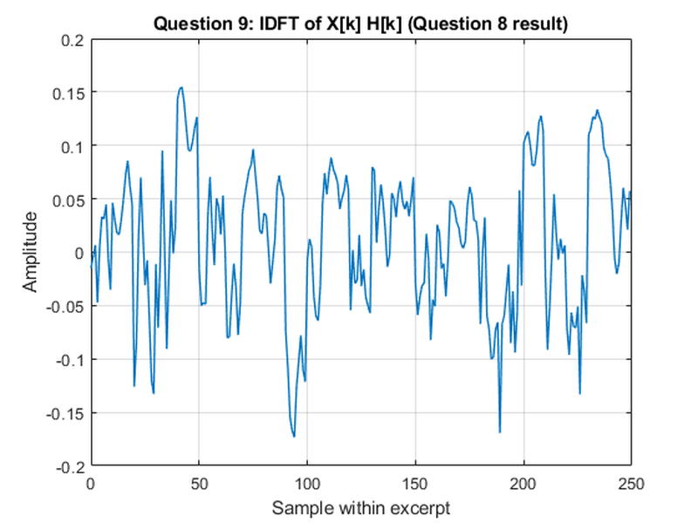
Figure 14. Question 9 plot of the Question 8 IDFT waveform.

Question 10: full-file product and comparison
Question 10 multiplies segment s of speech.wav by segment s of impulse.wav. The impulse file is shorter, so it is zero-padded to the speech length before the last block is padded to 10 samples. The average product magnitude is smoother than the excerpt plot because it includes the quiet parts of both files. The IDFT is the full-length sequence of 10-point circular convolutions, not one linear convolution of the two recordings.
Figure 17 recomputes the board excerpts. It matches Figures 13 and 14, so the MATLAB product and the board product are the same calculation. It does not match Figures 15 and 16. Those use time-aligned blocks of the full files. The board excerpts were the loudest 256 samples of each file, and they do not start at the same index.
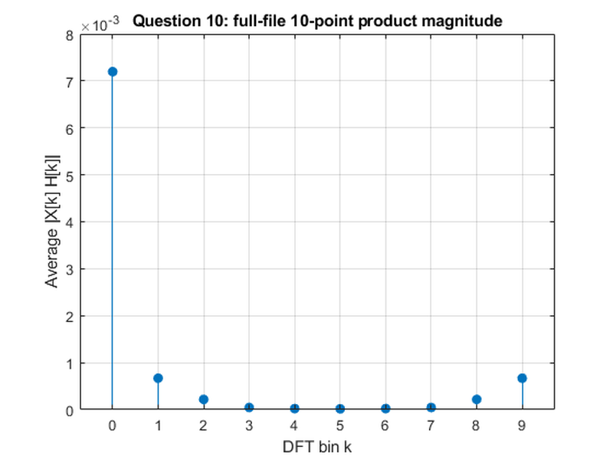
Figure 15. Question 10 average product magnitude of the full files.
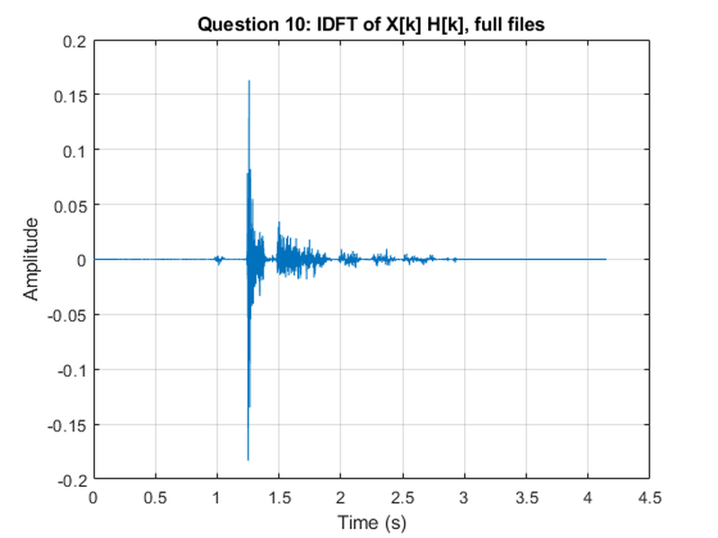
Figure 16. Question 10 IDFT of the full-file product.
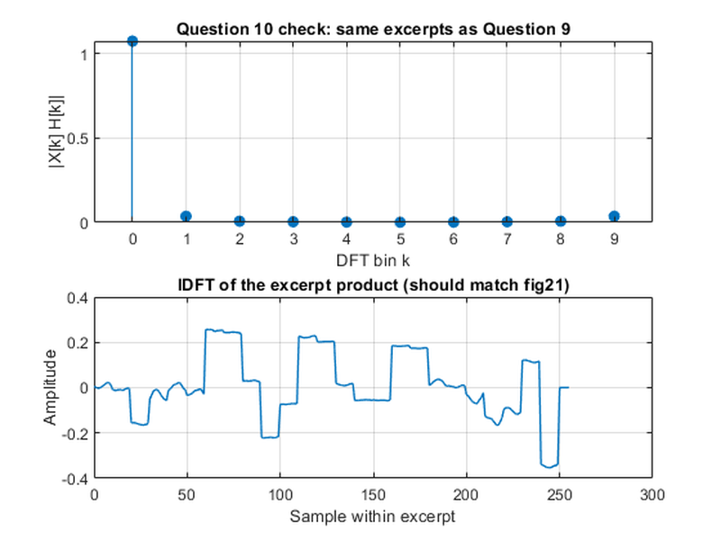
Figure 17. Question 10 check on the Question 9 excerpts. The stem plot matches Figure 13 and the time plot matches Figure 14.

Conclusion
A 10-point DFT and IDFT, written from the sum and applied in 10-sample blocks, reconstructs both Lab 7 recordings. The C results match the MATLAB results for speech and for the impulse. On the DSPLab, the same DFT runs on excerpts that fit in on-chip memory and can be shown on the D/A oscilloscope. Multiplying the DFTs and taking the IDFT implements a circular convolution per block. The board waveform and the MATLAB excerpt waveform agree. The full-file product is the same method on time-aligned blocks, so it is not expected to look like the excerpt photos.

Attached files
Code, signals, text results, figures, and scope photos are in the Final Project folder submitted with this report.
- signals: speech.wav, impulse.wav, echo_speech.wav
- code: Q1_speech_dft_idft.m, my_dft.m, my_idft.m, segmented_dft_idft.m, Q2_speech_dft.c, Q3_speech_idft.c, Q4_plot_c_speech.m, Q5_impulse_dft.m, Q5_plot_c_impulse.m, Q6_dft_osc_main.c, Q6_signals.h, dsplab55.gel, Q7_product_osc_main.c, Q8_idft_osc_main.c, Q9_plot_q7_q8.m, Q10_full_product.m
- data: Q2_speech_samples.txt, Q2_speech_dft.txt, Q3_speech_idft.txt, Q5_impulse_samples.txt, Q5_impulse_dft.txt, Q5_impulse_idft.txt
- figures: Q1 Fig01 through Fig06, Q4 Fig07 through Fig10, Q5 Fig11 through Fig19, Q9 Fig20 and Fig21, Q10 Fig22 through Fig24
- scope: Q6 speech, Q6 impulse, Q7 product, Q8 IDFT

File lengths
File | Samples | Fs (Hz) | Duration (s)
speech.wav | 182932 | 44100 | 4.148
impulse.wav | 130036 | 44100 | 2.949
echo_speech.wav | 312967 | 44100 | 7.097

