Statistical Inference: Peer Graded Assigment - Part 1

Wayne Heller

April 22, 2017

## Overview

*Part 1 Central Limit Theorem Simulation:* This part of the analysis compares the sample mean and variance for a large number of means of a simulated exponential distribution. The expected result is that the distribution of means will be Normal with a mean approximately equal to the theoretical mean of the exponential distribution and a variance approximately equal to the theoretical variance of the exponential distribution divided by the number of samples in each group.

## Simulations

Create an Exponential distribution with 1,000 simulated observations

seed = 12345  
nosim <- 1000 # number of simulated values  
lambda <- 0.2 # lambda of 0.2 was provided   
x.dist <- rexp(nosim, lambda) # simulated exponential distribution  
dat <- data.frame(x = x.dist) # create a dataframe from the values for plotting  
x.mean = mean(dat$x) # mean of the simulated distribution  
x.var = var(dat$x) # variance of the simulated distribution

Next, create a distribution of Means from 1,000 simulations of 40 observations each

nsize <- 40 # number of observations in 1 simulation  
x.dist <- rexp(nosim * nsize, lambda) # simulated exponential distribution  
x.avg = apply(matrix(x.dist, nosim), 1, mean) # calculates the mean of each simulation  
dat.avg <- data.frame(x = x.avg) # putting in a data.frame for plotting  
x.avg.mean = mean(dat.avg$x) # simulated mean  
x.avg.var = var(dat.avg$x) # simulated variance  
x.avg.mean.theoretical = 1/lambda # theoretical mean  
x.avg.var.theoretical = (1/lambda^2)/nsize # theoretical variance

### Simulated Exponential Distribution With Lambda = 0.2 and 1,000 Observations

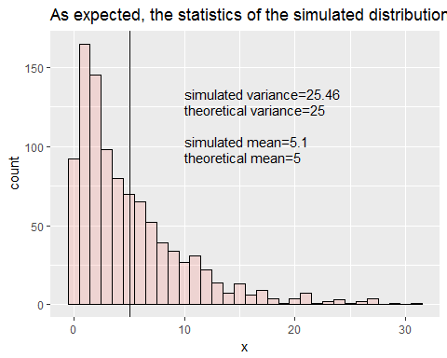

Figure 1: Exponential Distribution

### Distribution of Sample Means

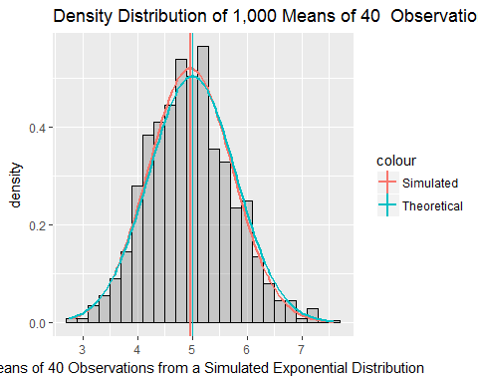

Figure 2: Distribution of Means

#### Comparison of Simulated and Theoretical Statistics

|  |  |  |
| --- | --- | --- |
| Statistic | Theoretical Value | Simulated Value |
| Mean | 5.000 | 4.9638222 |
| Variance | 0.625 | 0.5871752 |

### Summary

Comparing Figure 1 to Figure 2 demonstrates how the distribution of means becomes Gaussian for a large number of simulations. In addition, the distribution of means from the simulation (the green curve and line in Figure 2) is a close approximation to the theoretical normal distribution with mean = 1/lambda and variance = (1/lambda^2) / n, where n is 40 in this simulation (the red curve and line in Figure 2).

# APPENDIX

### Code for Figure 1

createFig1

## function() {  
##   
## g <- ggplot(dat, aes(x = x, fill="red"))   
## g <- g + geom_histogram(alpha = .20, binwidth=1, colour = "black")   
## g <- g + geom_vline(xintercept=x.mean)   
## g <- g + annotate(geom = "text", x=10, y=100, label=paste0("simulated mean=", as.character(round(x.mean,digits=2))), size=4, angle=0, vjust=0, hjust=0)  
##   
## g <- g + annotate(geom = "text", x=10, y=90, label=paste0("theoretical mean=", as.character(round(1/lambda,digits=2))), size=4, angle=0, vjust=0, hjust=0)  
##   
## g <- g + annotate(geom = "text", x=10, y=130, label=paste0("simulated variance=", as.character(round(x.var, digits=2))), size=4, angle=0, vjust=0, hjust=0)  
##   
## g <- g + annotate(geom = "text", x=10, y=120, label=paste0("theoretical variance=", as.character(round(1/lambda^2, digits=2))), size=4, angle=0, vjust=0, hjust=0)  
## g <- g + theme(legend.position="none")  
## g <- g + labs(title = "As expected, the statistics of the simulated distribution are close to the theoretical ")  
## print(g)  
## }

### Code for Figure 2

createFig2

## function() {  
## g <- ggplot(dat.avg, aes(x = x))   
##   
## g <- g + geom_histogram(alpha = .25, binwidth=.2, color = "black", aes(y=..density..))   
##   
## g <- g + geom_vline(aes(xintercept=x.avg.mean, color="Simulated"), size = 1.0)   
##   
## g <- g + stat_function(fun=dnorm,args=list(mean=x.avg.mean, sd=sqrt(x.avg.var)), size = 1.0, aes(color="Simulated"))  
##   
## g <- g + geom_vline(aes(xintercept=x.avg.mean.theoretical, color="Theoretical"), size=.5)   
##   
## g <- g + stat_function(fun=dnorm,args=list(mean=x.avg.mean.theoretical, sd=sqrt(x.avg.var.theoretical)), aes(color = "Theoretical"), size = 1.0)  
##   
## g <- g + labs(title = "Density Distribution of 1,000 Means of 40 Observations", x= " Means of 40 Observations from a Simulated Exponential Distribution")  
## print(g)   
## }