

**Site Plan**

**Site Name**

The site is going to be called atmospheria.org. I chose this word because weather is the state of the atmosphere and to make it more interesting, I changed the word slightly.

**Site Purpose**

The purpose of this site is to provide weather information to the user. The user will have access to today's weather, tomorrows weather, and the outlook which will cover the next 3 to 5 days. The weather reports will be available as a summary in the place you live but will also have the functionality to be able to search for other cities. Another service the site will provide will be an hourly breakdown and the percentage chance of sun/rain/snow/ice at that hour.

**Target Audience & Scenarios**

The target audience of atmospheria.org is as stated below:

**Who**:

* Someone who travels for work.
* Someone planning a weekend away or a vacation.
* Someone who needs to go shopping.
* Someone planning to go out on a boat.
* A parent wanting to see if the soccer game will be a washout.
* A teenager who has a paper route might want to know the weather for the next day.
* Someone who loves sport like roller skating or surfing.
* Someone meeting friends for a walk.

**Age**: 16-100

**Technology**: The user of atmospheria.org will access the site using the following ways:

* Mobile phones and tablets when out and about
* Laptops when travelling for business.
* Computers when at home or work.

**Motivation**: When the user would like to go out for any reason, they will be able to check the weather beforehand to decide if they are going to do that thing or not and also the shoes and clothing they are going to wear.

**Personas**

**Persona 1**

**Occupation**: Full time student

**Demographics and Education**: 16 year old male. Likes to play soccer at the weekend. Has an evening job a short walk from home.

**Goals and Motivation for using the site**: To make me aware what the weather holds for soccer at the weekends and my walk to work.

**Social**: Has a very active social life. At school during the week then out with friends at the weekend.

**Technology**: Definitely a mobile phone. Also uses a tablet and laptop at home.

**Quote**: I just go with the flow and hang out with my friends. Being busy keeps me out of trouble.

**Persona2**

**Occupation**: Full time examination administrator and invigilator. Works for a college 3 miles from home.

**Demographics and Education**: 38 year old female. Married with 3 children. Has qualifications in IT, and Administration to college standard.

**Goals and Motivation for using the site**: Need to know how the weather will be on the school run and also on the way to work.

**Social**: Not much of a social life. The odd evening out with friends. Prefers the company of spouse and children.

**Technology**: Always has a mobile with her and had use of husbands laptop and uses her laptop.

**Quote**: I don’t like going out without checking what I need to wear and if I need an umbrella.

**Scenarios**

1. I want to go running on Saturday morning
2. I need to go and pick up my son from school
3. I am planning to go away for the weekend
4. I am heavily pregnant and need to know if I need the aircon on
5. I like to wash my car on a regular basis

**Scenario 1**

The forecast can be checked to see if the sun is shining this Saturday.

**Scenario 2**

This is an emergency pickup as the son is sick. The weather will give an idea of how quickly he can be picked up.

**Scenario 3**

Will the sun be shining at the weekend? You will be able to find out.

**Scenario 4**

If the sun is too hot it can be uncomfortable. Aircon or no aircon. That question will be answered.

**Scenario 5**

It all depends on what type of weather a person likes to wash the car. My neighbour does it when it is raining so it all depends on preference.

**Site Map**

This section describes how the atmospheria.org website will be structured.

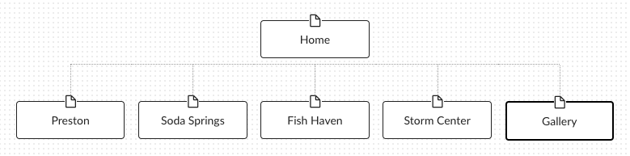

**Color Scheme**

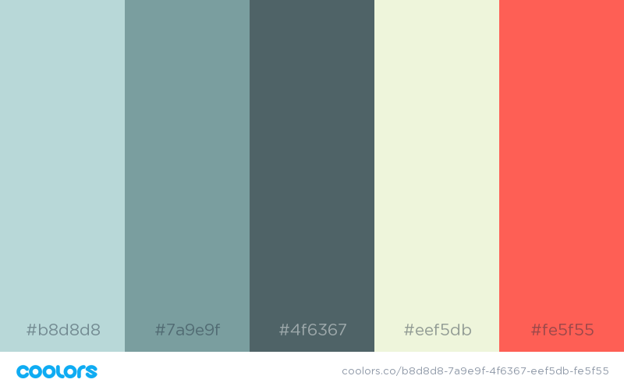

**Typography**

|  |  |  |  |  |
| --- | --- | --- | --- | --- |
|  | Font | Size | Hex Code | Sample of Font |
| Site Header | Montserrat | 3rem | #4f6367 | Sample |
| Motto | Montserrat | 1rem | #fff | Sample |
| Primary Navigation | Montserrat | .9rem | #b8d8d8 | Sample |
| Footer Navigation | Montserrat | 0.75rem | #4f6367 | Sample |
| Heading 1 (h1) | Montserrat | 1.875rem | #7a9e9f | Sample |
| Heading 2 (h2) | Montserrat | 1.5625rem | #7a9e9f | Sample |
| Heading 3 (h3) | Montserrat | 1.25rem | #7a9e9f | Sample |
| Paragraph text (p) | Raleway | 1rem | #000000 | Sample |

**Wireframe Sketches**