2026.04.26 06:29:25.868 2026.03.01 00:00:00 GoldPulse_BurstTrend_v3_10_TradeFlow initialized on GOLD
2026.04.26 06:29:25.868 2026.03.01 00:00:00 Mode: EDGE-FIRST BURST TREND | TrendTF=PERIOD_M5 EntryTF=PERIOD_M1 BiasTF=PERIOD_H1
2026.04.26 06:29:25.868 2026.03.01 00:00:00 Trend: EMA 7/24 anchor=100 bias=OFF
2026.04.26 06:29:25.868 2026.03.01 00:00:00 Probe confirm: 45.0 pts or $0.30 | spread mult 0.80
2026.04.26 06:29:25.868 2026.03.01 00:00:00 Basket: target $1.50 loss $-2.00 max life 900 sec
2026.04.26 06:29:25.868 2026.03.01 00:00:00 Exposure: probe lot 0.01 burst lot 0.01 max positions 3 max lots 0.03
2026.04.26 06:29:25.868 2026.03.01 00:00:00 ============================================================
2026.04.26 06:29:26.520 GOLD : real ticks begin from 2026.03.02 00:00:00

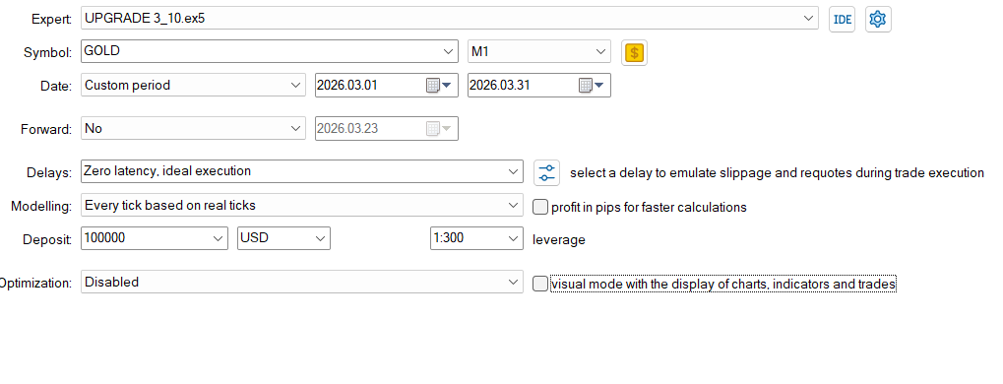

DATA EVERY TICK BASED ON REAL TICK
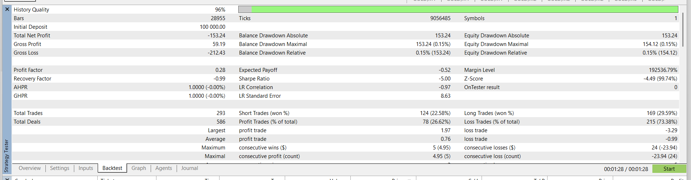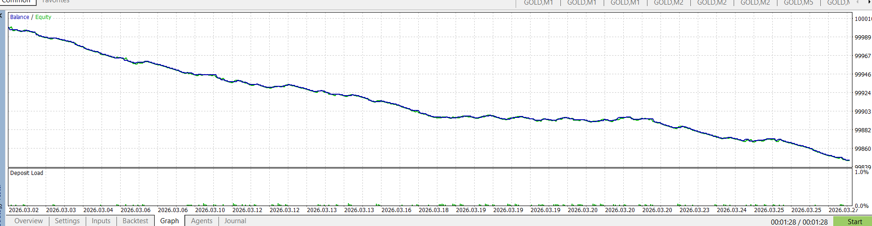

EVERY TICK DATA
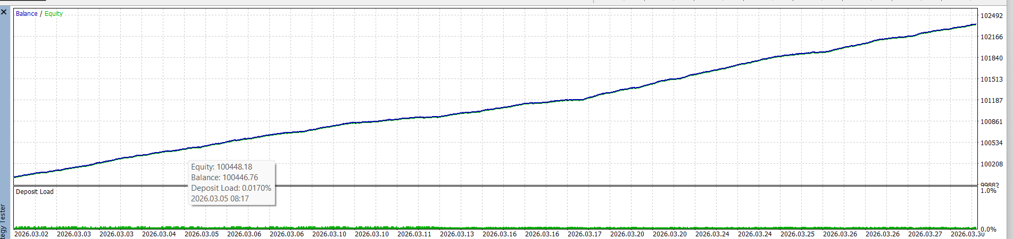
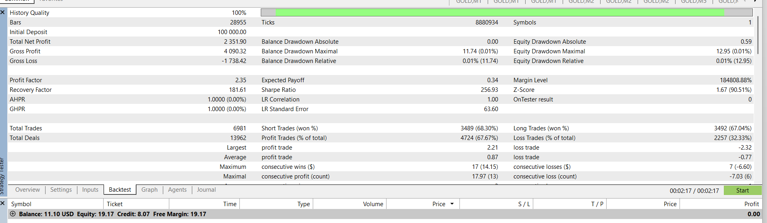
SETTINGS USED ON EVERY TICK
; saved on 2026.04.26 04:34:33
; this file contains input parameters for testing/optimizing UPGRADE 3_10 expert advisor
; to use it in the strategy tester, click Load in the context menu of the Inputs tab
;
; === EA IDENTITY ===
InpEAName=GoldPulse_BurstTrend_v3_10_TradeFlow
InpMagicNumber=26042530||26042530||1||260425300||N
InpShowDashboard=true||false||0||true||N
InpDebug=false||false||0||true||N
; === TRADE DIRECTION ===
InpSignalMode=0||0||0||2||N
InpAllowHedgeBuySell=false||false||0||true||N
; === TIMEFRAMES ===
InpEntryTF=1||0||0||49153||N
InpTrendTF=5||0||0||49153||N
InpBiasTF=16385||0||0||49153||N
InpATRTF=5||0||0||49153||N
; === TREND FILTERS ===
InpUseTrendFilter=true||false||0||true||N
InpTrendFastEMA=7||20||1||200||N
InpTrendSlowEMA=24||50||1||500||N
InpTrendAnchorEMA=100||200||1||2000||N
InpUseTrendAnchor=true||false||0||true||N
InpUseTrendSlopeFilter=true||false||0||true||N
InpTrendSlopeLookback=3||3||1||30||N
InpUseBiasFilter=false||false||0||true||N
InpBiasEMA=200||200||1||2000||N
; === ADX / DI FILTER ===
InpUseADXFilter=true||false||0||true||N
InpADXPeriod=14||14||1||140||N
InpADXMin=14.0||14.0||1.400000||140.000000||N
InpUseDIFilter=false||false||0||true||N
; === M1 CANDLE / EMA CONFIRMATION ===
InpUseM1CandleConfirm=false||false||0||true||N
InpEntryFastEMA=20||20||1||200||N
InpEntrySlowEMA=50||50||1||500||N
InpMinBodyATR=0.03||0.03||0.003000||0.300000||N
InpRequireCloseBeyondPrev=true||false||0||true||N
InpMaxCloseDistanceATR=1.8||1.8||0.180000||18.000000||N
; === TICK IMPULSE CONFIRMATION ===
InpProbeStyle=1||0||0||1||N
InpTickLookback=6||6||1||60||N
InpTickImpulsePoints=20.0||20.0||2.000000||200.000000||N
InpMinDirectionalTicks=3||3||1||30||N
InpMaxImpulseSeconds=3.0||3.0||0.300000||30.000000||N
; === SPREAD / VOLATILITY FILTER ===
InpMaxSpreadPoints=80||80||1||800||N
InpUseSpreadATRFilter=true||false||0||true||N
InpMaxSpreadATRRatio=0.25||0.25||0.025000||2.500000||N
InpATRPeriod=14||14||1||140||N
InpUseATRRangeFilter=true||false||0||true||N
InpMinATRPoints=80.0||80.0||8.000000||800.000000||N
InpMaxATRPoints=1500.0||1500.0||150.000000||15000.000000||N
InpExtraStopBufferPoints=5||5||1||50||N
InpSlippagePoints=30||30||1||300||N
; === LOT / EXPOSURE ===
InpLotMode=0||0||0||1||N
InpFixedLot=0.01||0.01||0.001000||0.100000||N
InpRiskPercent=0.25||0.25||0.025000||2.500000||N
InpProbeLot=0.01||0.01||0.001000||0.100000||N
InpBurstLot=0.01||0.01||0.001000||0.100000||N
InpMaxLot=1.0||1.0||0.100000||10.000000||N
InpMaxPositionsPerSide=3||3||1||30||N
InpMaxTotalPositions=3||3||1||30||N
InpMaxTotalLots=0.03||0.03||0.003000||0.300000||N
; === PROBE -> BURST LOGIC ===
InpProbeConfirmPoints=45.0||45.0||4.500000||450.000000||N
InpProbeConfirmMoney=0.3||0.3||0.030000||3.000000||N
InpProbeConfirmSpreadMult=0.8||0.8||0.080000||8.000000||N
InpProbeFailPoints=80.0||80.0||8.000000||800.000000||N
InpProbeFailMoney=-0.9||-0.9||-0.090000||-9.000000||N
InpProbeMaxSeconds=90||90||1||900||N
InpProbeTimeoutMinPoints=-10.0||-10.0||-1.000000||-100.000000||N
InpDirectionPauseAfterProbeFailSec=120||120||1||1200||N
InpMaxProbeFailsBeforeLongPause=2||2||1||20||N
InpLongDirectionPauseSec=600||600||1||6000||N
; === BURST ADD RULES ===
InpBurstOrdersPerAdd=1||1||1||10||N
InpMinSecondsBetweenAdds=5||5||1||50||N
InpMinBasketProfitToAdd=-0.1||-0.1||-0.010000||-1.000000||N
InpMinSameSideSpacingPoints=30.0||30.0||3.000000||300.000000||N
InpRequireFreshSignalToAdd=true||false||0||true||N
InpAddOnlyIfPriceImproves=true||false||0||true||N
; === BROKER STOP / TRADE MANAGEMENT ===
InpStopMode=1||0||0||1||N
InpFixedSLPoints=450.0||450.0||45.000000||4500.000000||N
InpATRSLMultiplier=0.85||0.85||0.085000||8.500000||N
InpUseBreakEven=true||false||0||true||N
InpBETriggerPoints=70.0||70.0||7.000000||700.000000||N
InpBEPlusPoints=8.0||8.0||0.800000||80.000000||N
InpUseTrailing=true||false||0||true||N
InpTrailStartPoints=100.0||100.0||10.000000||1000.000000||N
InpTrailATRMultiplier=0.6||0.6||0.060000||6.000000||N
InpTrailMinPoints=70.0||70.0||7.000000||700.000000||N
InpTrailStepPoints=15.0||15.0||1.500000||150.000000||N
InpMinSecondsBetweenTrailUpdates=2||2||1||20||N
; === BASKET EXITS ===
InpUseBasketClose=true||false||0||true||N
InpBasketProfitMoney=1.5||1.5||0.150000||15.000000||N
InpBasketLossMoney=-2.0||-2.0||-0.200000||-20.000000||N
InpUseBasketProfitTrail=true||false||0||true||N
InpBasketTrailStartMoney=1.0||1.0||0.100000||10.000000||N
InpBasketTrailGivebackMoney=0.55||0.55||0.055000||5.500000||N
InpBasketMaxLifeSeconds=900||900||1||9000||N
InpCooldownAfterBasketProfitSec=10||10||1||100||N
InpCooldownAfterBasketLossSec=180||180||1||1800||N
; === SESSION / DAILY PROTECTION ===
InpUseSessionFilter=false||false||0||true||N
InpSessionStartHourServer=7||7||1||70||N
InpSessionEndHourServer=21||21||1||210||N
InpTradeMondayToFridayOnly=true||false||0||true||N
InpMaxTradesPerDay=2000||120||1||1200||N
InpMaxConsecutiveBasketLosses=5||4||1||40||N
InpDailyProfitTargetMoney=0.0||0.0||0.000000||0.000000||N
InpDailyLossLimitMoney=150.0||150.0||15.000000||1500.000000||N
InpDailyLossLimitPercent=2.0||2.0||0.200000||20.000000||N
; === ALERTS ===
InpEnableAlerts=false||false||0||true||N
InpEnableSound=false||false||0||true||N
InpBuySound=alert.wav
InpSellSound=request.wav

When you ran “Every tick based on real ticks”, did you also set Spread = Current (or variable)? And in the “Every tick” run was spread effectively fixed/ideal? That single difference can explain a huge performance gap. NO

