BSCMail User Guide

# Introduction

BSCMail is a volunteer-management and scheduling application suitable for use by non-profit and for-profit organizations alike. It is easy to use and customizable to meet virtually any need.

BSCMail is distributed under the GNU General Public License. Please read the file LICENSE or visit <http://www.gnu.org/licenses/> for details.

This guide corresponds to BSCMail version 4.0.

# Tutorial

What is BSCMail?

BSCMail is an application that helps an organization manage volunteers and send scheduling emails. Let’s run through some of the features of BSCMail together.

When you launch BSCMail, you see the Main Window.

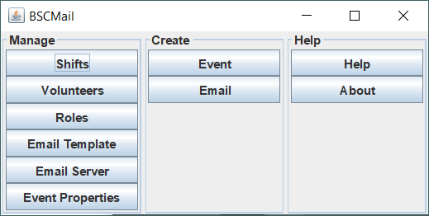

You’re running an event, so click the **Event** button in the **Create** column.

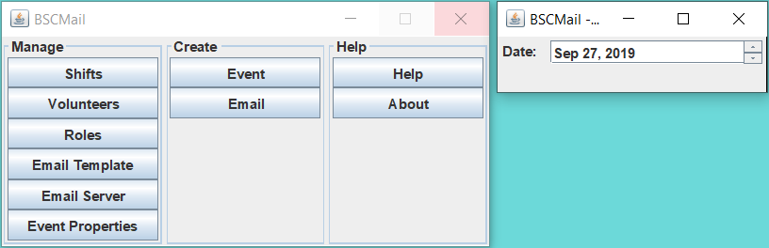

Hm. There’s not much to do here. You can change the date of the event and... not much else. We need to add more definition to the event. Let’s add some volunteer shifts. Click the Shifts button in the Manage column of the main window to launch the Manage Shifts Window. You can leave the Event Setup window open.

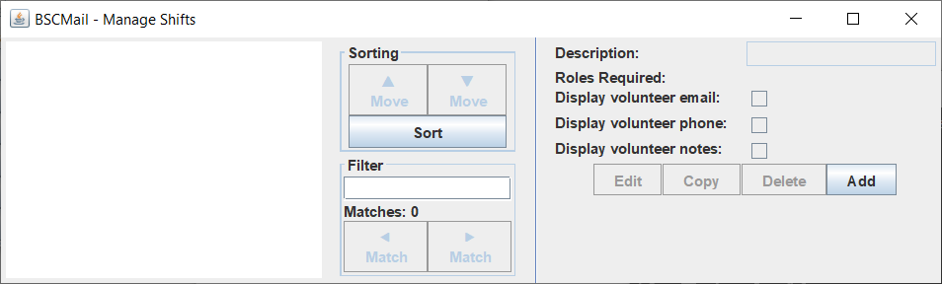

There are no shifts defined in the application. Let’s create one. Click the **Add** button. The application opens the Add Shift Window.

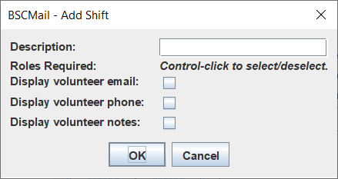

Type “Setup 8:00-9:00” in the **Description** text field and click **OK**.

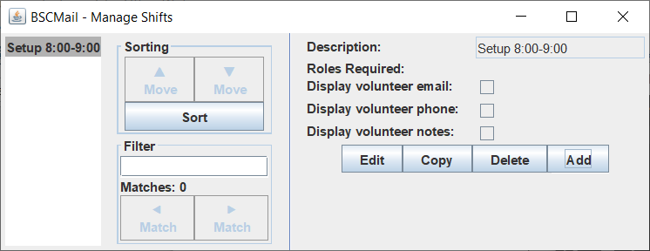

Let’s add another shift. Click the **Add** button, type “Door 9:00-11:00” in the **Description** text field, and click **OK**.

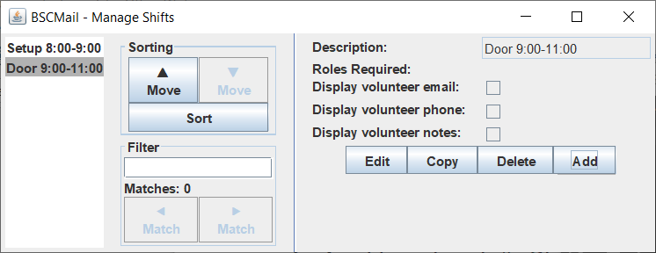

Oops! We made an error; the shift goes until 10:00, not 11:00. Select the shift in the list on the left and click the **Edit** button. The application opens the Add Shift Window.

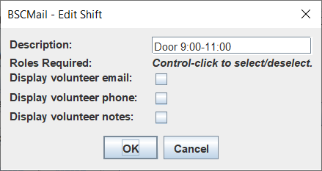

Edit the description of the shift and click the **OK** button.

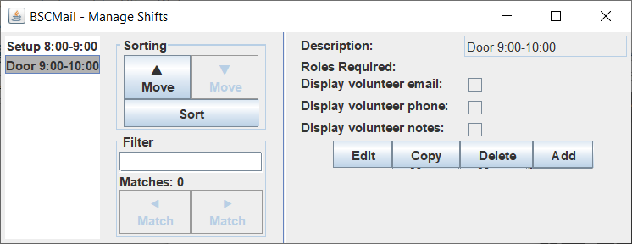

|  |
| --- |
| ***Tip!*** *You can edit multiple shifts at once. Hold the* ***Ctrl*** *button while you click to select or deselect shifts. When you click the* ***Edit*** *button, you will edit all the selected shifts simultaneously.* |

We actually need two people at the door at 9:00. Select the shift and click the **Copy** button. BSCMail makes a copy of that shift and places it immediately after.

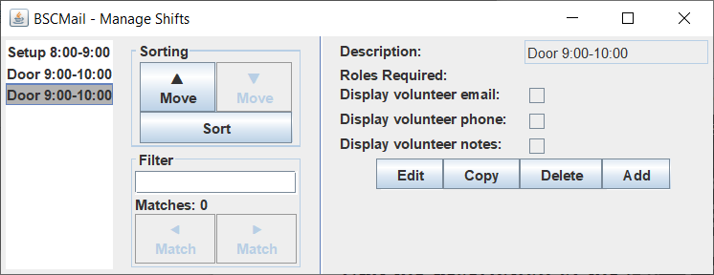

|  |
| --- |
| ***Tip!*** *You can copy multiple shifts at once. When you click the* ***Copy*** *button, copies of all the selected shifts will appear after the last selected shift.* |

Take another look at the Event Setup window.

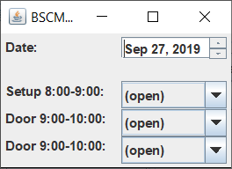

The shifts you added automatically appeared. Most of the changes you will make in other screens will automatically be reflected in the Event Setup window. Now let’s try to assign a volunteer to one of the shifts. Click one of the dropdown boxes next to the shifts.

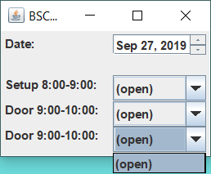

Whoops! We don’t have any volunteers defined. Go back to the Main Window and click the **Volunteers** button in the **Setup** column to launch the Manage Volunteers Window.

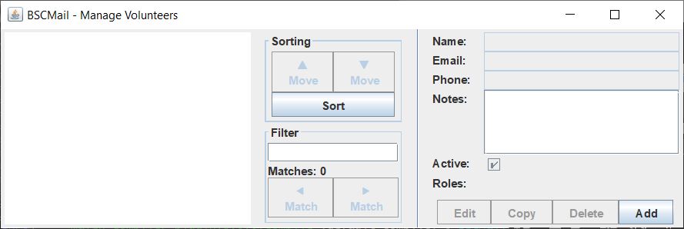

The Manage Volunteers Window works similarly to the Manage Shifts Window. Let’s enter a few volunteers. Click the **Add** button, enter the volunteer’s name, email address, and phone number in the appropriate text boxes, and click the **OK** button. Do this a few times to create some volunteers.

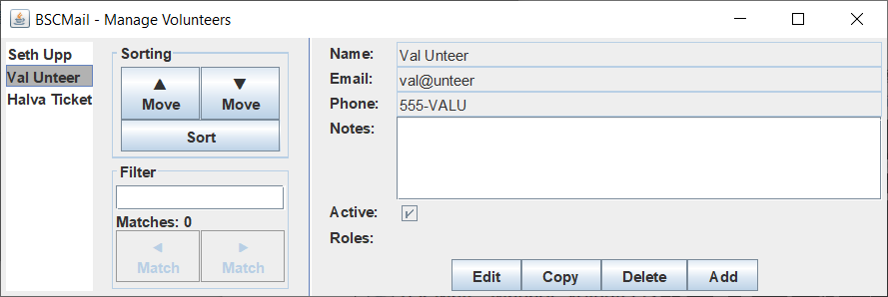

You can select a volunteer and move it up or down in the list by clicking the **▲ Move** or **▼ Move** buttons. You can also sort them alphabetically by clicking the **Sort** button. Try clicking it now.

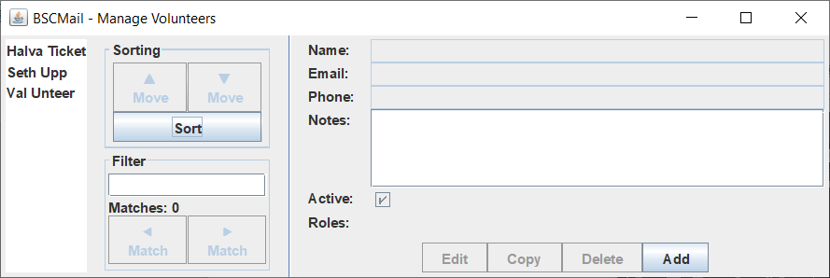

|  |
| --- |
| ***Tip!*** *You can move multiple volunteers at once. Hold the* ***Ctrl*** *button while you click to select or deselect volunteers. When you click the move buttons, all the selected volunteers will move!* |

|  |
| --- |
| ***Another tip!*** *You can also move volunteers of groups of volunteers by draging and dropping them with the mouse!* |

Notice that the volunteers have been sorted. Now let’s assign them to the shifts for the event. Go to the Event Setup Window and try clicking on one of the dropdowns again.

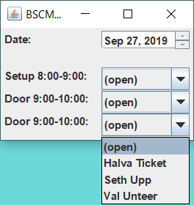

Good, we have some volunteers. Select some volunteers from the dropdowns to assign them to the shifts.

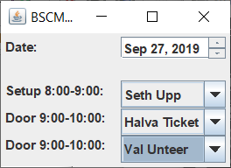

Great! We’re able to use BSCMail to schedule volunteers now. But we can add a little bit of sophistication to the way we schedule. Suppose we want to restrict a shift to a certain subset of volunteers. (For instance, suppose we want to restrict the Door 9:00-10:00 shift to a set of volunteers who are trusted to handle money.) To do this, we need to create some volunteer roles. Go back to the Main Window and click the **Roles** button in the **Setup** column to launch the Manage Roles Window.

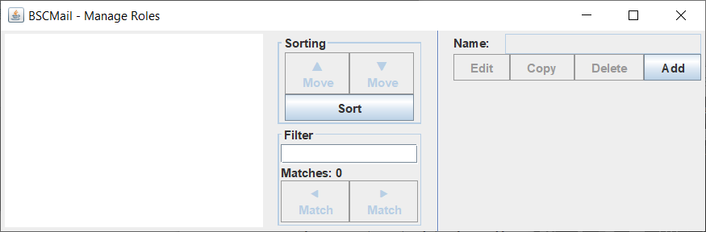

The Manage Roles Window works similarly to the Manage Shifts Window and Manage Volunteers Window. Let’s add a new role. Using the **Add** button, add a role called “Money handling”. While we’re at it, let’s add another role called “Customer service”.

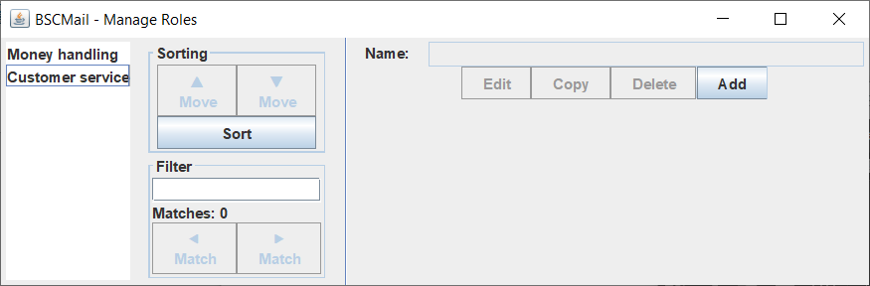

Good. Now let’s assign a role to the door shift. Return to the Manage Shifts Window, select the two Door 9:00-10:00 shifts, and click the **Edit** button.

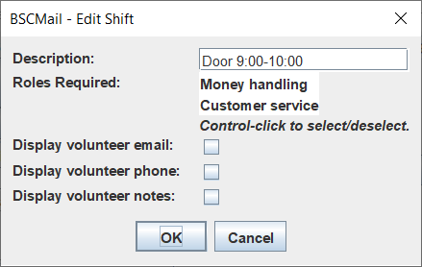

Any roles selected for a volunteer will show up selected in the **Roles Required** list. As you can see, no roles have been selected for this shift. Select the “Money handling” role and click the **Save** button.[1]

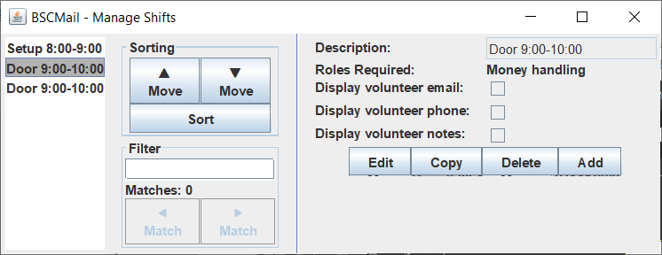

You can see all the roles selected for this shift are listed in the **Roles Required** label. Now we need to assign this role to a volunteer. Return to the Manage Volunteers Window and edit a volunteer. Add the “Money handling” role to it, the same way you added the role to the “Door 9:00-10:00” shifts.

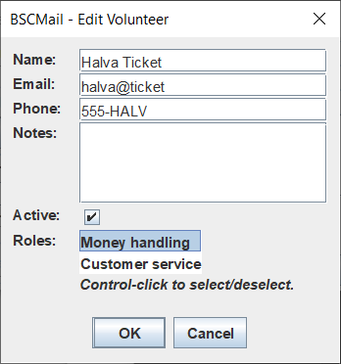

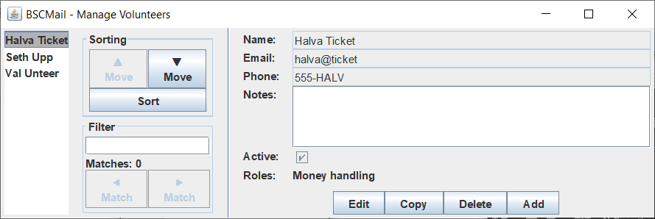

Now return to the Event Setup Window. Click the dropdown next to the Door 9:00-10:00 shift.

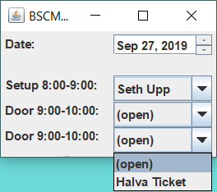

Notice that only the volunteers with the appropriate roles are listed! It would be nice, however, if we could add a bit more information to the event, such as the location. (The event moves around from week to week.) Go back to the Main Window and click the **Event Properties** button in the **Manage** column to launch the Manage Event Properties Window.

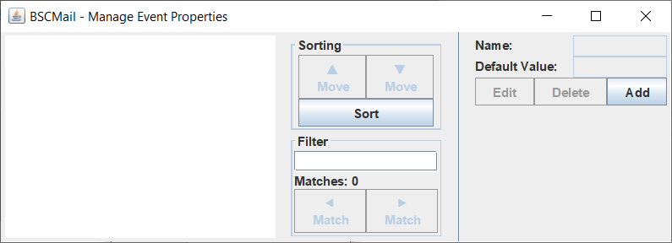

The Manage Event Properties Window works similarly to the Manage Shifts Window, Manage Volunteers Window, and Manage Role Window. Let’s add a new property. Click the **Add** button, type “Location” in the **Name** text box, and click the **OK** button.

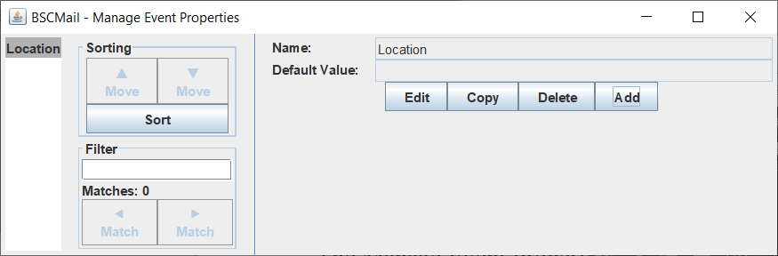

Now return to the Event Setup Window.

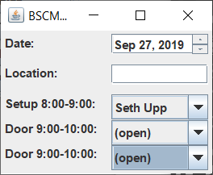

Notice that “Location” has been added to the Event Setup Window. We can type any value into this field. Enter a location.

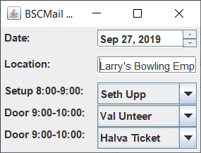

It is possible to enter a default value for a property. (Say, if the event can move from week to week but is usually in one specific place.) Return to the Manage Event Property Window, select “Location” from the list, click the **Edit** button, enter a default value, and click the **OK** button.

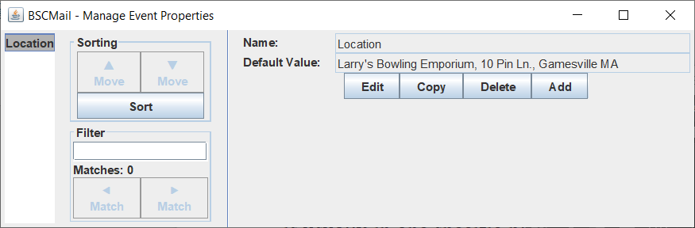

The Event Setup Window will display the default value for any event property when it is first opened. You may change value for the event by typing in the Event Setup Window. (This will not affect the default value.)

The event is looking pretty good now. Let’s create the scheduling email. Assign some volunteers to the shifts, then go back to the Main Window and click the **Email** button in the **Create** column to launch the Event Email Text Window.

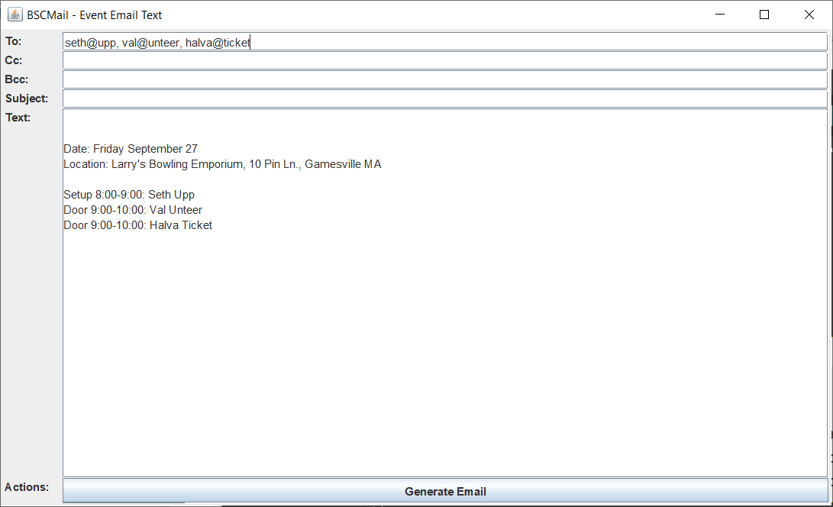

Well, that’s helpful at least. The email addresses of all the volunteers are listed in the **To** field, and the event properties and volunteer schedule have been placed in the **Text** field. It would be nice if we could add a bit more detail, though. Close this window, return to the Main Window, and click the **Email Template** button in the **Manage** column to launch the Manage Email Template Window.

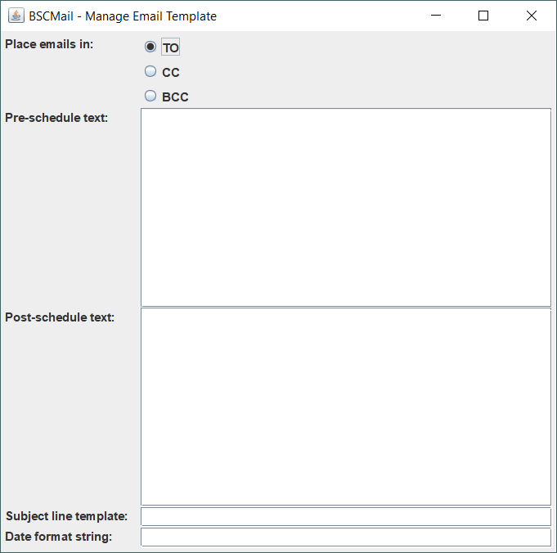

This window allows you to define the email template. The text in the **Pre-schedule text** field will appear before the event schedule, while the text in the **Post-schedule text** field will appear after. Try typing some text into these fields. The text will be automatically saved as you type.

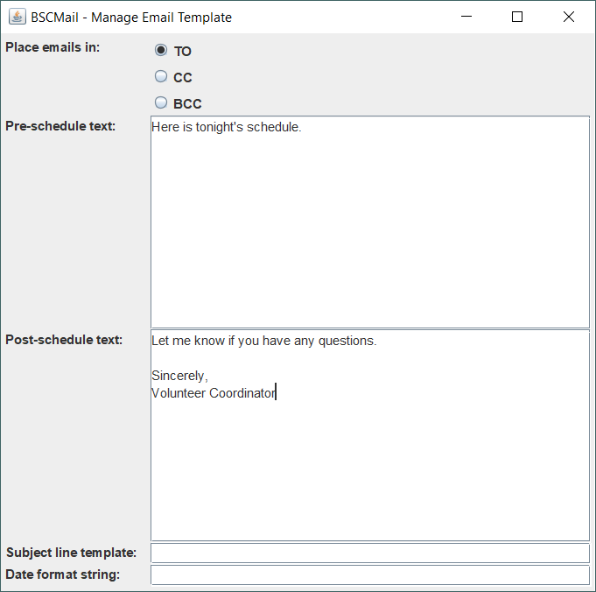

Now re-open the Email Text Window.

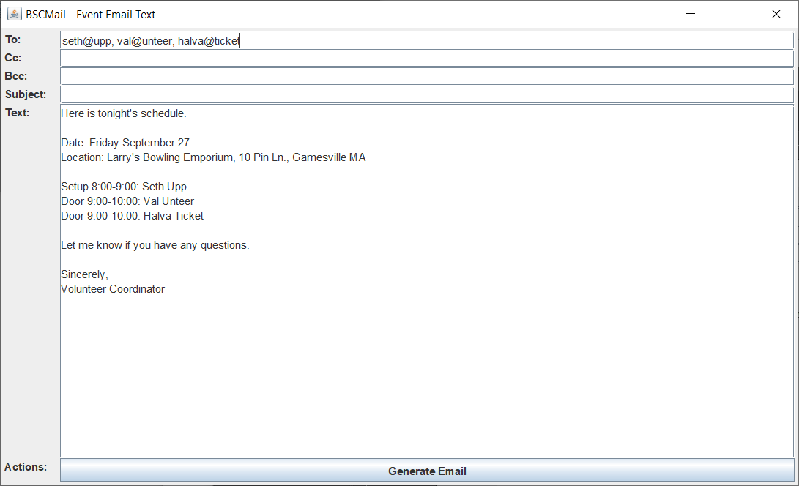

That’s certainly better, but we’re missing a subject line. Return to the Manage Email Template Window and enter some text in the **Subject line template** field. The text will be saved automatically as you type.

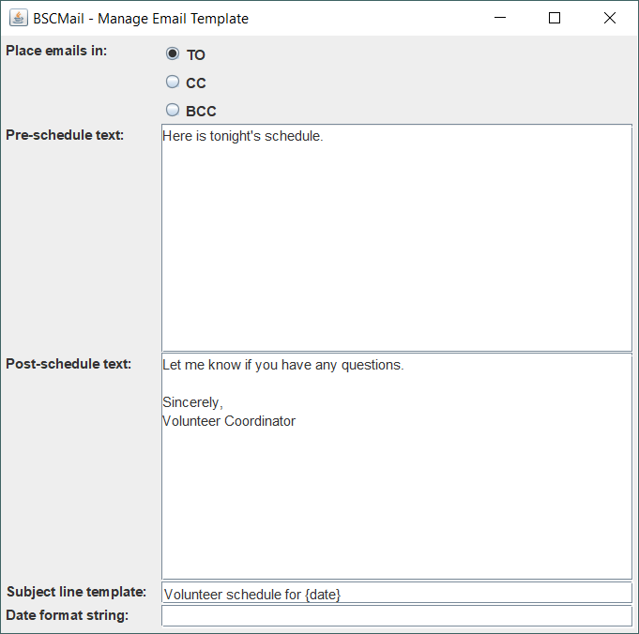

The “{date}” character sequence is special and represents the event date. BSCMail will automatically replace it with the event date.

Now open the Event Email Text window once more.

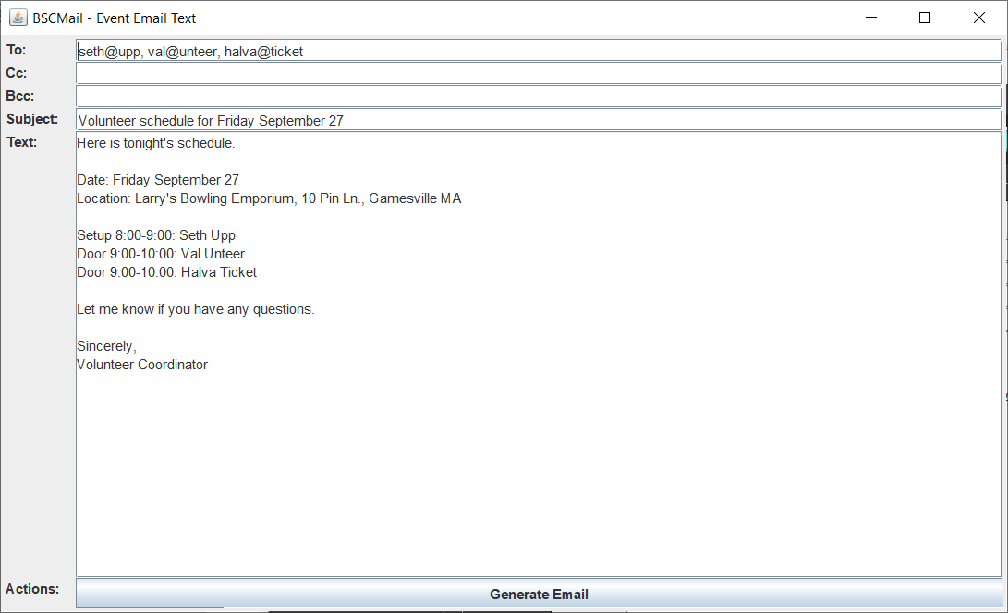

Now that’s a good-looking email! You can edit any of the fields in this window; it will not change the email template. You can copy and paste the text into an email program, or click the **Generate Email** button to automatically send an email. In fact, let’s try it now!

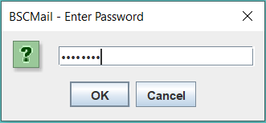

First you are prompted to enter you email password. Enter your password and click the **OK** button. Your password will not be displayed in plaintext.

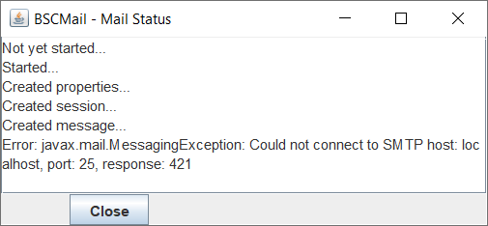

Oops! We forgot to enter our mail server information! Go back to the Main Window and click the **Email Server** button in the **Manage** column to launch the Manage Email Server Window.

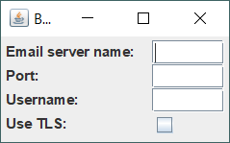

Enter the correct settings for your email server; the values will be saved as you type. When done, return to the Event Email Text screen and click the **Generate Email** button. At the prompt, enter your email password.

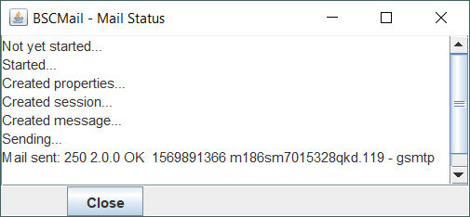

Success! You created an event, assigned volunteers, and emailed the schedule to everyone. Congratulate yourself on a job well done!

We have reached the end of this tutorial. For more information on how BSCMail works, refer to the remainder of this guide.

Happy scheduling!

## Advanced section: date formatting

Starting in version 3.3, it is possible to customize the format of the date in the email. To change the date format, enter a custom format in the **Date format string** field of the Manage Email Window. Some codes you can use are:

* yyyy: four-digit year (“2019”)
* yy: two-digit year(“19”)
* MMMM: full month name (“September”)
* MMM: month abbreviation (“Sep”)
* M: month number (“9”)
* d: day of month (“27”)
* EEEE: full day name (“Friday”)
* EEE: day abbreviation (“Fri”)

You can also use text like commas, spaces, or dashes. If you enter an invalid code, the field will turn pink.

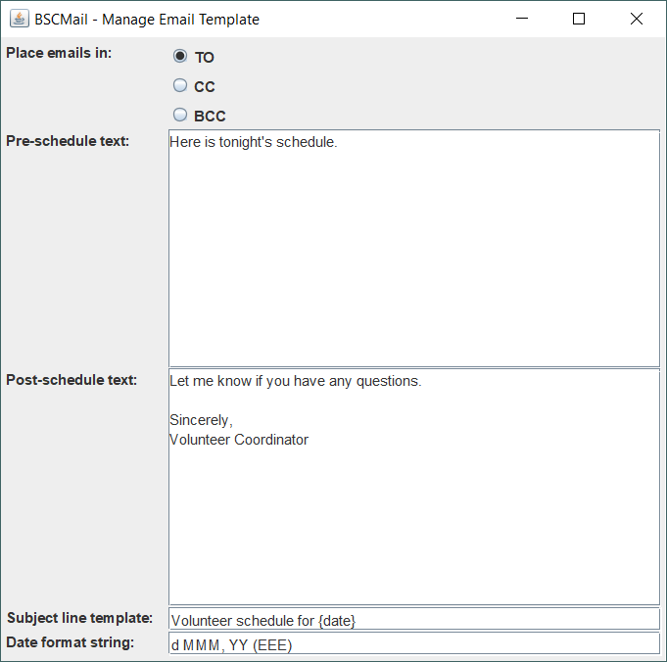

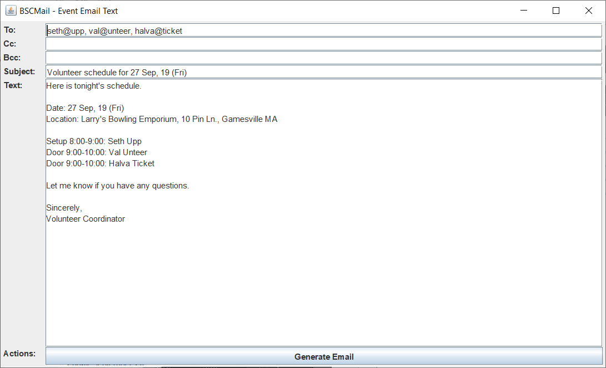

More details about this feature may be found in the Manage Email Window GUI Reference.

## Advanced section: filtering and searching

Starting in version 4.0, it is possible to filter and search shifts, volunteers, roles, and event properties.

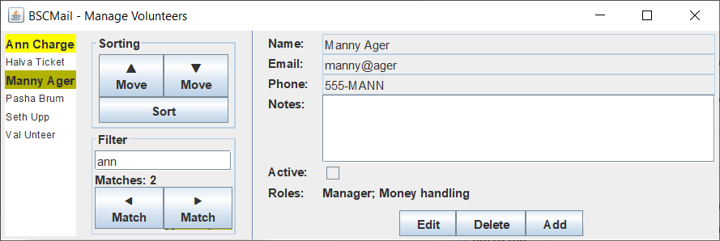

As you type in the **Filter** text box, any elements that match the filter are highlighted in the list. Elements may match on their display name, or on other criteria.

* *Shifts* may match on their description (case insensitive), or on any of their required roles.
* *Volunteers* may match on their name, email, phone, notes (all case insensitive), or on any of their assigned roles. In addition, active volunteers match the filter text “active” and inactive volunteers match the filter text “inactive”.
* *Roles* match on their name (case insensitive).
* *Event properties* may match on their name or default text (both case insensitive).

The **Matches** label displays the total number of matching elements. The **⯇ Match** and **⯈ Match** buttons navigate to the previous matching element and the next matching element, respectively.

# GUI Reference

## Main Window

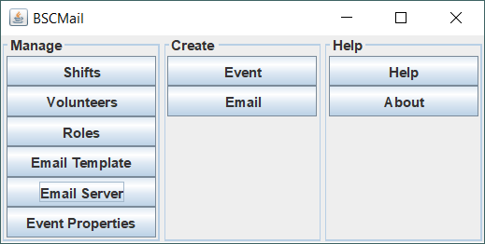

The BSCMail main window is the starting point when the application is launched. There are a number of buttons on the main window, each performing a different function. Note that the buttons are grouped into three columns: **Manage**, **Create**, and **Help**. The buttons perform the following functions.

* The **Manage, Shifts** button opens the Manage Shifts window, which allows you to manage volunteer shifts for events.
* The **Manage, Volunteers** button opens the Manage Volunteers window, which allows you to manage the list of volunteers.
* The **Manage, Roles** button opens the Manage Roles window, which allows you to define specific volunteer roles.
* The **Manage, Email Template** button opens the Manage Email Template window, which allows you to define a template for sending scheduling emails.
* The **Manage, Email Server** button open the Manage Email Server window, which allows you to set up and manage a connection to your email server.
* The **Manage, Event Properties** button opens the Manage Event Properties window, which allows you to define custom properties for your event.
* The **Create, Event** button opens the Event Setup window, which allows you to assign volunteers to and write information for a specific event.
* The **Create, Email** button opens the Event Email Text window, which displays a custom crafted scheduling message for your event.
* The **Help, Help** button opens this user guide.
* The **Help, About** button opens a window displaying information about this version of BSCMail.

## Manage Shifts Window

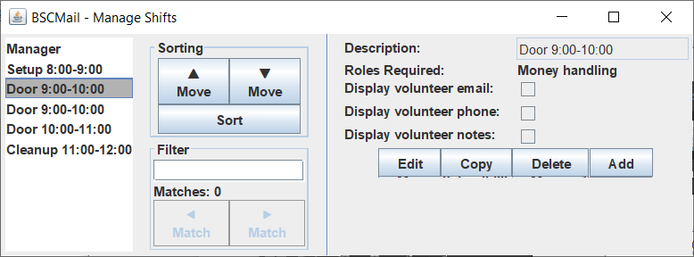

The Manage Shifts window allows you to manage volunteer shifts.

The pane on the left lists all the shifts defined in the application. You can auto-sort the list by clicking the **Sort** button, or you can manually move shifts by selecting them in the list and clicking the **▲** or **▼** buttons or by dragging them with the mouse.

The pane on the right displays the properties of the selected shift.

* The **Description** text box displays the shift’s description.
* The **Roles Required** label displays the volunteer roles necessary for the shift.
* The **Display volunteer email**, **Display volunteer phone**, and **Display volunteer notes** checkboxes all control what volunteer information is displayed in the scheduling message. This information may be displayed on a shift-by-shift basis.

To edit the properties of a shift, select the shift from the list, click the **Edit** button, edit the properties to your liking in the popup, and click the **OK** button. To copy a shift, select it from the list and click the **Copy** button. To delete a shift, select it from the list and click the **Delete** button. To create a new shift, click the **Add** button, edit the properties to your liking in the popup window, and click the **OK** button. The shift will appear at the bottom of the list.

You can move, edit, copy, and delete multiple shifts simultaneously by making multiple selections.

## Manage Volunteers Window

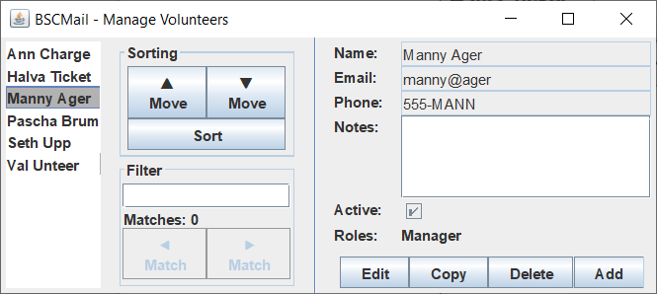

The Manage Volunteer window allows you to manage volunteers.

The pane on the left lists all the volunteers defined in the application. You can auto-sort the list by clicking the **Sort** button, or you can manually move volunteers by selecting them in the list and clicking the **▲** or **▼** buttons or by dragging them with the mouse.

The pane on the left displays the properties of the selected volunteer.

* The **Name** text box displays the volunteer’s name.
* The **Email** text box displays the volunteer’s email address.
* The **Phone** text box displays the volunteer’s phone number.
* The **Notes** text box displays notes about the volunteer.
* The **Active** check box is checked if the volunteer is currently active, or unchecked if the volunteer is inactive.
* The **Roles** list control displays the roles assigned to the volunteer.

To edit the properties of a volunteer, select the volunteer from the list, click the **Edit** button, edit the properties to your liking in the popup, and click the **OK** button. To copy a volunteer, select it from the list and click the **Copy** button. To delete a volunteer, select it from the list and click the **Delete** button. To create a new volunteer, click the **Add** button, edit the properties to your liking in the popup window, and click the **OK** button. The volunteer will appear at the bottom of the list.

You can move, edit, copy, and delete multiple volunteers simultaneously by making multiple selections.

## Manage Roles

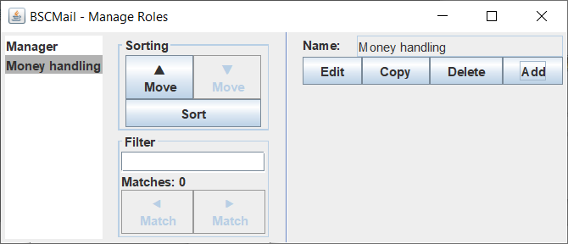

The Manage Roles window allows you to manage roles.

The pane on the left lists all the roles defined in the application. You can auto-sort the list by clicking the **Sort** button, or you can manually move roles by selecting them in the list and clicking the **▲** or **▼** buttons or by dragging them with the mouse.

The pane on the left displays the properties of the selected role. Roles have only a single property, **Name**.

To edit the properties of a role, select the role from the list, click the **Edit** button, edit the properties to your liking in the popup, and click the **OK** button. To copy a role, select it from the list and click the **Copy** button. To delete a role, select it from the list and click the **Delete** button. To create a new role, click the **Add** button, edit the properties to your liking in the popup window, and click the **OK** button. The role will appear at the bottom of the list.

You can move, edit, copy, and delete multiple roles simultaneously by making multiple selections.

## Manage Email Template Window

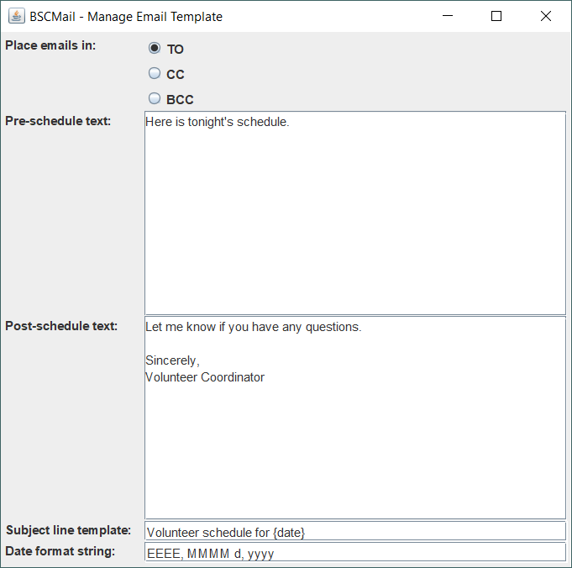

The Manage Email Template window allows you to edit the email template used to create the scheduling email.

The fields of this window are as follows.

* The **Place emails in** radio button group indicates whether the email addresses will be placed in the “To” field, the “Cc” field, or the “Bcc” field in the scheduling email.
* The **Pre-schedule text** text area displays the text that is placed before the schedule in the scheduling email.
* The **Post-schedule text** text area displays the text that is placed after the schedule in the scheduling email.
* The **Subject line template** text field displays the template used for the scheduling email’s subject line. The subject line template is used as the basis for the subject line. Most text appears exactly as typed. The brace characters ({ and }), however, are special and undergo substitution.
  + Bare, single brace characters are simply removed.
  + Double braces ({{ or }}) are transformed into single braces.
  + The string {date} is replaced with the date of the event.
* The **Date format string** defines the format used to display the event date in the subject line and body of the email. The date format string must conform to the format used for a SimpleDateFormat object in Java. (See <https://docs.oracle.com/javase/8/docs/api/java/text/SimpleDateFormat.html>.)

To edit any text field, simply type in the corresponding text area; the changes will be automatically saved. If the date format string is invalid, the background of the text field will turn pink.

## Manage Email Server Window

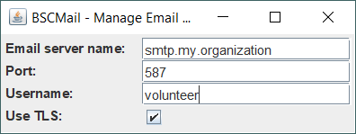

The Manage Email Server Window allows you to manage the connection to your email server.

The fields of this window are as follows.

* The **Email server name** text box displays the hostname of your email server.
* The **Port** text box displays the SMTP connection port of your email server.
* The **Username** text box displays your email server username.
* The **Use TLS** checkbox indicates whether BSCMail should use TLS when connecting to your email server.

To edit any text field, simply type in the corresponding text area; the changes will be automatically saved. Changes are also automatically saved whenever the **Use TLS** checkbox value is changed.

## Manage Event Properties Window

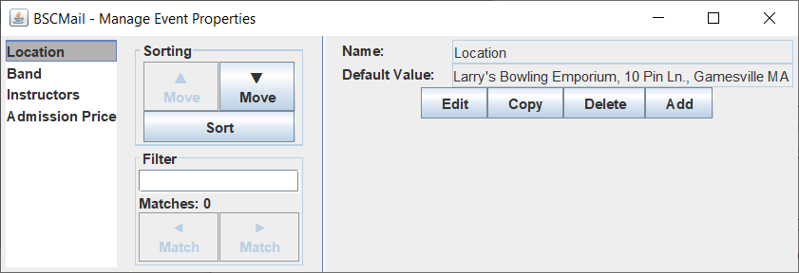

The Manage Event Properties window allows you to manage event properties.

The pane on the left lists all the event properties defined in the application. You can auto-sort the list by clicking the **Sort** button, or you can manually move event properties by selecting them in the list and clicking the **▲** or **▼** buttons or by dragging them with the mouse.

The pane on the left displays the properties of the selected event property.

* The **Name** text box displays the name of the event property.
* The **Default Value** text box displays the default value of the event property.

To edit the properties of an event property, select the event property from the list, click the **Edit** button, edit the properties to your liking in the popup, and click the **OK** button. To copy an event property, select it from the list and click the **Copy** button. To delete an event property, select it from the list and click the **Delete** button. To create an event property, click the **Add** button, edit the properties to your liking in the popup window, and click the **OK** button. The event property will appear at the bottom of the list.

You can move, edit, copy, and delete multiple event properties simultaneously by making multiple selections.

## Event Setup Window

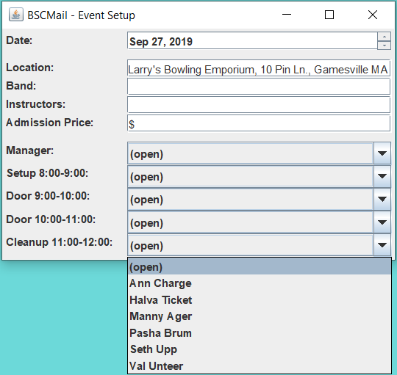

The Event Setup window allows you to create a specific event and assign data to it. The various data are listed on the window

The first field, labeled **Date**, is the date of the event. You can type in a date or use the up/down control to adjust the month, day, and year.

The next fields are the event properties as defined in the Manage Event Properties window. The properties are all listed in order and filled in with their default values. You can leave them as-is or enter new values for this specific event. This window is dynamic; edits made in the Manage Event Properties window show up here in real time.

The final fields are the shifts as defined in the Manage Shifts window. The shifts are all listed in order. Each shift has a dropdown box containing a list of all the volunteers who are active and eligible for that shift; select one to assign them to the shift, or select “(open)” to select no volunteer. This window is dynamic; edits made to shifts in the Manage Shifts window and edits made to volunteers in the Manage Volunteers window show up here in real time.

## Event Email Text Window

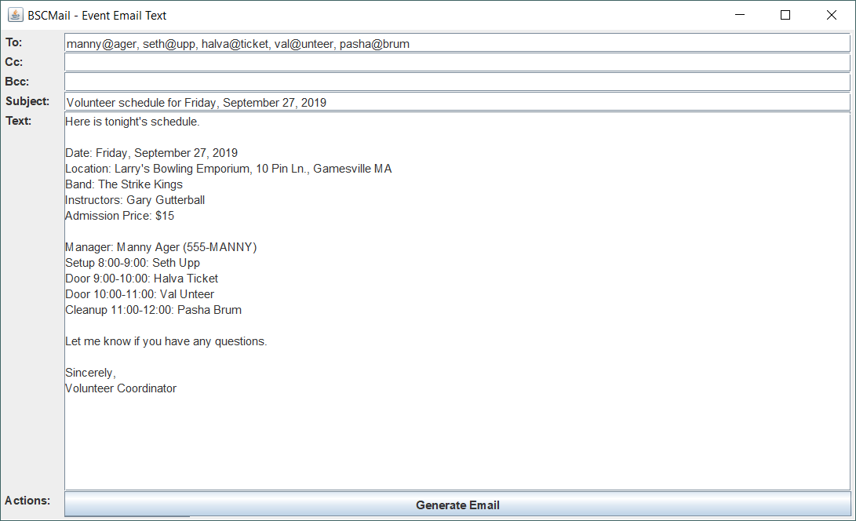

The Event Email Text window constructs and displays a scheduling email for the event defined in the Event Setup window. The email is based off of the email template defined in the Manage Email Template window.

The email is placed in several text boxes. The email addresses of all the volunteers assigned to the event are listed in either the **To** text box, the **Cc** text box, or the **Bcc** text box. The **Subject** text box lists an appropriate subject line containing the date of the event. The **Text** text box contains the email message. All the event properties and shifts with volunteers are listed. Each of the text boxes is editable, so you can make any last-minute alterations you desire.

The **Generate Email** button sends the email using the email server defined in the Manage Email Server window.

# Data Format

The data for BSCMail is contained in XML files stored in the program directory. The files are as follows.

* emailServerProperties.xml — the email server properties
* emailTemplate.xml — the email template
* eventProperties.xml — the list of event properties
* roles.xml — the list of volunteer roles
* shifts.xml — the list of volunteer shifts
* volunteers.xml — the list of volunteers

The data files are updated by the application in real time. They ought not be edited by hand, although they are human-readable for the sake of convenience.

emailServerProperties.xml:

* The root element of emailServerProperties.xml is <emailserverproperties-list>. It contains exactly one child element, <emailserverproperties>.
* The <emailserverproperties> corresponds to the application’s email server properties. It contains four child elements: <hostname>, <port>, <username>, <useTLS>.
* <hostname> is a text node containing the hostname of the email server.
* <port> is a text node containing the SMTP port of the email server.
* <username> is a text node containing the username used to connect to the email server.
* <useTLS> is a text node containing the value of the “use TLS” property.

emailTemplate.xml:

* The root element of emailTemplate.xml is <emailtemplate-list>. It contains exactly one child element, <emailtemplate>.
* The <emailtemplate> element corresponds to the application’s email template. It contains five child elements: <sendType>, <preScheduleText>, <postScheduleText>, <subjectLineTemplate>, and <dateFormatString>.
* <sendType> is a text node containing the send type of the email template: “to”, “cc”, or “bcc”.
* <preScheduleText> is a text node containing the pre-schedule text of the email template.
* <postScheduleText> is a text node containing the post-schedule text of the email template.
* <subjectLineTemplate> is a text node containing the subject line template of the email template.
* <dateFormatString> is a text node containing the date format string of the email template.

eventProperties.xml

* The root element of eventProperties.xml is <eventproperty-list>. It corresponds to the list of event properties. It contains a number of child elements of type <eventproperty>.
* Each <eventproperty> element corresponds to an event property. Each contains three child elements: <name>, <defaultValue>, and <value>.
* <name> is a text node containing the name of the event property.
* <defaultValue> is a text node containing the default value of the event property.
* <value> is an empty node.

roles.xml

* The root element of roles.xml is <role-list>. It corresponds to the list of volunteer roles. It contains a number of child elements of type <role>.
* Each <role> element corresponds to a volunteer role. Each contains one child element: <name>.
* <name> is a text node containing the name of the volunteer role.

shifts.xml

* The root element of shifts.xml is <shift-list>. It corresponds to the list of volunteer shifts. It contains a number of child elements of type <shift>.
* Each <shift> element corresponds to a volunteer shift. Each contains five child elements: <description>, <roles>, <displayVolunteerEmail>, <displayVolunteerPhone>, and <displayVolunteerNotes>.
* <description> is a text node containing the description of the volunteer shift.
* <roles> is a text node containing a comma-delimited list of the volunteer roles required by the volunteer shift.
* <displayVolunteerEmail> is a text node containing the value of the “display volunteer email” property of the volunteer shift.
* <displayVolunteerPhone> is a text node containing the value of the “display volunteer phone” property of the volunteer shift.
* <displayVolunteerNotes> is a text node containing the value of the “display volunteer notes” property of the volunteer shift.

volunteers.xml

* The root element of volunteers.xml is <volunteer-list>. It corresponds to the list of volunteers. It contains a number of child elements of type <volunteer>.
* Each <volunteer> element corresponds to a volunteer. Each contains six child elements: <name>, <email>, <phone>, <notes>, <active>, and <roles>.
* <name> is a text node containing the name of the volunteer.
* <email> is a text node containing the email address of the volunteer.
* <phone> is a text node containing the phone number of the volunteer.
* <notes> is a text node containing the notes about the volunteer.
* <active> is a text node containing the value of the “is active” property of the volunteer.
* <roles> is a text node containing a comma-delimited list of the roles possessed by the volunteer.

1. To select multiple roles, hold the **Ctrl** button while you click. **Ctrl**+click toggles an individual role on or off.